Name the _____________________________________

Global pollinator declines threaten to derail agricultural productivity and ecosystem stability, with consequences for human health, biodiversity, and the health of natural systems. Projects that monitor factors such as pollinator presence and abundance in relationship to global change are valuable for pollinator conservation and as metrics of future risk to international food security.

- During our lab on September 8th, we contributed to the city of Harrisonburg’s pollinator bioblitz by surveying 35 1 x 1 meter quadrats within JMU’s Hillside meadow and uploading observations to the iNaturalist Harrisonburg Parks for Pollinators project.

The dataset ‘HillsidepollinatorsSept2025.csv’ contains a summary of pollinator data we collected. Download these data from Canvas Assignments Exam 11/05/2025 to answer the questions below. The column names in the data are:

- Pair_Quadrat = Student pair collecting data and 1 x 1 m quadrat ID
- Minutes = Minutes spent monitoring each quadrat
- PollinatorGroup = Assignment to one of seven pollinator groups
- Count = Number of individuals of observed during survey
- FloweringUnits = number of flowering units counted within quadrat

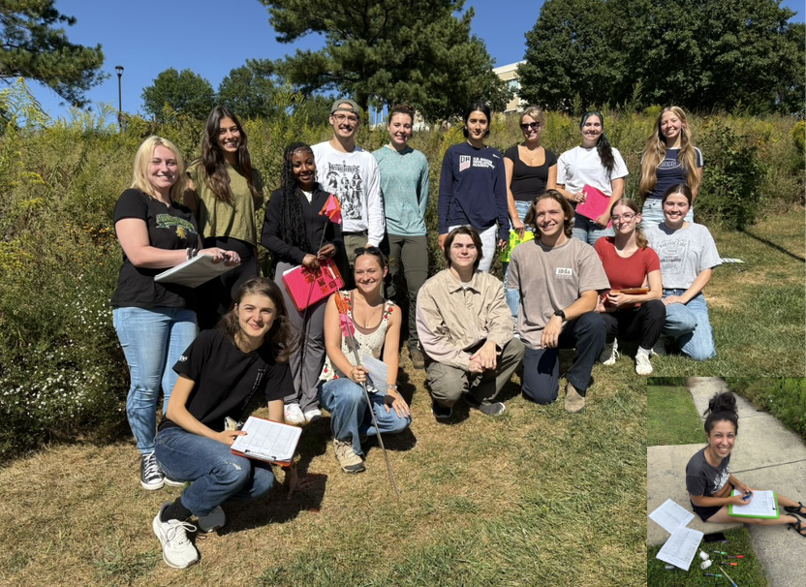
- Do the number of minutes surveyed or total flowering units per 1 x 1 m quadrat affect the mean number of bumble bees observed per minute?
Subset data to include only bumble bees (one option is to create a new dataframe from the original, e.g.,
bumble <- polldat[polldat$PollinatorGroup=="bumble bee",]. But be sure to check that the new dataframe looks right!

- Look at the data. Provide three reasons why you might compare Poisson, 0-inflated, and negative binomial models for analyzing these data to address the above question? (9 pts)

- 3 pts for each justification for using these types of models

- To answer the question, do the number of minutes surveyed or total flowering units per quadrat affect the mean number of bumble bees observed per minute…

- First, determine the best model structure by running a series of fully-saturated Poisson-family models with flowering units and number of minutes as predictors, and an offset of minutes (to estimate the per minute mean number of bumble bees seeing in the quadrat). (Hint: there are four models you should run).

- Which model distribution is the best choice to address our question? Support your model choice with complete statistics derived from a model comparison. (10 pts)

- Best model = 2 pts; 8 pts = 2 pts each for correct model stats that allow comparison for each of the 4 models
- All models for this part should include flowering unit and number of minutes as predictors, just include the additive effects for now (i.e., no interaction)
- What is your code for each of the four models?
- What are the AIC and dAIC for each of the four models?

- Second, use a marginal hypothesis test to test for significance of the two predictor variables included in the best model from above.

- Is there an effect of number of minutes a quadrat was observed or the number of flowering units counted on the mean number of bumble bees observed per minute? Report the line of code you used to test for significance and support your answer with statistics (test statistic, df, p-value). (10 pts)

- 1 pt for answer to whether or not there was an effect of flowering units
- 1 pt for answer to whether or not there was an effect of number of minutes of observation
- 2 pts for using the correct test to test for significance (based on those we learned and used extensively in class)
- 3 pts for correct test stat, df and p-value for effect of flowering units
- 3 pts for correct test stat, df and p-value for effect of minutes of observation

- Pollinator body sizes may be changing in response to global environmental changes. Specifically, climate change may lead to smaller body sizes favored by warmer temperatures, whereas fragmentation associated with land cover change may lead to larger body sizes to facilitate the longer dispersal necessary to reach suitable habitat.

Researchers measured the body size of >2000 museum specimens of four bumble bee species (Bombus spp.) found in Europe to investigate whether body size changes have occurred over the past century (Gerard et al. 2021, Ecography 44(2): 255-264). Their metric of body size, intertegular distance (ITD), is the distance between the wings (see image to right).

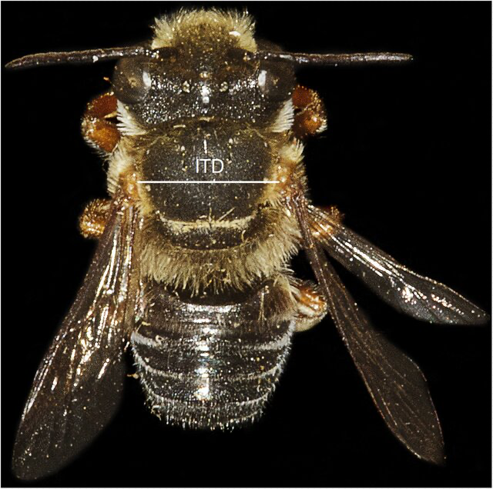

Download the dataset ‘EURObumbles_ITD.csv’ from Canvas Assignments Exam 11/05/2025. The column names in the data are:

- Date: Year specimens were collected
- Species: One of four Bombus species
- Area: Country of origin
- MeanITD: Mean intertegular distance of specimens
  - Run a model with only year as a numeric predictor of ITD (i.e., a single predictor model).
- Is the direction of the effect of year on body size positive or negative (how can you tell)? What is the value of this coefficient from the model? (7 pts)

- Direction of effect = 2 pt
- How can you tell = 2 pt (I’m looking for a simple, obvious answer)
- Value of model coefficient = 3

- What does the above value mean biologically about how body size is changing over time (i.e., is it increasing or decreasing)? What might we infer about the cause of this change in body size (e.g., is it climate vs land cover change and why)? (6 pts)

- Body size increasing or decreasing over time = 3 pts
- Cause of the change in body size = 3 pts
- If you read the exam carefully, the answer to the second half should be apparent

  - Run a model with species only as a predictor of intertegular distance. Report the mean ITD per species and confidence intervals around these means. Looking at these values, how can you tell if ITD does or does not differ among species? (10 pts)

- 1 pt for mean for each species x 4 species = 4 pts
- 1 pt for CIs for each species x 4 species = 4 pts
- How can you infer if there is difference in ITD among species just based on looking at the means and CIs = 2pts

- Abundance surveys for bee populations are not as common nor as long-standing as those for some other popular pollinators. For instance, overwintering monarch butterfly populations have been monitored by citizen scientists since 1997 at about 100-300 overwintering sites along coastal California.

Download the 1997-2019 dataset ‘WestMonarchs.csv’ from Canvas. This dataset contains the average per site count of overwintering monarchs per year.

  - Report the back-transformed population growth rate from analysis of the monarch count data using each of the three models listed below. Also, report the line of code you used to run your model.

- Make sure you are choosing the BEST model for the data for each sub-question (i, ii and iii).
- Use the column names from the provided data in your code

(i) growth rate and code for an observation error-only model (8 pts)

- Correct code = 4 pts
- Correct growth rate = 4 pts

(ii) growth rate and code for a process error-only model (8 pts)

- Correct code = 4 pts
- Correct growth rate = 4 pts

(iii) growth rate and code for a process error model with density dependence (8 pts)

- Correct code = 4 pts
- Correct growth rate = 4 pts

  - Which model above is the best model for these data based on AIC scores? (Report the scores as well) (8 pts)

- Which is best model = 2 pts
- AIC for each of the three models, 2 pts for each x 3 = 6 pts

  - Analyze these data using the MARSS package.

Report the growth rate from the model fit using MARSS. Is this population growing or declining on average and how did you come to this conclusion? (8 pts)

Note: You can also get confidence intervals using the function MARSSparamCIs()

- Correct growth rate = 3 pts (should be reported on the natural scale)
- Is population increasing or declining = 2 pts
- How did you conclude if the population is increasing or decreasing on average = 3 pts

After reviewing the output of the MARSS model, which of the four models do you think is best for analyzing these data and why? (8 pts)

- Which model is best = 2 pts
- How did you conclude this? = 6 pts

Possibly-useful functions and formulae:

$$P\left(x=k|N,p\right)=\left(\begin{matrix}N \\ k\end{matrix}\right)p^{k}{\left(1-p\right)}^{N-k}$$ | glm(Y ~ 1, family = …)
$$\hat{p}=\frac{k}{N}$$ | glm(Y ~ -1 + treatment, family = …) # means
 | glm(Y ~ treatment, family = …) # effects
$$\hat{σ^{2}}=Np(1-p)$$ | zeroinfl(Y ~ count.terms|zero.terms, dist = “poisson”)
 | zeroinfl(Y ~ count.terms|zero.terms, dist = “negbin”)
$$P\left(model|data\right)\frac{P\left(data|model\right)P\left(model\right)}{P\left(data\right)}$$ | AIC(model.name)
 | logLik(model.name)
AIC_{i} = -2log(L_{i}) + 2k₁ | glm(Nt ~ 1, offset = log(Ntm1), family = poisson)
$E\left[x\right]=Np$ | glm(Nt ~ time, family = poisson)
dbinom(k,N,p, log = TRUE/FALSE) | ICtab(model.name1, model.name2, …)
dpois(x, λ, log = TRUE/FALSE) | lrtest(model.name1, model.name2)
cbind(successes, failures) | confint(model.name)
library(pscl) | coef(model.name) # glm model coefficients
library(lmtest) | Anova(model.name)
library(bbmle) | library(car)
$$N_{t}=N_{0}λ^{t}$$ | $$N_{t+1}=N_{t}λ$$

