Svaapta It-Ally Solutions Pvt Ltd

AN INTERNSHIP REPORT

Submitted by
Barot Smit NikulKumar
220413116001
In fulfilment Of

BACHELOR OF ENGINEERING

in

Information Technology



SARDAR VALLABHBHAI PATEL INSTITUTE OF TECHNOLOGY, VASAD

Gujarat Technological University, Ahmedabad 2024-2025



Sardar Vallabhbhai Patel Institute of Technology Vasad

CERTIFICATE

This is to certify that the Internship report submitted by Smit Barot (220413116001) has been carried out under my guidance in fulfillment of the requirements for the degree of Bachelor of Engineering in Computer, 8th Semester of Gujarat Technological University, Ahmedabad, during the academic year 2024-25. The internship was undertaken at Svaapta IT Ally Pvt. Ltd., where he was engaged as a Software Developer Intern, working on web development using PHP and Laravel.

Prof. Shefali Rana Dr. Mala Mehta
Internal Guide Head of the Department
IT-Department IT-Department

Sardar Vallabhbhai Patel Institute of Technology, Vasad

DECLARATION
We hereby declare that the Internship report submitted along with the internship entitled "Software Developer Internship in PHP, Laravel", submitted in fulfillment for the degree of Bachelor of Engineering in Information Technology to Gujarat Technological University, Ahmedabad, is a bonafide record of original project work carried out by me at Svaapta IT Ally Pvt. Ltd., under the supervision of Mr. Amol Dharkar (Company Mentor) and Prof. Shefali Rana (College Guide). We further declare that no part of this report has been directly copied from any student’s report or taken from any other source without providing due reference.
Name of the Student Sign of Student
Smit Barot ____________

Company certificate

ACKNOWLEDGEMENT

I extend my heartfelt gratitude to all those who have been instrumental in making my internship a valuable and enriching experience. Their unwavering support, guidance, and encouragement have contributed significantly to my professional growth. I would like to acknowledge the following individuals and organizations.

Mr. Amol Dharkar, my sincere appreciation for his technical expertise and unwavering support throughout the internship. His guidance was invaluable in shaping my understanding of web development using PHP, Laravel.

Prof. Shefali Rana, I am deeply thankful for her mentorship and insightful advice. Her contributions played a crucial role in supporting me academically and guiding me through the Final Year Internship.

My College and Faculty, I express my gratitude to the college and all the faculty members who showed interest in my work and provided valuable feedback. Their encouragement and cooperation were essential during the Final Year Internship Project.

This internship experience has been transformative, and I am grateful to everyone who contributed to its success. Thank you for being part of my journey.

ABSTRACT

This report is a detailed overview of my internship journey at Svaapta IT Ally Pvt. Ltd.

During my internship, I gained practical experience in how back-end development works in real-world projects using PHP, I learned about key development parameters, team workflows, and how to contribute effectively to ongoing projects in a professional environment.

This experience provided me with deep insight into the roles and responsibilities of a back-end developer and helped me understand how development teams function collaboratively to deliver high-quality software solutions.

Working in a corporate setup not only enhanced my technical skills but also contributed to my personal growth. My efforts and contributions were appreciated by my Team Lead and colleagues, which encouraged me to keep learning and improving.

The experience has had a strong influence on my career interests. It gave me the opportunity to see how the back-end development field is evolving globally, and helped me shape my vision for the future.

Although this report has been prepared within a limited time frame, I have done my best to make it meaningful by reflecting on my tasks and contributions at the company. I have also summarized my overall experience, highlighting the key learnings and challenges I faced as an intern.

Table of Contents
Sr no | Contents | Page No
 | Acknowledgement | 5
 | Abstract | 6
 | Table of Contents | 7
Chapter 1 | Overview of the Company | 11
1.1 | About Company | 11
1.2 | Company Details | 12
Chapter 2 | Overview of Different Departments of the Organization | 13
2.1 | Work Carried Out in Each Department | 13
2.2 | Technical Specifications | 21
2.3 | Our Working Process | 21
Chapter 3 | Introduction to Internship | 23
3.1 | Internship Summary | 23
3.2 | Purpose | 23
3.3 | Objective | 23
3.4 | Internship Planning | 24
3.4.1 | Internship Development Approach and Justification | 24
3.4.2 | Internship Effort, Time, Cost Estimation | 24
3.4.3 | Roles and Responsibilities | 24
Chapter 4 | Platform And Task Base Analysis | 25
4.1 | Tasks Overview Instead of Project | 25
4.2 | Objective Of Assigned tasks | 25
Chapter 5 | Scope of Platforms and Technologies Used | 26
5.1 | Development tools | 26
Chapter 6 | Implement of Assigned Tasks | 30
6.1 | JavaScript task – User Register Form | 30
6.2 | Jquery task- User Register Form | 31
6.3 | PSD TO HTML Task | 33
6.4 | Responsive Web Page Design | 37
6.5 | Bootstrap Web Page Design | 38
6.6 | PHP basic Programming | 39
6.7 | Employee Registration System (php & mysql ) | 41
6.8 | Dynamic Dependent Dropdown using ( php & Ajax ) | 43
6.9 | PHP + MYSQL | 45
6.10 | Shopify (E-commerece) | 47
6.11 | Laravel -task | 50
Chapter 7 | Conclusion and Discussion | 53
7.1 | Overall Analysis of Internship | 53
7.2 | Summary of Internship | 53
7.3 | Limitations and Future Enhancements | 54

Figure Table
Fig. No. | Fig Name | Page. No.
6.1.1 | User Register form change field color according to selected department | 30
6.1.2 | Validation pops when input data are not satisfy according to set validation | 31
6.2.1 | User Register form change field color in Jquery | 32
6.2.2 | Validation pop alert | 32
6.3.1 | Carousel Img 1 | 33
6.3.2 | Carousel Img 2 | 33
6.3.3 | Servies cards Img | 34
6.3.4 | Project cards Img | 34
6.3.5 | About us, map and review section img | 35
6.3.6 | Contact section img | 36
6.4.1 | Web page Desktop size | 37
6.4.2 | Moblie View of Web Page | 37
6.5.1 | Bootstrap task | 38
6.6.1 | Php basic programming Img 1 | 39
6.6.2 | Php basic programming Img 2 | 40
6.7.1 | Employee form with validation | 41
6.7.2 | Employee list Page | 42
6.7.3 | Employee Edit Page | 42
6.8.1 | First view of web page (PHP-Ajax) | 43
6.8.2 | Select Country view page | 43
6.8.3 | Select State view page | 44
6.8.4 | Select City view page | 44
6.9.1 | Register form view dark and light mode | 45
6.9.2 | Employee list page | 46
6.9.3 | Update profile view | 46
6.10.1 | Carousel sider imge of technovaa | 47
6.10.2 | Product list | 47
6.10.3 | Laptop collection img | 48
6.10.4 | Shipping method | 48
6.10.5 | Blog view page | 49
6.11.1 | Laravel form create a user profile view page | 50
6.11.2 | Email add button work | 50
6.11.3 | Address copy check box working | 50
6.11.4 | contacts page | 51
6.11.5 | Edit User profile page | 51

CHAPTER 1: OVERVIEW OF THE COMPANY

  - About Company

Name : Svaapta It-Ally Solutions Pvt Ltd
Address : National Plaza, S7, RC Dutt Rd, Aradhana Society, Vishwas Colony, Alkapuri, Vadodara, Gujarat 390007
Website : https://www.svaapta-it-ally.com/
E-Mail : sales@svaapta.com
Phone no : 099099 60870

Established in 2004, Svaapta IT-Ally Solutions Pvt. Ltd. is a leading IT and software development company based in Vadodara, Gujarat, India. The company specializes in Web Design, Software Development, and Mobile App Development, offering solutions using technologies like PHP, ASP.NET, WordPress, ReactJS, AngularJS, Android, iOS, and more.

With a team of skilled professionals, Svaapta has successfully delivered 150+ projects across 15+ countries, including the USA, UK, Canada, Europe, and Australia. The company is known for building innovative, reliable, and user-focused digital solutions that help businesses grow in the digital era.

  - Company Details

- Our Services
- Enterprise Software Development
Custom software solutions built for scalability, performance, and business-specific needs.
- Web Development
Frontend and backend development using modern technologies like React, Angular, PHP, and Laravel.
- Mobile Application Development
Cross-platform and native mobile apps for Android and iOS platforms.
- UI/UX Design
User-centric design services to enhance usability and engagement.
- E-Commerce Solutions
End-to-end development of robust and scalable e-commerce platforms.
- Cloud Solutions
Deployment and management of cloud-based systems for flexibility and performance.
- Maintenance & Support
Ongoing technical support, troubleshooting, and updates for sustained performance.

CHAPTER 2: OVERVIEW OF DIFFERENT DEPARTMENT OF THE ORGANIZATION
  - WORK CARRIED OUT IN EACH DEPARTMENT

2.2.1 Web Design

Design Approach
Our design philosophy is centered on the idea that “you only have a few seconds to grab the user’s attention.” With this in mind, our designers focus on creating layouts that are clean, intuitive, and purposeful.
We specialize in:
- Wireframing and Prototyping
- Visual Design
- UI/UX Design
- Cross-platform Compatibility
- Security Integration
We ensure that every interface is built to deliver excellent usability, with a deep understanding of user behavior and expectations.

Front-End Development
Our front-end development focuses on creating responsive and interactive user experiences using the latest technologies:
- HTML5/CSS3: Core technologies used to structure and style content.
- jQuery Plugins: For enhanced interactivity and effects.
- Responsive Layouts: Designs that adjust fluidly to different screen sizes and devices.
This combination allows us to deliver dynamic websites that function seamlessly across various platforms.

Mobile UI/UX Design
Mobile usage is increasing rapidly, and we design mobile interfaces that:
- Provide a consistent and smooth experience across all devices.
- Look and feel unique, yet intuitive.
- Are optimized for performance and user satisfaction.
Our goal is to enhance usability while maintaining brand consistency on all screen sizes.

UI/UX Strategy

Wireframes
Wireframes serve as the blueprint of any design. We create comprehensive wireframes to define structure, navigation flow, and content layout before visual design begins.

User Interface Design
We design aesthetically pleasing, user-friendly interfaces that provide an engaging user experience, bridging the gap between users and technology.

User Experience (UX)
We place users at the core of our design process by conducting:
- User research
- Journey mapping
- Usability testing
This ensures that the final product meets the users’ needs and expectations effectively.

Logo Design & Branding
We offer creative branding solutions including:
- Logo Design
- Color Schemes
- Typography and Visual Identity

- Web Application Development

PHP Development Services
- Dynamic Website Development
  - Skilled developers deliver fast, responsive, and dynamic websites.
  - Performance and flexibility are key priorities.
- Custom Application
  - Personalized PHP solutions tailored to client-specific requirements.
  - Emphasis on intuitive user experience and scalability.
- CMS Development
  - User-friendly content management systems.
  - Ensures clients can manage their content with ease.
- PHP-based eCommerce
  - Customized online shopping platforms.
  - Seamless shopping and secure payment integration.

ASP.NET Development
- ASP.NET Enterprise Solutions
  - Enterprise-level applications to meet evolving business needs.
  - Focus on scalability, reliability, and performance.
- Custom .NET Applications
  - Robust applications built using ASP.NET and C#.
  - Supports complex functionality and high-end performance.
- DNN Development
  - Expertise in DotNetNuke module development and integration.
  - Scalable enterprise-level CMS development.
- MVC Development
  - Web and mobile applications using MVC architecture.
  - Greater control, flexibility, and maintainability.

AngularJS Development
- AngularJS Plugin Development
  - Custom plugins to extend functionality.
  - Simplifies complex front-end requirements.
- AngularJS App Development
  - Scalable, fast, and interactive Angular applications.
  - Built with MVC and RESTful integration.
- AngularJS Design & Development
  - UI/UX-focused web applications.
  - Designed to exceed competitive benchmarks.
- Custom AngularJS Development
  - Solutions for complex business logic using AngularJS.
  - Highly maintainable and scalable structure.

Node.js Development
- Web Application Development
  - Real-time, efficient, and scalable applications.
  - Built using modern JavaScript-based architecture.
- API Development
  - Strong and secure APIs using top frameworks.
  - Enables seamless system integration.
- Plugin Development
  - Creative and asynchronous plugins for enhanced performance.
  - Leverages Node.js’s non-blocking I/O model.
- ECommerce Solutions
  - Scalable Node.js platforms for online shopping.
  - Focus on speed, usability, and reliability.

Vue.js Development
- VueJS Web Application Development
  - Lightweight and interactive web applications.
  - Built using modern Vue.js components.
- VueJS Support & Maintenance
  - Continuous support after deployment.
  - Ensures apps stay updated and bug-free.
- Interactive UI Development
  - Attractive, engaging UI interfaces.
  - Designed to improve user interaction and satisfaction.
- Component Development
  - Reusable Vue.js components.
  - Speeds up development and ensures consistency.

ReactJS Development
- Custom Development
  - Tailor-made ReactJS applications.
  - Focus on quality and precise client requirements.
- AJAX Development
  - Enables dynamic content loading.
  - Enhances speed and interactivity.
- Plugin Development
  - Secure and custom plugins for extended functionality.
  - Built with modern features and flexible APIs.
- ReactJS Migration
  - Smooth transition from legacy systems to ReactJS.
  - Improves app performance and scalability.

- CMS & E-Commerce Development

WordPress Development
- CMS Development
  - We ensure that users can easily manage their websites after delivery, with a user-friendly content management system.
- Web Development
  - Expertly crafted websites for CMS, businesses, and blogs, built to be simple, manageable, and responsive.
- Plugin Development
  - We customize and implement plugins as needed, making site functionality smoother for our clients.
- Maintenance & Support
  - Post-deployment support is handled promptly to ensure the system runs efficiently and without interruption.

Magento Development
- Svaapta IT-Ally offers professional Magento development services with a flexible approach, ideal for small to mid-sized businesses across the UK, USA, and globally.
- Long-term client relationships are built on quality Magento solutions tailored for e-commerce success.
- Magento 2 Migration and Update
  - Seamless migration and updates to Magento 2 for enhanced performance and features.
- Magento 2 Store Design and Development
  - A skilled team of Magento experts creates fully-functional stores that meet client needs.
- Magento Custom Development
  - Custom functionality and module integration for tailored business solutions.
- Magento Enterprise Development
  - Enterprise-grade Magento solutions focused on performance, flexibility, and scalability.

Joomla Website Development
- With extensive Joomla experience, we deliver robust custom websites suited for startups to large enterprises.
- Our process involves analyzing client requirements, suggesting improvements, and delivering reliable solutions.
- Application Development
  - Skilled Joomla developers deliver excellent eCommerce applications.
- Plugin Development
  - Best practices in plugin development ensure flexible, feature-rich websites.
- Maintenance & Services
  - Post-deployment issues are handled swiftly to ensure uninterrupted service.
- Custom Web Development
  - We prioritize client expectations and deliver high-quality, tailored web solutions.

Shopify Website Development
- Migrate to Shopify
  - Upgrade your eCommerce platform with our smooth Shopify migration services.
- Custom Website Design
  - Experienced designers and developers build responsive and fully customized stores.
- Store Development
  - Our Shopify developers create competitive and feature-rich online stores.
- Theme Development
  - We design Shopify themes that perfectly match your business identity and goals.

DotNetNuke (DNN) Development
- DNN is an ideal platform for building secure, scalable, and customizable business applications.
- DNN Web Application Development
  - Responsive and tailored DNN web development for various business domains.
- DNN Module Development
  - Efficient and powerful modules ensure smooth and dynamic system performance.
- DNN Skin Designing
- We create visually appealing, responsive DNN skins to match your brand.
- Mobile Application Development

Android App Development
- Skilled Team
  - Our Android UX/UI designers and developers deliver high-quality Android apps using platform-independent tools and languages.
- Dynamic Website Integration
  - Our apps support multimedia formats — text, graphics, video, and animation — to meet all user requirements.
- eCommerce Apps
  - We build feature-rich and functional mobile stores designed to boost online sales and user engagement.
- Location-Based Apps
  - Designed for mass-market appeal, our cost-effective apps use geo-location to enhance reach and user value.
- Enterprise Apps
  - Developed by experienced professionals using the latest technologies to power your enterprise mobility.

iOS App Development
- Our Swift developers handle everything — from design to deployment — delivering secure, scalable, and results-oriented iOS apps.
- Custom Development
  - Apps built with a deep understanding of your business purpose and market demands.
- Swift User Experience
  - We deliver fast, fluid, and user-friendly iOS applications.
- Expert Developers
  - Skilled professionals with a passion for crafting intuitive and robust apps.
- Security & Privacy
  - We ensure full confidentiality of your project and provide future-focused consultation.
Cross Platform Mobile App Development
- We build apps that work seamlessly across iPhone, iPad, Android, and other platforms using tools like Xamarin and PhoneGap.
- Cross Platform App Development
  - From eCommerce to multimedia, our apps run efficiently across all platforms and devices.
- Multi Platform Compatibility
  - Platform-independent apps ensure consistent performance on every screen size and operating system.
- App Theme Design
  - Custom theme designs using modern design principles to ensure aesthetic appeal and usability.
- Responsive Web Apps
  - Designed to perform well across all devices with a responsive interface.

React Native App Development
- We help brands grow with agile and efficient React Native development services backed by cutting-edge technologies and best practices.
- Dynamic Web Integration
  - High-performing PHP development ensures smooth data flow and enhanced functionality.
- Custom Applications
  - Focused on delivering a personalized app experience tailored to your needs.
- CMS Development
  - We ensure the app's content can be easily updated and managed by your team.
- PHP-Based eCommerce
  - Easy shopping experiences powered by custom PHP solutions and secure payment systems.

2.2 Technical Specifications
- Technical specifications utilized across departments at our company encompass a wide range of platforms and frameworks tailored for different development needs.
- Web Application Development employs technologies such as PHP, ASP.NET, React, and Angular for back-end and front-end functionality. Visual Studio Code and IntelliJ IDEA are the preferred IDEs for efficient coding and debugging.
- Web Design tasks utilize tools like HTML5, CSS3, JavaScript, Bootstrap, and Tailwind CSS to ensure responsive and visually appealing layouts. UI/UX designs are crafted using Figma, Adobe XD, and Photoshop to create user-friendly and interactive experiences.
- CMS & eCommerce solutions are built using platforms such as WordPress, Magento, Joomla, Shopify, and DotNetNuke (DNN). Custom plugin/module development, theme customization, and enterprise integrations ensure tailored experiences. Magento and Shopify are specifically used for high-performing eCommerce store setups with scalable architectures.
- Mobile Application Development spans across Android, iOS, and Cross-Platform environments. Android apps are developed using Java, Kotlin, and Android Studio, while iOS apps leverage Swift and Xcode. Cross-platform solutions are built using React Native, Xamarin, and PhoneGap for seamless performance across devices.
- Additionally, Microsoft services such as Power BI and Microsoft Dynamics are integrated into operational workflows, enhancing business intelligence, data visualization, and enterprise resource planning.
2.3 Our Working Process
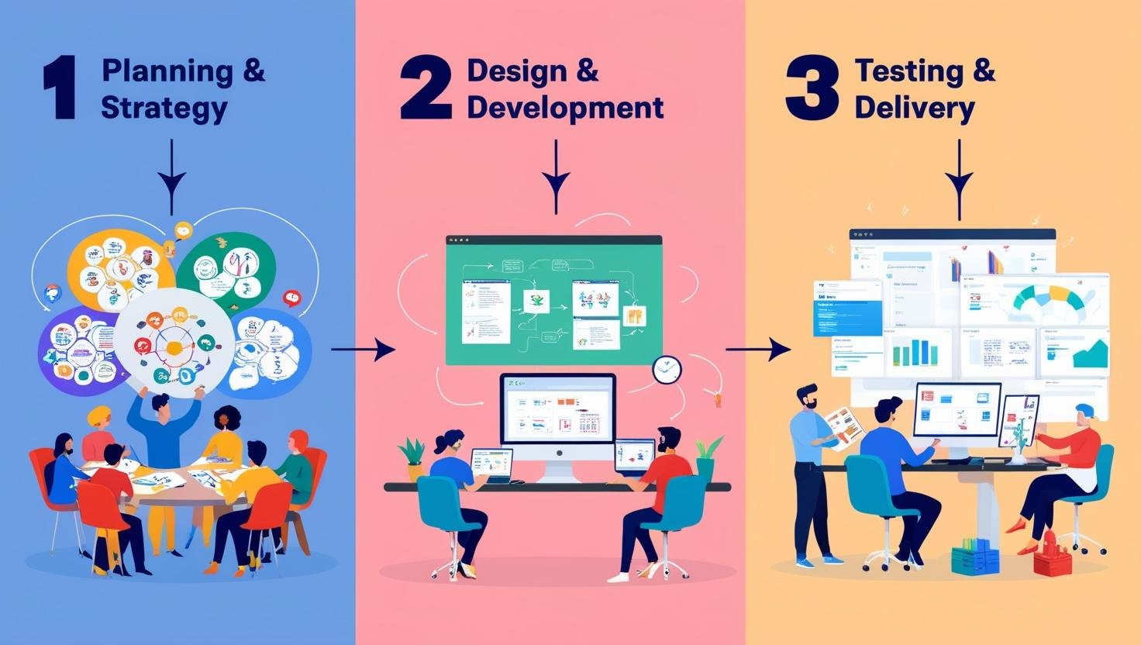
- Planning & Strategy
The production process begins with thorough planning and strategy formulation. Our project team gains an in-depth understanding of the client’s concept, goals, and requirements. This stage ensures all essential information is collected and analyzed to lay a strong foundation for the project.
- Design & Development
Based on the defined specifications, our design team initiates the creation of wireframes and UI/UX layouts. Once approved, the development phase begins using cutting-edge technologies. We follow the AGILE methodology to manage tasks, ensuring iterative progress, continuous feedback, and on-time delivery.
- Testing & Delivery
After development, the entire solution undergoes rigorous quality testing to meet industry standards and project objectives. Once validated, the final product is deployed into a live working environment, ready for end-user interaction.

CHAPTER 3: INTRODUCTION TO INTERNSHIP

3.1 INTERNSHIP SUMMARY
During this internship, I received mentored training that focused on enhancing both my logical thinking and development capabilities. The tasks assigned by my company guide ranged in complexity, encouraging me to push my limits and grow with each challenge. These real-time assignments gave me valuable exposure to actual industry workflows, significantly improving my problem-solving skills and understanding of software development practices.

I worked in the organization as a PHP Intern. Throughout the internship, I gained hands-on experience with technologies such as PHP, MySQL, Docker, and the Model-View-Controller (MVC) architecture. I also explored and worked on API creation and endpoint.

3.2 PURPOSE
• Gaining hands-on experience in PHP, MVC architecture to strengthen development skills.
• Learning to work with tools like Docker to build efficient and scalable containers and images.
• Developing real-world projects under guidance to understand the complete software development life cycle.
• Adapting to a professional work environment and understanding team collaboration and task management.
• Improving problem-solving abilities and exploring practical applications of theoretical knowledge.

3.3 OBJECTIVE
The objective of the internship is to gain practical experience and deepen my expertise in web development by working on real-time projects using technologies like PHP and MVC architecture. This internship aims to offer hands-on learning, guidance from experienced mentors, and exposure to building efficient, scalable web applications. It also focuses on improving my understanding of modern development practices, tools, and workflows used in the software industry.

3.4 INTERNSHIP PLANNING

3.4.1 Internship Development Approach

The internship was structured into multiple phases to ensure progressive learning and skill development.

The first three months were focused on the learning phase, where I was introduced to core technologies such as HTML, CSS, JavaScript, MySQL, PHP, MVC architecture, and tools like Docker and Postman. During this period, I was assigned various tasks to apply my learning in practical scenarios.

After completing the initial phase, the next three months transitioned into the stipend phase, where I started contributing to real-time projects under the guidance of mentors. This phase emphasized applying the knowledge gained during training to actual development work.

After six months, based on performance, time management, and responsibility, there is an opportunity to be considered for selection into the company as a full-time developer.

3.4.2 Internship Effort and Time, Cost Estimation

The effort, time, and cost estimation of the internship was evaluated on a monthly basis. This included tracking daily working hours, tasks performed, leaves taken, and any extra effort or overtime. All work was monitored and managed systematically under the guidance of mentors during the internship tenure.

3.4.3 Roles and Responsibilities

My role during the internship was as a Software Development Intern. My key responsibilities included understanding the tasks assigned by mentors, working on both individual and collaborative project modules, and delivering outputs as per requirements. I also closely coordinated with fellow interns and developers to ensure smooth project progress. Logging daily hours and tracking task completion was a part of my routine to maintain transparency and efficiency.

CHAPTER 4 : PLATFORM AND TASK-BASED LEARNING ANALYSIS

4.1 TASKS OVERVIEW INSTEAD OF PROJECT

During my internship at Svaapta IT-Ally Solutions, I was not assigned a major project. Instead, I was given various task-based assignments by my mentor to enhance my practical skills in web development. These tasks were focused on real-world requirements and development activities that are commonly performed in a professional IT environment.

The core technologies I worked with include:

- HTML & CSS – for structuring and styling webpages
- JavaScript – for adding interactivity to websites
- Bootstrap – for responsive and mobile-first UI design
- PHP & Laravel – for developing dynamic websites and understanding server-side logic
- Docker – For understanding the containerization and perfect deployment of any project.

These assignments helped me to strengthen my understanding of full-stack development basics, UI responsiveness, and platform-specific development like Docker, GitHub. Each task provided a practical challenge that contributed to improving my coding skills, time management, and ability to work independently under guidance.

4.2 OBJECTIVES OF ASSIGNED TASKS

The main objectives of the tasks assigned during my internship at Svaapta IT-Ally Solutions were focused on practical learning and skill development in the field of web development. Each task was aimed at helping me understand the industry workflow and enhance my technical expertise. The key objectives included:

- To gain hands-on experience with front-end technologies like HTML, CSS, Bootstrap, and JavaScript.
- To understand the process of web development from design to deployment.
- To work with server-side scripting using PHP and explore the Laravel framework.
- To get hands on experiance with CRM customization.
- To improve problem-solving skills by working on real-world issues and debugging tasks.
- To follow development standards used in the professional environment, including proper code structuring and version control.

CHAPTER 5 : SCOPE OF PLATFORMS AND TECHNOLOGIES USED

5.1 Development Tools

During my internship at Svaapta IT-Ally Solutions, I worked with a focused set of web technologies and platforms that helped enhance my technical knowledge and practical skills. The scope of the tools and technologies used was aligned with real-world project requirements and best practices in the industry.
The main technologies and their scope included:

HTML & CSS
HTML (HyperText Markup Language) and CSS (Cascading Style Sheets) are the foundational technologies for web development.
Features and Benefits:
- Structure and Styling: HTML is used for structuring web content, while CSS styles the appearance of content across devices.
- Responsive Design: CSS with media queries ensures web pages are mobile-friendly and adaptable to screen sizes.
- Ease of Learning: Both are beginner-friendly and form the core of front-end development.
- Browser Compatibility: HTML and CSS are supported by all modern browsers.

JavaScript
JavaScript is a high-level, interpreted programming language used to add interactivity and functionality to web pages.
Features and Benefits:
- Client-Side Interactivity: Enables real-time updates, animations, and dynamic elements.
- DOM Manipulation: Allows manipulation of HTML elements based on user interaction.
- Event Handling: Supports robust event handling like click, hover, form submit, etc.
- Cross-Browser Support: Widely compatible with all major browsers.

Bootstrap
Bootstrap is an open-source front-end framework for developing responsive and mobile-first websites.
Features and Benefits:
- Prebuilt Components: Offers reusable UI components such as buttons, modals, and navbars.
- Responsive Grid System: Ensures consistent layout across all devices.
- Faster Development: Speeds up the development process using predefined classes.
- Cross-Browser Compatibility: Works seamlessly across different browsers and devices.

PHP
PHP is a widely-used open-source scripting language especially suited for web development and server-side logic.
Features and Benefits:
- Server-Side Scripting: Used for handling form data, file uploads, and server-side validations.
- Database Connectivity: Easily connects to MySQL and other databases.
- Cross-Platform: PHP scripts can run on multiple platforms like Windows, Linux, and macOS.
- Wide Community Support: Extensive documentation and community help available.

Laravel
Laravel is a PHP framework that provides an elegant syntax and simplifies complex web development tasks.
Features and Benefits:
- MVC Architecture: Separates logic, data, and presentation for better code management.
- Blade Templating Engine: Lightweight templating engine that simplifies UI design.
- Built-in Authentication and Routing: Offers prebuilt solutions for common tasks.
- Database Migration and Seeding: Manages database versioning and dummy data.

SuiteCRM
SuiteCRM is a leading CRM solution which is open-source and easy to customize and its the most demanded among the CRM’s.
Features and Benefits:
- Module Customization: Modify existing module or build new ones from scratch.
- API Integration: Add advanced functionality via API or custom entry points.
- Easy Management: Efficient back-end system for sales and team management.
- User Friendly: Optimized for the user and it have a clean UI to behave user friendly.

Git & GitHub
Git is a version control system, and GitHub is a platform for hosting and collaborating on Git repositories.
Features and Benefits:
- Version Control: Track code changes, roll back to previous versions.
- Branching and Merging: Safely experiment and merge features without affecting the main code.
- Collaboration: Multiple developers can work on a project simultaneously.
- Issue Tracking & Documentation: Manage bugs and document changes.

Docker
Docker is a platform that packages applications and their dependencies into containers.
Features and Benefits:
- Environment Consistency: Ensures the application runs the same on all environments.
- Isolated Containers: Prevents conflicts between different project setups.
- Simplified Deployment: Speeds up deployment and scaling with minimal setup.

CHAPTER 6: IMPLEMENTATION OF ASSIGNED TASKS

6.1 . JavaScript Task – User Register Form
Task Description:
This task involved designing and developing a fully functional User Registration Form. The form includes field validation, conditional logic, and dynamic styling behavior based on user input, especially from the dropdown selection.
Features Implemented:
- Dropdown Menu – Department Selection:
  - Users can choose a department (e.g., HR, Admin, IT).
  - On selection, the Input field color of the entire form changes to visually distinguish the selected department using JavaScript.
- Form Fields:
  - First Name (Required)
  - Middle Name (Optional)
  - Last Name (Required)
  - Password (Required – Minimum 8 characters)
  - Confirm Password (Required – Must match Password)
  - Email (Required – Must be a valid email format)
  - Profile Picture (Required – Max file size: 1 MB)
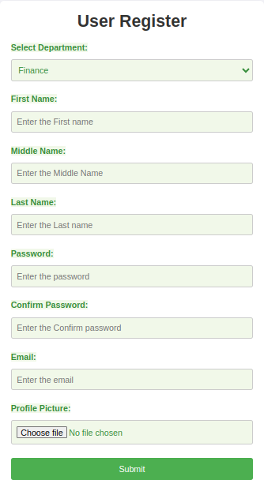
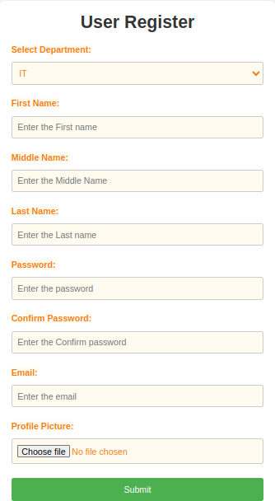
Photo :
fig 6.1.1 : User Register form change field color according to selected department
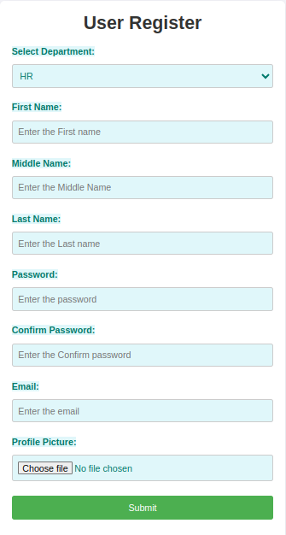
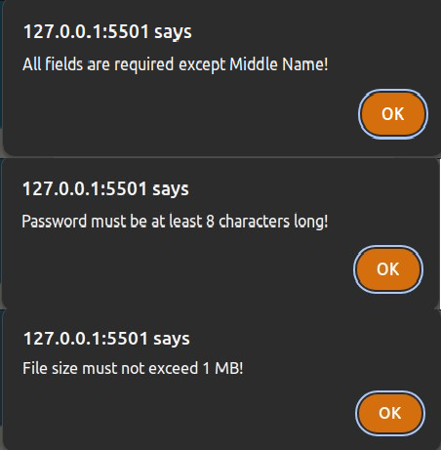
fig 6.1.2 : Validation pops when input data are not satisfy according to set validation
6.2 : Jquery Task – User Register Form
Task Description:
In this task, I designed and implemented a User Registration Form with jQuery to manage real-time form validation and visual feedback based on user interaction. The goal was to show how jQuery makes JavaScript development easier and more efficient.
- Dropdown Menu – Department Selection:
  - Users can choose a department (e.g., HR, Admin, IT).
- On selection, the Input field color of the entire form changes to visually distinguish the selected department using JavaScript.
- Validation Rules via jQuery:
- All fields except Middle Name are mandatory.
- Password length must be at least 8 characters.
- Confirm Password must match Password.
- Email must be valid (e.g., user@gmail.com).
- File input must not exceed 1 MB in size.
- Real-time error messages appear when rules are violated.
Photo:
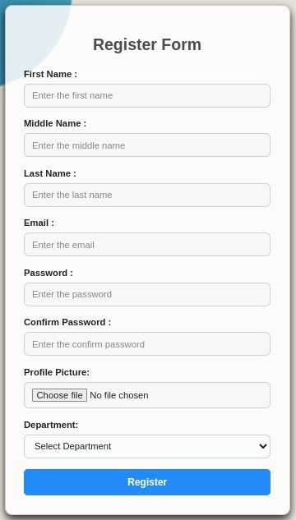
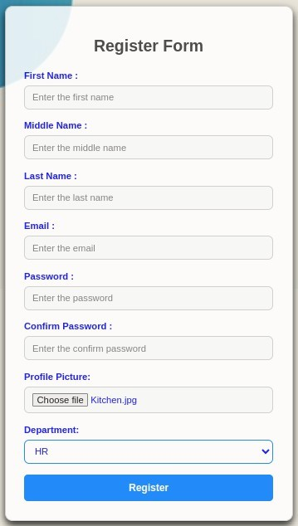
fig 6.2.1 :User Register form change field color in Jquery
fig 6.2.2 :Validation pop alert

6.3 : PSD to HTML TASK

Task Description:
In this task, my mentor provided me with a PSD (Photoshop Design) file of a web page layout. My job was to convert the design into a fully responsive and functional HTML web page. I used HTML, CSS, and Bootstrap to recreate the exact look and structure of the original design.

,Photo :
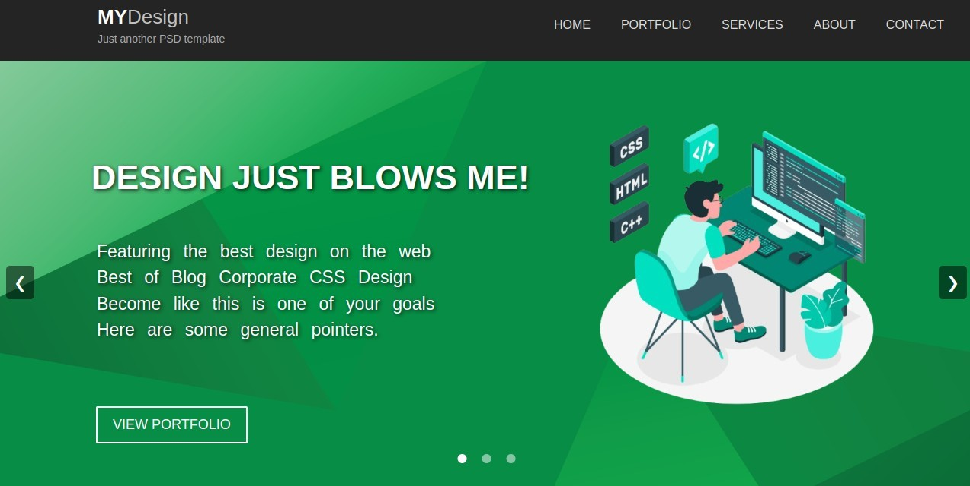
Fig 6.3.1: Carousel Img 1

Fig 6.3.2 : Carousel Img 2
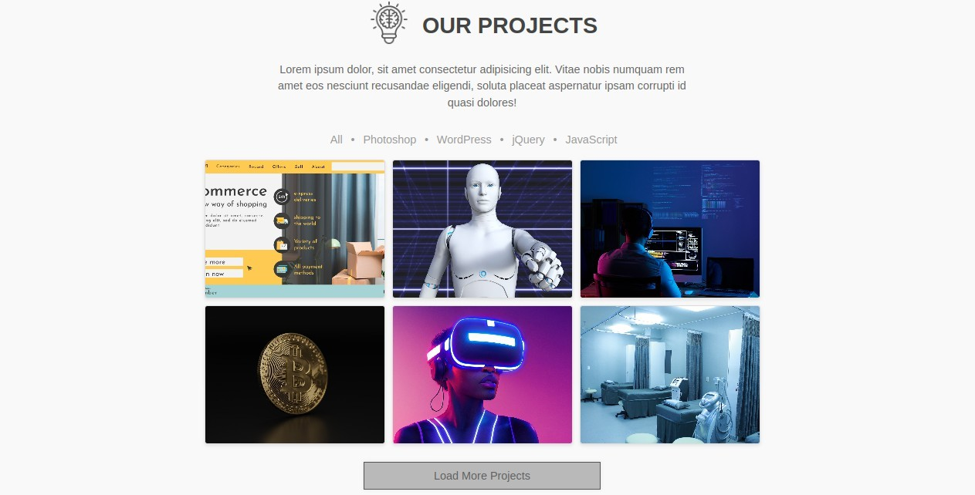
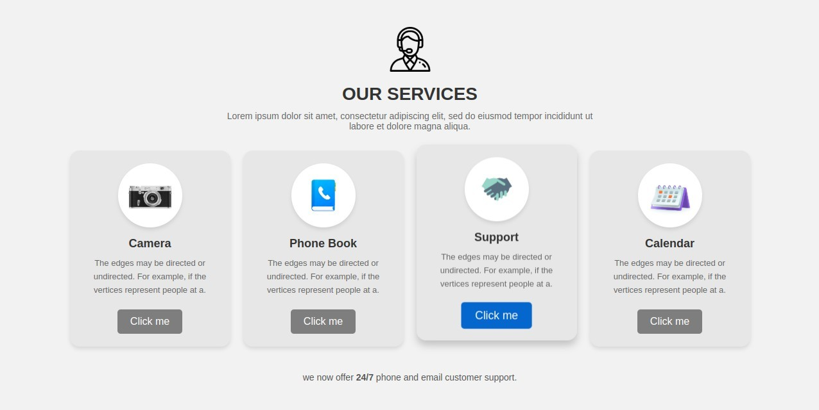
Fig 6.3.3 : Servies cards Img
Fig 6.3.4 : Projects cards Img


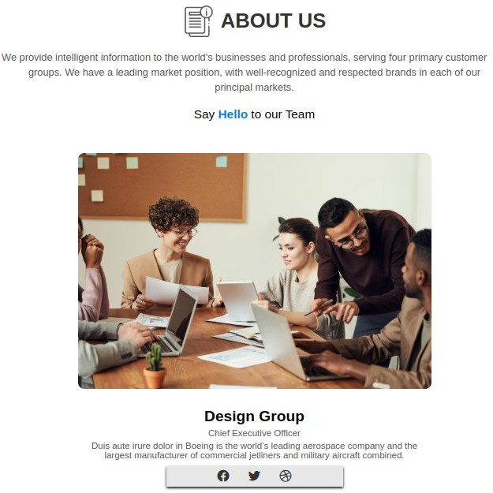
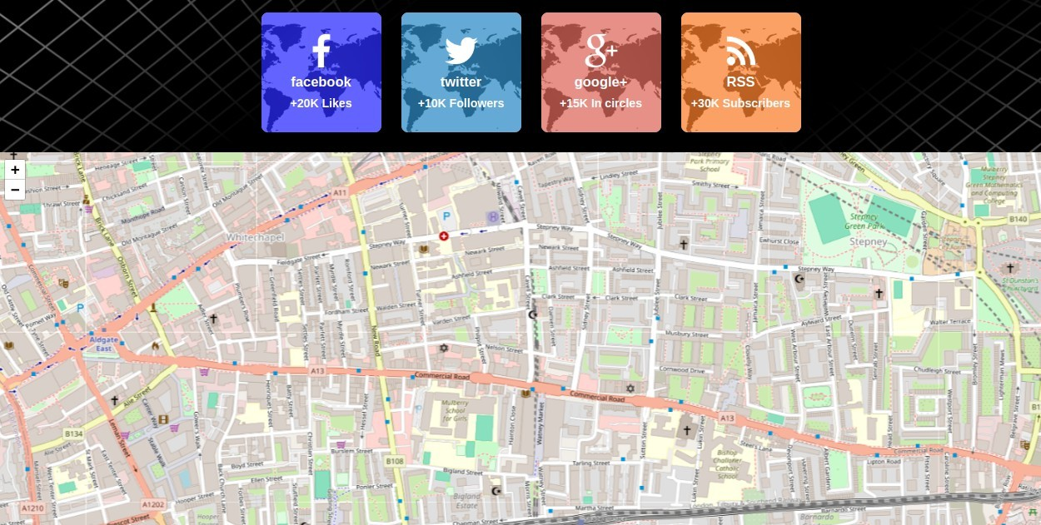

Fig 6.3.5 : About us, map and review section img

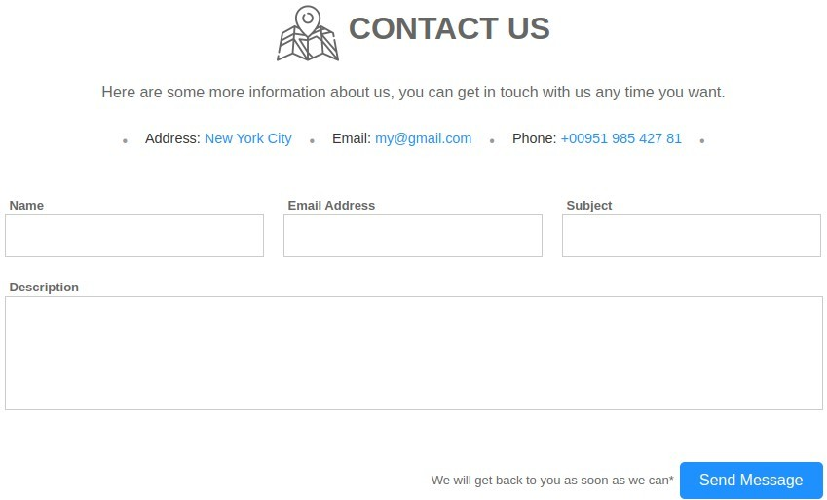

Fig 6.3.6 : Contact section Img

6.4 : Responsive Web Design – Task

Task Description:
In this task, my mentor shared an image of a web design with me. Based on the image, I created a fully responsive web page using HTML and CSS. The layout adjusts smoothly across different screen sizes such as mobile, tablet, and desktop.

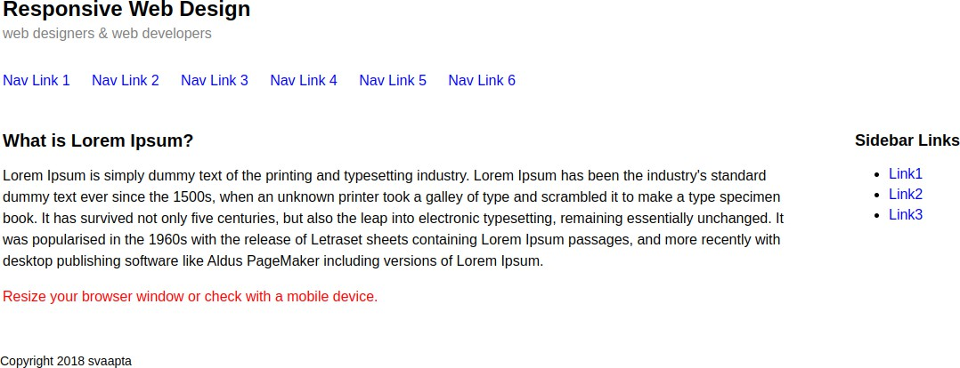
Photo :
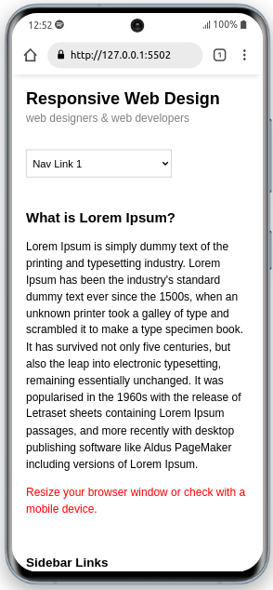
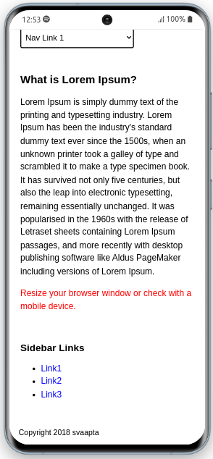
Fig 6.4.1 : Web page Desktop size
Fig 6.4.2 : Moblie View of Web Page

Task 6.5: Bootstrap Web Page Design
Task Description:
In this task, my mentor shared an image of a web page layout. I recreated the same web page using Bootstrap framework. The goal was to match the design exactly while using Bootstrap classes for layout, responsiveness, and styling.

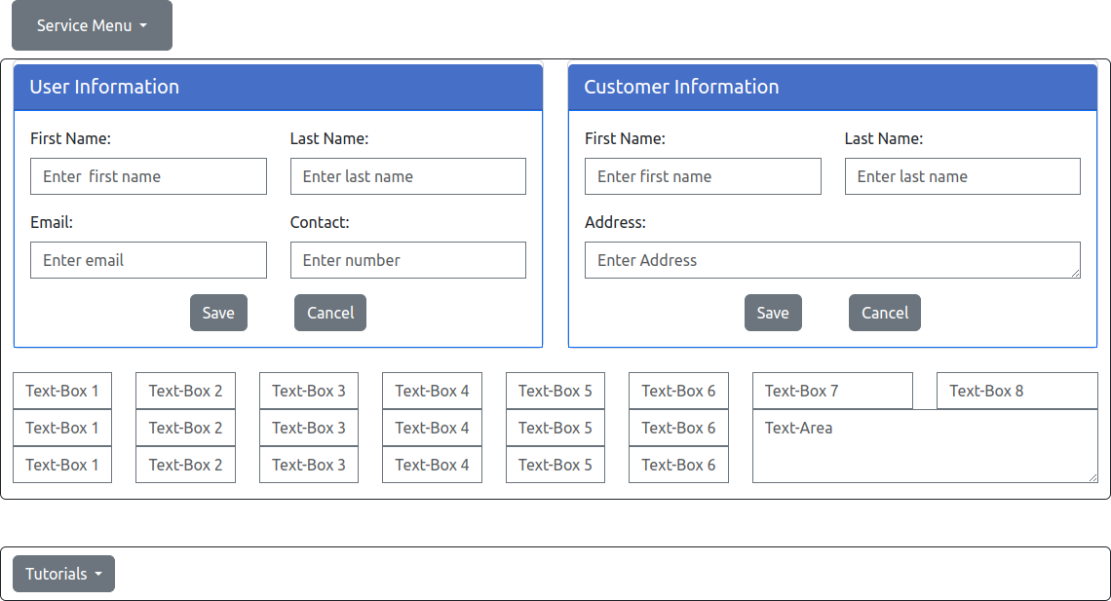
Photo:
Fig 6.5.1 : Bootstrap task

Task 6.6: PHP Basic Programs
Task Description:
In this task, I practiced basic PHP concepts by completing a set of small problems. Each problem was designed to strengthen my understanding of PHP syntax, string and array handling, loops, and conditional statements.

Subtasks:
- String Analysis Program
  - Enter a string and on clicking "Show", the program displays:
    - Total number of characters
    - Number of vowels
    - Number of consonants
    - Number of digits
    - Number of whitespace characters
    - Occurrences of the letter 'a'
- Prime Numbers from 1 to 100
  - Created a PHP script to display all prime numbers between 1 and 100.
- Leap Years from 2000 to 3000
  - Wrote a program to find and print all leap years in the given range.
- Find the Largest Number in an Array
  - Developed a script to find the maximum value in a user-defined array.
- Sort an Array Using Loop (Without Built-in Functions)
  - Implemented manual sorting of an array using loops (e.g., bubble sort or selection sort).
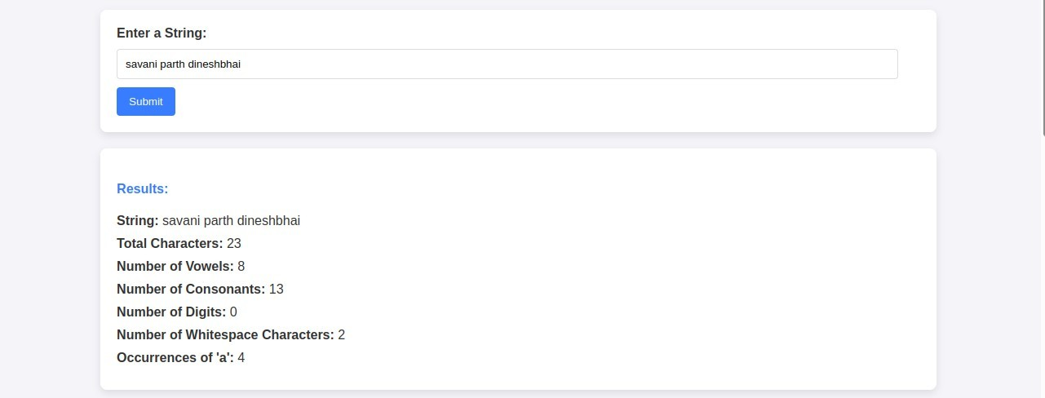
Photo :

Fig 6.6.1 : Php basic programming Img 1

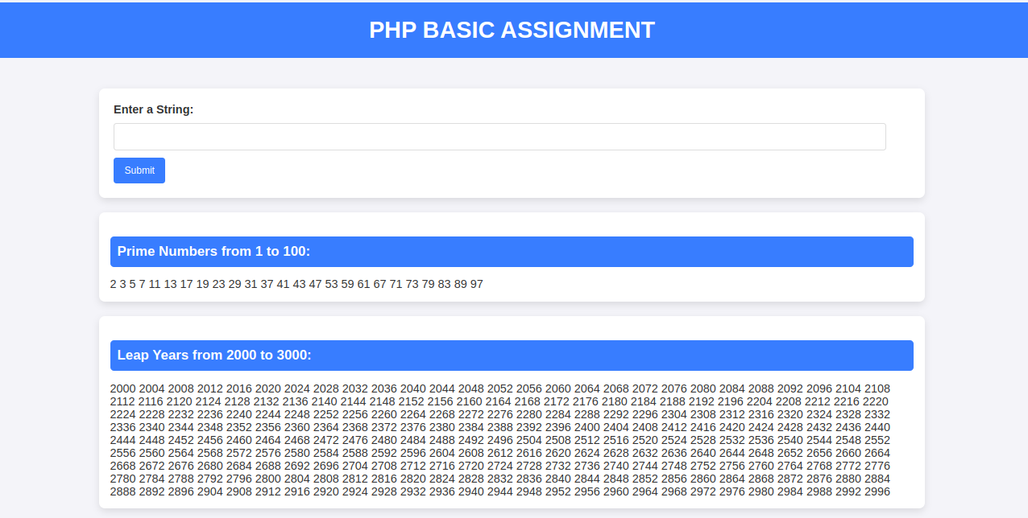
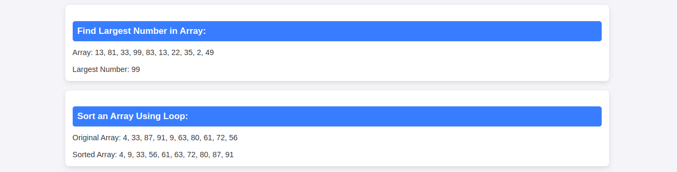
Fig 6.6.2 : Php basic programming Img 2

Task 6.7 : Employee Registration System (PHP & MySQL)
Task Description:
In this task, I created an Employee Registration system using PHP and MySQL. The system includes a registration form with validation, image upload, and stores data in a database. All registered employees are displayed in a list with options to Edit, Delete, and View their profile. Each employee's photo is also shown in the list.
Photo :
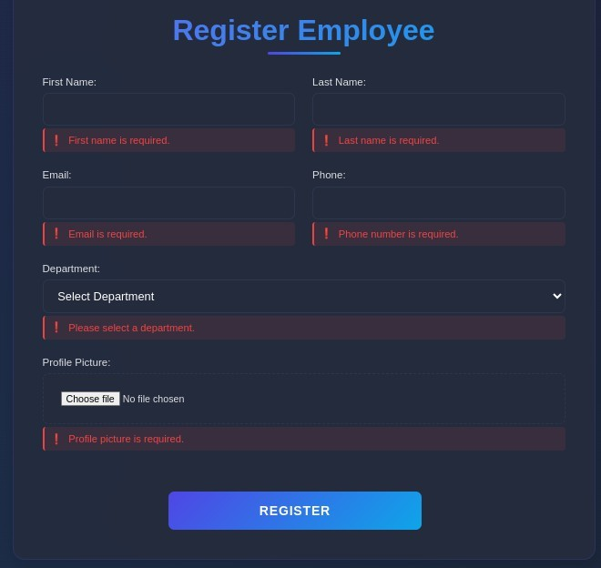

Fig 6.7.1 Employee form with validation

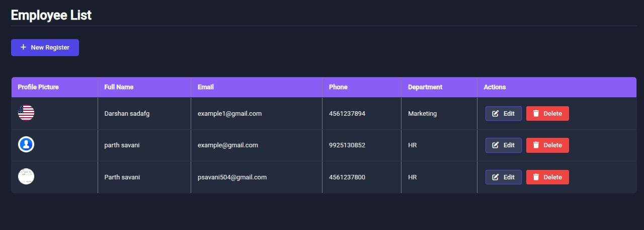

Fig 6.7.2 Employee list Page
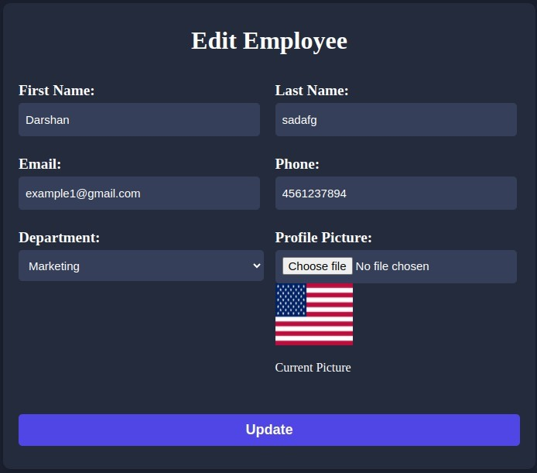

Fig 6.7.3 Employee Edit Page

Task 6.8 : Dynamic Dependent Dropdown using PHP & AJAX
Task Description
The dropdown should allow users to first select a Country, which will then load the corresponding States dynamically. Once a State is selected, the next dropdown should load the related Cities. Each dropdown should remain disabled until the previous one has a selected value.

Photo :
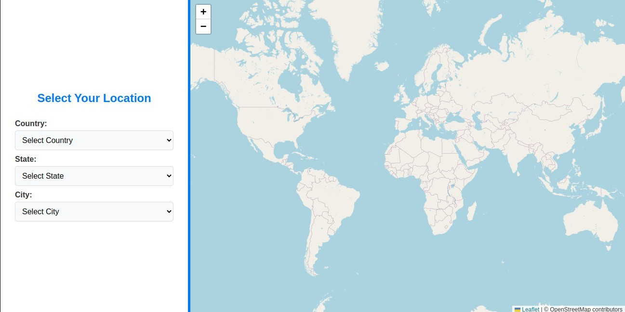
Fig 6.8.1 First view of web page (PHP-Ajax)
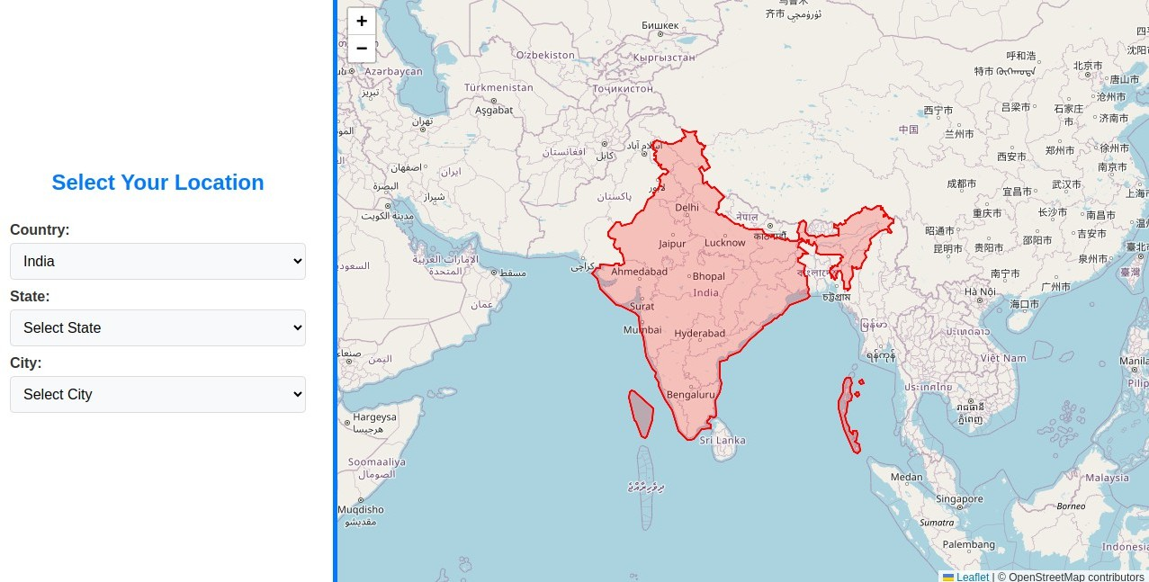
Fig 6.8.2 Select Country view page

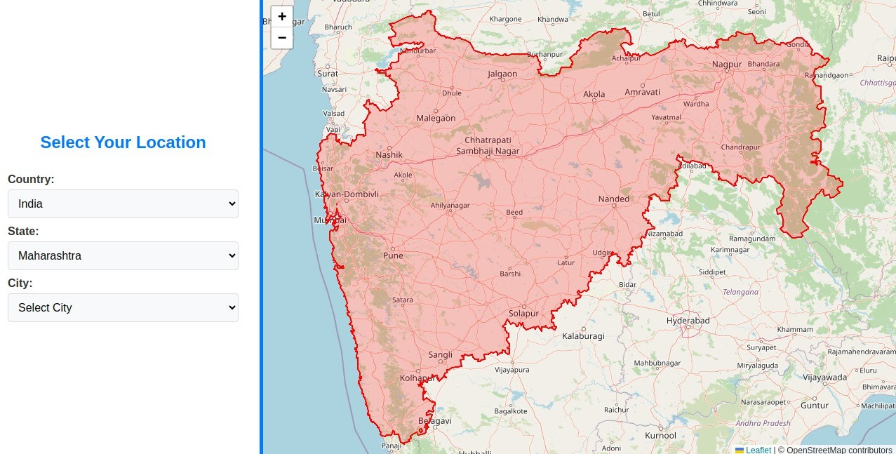

Fig : 6.8.3 : State select view page

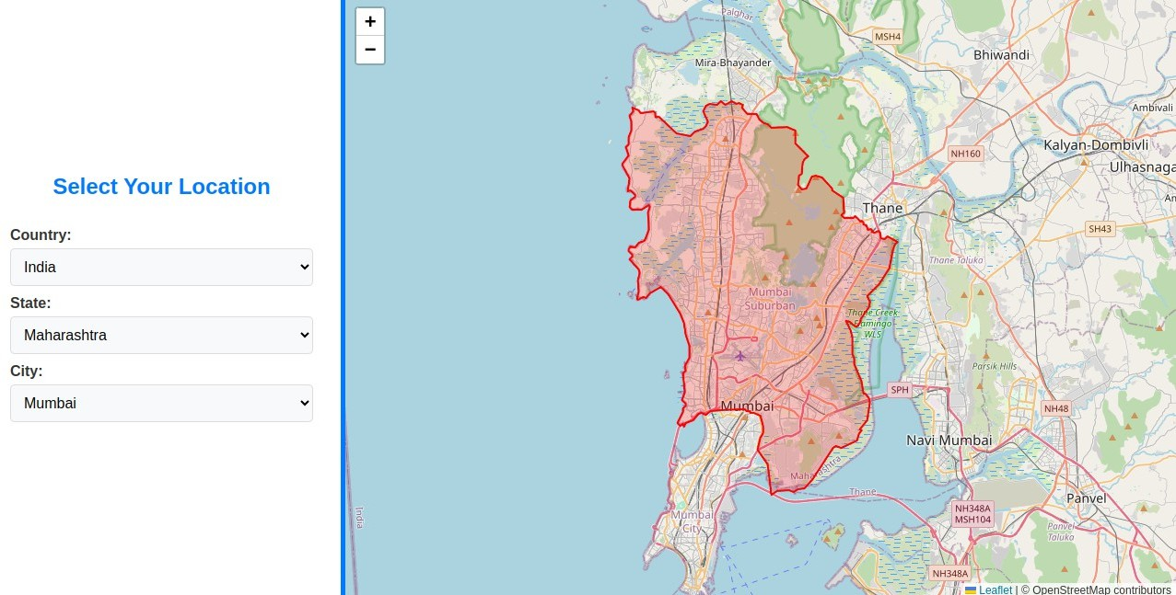

Fig : 6.8.4 : City select view page

Task 6.9 : PHP + MYSQL

Task Description
Make a register form use of all small task use and build a in one project, add First name , last name email, gender , address , country, state and city , technology checknox, username
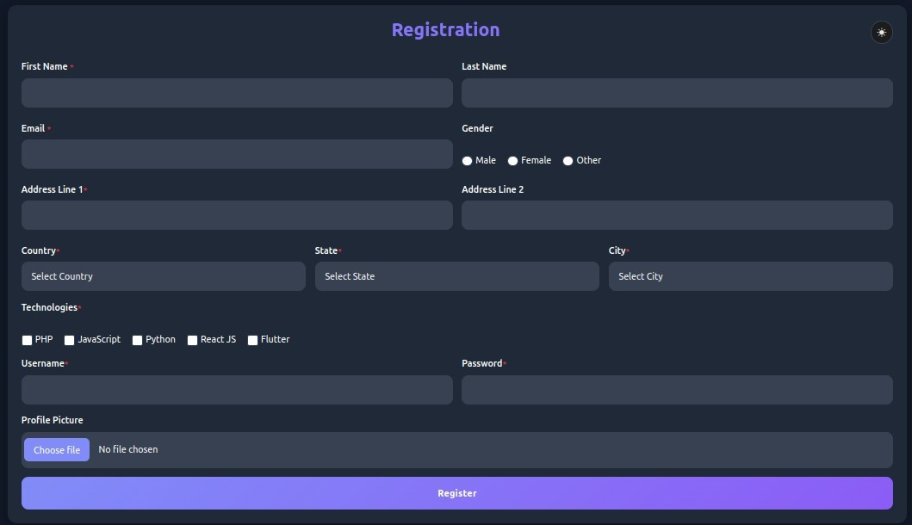
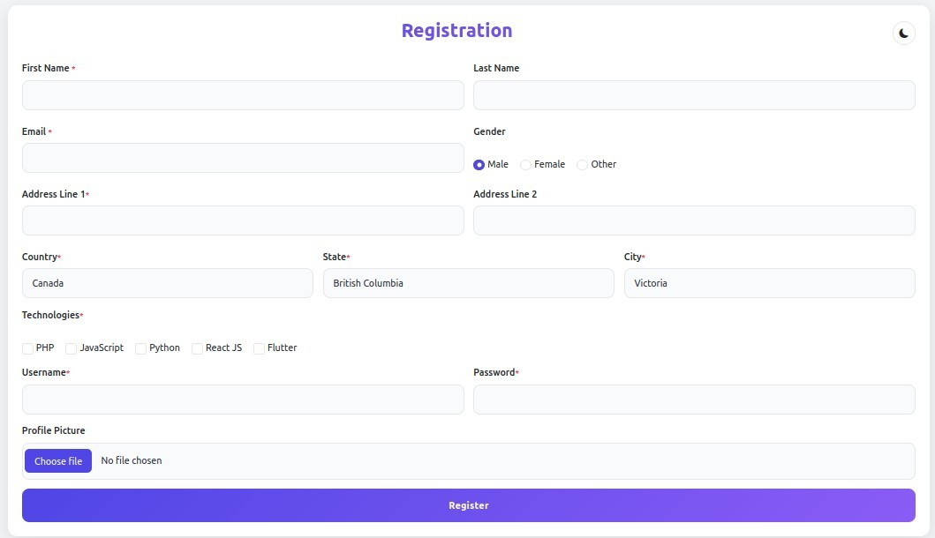
Password and upload files imges add some validation.
photo :
Fig : 6.9.1 : Register form view dark and light mode

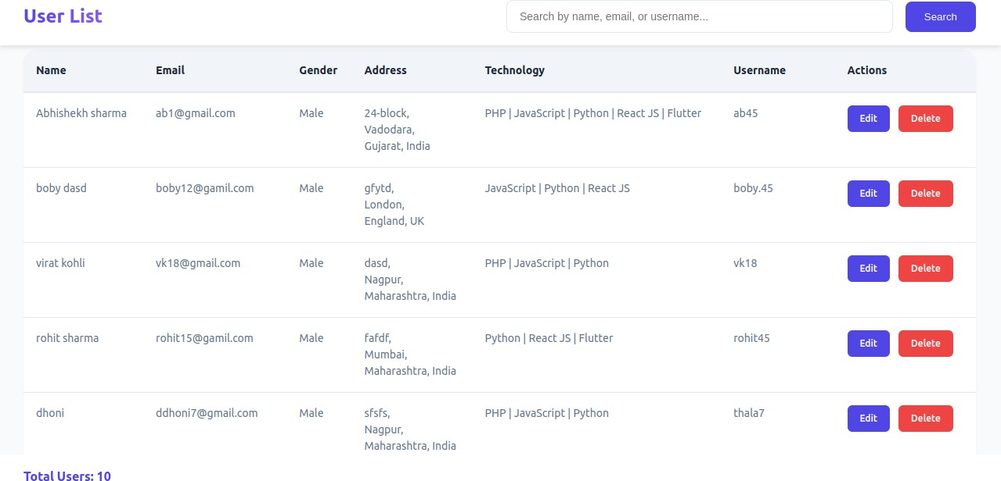

Fig : 6.9.2 : Employee list view page
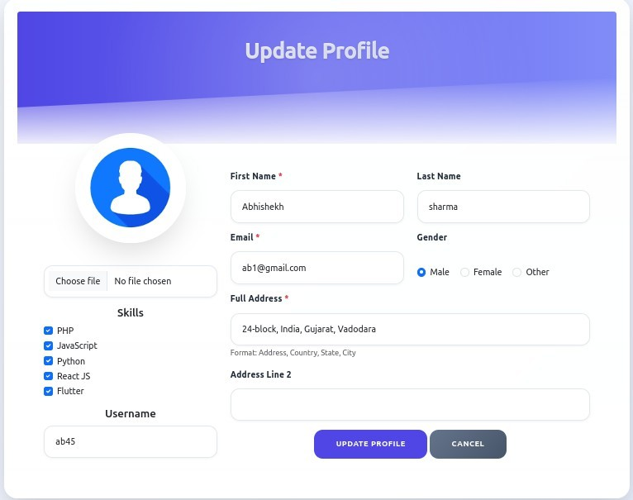

Fig : 6.9.3 : Update profile view page.

Task 6.10 : Shopify (make E-commerce)

Task Description
Make a E-commerce website , use of shopify , customize section , understand liquied code
And make also discount some product , made blogs also.

Photo:


Fig : 6.10.1 : Carousel sider imge of technovaa

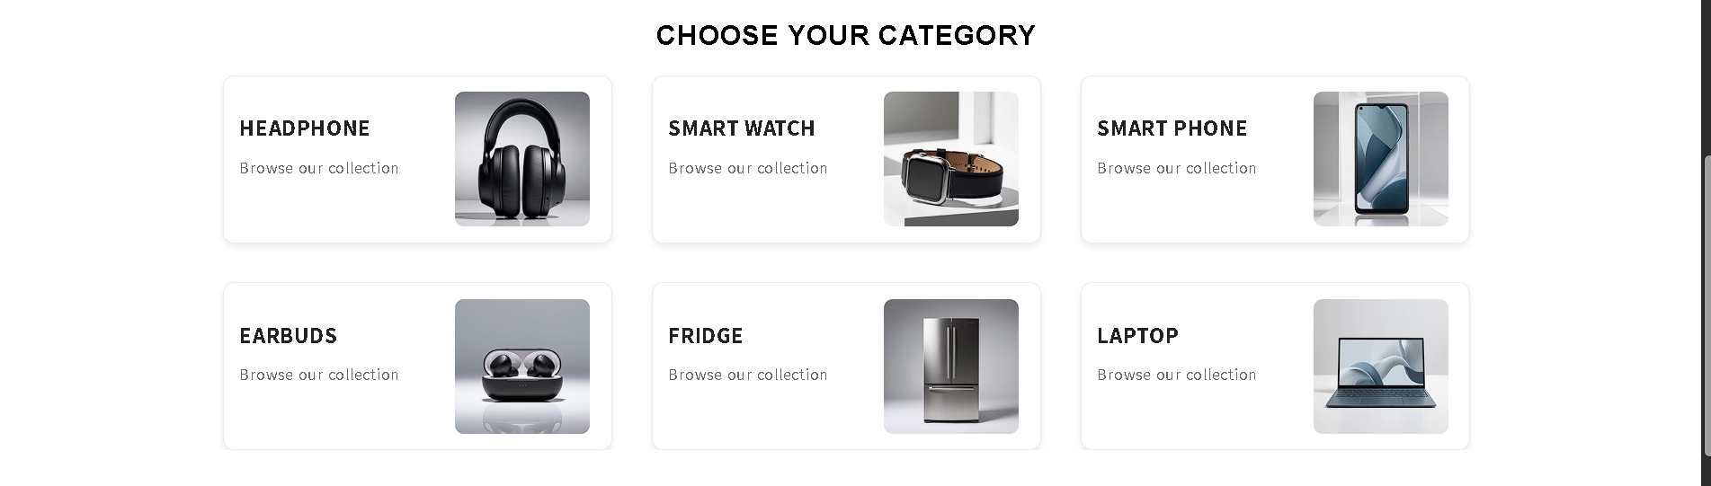
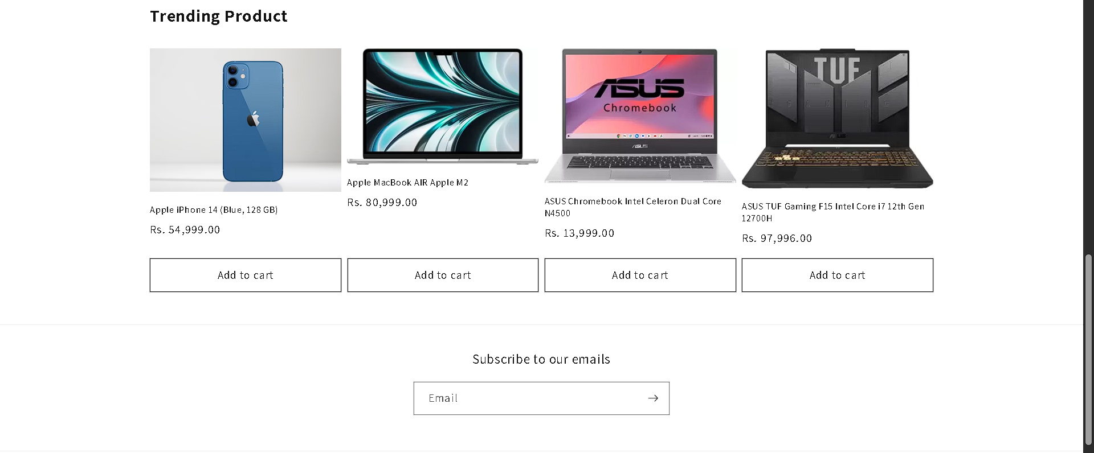
Fig : 6.10.2 : Product list

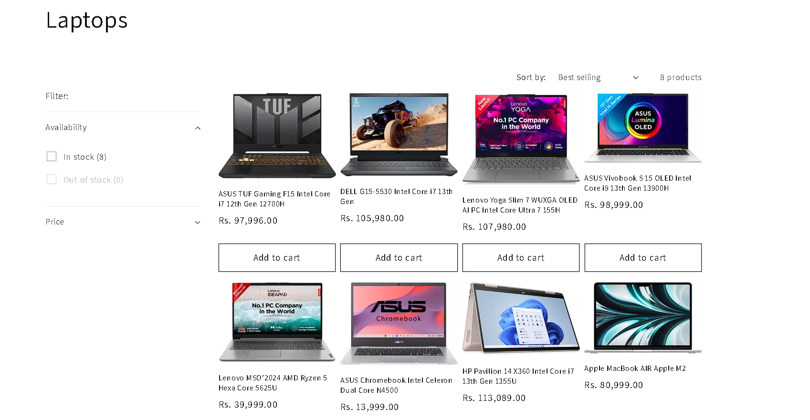

Fig : 6.10.3 : Laptop collection img

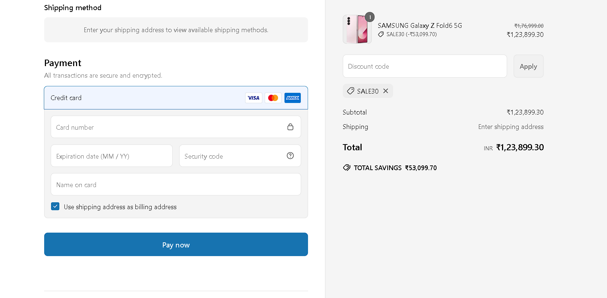

Fig : 6.10.4 :Shipping method img

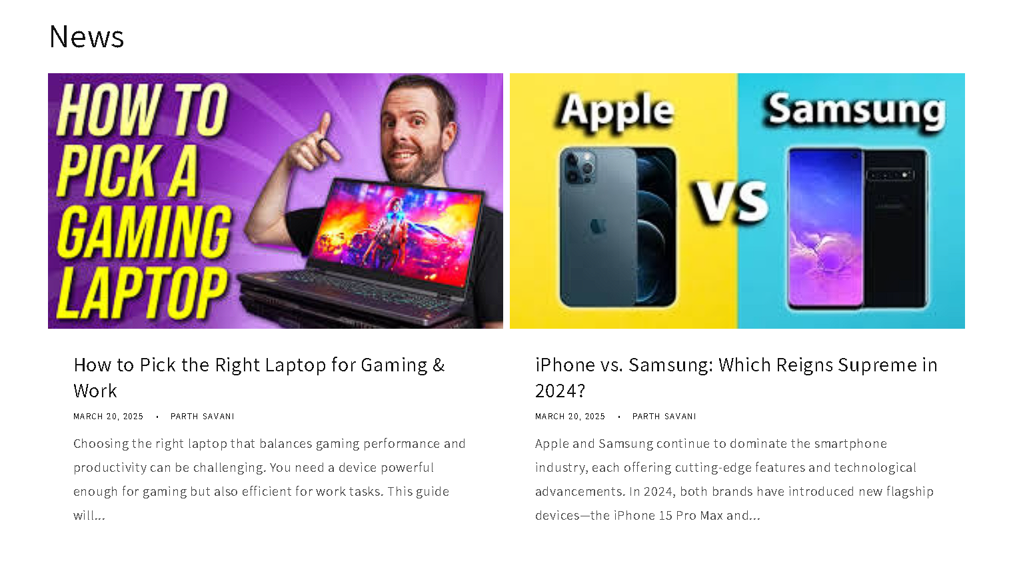

Fig : 6.10.5 :Blog view page

Task 6.11 : Laravel

Task Description
This task I have given image by my mentor to make a form with same like in image.

Photo :
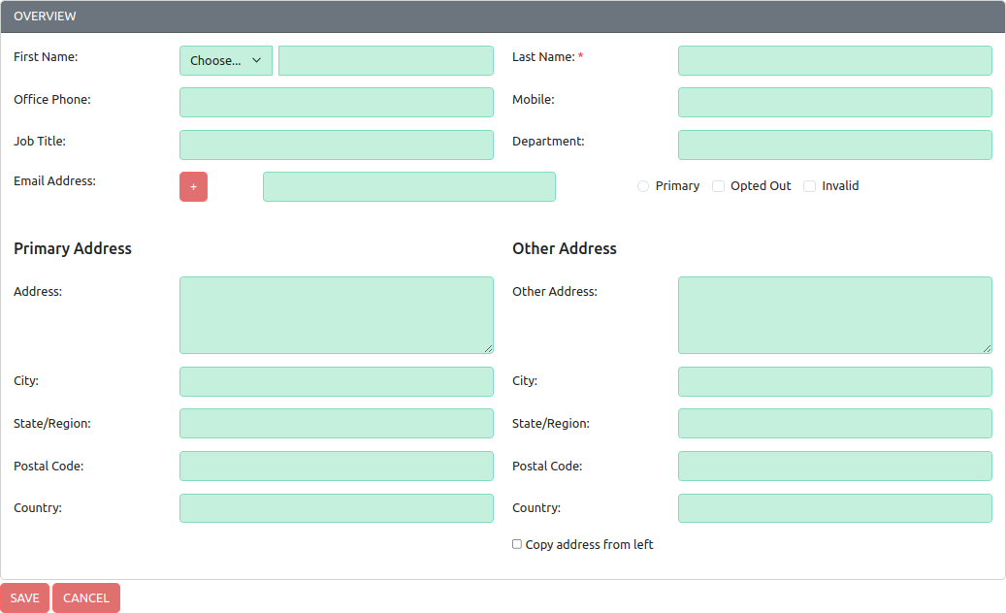

Fig : 6.11.1: Laravel form create a user profile view page
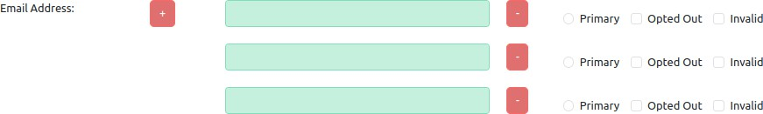
Fig : 6.11.2: Email add button work
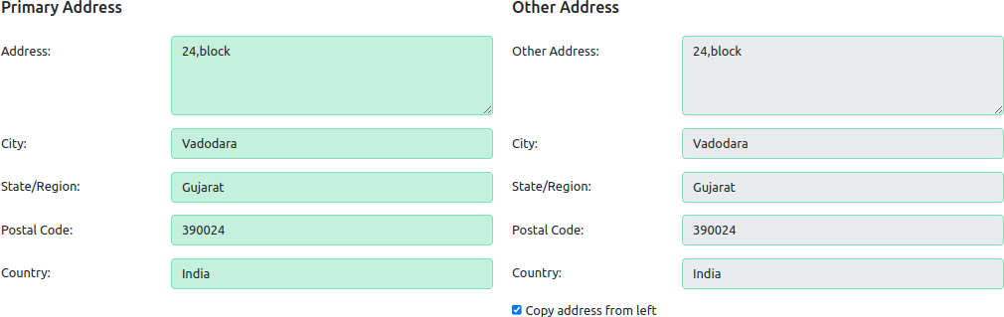

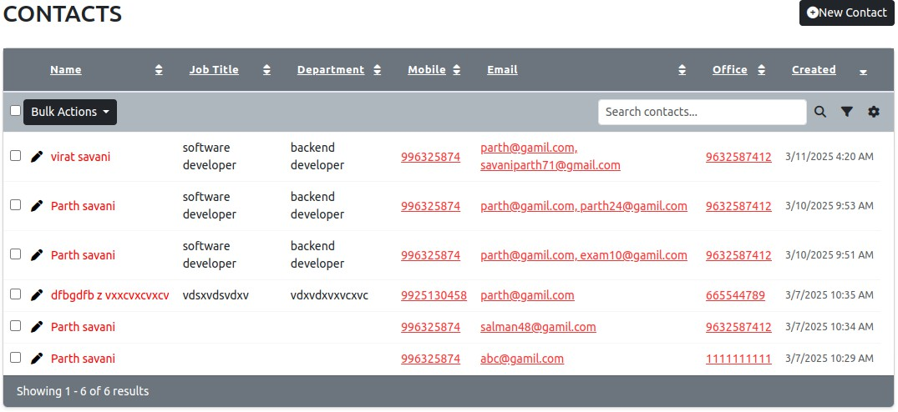
Fig : 6.11.3: Address copy check box working

Fig : 6.11.4: contacts page
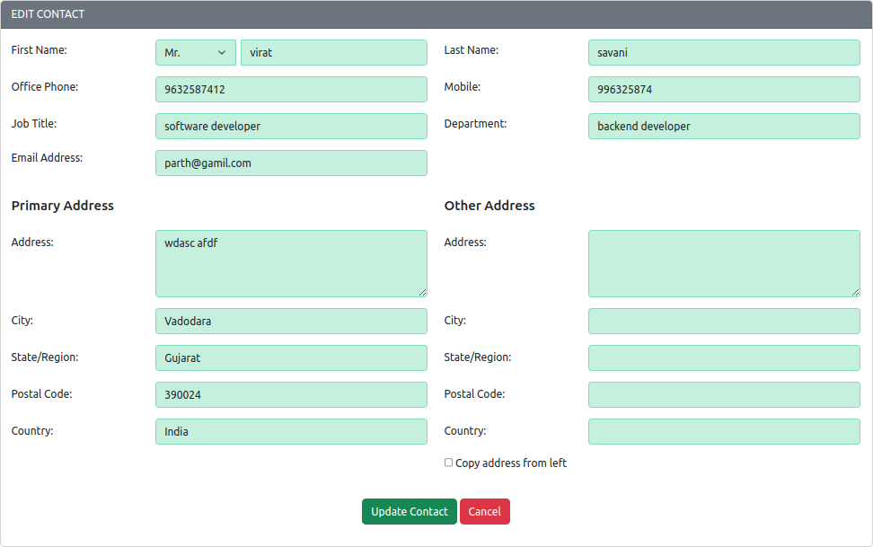

Fig : 6.11.5: Edit User profile page

CHAPTER 7: CONCLUSION AND DISCUSSION

7.1 Overall Analysis of Internship

The internship at Svaapta IT-Ally Solutions Pvt. Ltd. provided a highly valuable learning experience and professional exposure to the IT industry. During the internship, I had the opportunity to apply the theoretical knowledge gained in my academic curriculum to real-world tasks and projects. The supportive work environment and guidance from experienced mentors helped me enhance both my technical and interpersonal skills.

I worked on various tasks involving front-end and back-end technologies, including HTML, CSS, JavaScript, Bootstrap, jQuery, PHP, MySQL, Laravel, and Shopify. Each task helped strengthen my understanding of web development and allowed me to see how real-world projects are planned, executed, and delivered. The overall experience has significantly contributed to my growth as a budding web developer.

7.2 Summary of Internship

Over the course of my internship at Svaapta IT-Ally Solutions Pvt. Ltd., I completed a wide range of tasks that contributed to the development of my technical skillset:

- Front-End Development: Designed and developed responsive web pages using HTML, CSS, Bootstrap, and converted PSD templates to HTML code.

- JavaScript & jQuery: Implemented form validations, dynamic UI elements, and user interaction features.

- Back-End Development: Created user registration systems, performed CRUD operations using PHP and MySQL.

- Advanced Web Tasks: Built dynamic dependent dropdowns using PHP and AJAX, explored Laravel framework for structured PHP development.

- E-Commerce Integration: Gained introductory experience with Shopify and its e-commerce capabilities.

Overall, this internship helped bridge the gap between classroom learning and industry expectations, preparing me for future opportunities in the tech field.

7.3 Limitations and Future Enhancements

While the internship was a rewarding experience, there were a few limitations:

- Time Limitations: The internship period was limited, which restricted in-depth exploration of certain frameworks and advanced features.

- Less Collaborative Work: Most tasks were completed individually, offering fewer opportunities to work in a team using collaboration tools like Git in a shared environment.

- Limited Exposure to Deployment: While I worked on development, I had minimal exposure to deploying web applications on hosting or cloud platforms.

Future Enhancements:

- Explore advanced features of Laravel, including API integration, middleware, and security.

- Improve skills in version control systems like Git and practice collaborative development via GitHub.

- Learn about deployment and DevOps tools for launching and maintaining web applications in real-time.

- Work on full-stack personal projects to gain deeper practical experience across the entire development lifecycle.

