Internship Report
Svaapta IT Ally Solutions

AKNOWLEDGEMENT

I, Barot Smit Nikulkumar enroll no. 220413116001 , would like to express my deepest gratitude to Svaapta IT Ally Solutions for selecting me for the Web Development internship. This opportunity has been pivotal in enhancing my skills and knowledge in the field, and I am truly grateful for the experience.
I would like to extend a special thanks to the entire team at Svaapta IT Ally Solutions for their guidance and support throughout the internship. Their expertise and encouragement have been invaluable in helping me grow both professionally and personally.
I am also profoundly thankful to my internal guide, Prof. Shefali Rana, for her continuous guidance and supervision during this project. Her insightful feedback and unwavering support were crucial in the successful completion of my internship and project work.
Lastly, I would like to acknowledge the encouragement and patience of my parents, which has been a constant source of motivation throughout this journey.

ABSTRACT

GetInPlay is an advanced online slot booking system designed to streamline the process of reserving slots for popular games such as 8-Ball Pool, Snooker, and Bowling. The platform offers a user-friendly interface that allows users to book slots seamlessly and view real-time availability with updates every 2 seconds using AJAX. Users can book slots up to 48 hours in advance, while admins have complete control over slot management, game addition/removal, and booking cancellation.
The system features individual dashboards for users and admins, ensuring efficient management and a seamless user experience. The admin panel allows viewing registered users, managing game statistics, and dynamically modifying slots and games. Built using PHP, MySQL, HTML, CSS, JavaScript, jQuery, and AJAX, GetInPlay is optimized for high performance and responsiveness across devices. With secure authentication for admin and user logins, the platform ensures data integrity and security. The project aims to deliver a modern, minimalistic design with smooth transitions, hover effects, and an engaging gaming-centric UI.

INDEX

Sr. No | Figure Name | Page No.
 | ADMIN PAGES
1 | Login Page | 11
2 | Dashboard | 12
3 | Game Management | 12
4 | Add Game | 13
5 | View Game Details | 14
6 | User Management | 14
7 | Add User | 15
8 | View User Details | 16
9 | Terms & Conditions | 16
10 | Games Listing | 17
11 | Book Slot | 18
12 | Enter Details | 18
13 | Slot Booked | 19
 | USER PAGES
14 | Login Page | 19
15 | Home Page | 20
16 | Home Page Scroll | 20
17 | Home Page Scroll | 21
18 | Games Listing | 21
19 | Book Game Slot | 22
20 | Membership | 22
21 | Contact Us | 23
22 | About Us | 23

INDEX
Sr. No. | Chapter | Page No.
1 | Introduction | 6
1.1 | Technologies Used | 6
1.2 | Objectives | 6
1.3 | Motivation | 7
1.4 | Internship Goals | 7
2 | Overview of internship | 8
2.1 | About the company | 8
2.2 | Tasks of internship | 9
2.3 | Problems and Solutions | 24
2.3.1 | Problems | 24
2.3.2 | Solutions | 25
2.4 | Learning Outcomes | 26
2.4.1 | HTML | 26
2.4.2 | CSS | 26
2.4.3 | JavaScript | 26
2.4.4 | PHP & MySQL | 26
2.4.5 | AJAX & JQuery | 27
2.4.6 | Project Development | 27
3 | Summary/Conclusions | 28
4 | References | 29

1. Introduction

1.1 Technologies Used:

- User

- React JS
- JavaScript
- JSX
- Tailwind CSS

- Admin

- PHP
- MySQL
- CSS
- JavaScript
- AJAX
- Jquery

1.2 Objectives:-

The primary objective of this internship was to apply theoretical knowledge in a practical setting by developing a fully functional online slot booking system named GetInPlay. The project aimed to provide a seamless and engaging platform for users to book slots for various games such as 8-Ball Pool, Snooker, and Bowling, while allowing administrators to manage slot availability, bookings, and users dynamically.
Through this project, the goal was to:
- Enhance Technical Skills: Develop expertise in front-end and back-end technologies such as React.js, PHP, MySQL, HTML, CSS, JavaScript, and jQuery to create an interactive and responsive web application.
- Gain Project Management Experience: Learn the process of planning, developing, testing, and deploying a full-stack project within a given timeframe.
- Ensure Database Efficiency: Design and optimize a relational database using MySQL to store and manage user, game, and booking data effectively.
- Develop Secure Authentication System: Implement a secure login system for users and admins with password encryption and session management.
- Achieve Industry-level Standards: Follow industry best practices in terms of UI/UX design, security, and database management to ensure a smooth and secure booking experience.
This project provided hands-on experience in developing a real-world web application while offering valuable insights into industry practices through collaboration with professionals at Svaapta IT Ally Solutions.

1.3 Motivation
Developing a dynamic and responsive web application like GetInPlay has been an exciting and enriching experience. As I progressed through my internship, I gained a deeper understanding of web development technologies and real-time application management. Working on a project that involves slot booking and management has helped me relate to real-world scenarios, making it easier to grasp the technical concepts and apply them effectively. This project has motivated me to continue enhancing my skills and explore more advanced concepts in web development.

1.4 Internship Goal
- Enhance Practical Skills: Develop and refine web development skills by working on a real-world project, including designing and implementing a fully functional online slot booking system for games like 8-Ball Pool, Snooker, and Bowling.
- Improve Technical Proficiency: Increase proficiency in essential technologies such as PHP, MySQL, HTML, CSS, JavaScript, and jQuery, while becoming familiar with real-time data management using AJAX.
- Gain Project Management Experience: Learn about project management processes, including requirement gathering, database design, system architecture, development, testing, and deployment through active participation in project development.
- Document and Reflect: Document the entire internship experience comprehensively, reflecting on the learning outcomes, challenges faced, and the overall impact on personal and professional development.
- Learn the different technologies and also complete the given assignment to have a perfomance review.

2. Overview of Internship

2.1 About the company:-

Svaapta IT-Ally Solutions is a premier provider of IT and software solutions, offering top-notch services to businesses worldwide. With offices in Vadodara and Ahmedabad, India, Svaapta IT-Ally Solutions specializes in various domains, including:
- Custom Software Development: Delivering tailored software solutions to meet specific business requirements.
- Web and Mobile App Development: Creating responsive web applications and mobile apps to enhance user engagement.
- E-commerce Development: Developing robust e-commerce platforms to facilitate online business operations.
- ERP and CRM Solutions: Implementing Enterprise Resource Planning and Customer Relationship Management systems to streamline business processes.
- UI/UX Design: Designing intuitive user interfaces and experiences to improve customer satisfaction.
- Quality Assurance and Maintenance: Ensuring software quality through rigorous testing and providing ongoing support and maintenance.

The company also offers strategic consulting, technology solutions, and managed services, aiming to transform businesses from good to great through the power of enterprise solutions. Their commitment to understanding client pain points, goals, and objectives allows them to deliver high-performing business solutions and services.

Svaapta IT-Ally Solutions prides itself on building long-term client relationships by aligning with clients in the area of IT, ensuring that their professionals operate effectively at any point of interaction, be it technology, strategy, or implementation.

With a focus on delivering reliable IT partnerships, Svaapta IT-Ally Solutions strives to help clients win in the global marketplace by providing best-in-class delivery models and innovative solutions.

Website:- https://www.svaapta-it-ally.com/

Office Location:- Alkapuri, Vadodara, Gujarat

Founded:- 2013

2.2 Tasks of internship:-

Task 1: Learn HTML and CSS in Depth
- Objective: Develop a strong foundation in HTML and CSS by understanding structure, layout, and styling.
- Learning Areas:
  - Semantic HTML for better accessibility.
  - CSS Flexbox and Grid for layout designs.
  - Responsive design using media queries.
  - CSS transitions and animations to enhance user experience.
- Assignment:
  - PSD to HTML Conversion:
    - Convert a PSD design into a fully functional and responsive HTML page.
    - Ensure pixel-perfect conversion with proper use of HTML structure and CSS styles.
    - Validate the page with W3C standards.

Task 2: Learn JavaScript and Implement in Assignments
- Objective: Gain proficiency in JavaScript to add interactivity and functionality to web pages.
- Learning Areas:
  - Basics of JavaScript (variables, loops, conditions, functions).
  - DOM Manipulation for dynamic UI changes.
  - Event handling for user interactions.
  - Basic understanding of asynchronous JavaScript (AJAX, Promises).
- Assignment:
  - Interactive Form Validation:
    - Create a form with real-time validation using JavaScript.
    - Implement error messages and success states.
  - Dynamic Content Updates:
    - Use JavaScript to manipulate and update DOM elements dynamically.

Task 3: Learn phpMyAdmin and MySQL for Database Management
- Objective: Understand database design, management, and query execution using MySQL.
- Learning Areas:
  - Basics of Relational Database Management Systems (RDBMS).
  - Creating and managing databases, tables, and records.
  - Understanding primary and foreign keys.
  - Performing CRUD operations (Create, Read, Update, Delete).

- Assignment:

  - Database Design and CRUD Implementation:
    - Design a normalized database.
    - Implement CRUD operations using SQL queries.
    - Use phpMyAdmin to manage and interact with the database.

Task 4: Learn PHP and Apply in Assignments
- Objective: Develop backend skills by learning PHP and handling server-side operations.
- Learning Areas:
  - Basics of PHP syntax and structure.
  - Handling form data and session management.
  - Connecting PHP with MySQL using mysqli/PDO.
  - Implementing CRUD operations using PHP.
- Assignment:
  - User Authentication System:
    - Create a login and registration system using PHP and MySQL.
    - Implement session-based authentication and user role management.

Task 5: Create UI Design
- Objective: Develop a visually appealing and user-friendly UI design for the GetInPlay project.
- Learning Areas:
  - Designing wireframes and prototypes.
  - Creating responsive layouts using HTML, CSS, and Bootstrap.
  - Using modern design principles with a focus on minimalism and usability.
- Assignment:
  - Design Web Application UI:
    - Create the home page, login page, admin dashboard, and user interface.
    - Ensure consistency in UI elements with a cohesive theme.
    - Optimize for desktop, tablet, and mobile devices.

Task 6: Create Login Page
- Objective: Develop a secure and fully functional login page.
- Learning Areas:
  - Form validation using JavaScript and PHP.
  - Handling user authentication and session management.
  - Password encryption using PHP hashing.
- Assignment:
  - Login System Implementation:
    - Create a login page with error handling for incorrect credentials.
    - Store encrypted passwords securely in the database.
    - Implement session management to maintain login state.

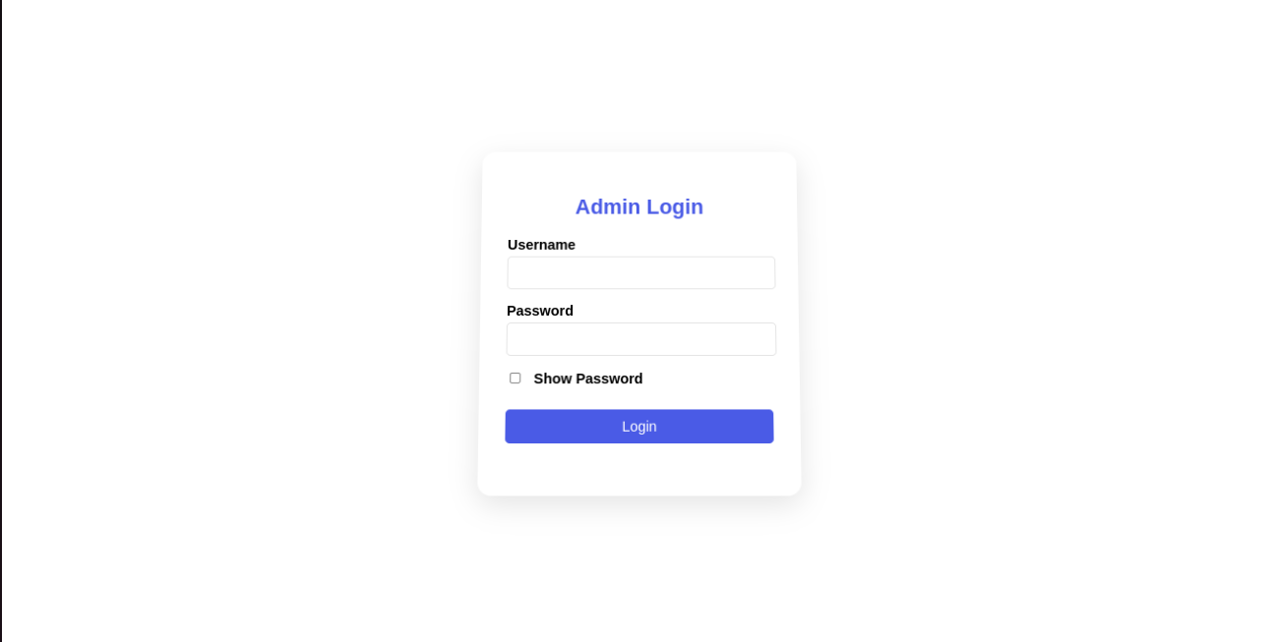
Login page

Task 7: Develop Admin Dashboard
- Objective: Build an intuitive and functional admin dashboard for managing games, users, and bookings.
- Learning Areas:
  - Admin dashboard design using HTML, CSS, Bootstrap.
  - Dynamic content rendering using PHP and MySQL.
  - Implementing secure admin authentication and access control.
- Assignment:
  - Admin Panel Development:
    - Design and develop a dashboard with navigation links.
    - Display key metrics and data for admin management.
    - Implement session-based authentication for admin access.

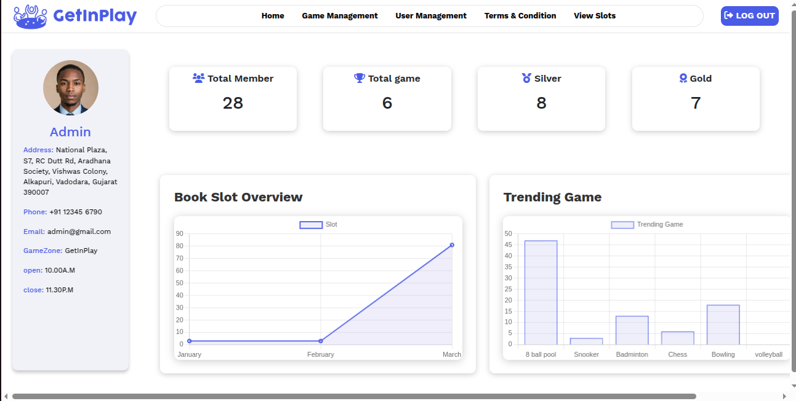
Admin Dashboard

Task 8: Implement Game Management System
- Objective: Enable admin to add, update, and delete games.
- Learning Areas:
  - CRUD operations with PHP and MySQL.
  - Using AJAX to dynamically update game data.
- Assignment:
  - Game Management:
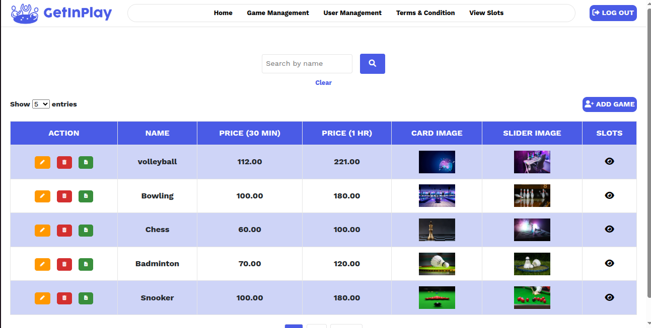
    - Display game details with options for updating and deleting.
Game Management

Task 9: CRUD Operations for Game Management
- Objective: Implement CRUD functionality for managing game details.
- Learning Areas:
  - Creating, reading, updating, and deleting records with PHP and MySQL.
  - Ensuring data consistency and validation.
- Assignment:
  - CRUD Implementation:
    - Implement complete CRUD operations for games.
    - Ensure error handling and validation for all operations.

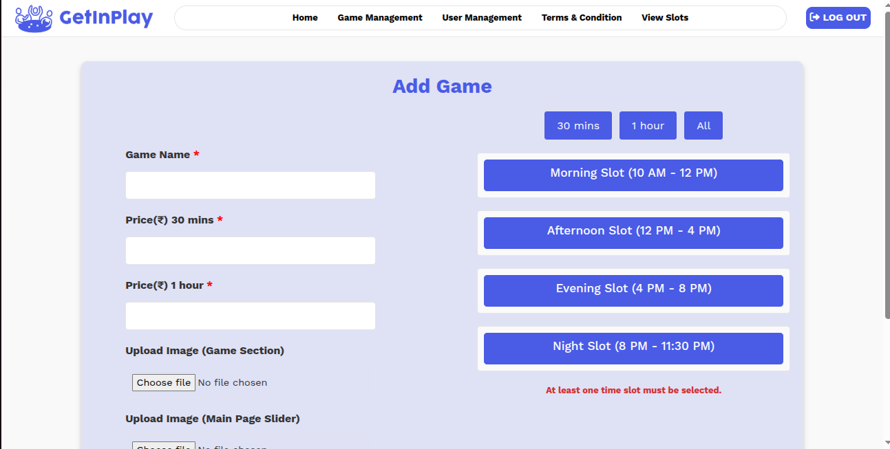
Add Game
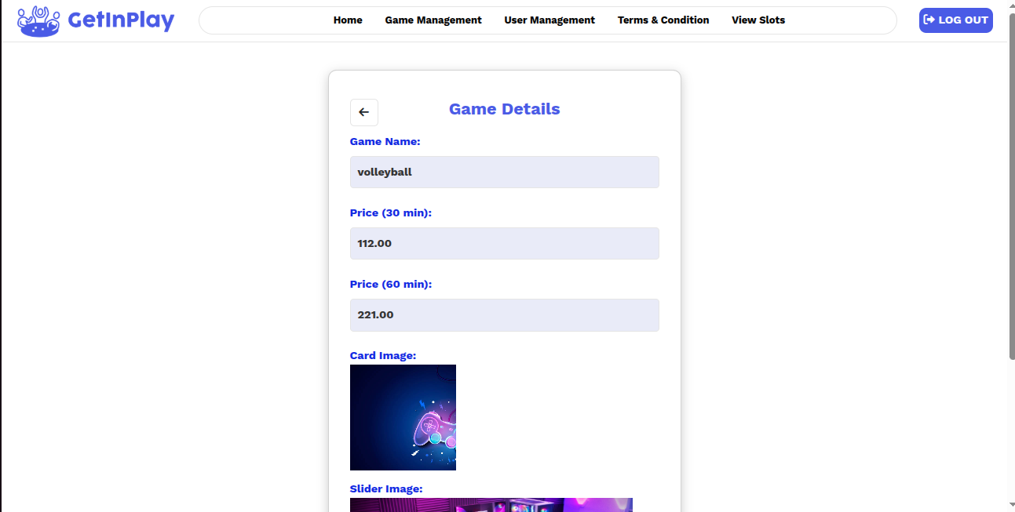
View Game Details

Task 10: Develop User Management System
- Objective: Create a system to manage users with admin privileges.
- Learning Areas:
  - CRUD operations for user records.
  - Role-based access and session handling.
- Assignment:
  - User Management:
    - Add, update, and delete user profiles.
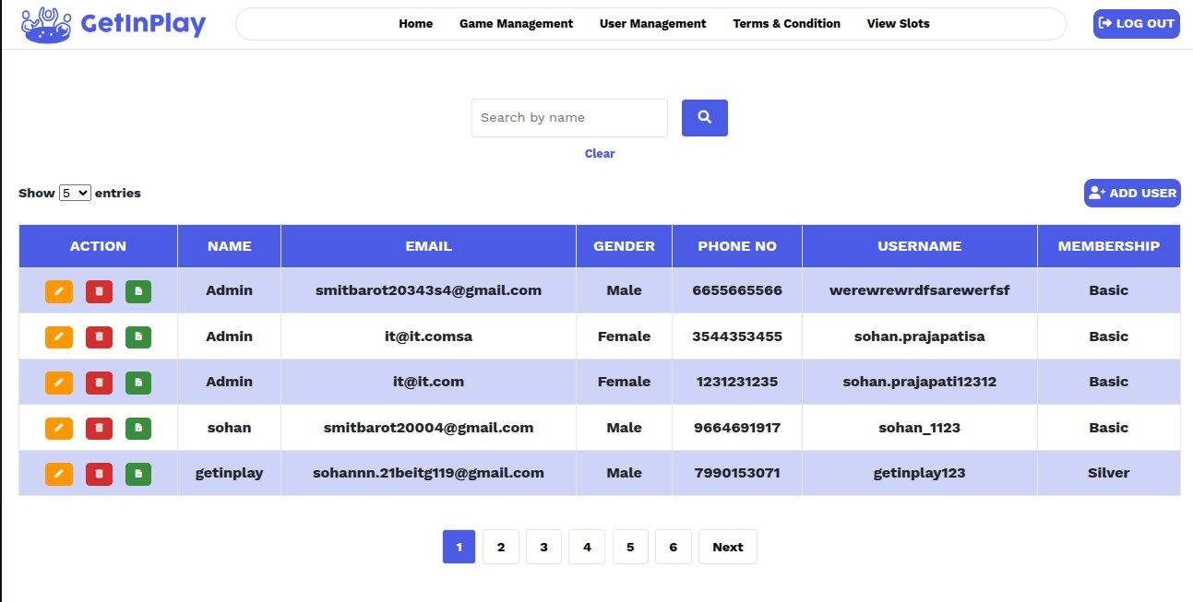
    - Assign user roles (admin/user) with proper access control.
User Management

Task 11: CRUD Operations for User Management
- Objective: Implement complete CRUD operations for user data.
- Learning Areas:
  - Creating, updating, deleting, and retrieving user information.
  - Ensuring data validation and security.
- Assignment:
  - User CRUD Operations:
    - Implement secure CRUD operations for managing users.
    - Add error handling and session control for data integrity.

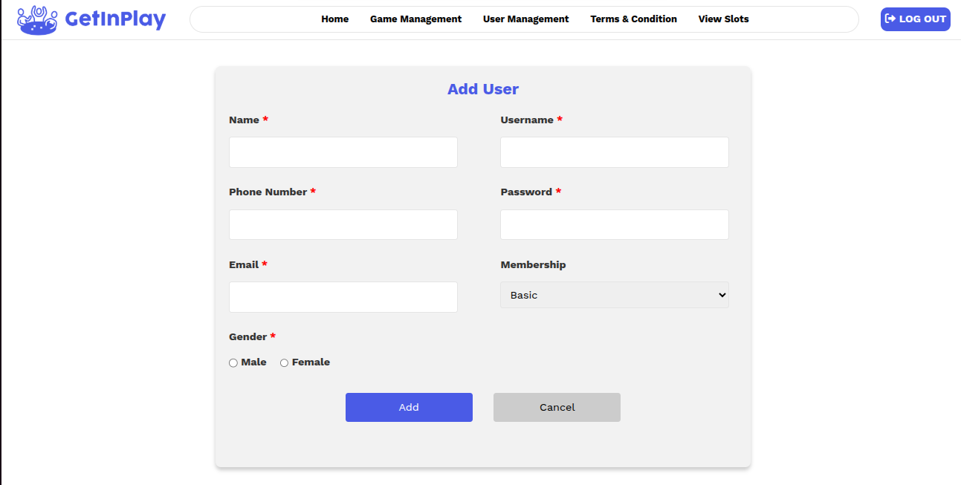
Add User
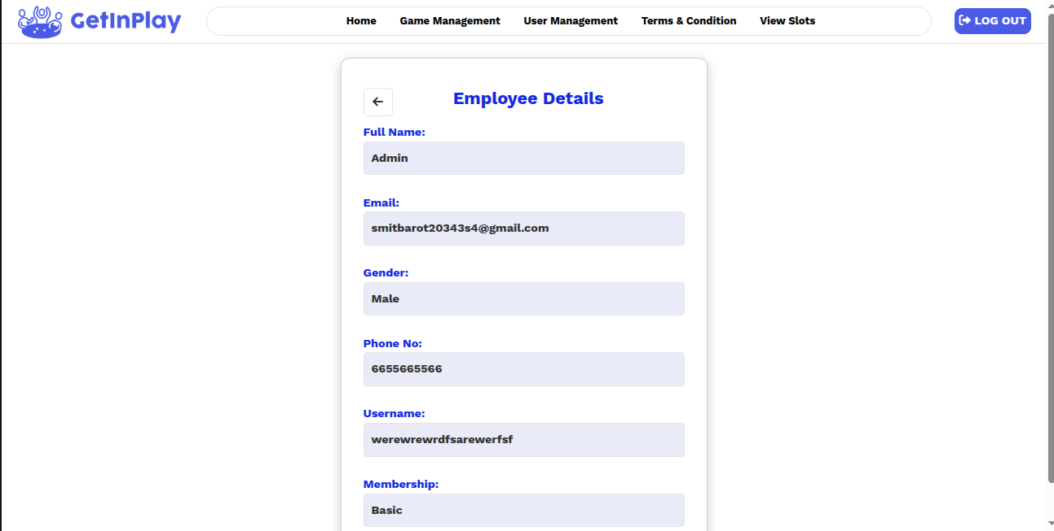
View User Detail

Task 12: Create Terms and Conditions Page (Admin Editable)
- Objective: Develop a dynamic page where the admin can add, update, and manage terms and conditions.
- Learning Areas:
  - Implementing dynamic content management.
  - Enabling text editing and saving functionality.
- Assignment:
  - Terms and Conditions Page:
    - Create a page where admin can edit and update terms.
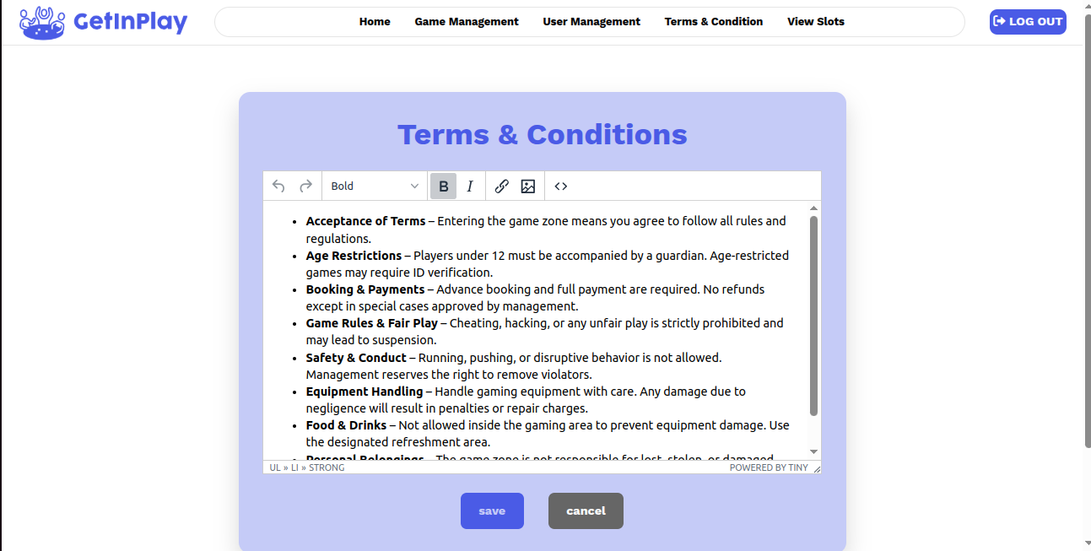
    - Display updated terms on the user side.
Terms & Conditions

Task 13: View Game Listing with Slot Booking Option
- Objective: Display available games with an option for users to book slots.
- Learning Areas:
  - Game listing with filters and pagination.
  - Slot selection and booking integration.
- Assignment:
  - Game Listing Page:
    - Display all available games with slot booking options.
    - Redirect users to the slot booking page for confirmation.

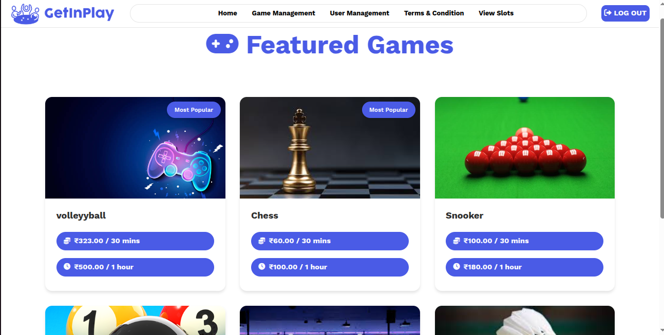
Game Listing

Task 14: Develop Slot Booking Page with Real Data
- Objective: Create a slot booking page with real-time slot availability and booking functionality.
- Learning Areas:
  - Handling real-time data updates using AJAX.
  - Implementing secure slot booking with PHP and MySQL.
- Assignment:
  - Slot Booking System:
    - Show real-time slot availability for each game.
    - Implement booking logic with conflict prevention.
    - Ensure booked slots reflect accurately on both user and admin sides.
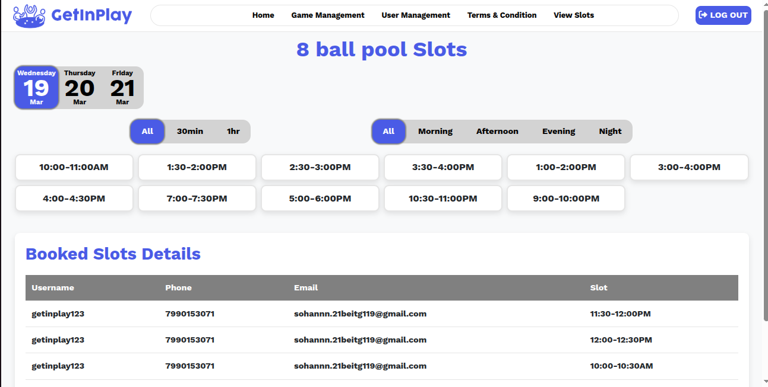
Book Slot

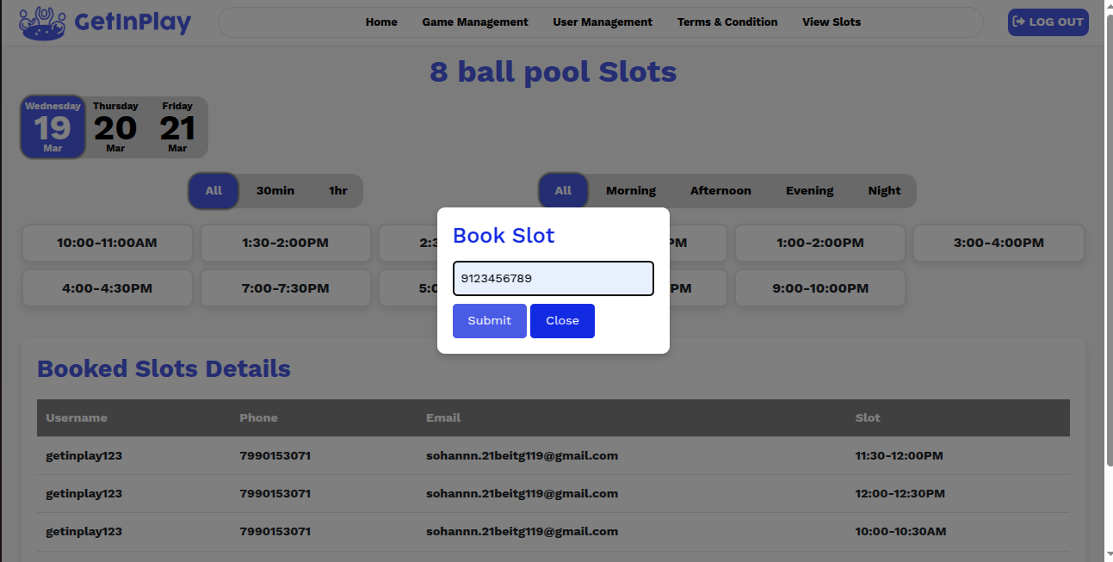
Enter Details

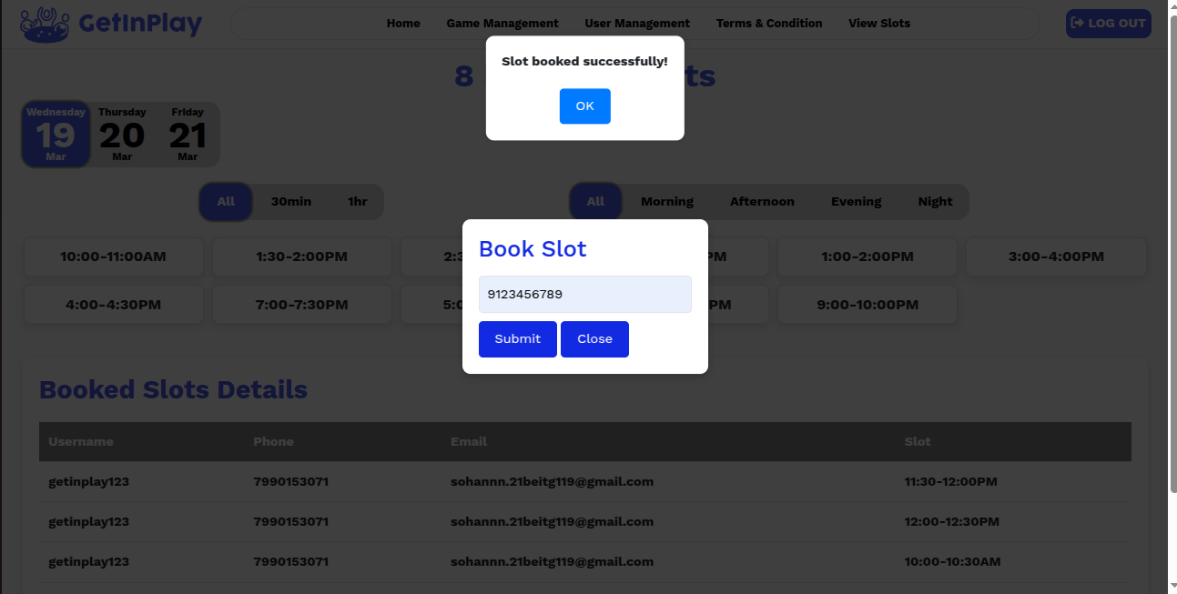
Slot Booked

USER SIDE PAGES:-
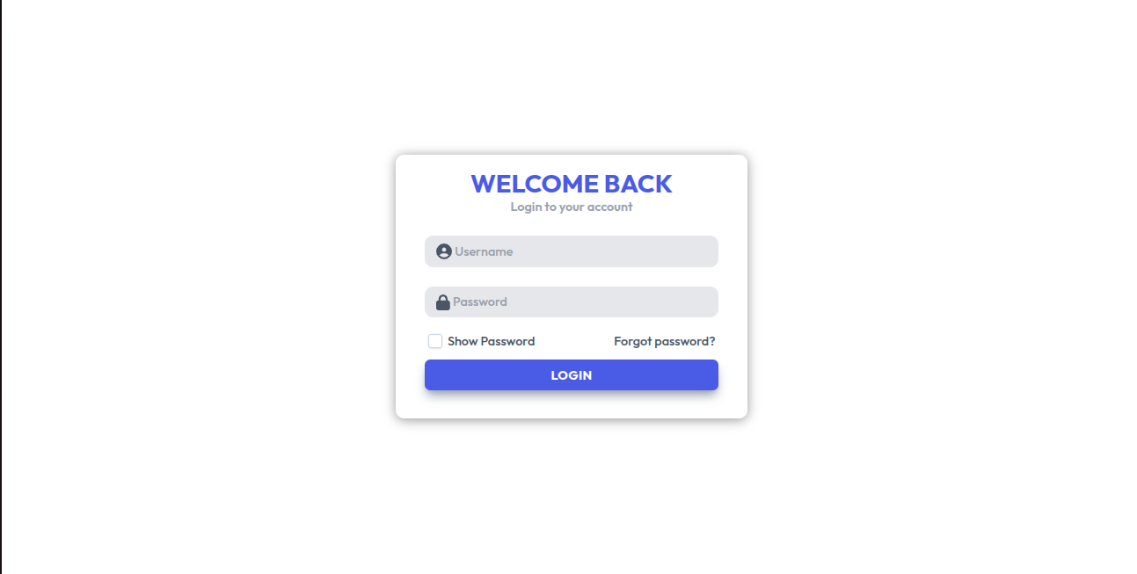

Login Page

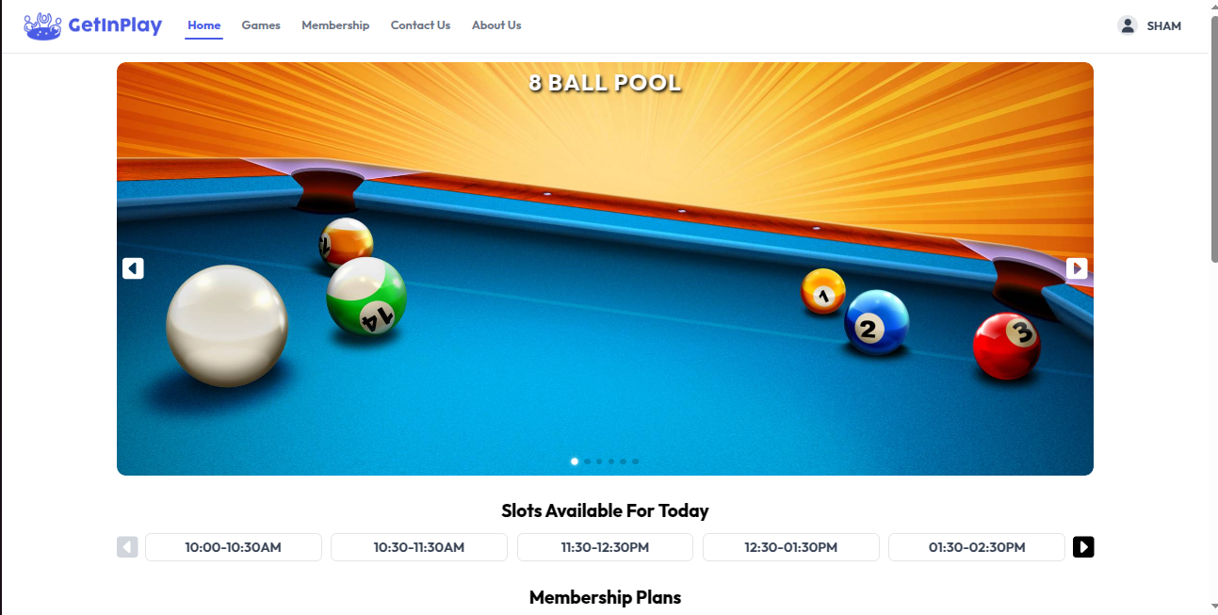
Home Page

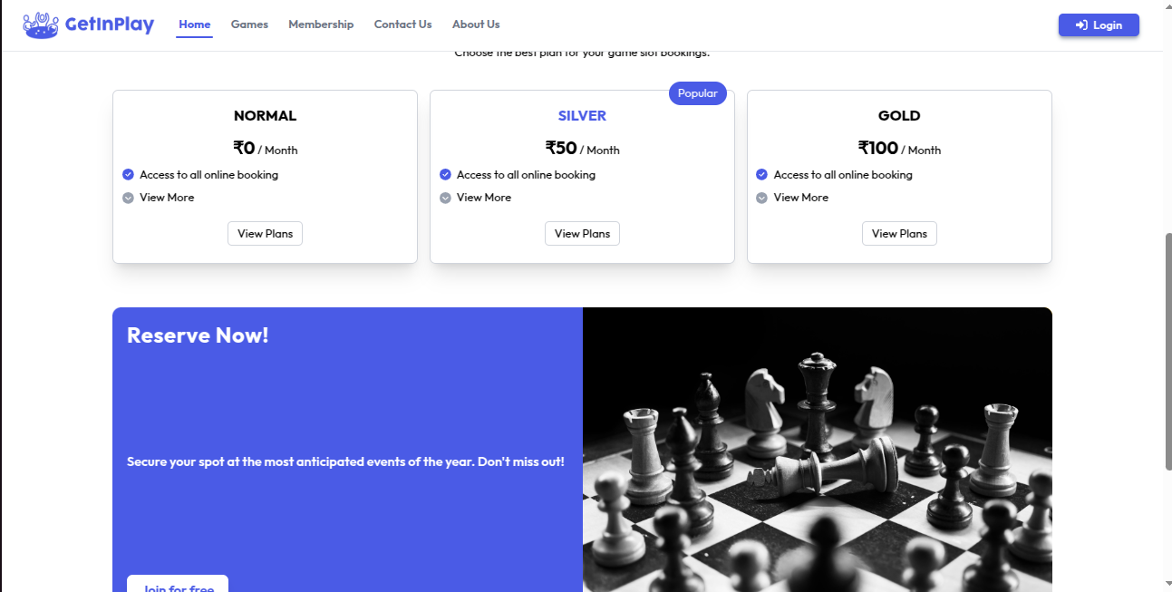
Home Page Scroll

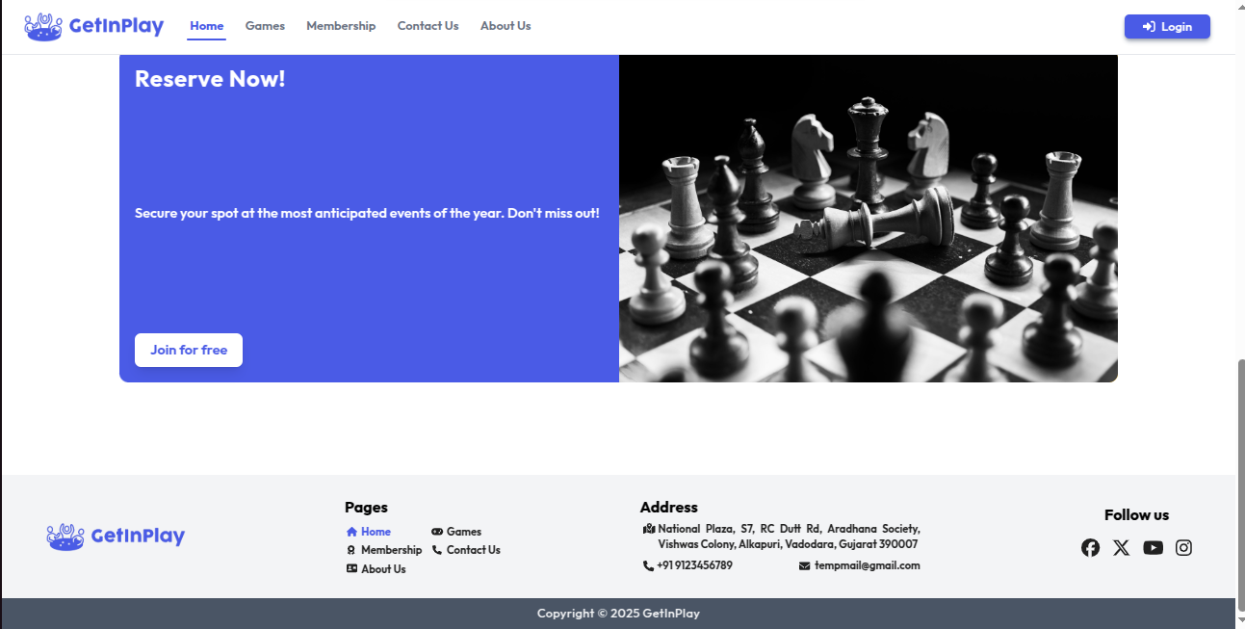
Home Page Scroll

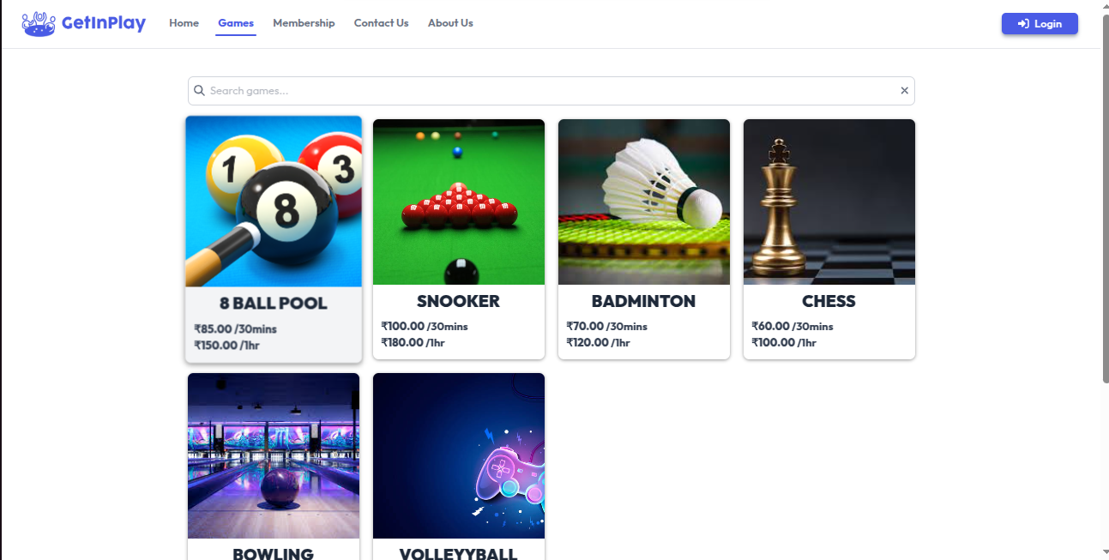
Game Listing

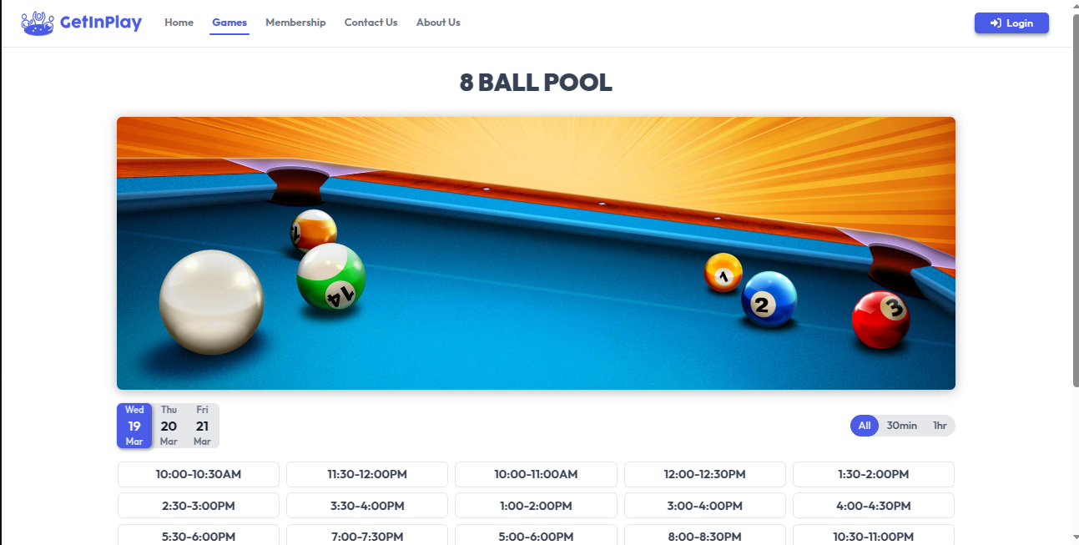

Book Game Slot

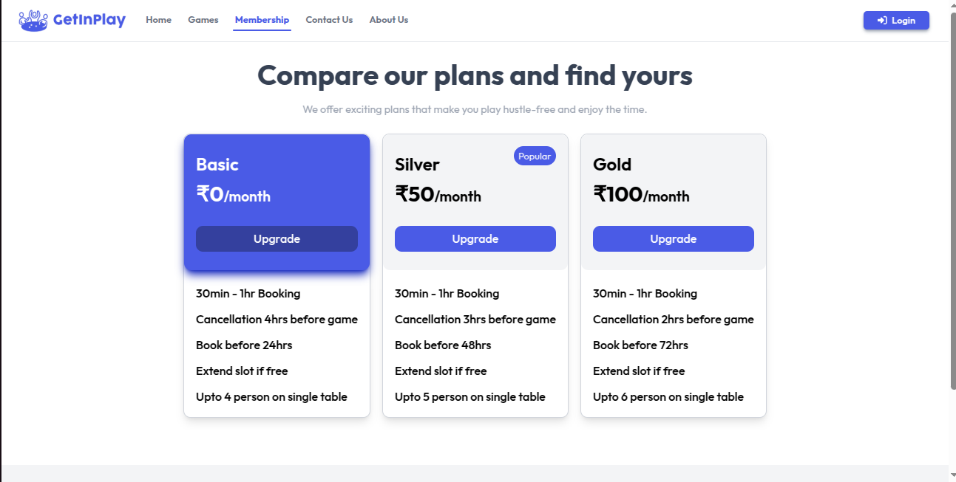
Membership

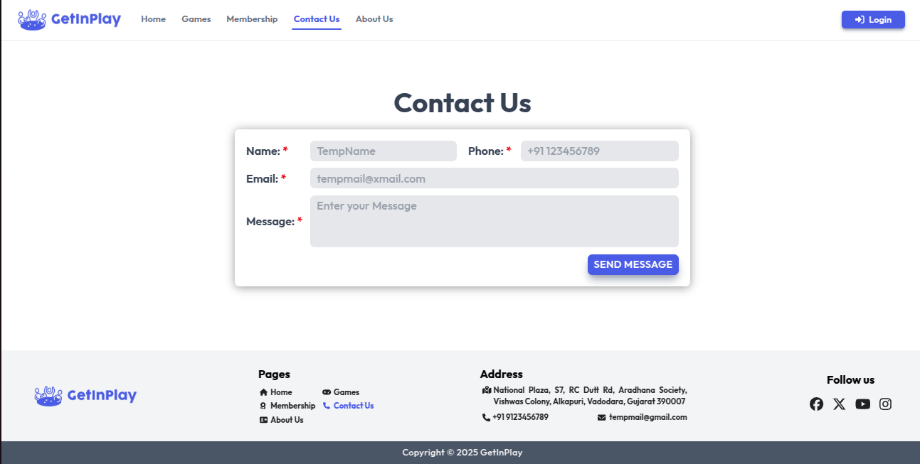
Contact Us

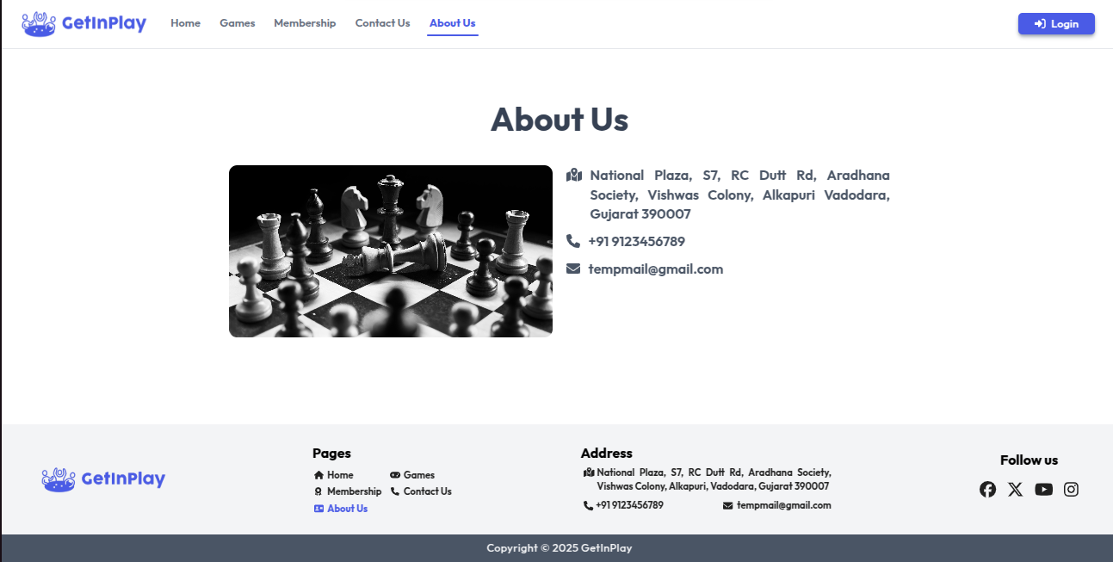
About Us

2.3 Problems and Solutions:-

2.3.1 Problems
During the development of the GetInPlay project, I encountered several challenges that tested my technical knowledge and problem-solving abilities. Working with different technologies like PHP, MySQL, JavaScript, jQuery, AJAX, and CSS, I faced issues with:
- Database Integration:
  - Fetching and updating real-time data from MySQL required ensuring data integrity and avoiding conflicts during slot booking.
  - Managing multiple CRUD operations while maintaining consistency across the admin and user sides was challenging.
- Slot Booking System Complexity:
  - Implementing a real-time slot booking system with dynamic slot availability for multiple games involved managing overlapping bookings and avoiding conflicts.
  - Ensuring that slots were correctly updated without delay required continuous real-time synchronization using AJAX.
- UI/UX Challenges:
  - Designing a responsive and visually appealing user interface for both admin and users that worked smoothly across different devices required detailed attention to CSS and Bootstrap.
  - Aligning multiple elements while maintaining responsiveness and performance was a time-consuming task.
- Security and Authentication:
  - Implementing a secure login and session management system was crucial for ensuring that unauthorized users could not access sensitive information.
  - Preventing SQL injection, securing form inputs, and managing session timeouts were critical security concerns.
- API and AJAX Issues:
  - Dynamic loading of slot data and game availability using AJAX sometimes resulted in unexpected errors due to improper handling of asynchronous responses.

2.3.2 Solutions
Overcoming these challenges was a valuable learning experience that improved my web development skills. Through persistent effort, I was able to implement the following solutions:
- Database Efficiency:
  - Optimized SQL queries and ensured data consistency with proper error handling to manage real-time updates effectively.
  - Maintained transactional integrity to prevent conflicting slot bookings.
- Real-time Slot Management:
  - Implemented AJAX to continuously fetch and update slot availability without refreshing the page, ensuring smooth slot management.
  - Introduced error handling to prevent slot conflicts and ensure accuracy in booking records.
- Responsive UI Design:
  - Applied Bootstrap and CSS best practices to create a responsive design that works flawlessly on all devices.
  - Ensured proper padding, margins, and element alignment to maintain consistency and provide a seamless user experience.
- Enhanced Security:
  - Used PHP session management and password hashing to safeguard user credentials.
  - Implemented form validation, input sanitization, and SQL injection prevention techniques to secure the system.
- AJAX and API Handling:
  - Handled asynchronous responses properly to ensure smooth data synchronization.
  - Debugged API and AJAX issues through continuous testing and error logging.
These solutions not only resolved the challenges but also helped me gain in-depth knowledge of web development processes and strengthened my technical expertise.

2.4 Learning Outcomes:-

2.4.1 HTML
- Basic HTML:
  - Tags, Elements, Attributes, Paragraphs, Headings, Line Breaks, Horizontal Rules, Lists, Tables, Color Codes, Fonts, Text Linking, Email, Images, Backgrounds, Meta Tags, Media, Charset.
- HTML Forms:
  - Input Fields, Text Fields, Password Fields, Checkboxes, Radio Buttons, Combo Boxes, Text Areas, File Uploads, and Buttons.

2.4.2 CSS
- Basic CSS:
  - Inline, Class, ID, Background, Font, Text Formatting, Padding, Margin, Borders, List Styling, Hover Effects, and Element Styling.
- Advanced CSS:
  - Border Radius, Opacity, Cursor Styles, Layering, Positioning, Display Properties, Float, Gradients, and Multi-column Layouts.
- UI Design with CSS:
  - Created responsive and visually appealing interfaces using CSS div-based structures.

2.4.3 JavaScript
- Basic JavaScript:
  - Syntax, Operators, Variables, Events, Alerts, and Printing Data.
- JavaScript String Handling:
  - String Manipulation, String Length, and Basic String Operations.
- Advanced JavaScript Concepts:
  - DOM Manipulation using getElementById, innerHTML, and Regular Expressions.

2.4.4 PHP & MySQL
- Core PHP:
  - Syntax, Variables, Loops, Functions, and File Handling.
- Form Handling:
  - Data Validation, File Uploads, and Error Management.
- MySQL Database:
  - CRUD Operations, Data Retrieval, and Managing Relationships between Tables.
- Advanced PHP:
  - Sessions, Authentication and Secure Login.

2.4.5 AJAX & jQuery
- AJAX Basics:
  - Sending and Receiving Data Asynchronously.
- jQuery:
  - DOM Manipulation, Event Handling, and Animations.

2.4.6 Project Development
- GetInPlay Project:
  - Developed a complete slot booking system integrating PHP, MySQL, JavaScript, and AJAX.
  - Implemented real-time slot booking, admin dashboards, and CRUD operations with high performance and security.

3. Summary/Conclusions

The internship at Svaapta IT-Ally Tech Pvt. Ltd. was an enriching experience that allowed me to bridge the gap between theoretical knowledge and real-world application. Throughout the internship, I encountered and resolved several challenges, including adapting to project requirements, debugging technical issues, and managing project timelines effectively. These challenges enhanced my technical expertise and improved my problem-solving abilities.
Working on diverse tasks, including developing a landing page, a portfolio, and the GetInPlay project, allowed me to apply my skills in HTML, CSS, JavaScript, PHP, and MySQL. The constructive feedback from my mentors guided me in refining my code quality and meeting industry standards. Furthermore, collaborating with experienced professionals provided insights into project management and best practices in web development.
Overall, this internship significantly strengthened my technical skills, deepened my understanding of web technologies, and prepared me to tackle future challenges in the IT industry.

4. References

- https://www.w3schools.com/html/
- https://www.w3schools.com/css/
- https://www.w3schools.com/js/
- https://www.geeksforgeeks.org/php-tutorial/
- https://www.mysqltutorial.org/
- https://www.tutorialspoint.com/ajax/index.htm
- https://www.php.net/manual/en/
- https://getbootstrap.com/
- https://www.tutorialspoint.com/how-to-create-a-responsive-admin-dashboard-using-html-css-and-javascript
- https://www.geeksforgeeks.org/create-login-page-using-php-and-mysql/
- https://www.tutorialspoint.com/crud-operations-in-php-and-mysql
- https://www.youtube.com/watch?v=ap7pX2oDL0E

