## horizontal line



A Robot waiter in restaurant

**─**

Team - SR

Smita- EVD16I016

Rohith- CED16I017

# Overview

In this age of technology ,The robot butler is on hand to greet arriving guests, deliver items to rooms, mingle in a first-floor club lounge and rooftop bar, and even dance or at least roll back and forth to music.

**SRS - Software Requirement Specifications.**

Depending on customer requirement ,the robot has to take order ,come back and follow the same path again to serve the food in restaurants and hotels.

1. We have two attributes which differ for each restaurant these are:

* Number of tables.
* Distance between the tables.

2. We have two different attributes while manufacturing the robot.

* Radius of the wheel.
* Distance between the two motors or legs of the robot
* RPM of the motor.

# Components

* Pyboard
* 5V DC Motors and wheels
* Ultrasonic Sensor
* Jumper wires
* Wheels

**Assumed Restaurant**

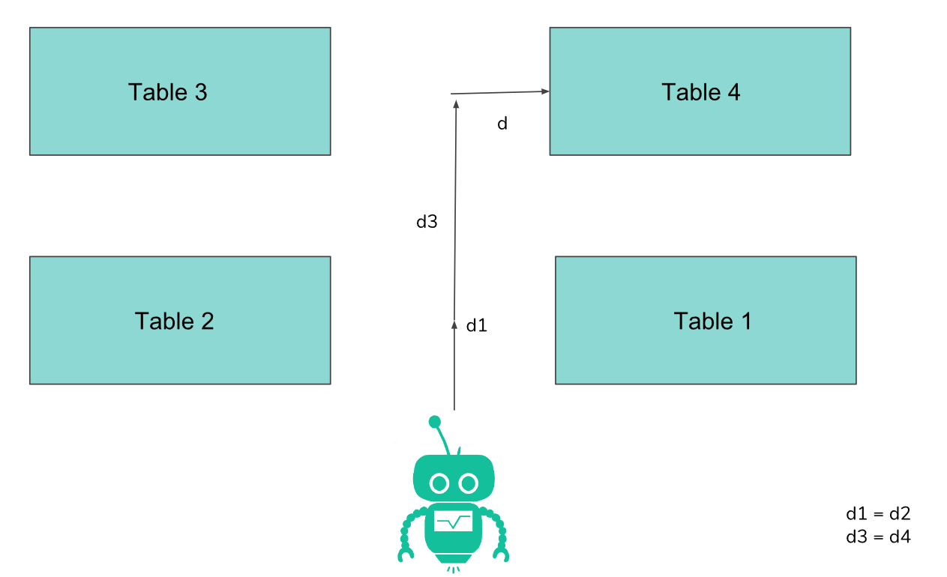

**Assumed Condition : Table-1**

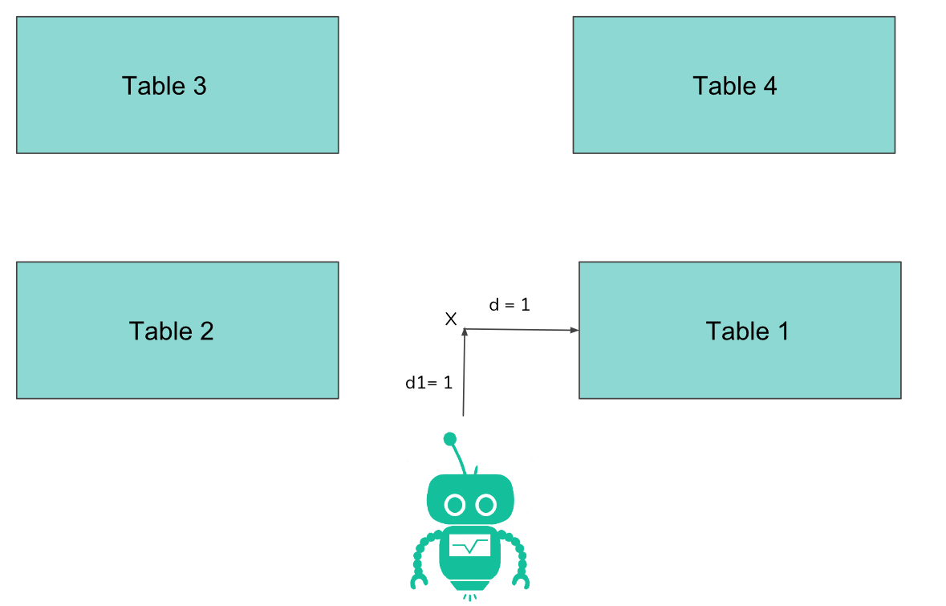

**Flowchart**

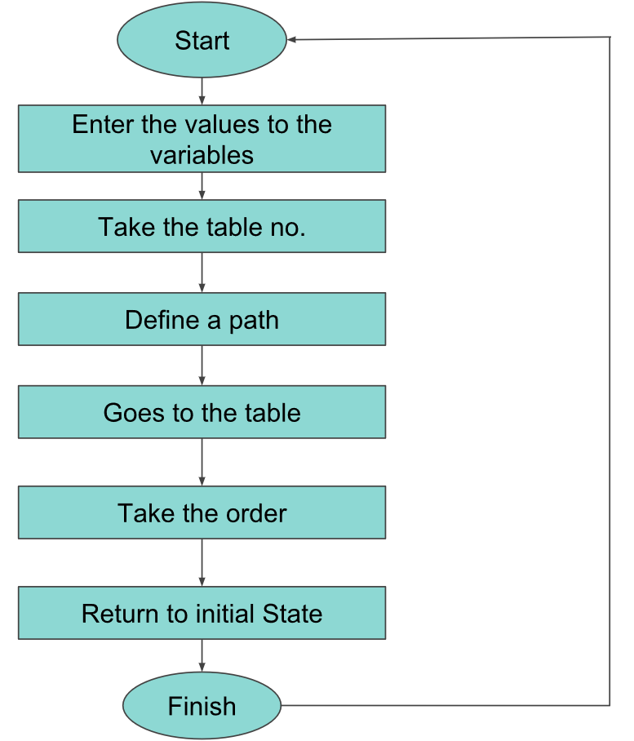

**Math behind the Logic**

1. In the previous diagram the distance between the robo and X is d1 and distance between X and the table is d. So we need to enter the X,Y beforehand. Similarly distances for all tables.
2. We know the rpm of the motor and we know the distance it has to travel so we can calculate the time of rotation.
3. We know that a circle travels a linear distance of 2r for a single rotation.

**Time = Distance/(rpm*2r)**

4. To rotate the robo or take a turn, one of the wheel is stopped and other is rotated in clockwise direction..Time taken to turn can be calculated as :.

**D = R𝜃**

**Time = D/(rpm*2r)**

Note: Here r is the radius of wheel. 𝜃 for the first rotation is 𝜋/2 and for the second rotation it is 𝜋

**Algorithm**

* Firstly we enter the distance of the tables form the counter.
* The robot goes to the desired table as requested by the owner.
* Once the robo has reached the table it waits till a switch is pressed to take order or serve the customer.
* When the switch is pressed it returns back to its initial state.
* And the process is repeated to deliver the items required to the customers.
* An ultrasonic sensor is used to avoid any collision with any obstacle present in front of the robo.
* The radius of the wheel is used to calculate the distance travelled.

**Led 1 is used to show the working of left leg of the robo(actually motor1) and led2 is taken for right leg of the robo (motor2)**

When table 1 is to be served:

* Both the wheel rotates in clockwise direction and the robo goes straight .
* Then it takes a right angle turn when it has to turn by clockwise rotation of only left wheel .
* When the robot reaches the table both the wheels stops rotating until it has taken order and served the customer .
* Left wheel rotates by 180 degree turn when the switch is pressed.
* After calculated delay taken to turn, both the motors are made to rotate in clockwise direction
* In similar manner it comes back to the counter
* In the code pyb.millis() returns the time elapsed since the board was last reset.
* We should subtract the time which the robo has not moved. (See the code for detailed explanation)
* We are using here so that we can know how much time we have to run the motor.

It does the same thing to take order from customer on any table just the delay and the motor to rotate changes for different path.

**Note:**

* This is done because giving the value high for the led is the same as giving high for a motor.
* All the distances are in m.
* Assumed rpm is 4000.

## Lorem Ipsum

Duis autem vel eum iriure dolor in hendrerit in vulputate velit esse molestie consequat, vel illum dolore eu feugiat nulla facilisis at vero eros et accumsan.

# Milestones

## Lorem ipsum

Lorem ipsum dolor sit amet, consectetuer adipiscing elit, sed diam nonummy nibh euismod tincidunt ut laoreet dolore magna aliquam erat volutpat.

## Dolor sit amet

Lorem ipsum dolor sit amet, consectetuer adipiscing elit, sed diam nonummy nibh euismod tincidunt ut laoreet dolore magna aliquam erat volutpat.