Step 1 : Install Python 3.6.4

* Python 3+, downloaded from [Python.org](https://www.python.org/)
* A willingness to learn!

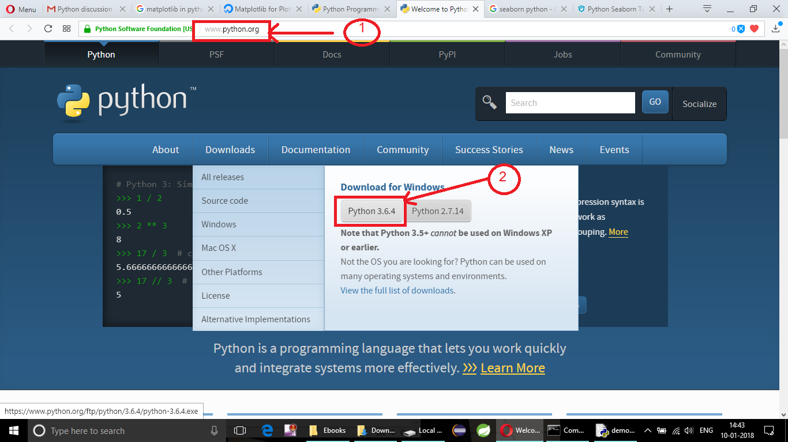

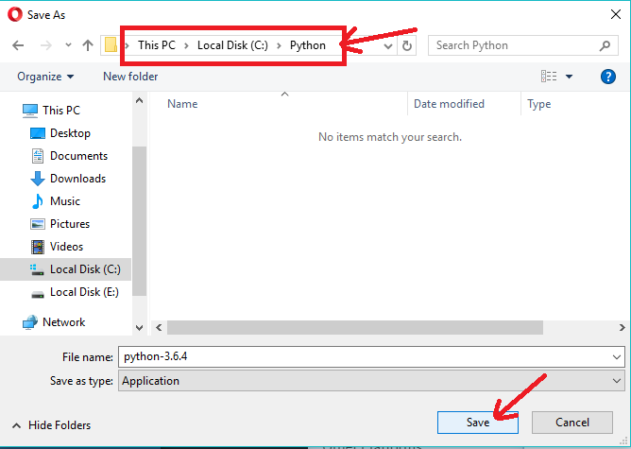

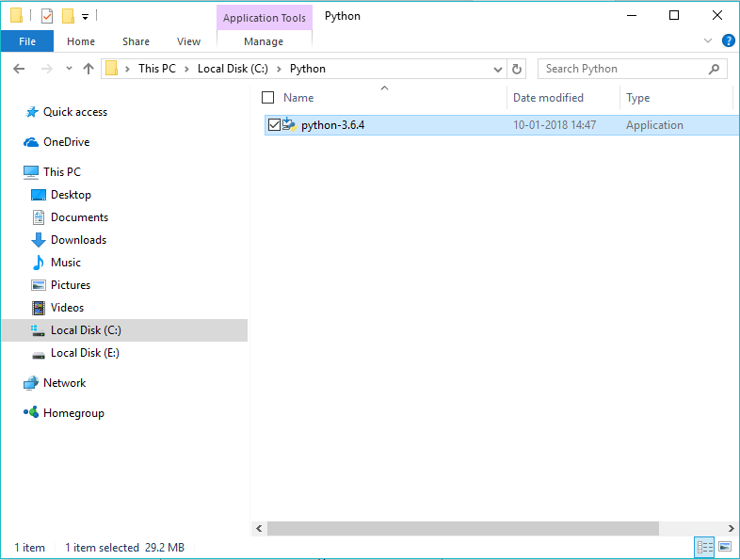

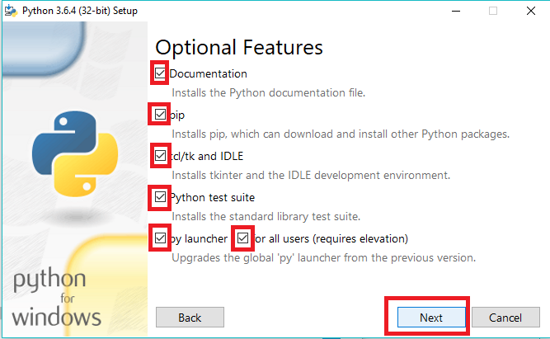

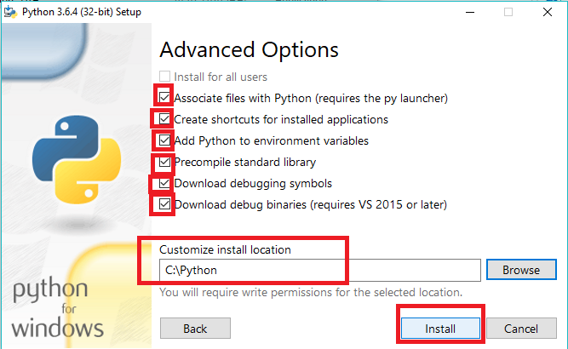

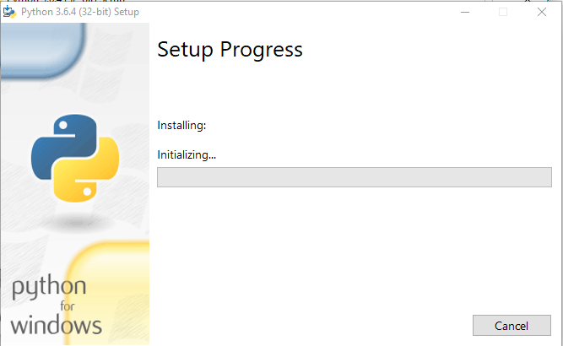

After installation completes

Then open cmd

And check by typing “python”

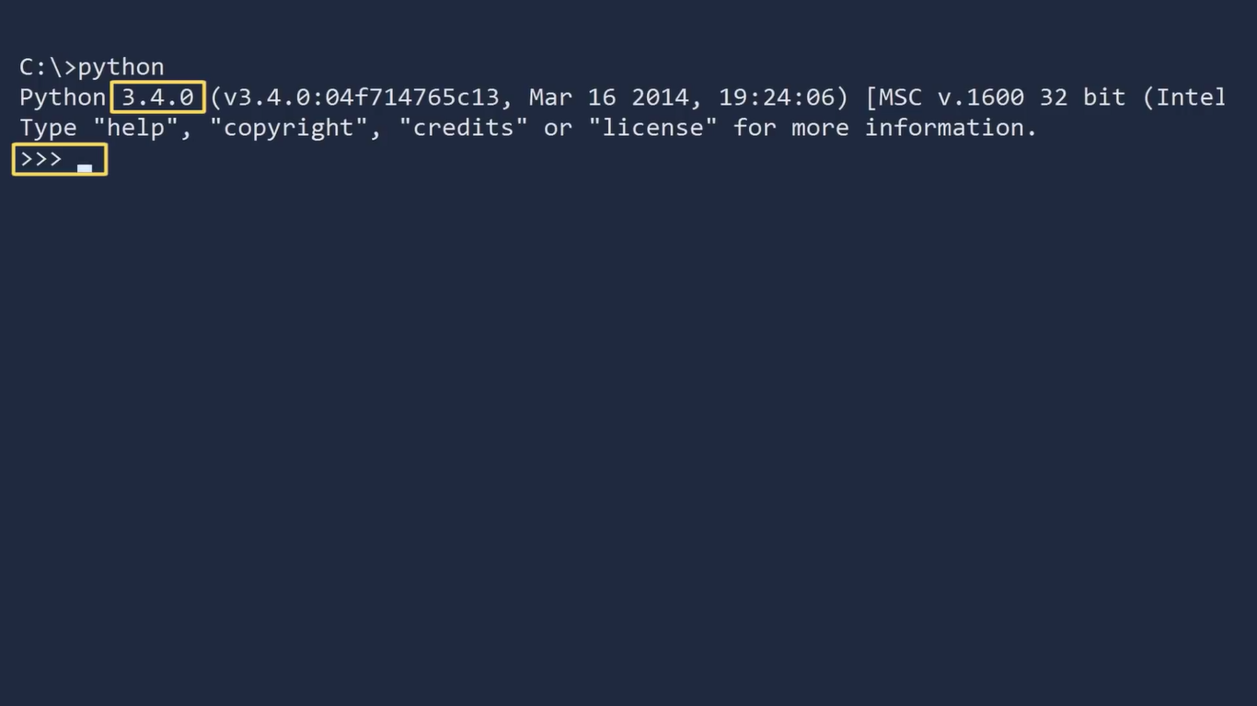

If its show the above screen then fine

Else set the python PATH in Environment variable

Refer document 2 for it

If everything fine the type the following cmd

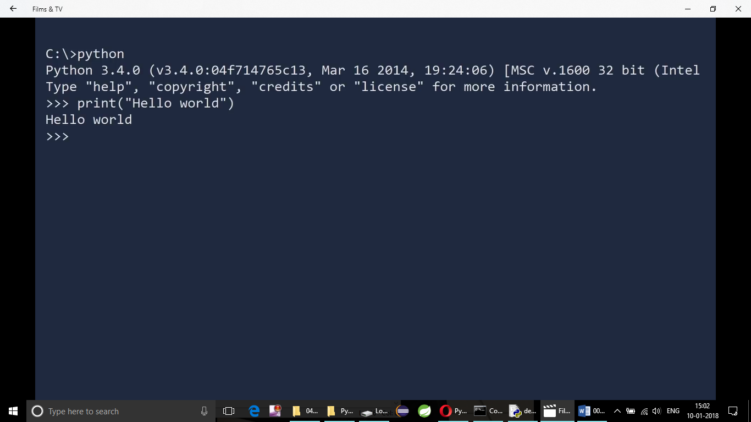

We can exit python with cmd

***quit()***