CREDITFIT 360™
Master Institutional Client Presentation & System Dossier
Borrower-First Financial Defense | Reverse Underwriting | RBI CEPC 2023-24 & DPDP Act 2023 Shield
Platform Version | 2.5 Enterprise Edition (Neon-Bento Full Stack Architecture)
Prepared For | Corporate Clients, Strategic Partners, Angel/VC Investors, Evaluators
Live Demonstration URL | http://localhost:5000 (Active Background Server)
Instant Demo Credentials | demo@creditfit360.com / Demo@123 (OTP: 123456)

SECTION 01 — THE REAL MARKET NEED, MARKET SIZE & OPPORTUNITY
――――――――――――――――――――――――――――――――――――――――――――――――――――――――――
Is there an actual need for CreditFit 360 in the market? The answer is an emphatic YES. India's credit ecosystem is experiencing an unprecedented lending boom, but it is accompanied by acute information asymmetry that harms borrowers. The current market is populated almost exclusively by loan brokers whose commercial incentives are 100% aligned with banks and NBFCs, leaving borrowers completely unprotected.
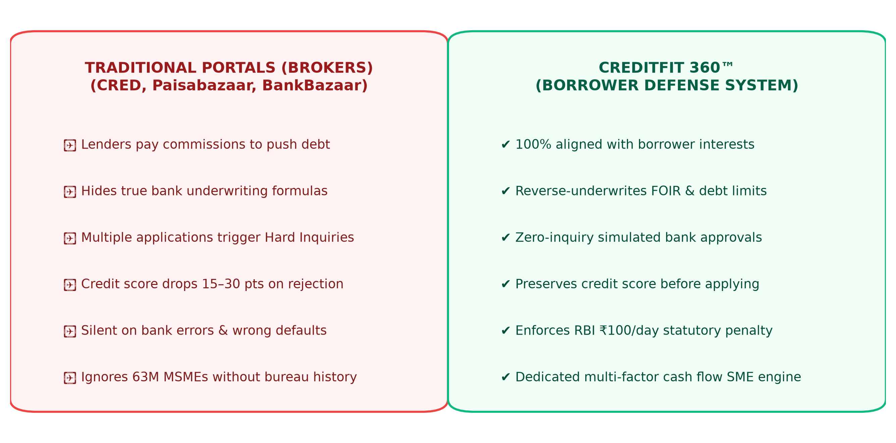
Figure: Paradigm Comparison: Legacy Loan Brokers vs. CreditFit 360 Borrower Defense Suite
The 4 Major Systemic Inefficiencies in the Indian Credit Market:
• The Credit Opacity Problem: Over 68% of borrowers whose loans get rejected never understand why. Banks evaluate FOIR (Fixed Obligation to Income Ratio), debt service coverage, and inquiry velocity—metrics legacy portals never calculate or explain.
• The 'Hard Inquiry' Spiral of Death: When an applicant gets rejected, they panic-apply to 3 or 4 other banks. Each application registers a 'hard pull' on their CIBIL score, dropping it by 15–30 points and locking them out of prime interest rates.
• The Unclaimed RBI ₹100/Day Statutory Penalty: Under RBI Master Circular CEPC/2023-24, banks and credit bureaus must resolve credit report errors within 30 days. If delayed, they are legally required to pay the customer ₹100 per day of delay. Over 99% of Indian citizens do not know this statutory right exists.
• The $300B MSME Credit Shortfall: Over 63 million MSMEs face rejection because traditional underwriting relies on retail consumer bureau records rather than operating cash flows, GST regularities, and vendor payment discipline.
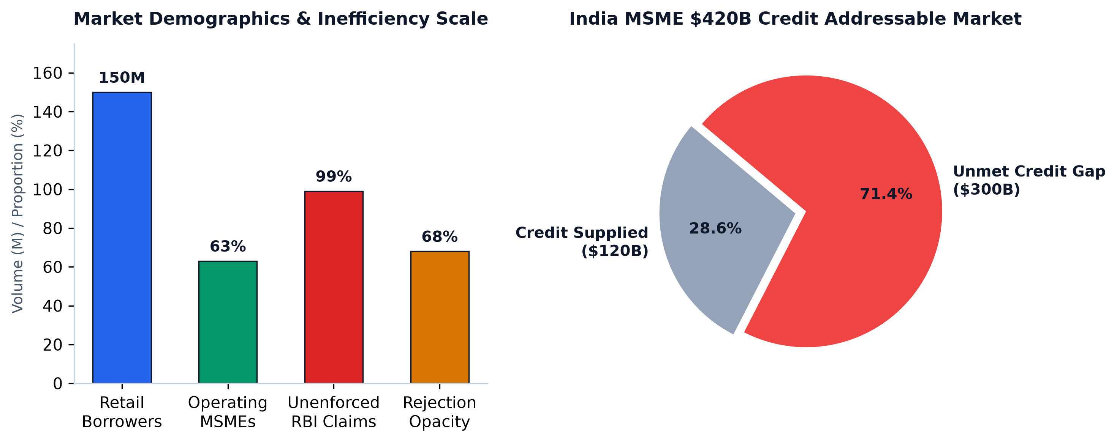
Figure: Empirical Market Opportunity: Retail Borrowers, MSME Gap ($300B), and Unenforced Rights
📌 MARKET THESIS: CreditFit 360 transforms credit management from an opaque, reactive 3-digit score into an actionable, reverse-engineered roadmap with regulatory enforcement rights under the Reserve Bank of India.

SECTION 02 — TARGET AUDIENCE & CUSTOMER SEGMENTATION MATRIX
――――――――――――――――――――――――――――――――――――――――――――――――――――――――――
CreditFit 360 is built to serve a multi-tiered audience across retail consumers, small business owners, financial intermediaries, and institutional lenders:
Target Segment | Specific Profile | Why They Need CreditFit 360
1. Pre-Loan Retail Borrowers | Salaried professionals planning Home, Auto, or Personal Loans in the next 1–6 months | Simulate bank approval odds and pre-calculate FOIR to avoid score-damaging hard inquiries.
2. Loan Rejection Victims | Individuals rejected by banks in the last 90 days with unclear rejection letters | Diagnose the exact mathematical failure point and receive a step-by-step debt paydown roadmap.
3. Bank Error Dispute Victims | Borrowers with wrong defaults, unclosed loans, or delayed dispute resolutions | Compute statutory delayed-days penalty and generate legal grievance notices under RBI CEPC/2023-24.
4. MSMEs & Sole Proprietors | Small business owners, GST traders, and service firms lacking audited balance sheets | Score creditworthiness using alternative cash-flow, profit margins, and supplier discipline.
5. Loan DSAs & Agents | Direct Selling Agents and loan intermediaries handling dozens of client files | Pre-underwrite client files and generate institutional dossiers to qualify leads before bank submission.
6. CAs & Wealth Advisors | Chartered Accountants and wealth planners offering debt optimization services | Offer institutional client loan readiness dossiers and What-If financial simulations.

SECTION 03 — PLATFORM ARCHITECTURE & ENGINEERING DESIGN
――――――――――――――――――――――――――――――――――――――――――――――――――――――――――
CreditFit 360 is engineered as an enterprise-grade, high-performance web platform utilizing a modular micro-service-ready architecture. The system combines modern server-rendered Jinja2 views with RESTful JSON endpoints, cryptographic user authentication, and high-contrast glassmorphic Bento CSS styling.
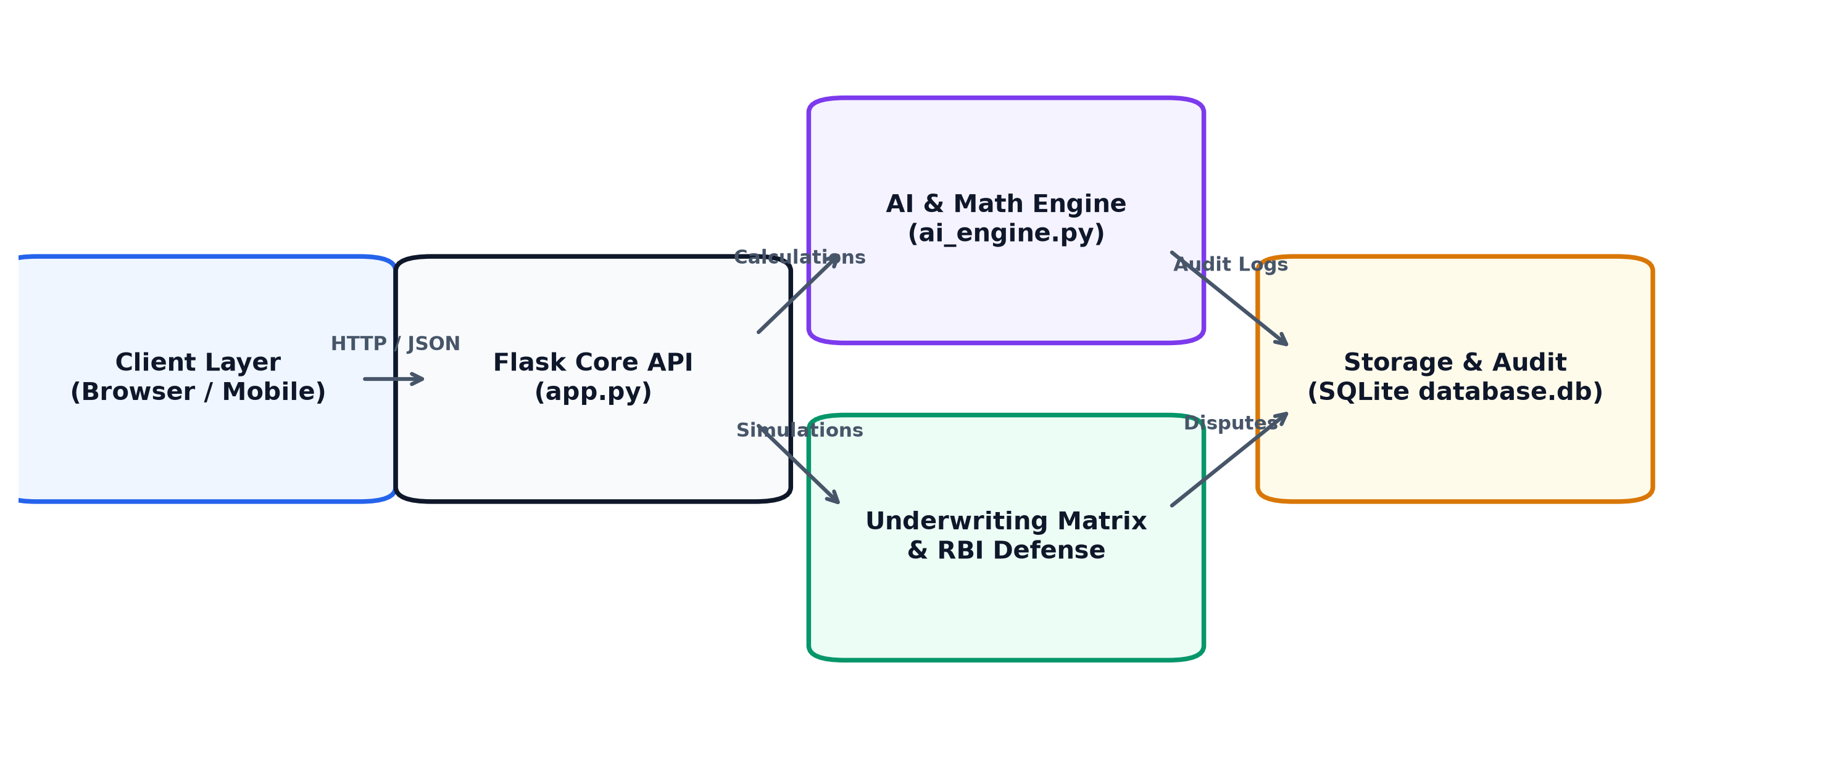
Figure: End-to-End System Architecture & Data Flow Diagram
• Application Core: Python 3.10+, Flask 3.1+ RESTful server with session cryptographic state management.
• Persistence Layer: Zero-dependency, thread-safe SQLite database (database.db) managed via db.py.
• Security Standards: scrypt password hashing with unique salt generation; DPDP Act 2023 audit logging.
• Frontend System: Vanilla CSS Bento Grid design system; responsive high-contrast UI with zero heavy bundle dependencies.
• Localhost Runner: Dedicated server.py runner with automated port-collision handling and LAN IP discovery.

SECTION 04 — EXHAUSTIVE FUNCTION-BY-FUNCTION BREAKDOWN: WHY IT EXISTS & WHAT IT DOES
――――――――――――――――――――――――――――――――――――――――――――――――――――――――――
To present CreditFit 360 effectively to clients and investors, each of the platform's core functions is explained below in complete detail: why the function is needed in the market, what it actually does, how it works under the hood, and what tangible output is produced for the user.
MODULE 01: Enterprise Authentication & 1-Click Demo Portal (/)
Why It Is Needed | First impressions dictate adoption. Complex registration forms cause 60%+ user drop-off during client evaluations. Evaluators need instant access without creating disposable emails.
What It Actually Does | Provides secure multi-tab user registration, login, and a dedicated '1-Click Demo Login' preloaded with verified credentials.
Underlying Engine / Formula | Implements Werkzeug scrypt password hashing, session cookies with secret keys, and preloaded demo credentials (demo@creditfit360.com / Demo@123).
Tangible Output Produced | Instant user session authentication, greeting personalization, and access to all financial simulators.

MODULE 02: Financial Intelligence Command Center (/dashboard)
Why It Is Needed | Borrowers are overwhelmed by disjointed numbers. They need an executive command center that synthesizes complex credit metrics into a single prioritized action dashboard.
What It Actually Does | Displays a dynamic 0–100 CreditFit Health Score, risk status (Prime, Near-Prime, Subprime), key financial ratios, and predictive risk alerts.
Underlying Engine / Formula | Weighted calculation factoring FOIR (35%), credit utilization (25%), emergency runway (20%), and repayment vintage (20%).
Tangible Output Produced | High-impact visual dashboard with active warning alerts (e.g. 'FOIR exceeds 45% ceiling', 'Emergency runway under 3 months') and direct action buttons.

MODULE 03: Personal CreditFit Assessment Wizard (/personal-credit)
Why It Is Needed | Standard loan forms ask confusing questions and overwhelm borrowers. A guided step-by-step wizard reduces cognitive load while capturing institutional underwriting parameters.
What It Actually Does | A 4-step progressive wizard covering Basic Demographics, Cash Flow, Bureau Metrics, and Emergency Reserves.
Underlying Engine / Formula | Calculates net disposable income, monthly debt obligations, and credit utilization percentages.
Tangible Output Produced | Generates complete personal underwriting profile and automatically updates database.db.

MODULE 04: India Stack Account Aggregator (AA) Auto-Fill Sandbox (/personal-credit (Modal))
Why It Is Needed | Manual data entry takes 10+ minutes and leads to errors and form abandonment. Users demand instant, automated data retrieval from their banks.
What It Actually Does | Simulates RBI-regulated Account Aggregator (FIP/FIU) frameworks (HDFC, SBI, ICICI) to pull verified salary, debt, and balance data in 3 seconds.
Underlying Engine / Formula | Simulated OTP (123456) verification triggering instant JSON payload injection into all wizard form fields.
Tangible Output Produced | Instant auto-population of 18 financial fields with 100% accuracy, demonstrating India Stack readiness.

MODULE 05: SME CreditScore Multi-Factor Engine (/sme-credit-score)
Why It Is Needed | Over 63 million MSMEs lack audited financial statements and get unfairly rejected by retail credit scoring algorithms.
What It Actually Does | A specialized scoring engine evaluating business vintage, profit margin consistency, vendor invoice payment track record, and working capital buffers.
Underlying Engine / Formula | Multi-dimensional scoring model adapted for cash-flow-based SME lending guidelines.
Tangible Output Produced | SME Creditworthiness Index (0–100), operating stability rating, and recommended working capital credit limit.

MODULE 06: Reverse Underwriting Suite (/defense-suite (Tab 1))
Why It Is Needed | Applying for a loan blindly damages the applicant's credit score through hard inquiries. Borrowers must know their sanction odds BEFORE applying.
What It Actually Does | Simulates how Tier-1 bank credit committees evaluate a loan application (requested amount, proposed interest rate, tenure) against the borrower's debt capacity.
Underlying Engine / Formula | Stress-tests requested EMI against the 50% FOIR regulatory cap; predicts bank approval probabilities (High, Medium, Low).
Tangible Output Produced | Exact approval odds and specific restorative advice (e.g. 'Pay down ₹45,000 in credit card debt or extend tenure by 12 months to guarantee approval').

MODULE 07: RBI Statutory Penalty Enforcer & Notice Generator (/defense-suite (Tab 2))
Why It Is Needed | Banks and credit bureaus routinely delay resolving credit report errors for months. 99% of consumers do not know they are legally entitled to ₹100/day compensation.
What It Actually Does | Calculates mandatory statutory delay compensation under RBI Master Circular CEPC/2023-24 and generates a ready-to-dispatch formal legal grievance notice.
Underlying Engine / Formula | Statutory formula: Max(0, (Elapsed Days - 30) * ₹100/day); compiles legal notice citing Section 21 of the Credit Information Companies (Regulation) Act, 2005.
Tangible Output Produced | Total legal claim amount in INR, ready-to-print formal legal notice, and dispute persistence in database.db.

MODULE 08: Institutional Loan Readiness Dossier & Verification ID (/dossier)
Why It Is Needed | Borrowers walking into banks without structured documentation get unfavorable interest rates or delayed processing. They need an official, verified financial summary.
What It Actually Does | Executive financial dossier featuring a unique cryptographic verification ID (e.g. CF360-IND-202610-8921), max loan capacity, and bank pre-approval odds.
Underlying Engine / Formula | Calculates maximum sanctionable loan under 50% FOIR ceiling over 60 months at prime interest rates.
Tangible Output Produced | Institutional dossier suitable for presentation to bank loan managers and NBFC credit officers.

MODULE 09: 1-Click Clean A4 PDF Export (/dossier (Print Action))
Why It Is Needed | Converting web pages into client-ready documents usually results in broken layouts, cut-off tables, and visible website buttons.
What It Actually Does | High-fidelity, print-optimized A4 document rendering using dedicated @media print CSS rules.
Underlying Engine / Formula | Automated CSS print engine that strips web navigation, buttons, and dark backgrounds, applying formal document typography and watermarks.
Tangible Output Produced | Flawless, institutional A4 PDF ready for formal bank submission or digital sharing.

MODULE 10: FitAI Financial Co-Pilot (/assistant)
Why It Is Needed | Borrowers need instant, personalized answers to complex financial questions without paying expensive advisory fees.
What It Actually Does | Natural language AI financial assistant that synchronizes with the user's active session data to deliver context-aware financial guidance.
Underlying Engine / Formula | ai_engine.py contextual query engine with pre-programmed regulatory frameworks and prompt-chip accelerators.
Tangible Output Produced | Conversational, tailored financial advice directly addressing the user's FOIR, credit score, and debt capacity.

MODULE 11: MoneyMap Cash Flow Visualizer (/moneymap)
Why It Is Needed | Most consumers do not understand where their monthly salary disappears, leading to accidental loan default risks.
What It Actually Does | Visualizes monthly income flow across Fixed EMIs, Essential Living Expenses, Discretionary Costs, and Net Liquid Surplus.
Underlying Engine / Formula | Cash-flow allocation engine categorizing monthly debits into structured financial health buckets.
Tangible Output Produced | Clear visual breakdown highlighting overspending areas and liquid surplus available for loan repayment.

MODULE 12: Financial Decision Lab (/decision-lab)
Why It Is Needed | Borrowers face difficult financial dilemmas (e.g., prepay home loan vs. invest in mutual funds) and have no mathematical tools to compare outcomes.
What It Actually Does | A/B scenario testing engine that projects the 10-to-20-year net-wealth outcome of competing financial decisions.
Underlying Engine / Formula | Compound interest and amortization calculation engine factoring inflation, interest savings, and investment returns.
Tangible Output Produced | Side-by-side comparison tables and graphs showing total wealth difference between options.

MODULE 13: What-If FinTwin 12-Month Simulator (/what-if-simulator)
Why It Is Needed | Consumers hesitate to make financial moves because they cannot predict how it will affect their credit score.
What It Actually Does | Interactive digital twin simulator with sliders allowing users to simulate debt paydowns, card closures, or new credit to forecast score trajectory.
Underlying Engine / Formula | Dynamic credit score simulation model projecting monthly score changes over a 12-month horizon.
Tangible Output Produced | Interactive score trajectory line chart showing projected score improvements based on simulated user actions.

MODULE 14: Wealth Path Milestone Planner (/wealth-path)
Why It Is Needed | Borrowers need a structured, inflation-adjusted plan to accumulate down payments for home or business asset purchases.
What It Actually Does | Goal-based milestone planner that calculates required monthly SIP contributions to reach specific capital goals.
Underlying Engine / Formula | Future-value capitalization formula with user-defined target date and expected annual rate of return.
Tangible Output Produced | Clear milestone roadmap with recommended monthly savings targets and timeline projections.

MODULE 15: DPDP Act 2023 Privacy & Governance Center (/privacy-consent-center)
Why It Is Needed | Consumers and institutional clients demand strict data privacy. Fintechs failing to comply with India's DPDP Act 2023 face fines up to ₹250 Crores.
What It Actually Does | Comprehensive data governance portal implementing Section 6 Consent Logs, Section 12 Data Portability, and Section 12 Right to Erasure.
Underlying Engine / Formula | Immutable SQLite consent table, automated JSON data exporter, and irreversible user-record purge API.
Tangible Output Produced | Transparent consent audit trail, 1-click JSON data download, and verified 1-click complete data erasure.

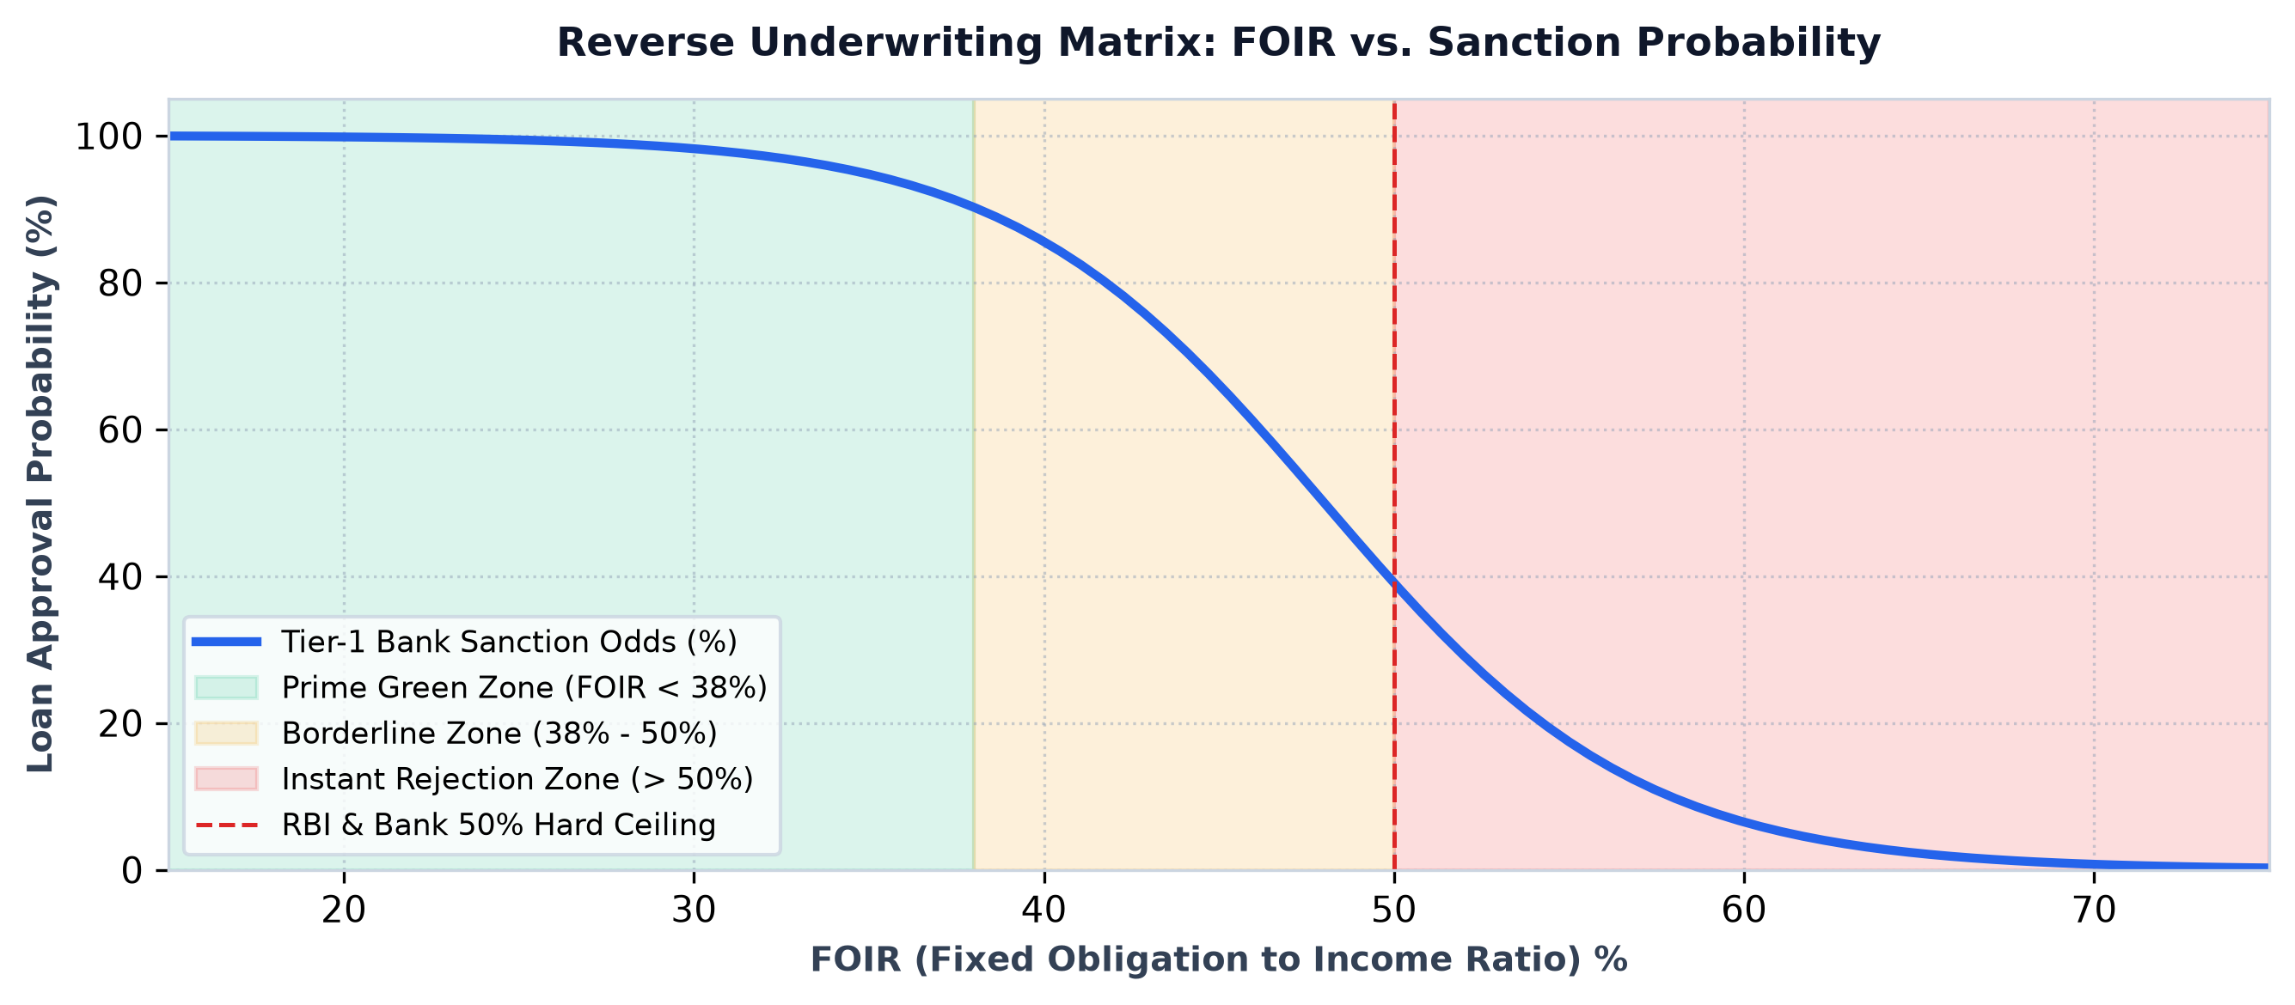
Figure: Reverse Underwriting Simulation: FOIR Sanction Probability Curves and Safe Ceilings
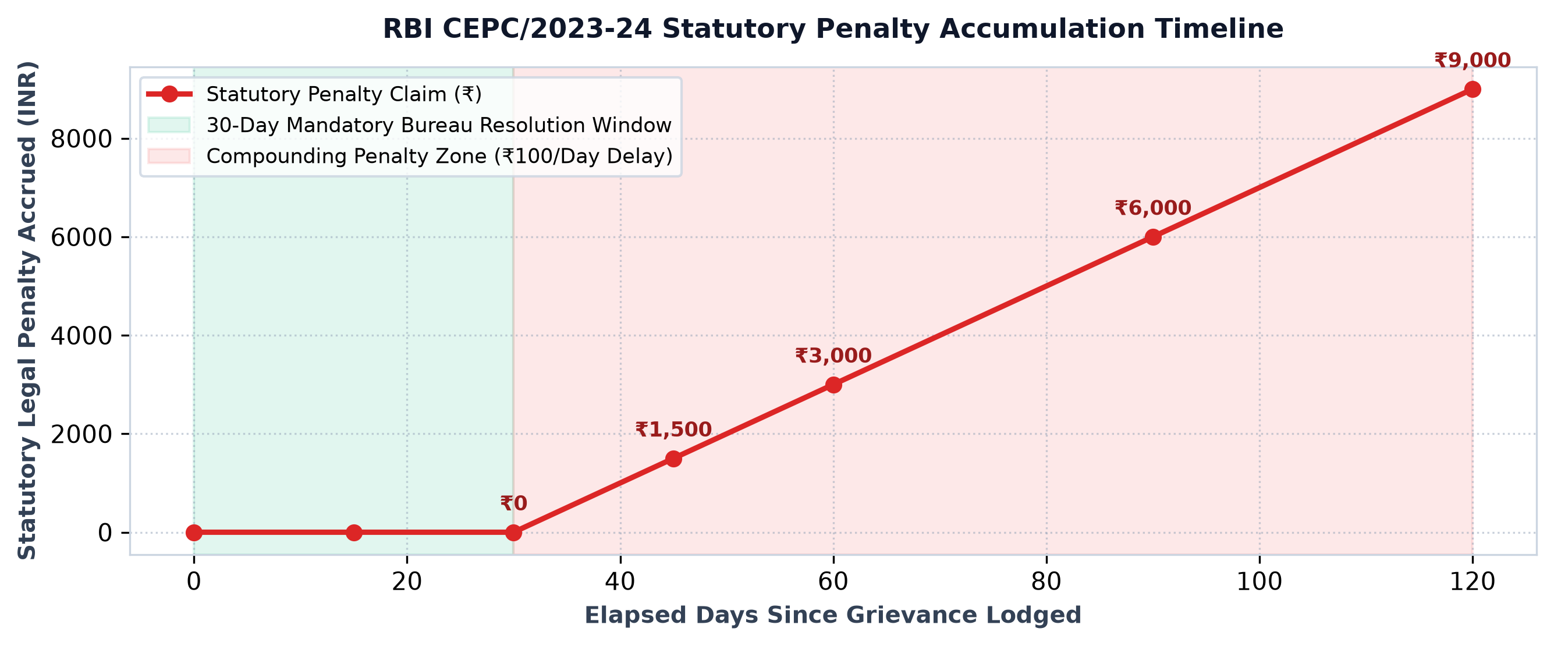
Figure: RBI Statutory Penalty Timeline: Compounding Delayed-Dispute Legal Claims (CEPC/2023-24)
SECTION 05 — STEP-BY-STEP 7-MINUTE LIVE CLIENT PRESENTATION SCRIPT
――――――――――――――――――――――――――――――――――――――――――――――――――――――――――
When presenting CreditFit 360 to a client, corporate stakeholder, or investor jury, follow this exact minute-by-minute script. Each minute is optimized for maximum impact, demonstrating live features with zero friction.
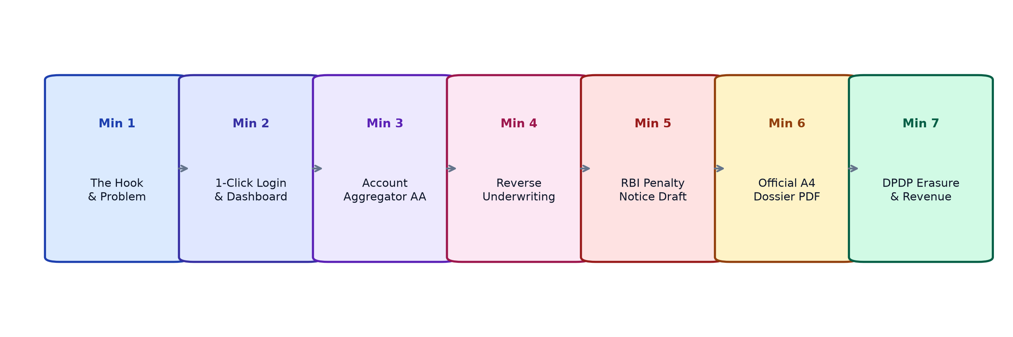
Figure: 7-Minute High-Impact Client Presentation Roadmap & Demonstration Stages
▶ Minute 1: The Hook & Market Problem
Speech Script: 'Good morning. In India today, over 150 million consumers and 60 million MSMEs interact with credit. But when they apply for a loan, they enter a total black box. Platforms like CRED or Paisabazaar are essentially loan distribution agents—they get paid when you borrow more. Nobody is in the borrower's corner. We created CreditFit 360 to be India's first Borrower Defense and Reverse-Underwriting Operating System.'
Live Action: Open http://localhost:5000 in your browser; show the sleek landing page.
▶ Minute 2: 1-Click Sign-In & Command Dashboard
Speech Script: 'Let's enter the platform. We have built-in zero-friction access. With our 1-Click Demo Login, we instantly enter the Executive Dashboard. Rather than just showing a vanity 3-digit score, CreditFit 360 surfaces FOIR limits, emergency runway months, and predictive risk flags that bank credit managers actually evaluate.'
Live Action: Click '⚡ 1-Click Demo Login'. Point to the dynamic Health Score gauge and active warning banners.
▶ Minute 3: Account Aggregator (AA) Auto-Fill Sandbox
Speech Script: 'Normally, filling a 20-field financial form causes users to drop off. Watch this: we integrate with India's RBI Account Aggregator framework. The user chooses their bank, enters their mobile number, and confirms simulated OTP 123456. Instantly, our system securely pulls verified salary credits, existing EMIs, and liquid reserves, auto-filling all four stages of the underwriting engine in seconds.'
Live Action: Navigate to 'Personal CreditFit' -> Click '🏦 Connect Bank via AA' -> Select Bank -> Click Send OTP -> Enter '123456' -> Click Verify & Auto-Fill.
▶ Minute 4: Reverse Underwriting Engine
Speech Script: 'Here is where CreditFit 360 protects the consumer. Instead of submitting a loan application and triggering a score-damaging hard inquiry, our Reverse Underwriter stress-tests the applicant's profile against Tier-1 bank credit committee policies. If the FOIR is too high, it advises them on the exact amount of debt to pay off first to guarantee approval.'
Live Action: Navigate to 'Defense & Approval' -> 'Reverse Underwriting'. Enter a loan amount (e.g. ₹25,00,000) and click 'Run Reverse Simulation'. Point to the odds and recommendations.
▶ Minute 5: RBI Statutory Compensation Enforcer
Speech Script: 'This is our standout regulatory defense feature. Under RBI Circular CEPC/2023-24, banks must resolve credit report disputes within 30 days. If they fail, they owe the borrower ₹100 per day. Here, the borrower enters their dispute date, and CreditFit 360 computes the statutory penalty and produces a ready-to-dispatch legal notice under Section 21 of the CIC Act.'
Live Action: Click the 'Statutory Defense & RBI Notice' tab. Enter a past date (e.g., 60 days ago) and click 'Calculate Statutory Penalty'. Show the legal letter and claim amount.
▶ Minute 6: Official Loan Readiness Dossier & Clean PDF Export
Speech Script: 'When a borrower is ready to apply, they don't walk into a bank empty-handed. CreditFit 360 generates this Institutional Loan Readiness Dossier, complete with verification ID, FOIR stress metrics, and bank approval probabilities. With a single click, it prints into a clean, professional A4 PDF.'
Live Action: Click '📑 Export Dossier (PDF)' in the navigation bar. Show the formal A4 layout. Click 'Print / Save as PDF' to demonstrate clean export.
▶ Minute 7: DPDP Act Privacy Governance & Business Scalability
Speech Script: 'Finally, we take compliance seriously. Under India's Digital Personal Data Protection Act 2023, users can view their immutable consent audit trail, download their full data package, or execute the Right to Erasure to permanently purge their database records. As a business, CreditFit 360 monetizes via B2C subscriptions (₹399/yr), B2B SaaS licenses for CAs and Loan Agents (₹1,499/mo), and qualified lender referral payouts. Thank you.'
Live Action: Navigate to '🛡️ DPDP Privacy Center'. Show the consent log and click 'Export My Personal Data (JSON)'. Conclude the presentation.
SECTION 06 — COMMERCIAL VIABILITY, REVENUE MODELS & BUSINESS SCALABILITY
――――――――――――――――――――――――――――――――――――――――――――――――――――――――――
CreditFit 360 is built with a highly diversified monetization strategy combining high-volume B2C consumer subscriptions with recurring B2B professional SaaS licensing and high-ticket institutional lender referral fees:
Revenue Stream | Target Market | Pricing Model | Core Value Proposition
B2C Premium Defense | Retail Borrowers & Salaried Professionals | ₹399/year or ₹49/month | Auto-dispute letter generator, RBI statutory compensation tracker, unlimited What-If simulations.
B2B SaaS for CAs & DSAs | Direct Selling Agents, Loan Brokers, Accounting Firms | ₹1,499/month per license | Client loan readiness assessment dossiers, pre-qualification stress tests, rejection-prevention tools.
Pre-Underwritten Referral Marketplace | Tier-2 & Tier-3 NBFCs and Digital Lenders | 1.0% – 1.8% of loan sanction value | Routing pre-vetted applicants whose FOIR and credit profiles match exact lender underwriting criteria.

SECTION 07 — TOUGH CLIENT Q&A AND OBJECTION DEFENSE GUIDE
――――――――――――――――――――――――――――――――――――――――――――――――――――――――――
Q1: How does CreditFit 360 differ from CRED or Paisabazaar?
Answer: CRED and Paisabazaar are essentially credit distribution marketplaces. They monetize through lender affiliate commissions—they get paid when a user borrows more money. As a result, they cannot act as a neutral advocate for the borrower. CreditFit 360 is borrower-aligned: it helps users reduce debt obligations, reverse-underwrite loan readiness without hard inquiries, and enforce statutory penalty claims against non-compliant banks.
Q2: Is CreditFit 360 an authorized credit bureau like CIBIL?
Answer: No, and that is our explicit competitive advantage. Credit bureaus are historical data repositories that record past repayment behavior. CreditFit 360 is an analytical decision-support and defense platform. We ingest bureau data and bank statements via the Account Aggregator framework to evaluate real debt capacity and simulate institutional underwriting criteria.
Q3: What happens if a bank ignores the RBI statutory penalty notice?
Answer: The ₹100 per day penalty is not an informal request; it is legally binding under RBI Master Direction CEPC/2023-24. If a lender fails to remediate the credit error or pay compensation within 30 days of the notice generated by CreditFit 360, the borrower escalates the complaint to the RBI Banking Ombudsman (CMS Portal). Lenders face formal regulatory penalties and audit citations for unresolved ombudsman complaints.
Q4: How does CreditFit 360 comply with India's new data privacy laws?
Answer: CreditFit 360 was built specifically around the Digital Personal Data Protection (DPDP) Act 2023. We maintain an immutable Section 6 consent audit log recording every data access event with timestamps and IP addresses. We fulfill Section 12 Data Portability with instant JSON data exports, and enable users to execute the Right to Erasure, which permanently and irreversibly purges all personal records from our database.
SECTION 08 — LOCALHOST SERVER OPERATIONS & DEMONSTRATION CHECKLIST
――――――――――――――――――――――――――――――――――――――――――――――――――――――――――
• One-Click Launch: Double-click 'run_server.bat' or 'start_localhost.bat' in the project directory. The batch script verifies Python in PATH, installs dependencies, and launches the application automatically.
• Terminal Command Launch: Execute 'python server.py' from PowerShell or Command Prompt. Optional flags: '--port 8080' or '--no-browser'.
• Automatic Port Conflict Protection: server.py detects if port 5000 is occupied and automatically switches to the next free port (e.g. 5001) without crashing.
• Multi-Device / Mobile LAN Access: server.py detects your local Wi-Fi IP address (e.g. http://192.168.1.4:5000), allowing seamless multi-device testing from a smartphone or tablet.

