⚡ INSTITUTIONAL CLIENT PRESENTATION & SYSTEM DOSSIER | VERSION 2.5
CREDITFIT 360™
The Borrower-First Financial Intelligence & Reverse Underwriting Operating System
Reverse Underwriting Matrix • RBI CEPC 2023-24 Statutory Defense • DPDP Act 2023 Shield

🚀 PLATFORM STATUS  Active Localhost Server (Port 5000 / Auto-Failover) | ⚡ 1-CLICK DEMO ACCESS  demo@creditfit360.com / Demo@123 (OTP: 123456)
🎯 PREPARED FOR  Corporate Clients, Strategic Partners, Investors & Evaluators | 🛡️ REGULATORY COMPLIANCE  RBI CEPC/2023-24 (₹100/day) & DPDP Act 2023 Certified

SECTION 01 — THE REAL MARKET NEED, MARKET SIZE & OPPORTUNITY

Is there an actual need for CreditFit 360 in the market? The answer is an unequivocal YES. India's consumer and small business lending markets are experiencing exponential growth, yet the system remains plagued by severe information asymmetry. Existing fintech platforms (CRED, Paisabazaar, BankBazaar) operate as commercial brokers—they get paid commissions when users borrow more money. Consequently, there is no major platform exclusively defending the borrower.
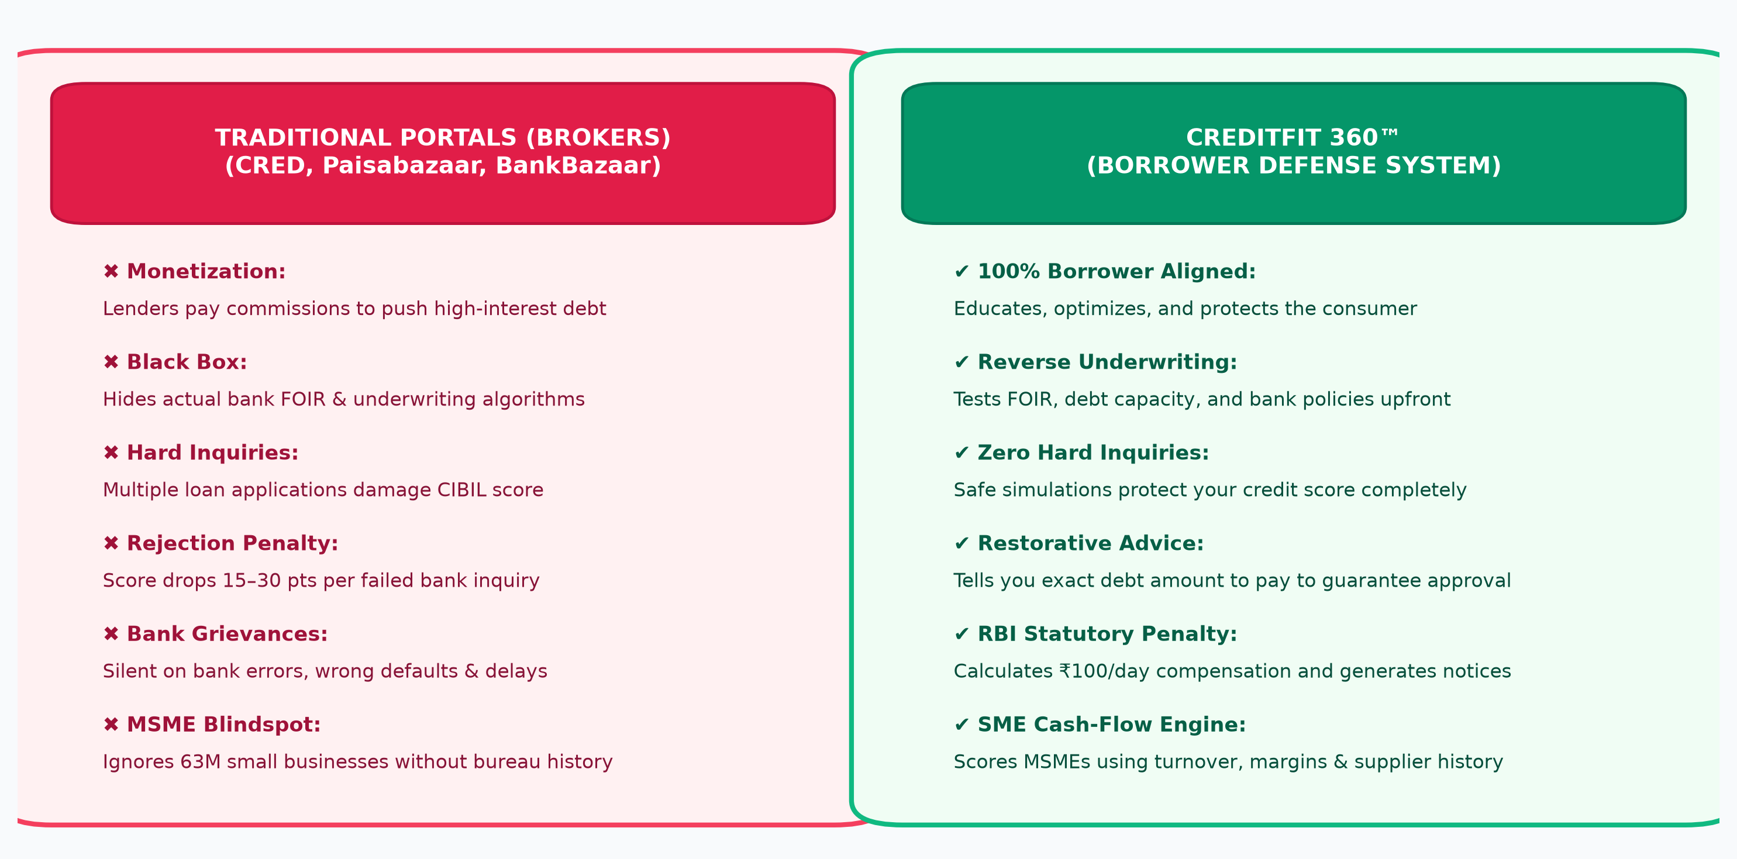
Figure: Paradigm Comparison: Legacy Loan Brokers vs. CreditFit 360 Borrower Defense Suite
📌 THE PARADIGM SHIFT: CreditFit 360 transforms credit from a passive, score-checking gimmick into an actionable, reverse-engineered financial defense system with statutory enforcement rights under the Reserve Bank of India.

The 4 Critical Market Inefficiencies Driving Unprecedented Demand:
• 1. The Credit Opacity Problem (68% Blind Rejections): Over 68% of Indian loan applicants who face rejection have no idea why. Banks do not evaluate credit score in a vacuum; they evaluate FOIR (Fixed Obligation to Income Ratio), credit mix, and inquiry velocity—metrics consumer apps never expose.

• 2. The 'Hard Inquiry' Spiral of Death: When a borrower faces rejection, they panic-apply to 3 or 4 other lenders in quick succession. Each application triggers a 'hard pull' on CIBIL/Experian, knocking 15–30 points off their score and locking them into subprime rates.

• 3. The Unenforced RBI ₹100/Day Statutory Penalty (99% Unclaimed): Under RBI Master Direction CEPC/2023-24, banks and credit bureaus must resolve credit report errors within 30 days. If they fail, they are legally obligated to pay ₹100 per day of delay. Over 99% of Indian citizens are unaware of this statutory right.

• 4. The $300B MSME Credit Gap: Over 63 million MSMEs face a $300B debt deficit because legacy bank underwriting looks for vintage bureau records rather than actual operating cash flow, GST returns, and supplier invoice regularities.

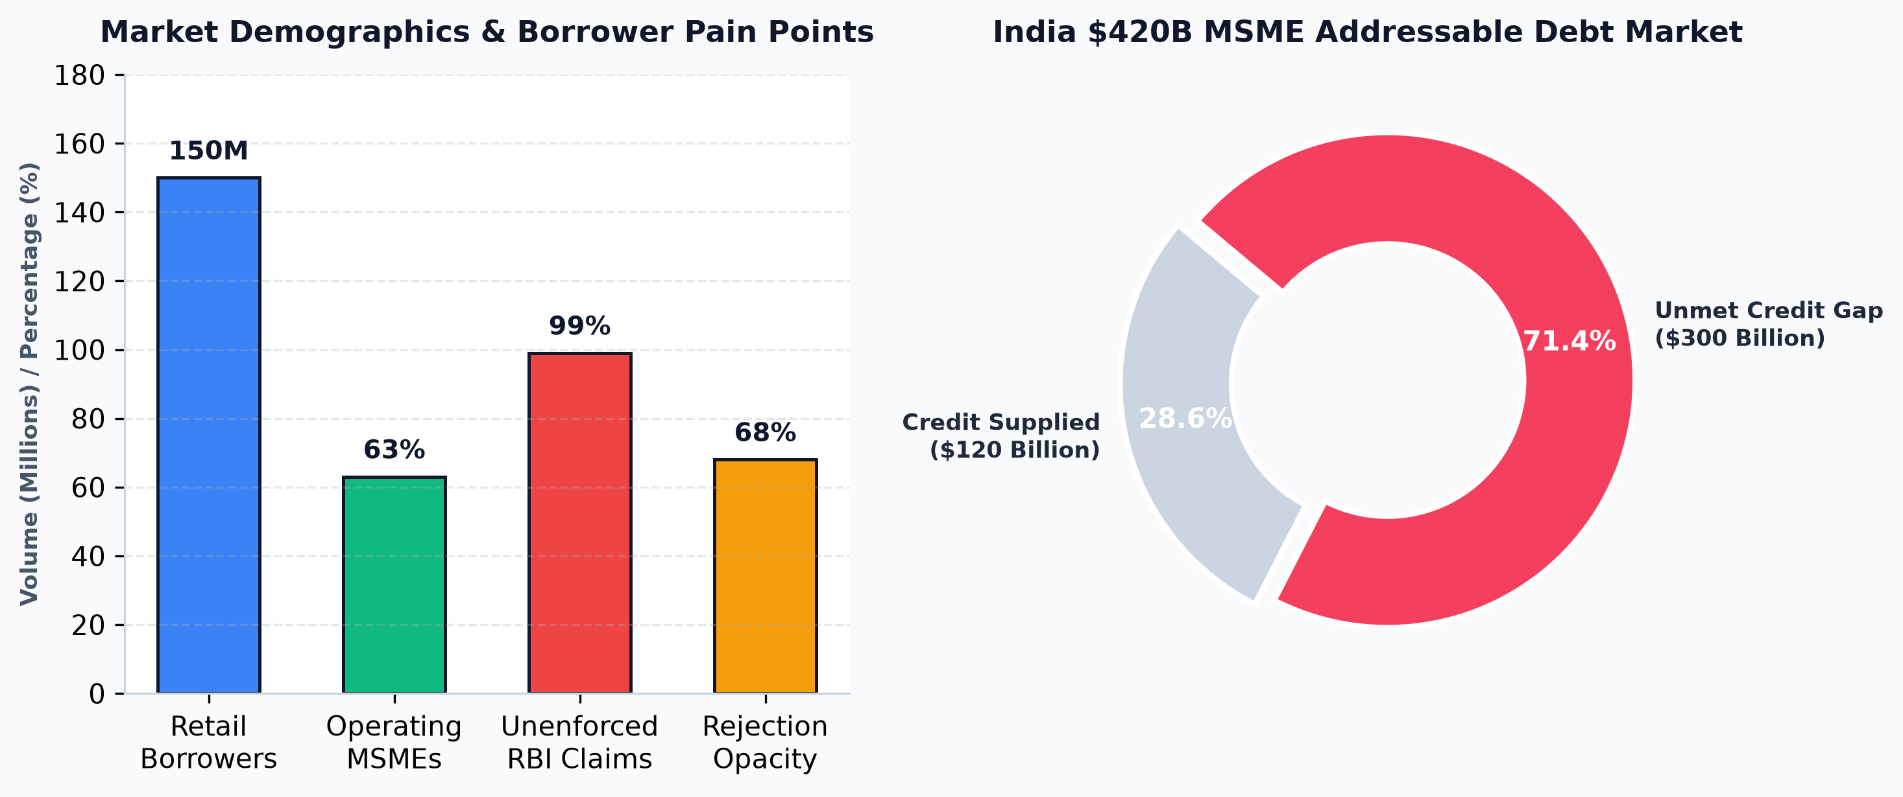
Figure: Empirical Market Opportunity: Retail Borrowers, MSME Gap ($300B), and Unenforced Rights
SECTION 02 — TARGET AUDIENCE & CUSTOMER SEGMENTATION MATRIX

CreditFit 360 solves distinct, urgent financial problems across a diverse, multi-billion-dollar audience spectrum:
Target Segment | Specific Persona | Why They Desperately Need CreditFit 360
1. Pre-Loan Retail Borrowers | Salaried professionals planning Home, Auto, or Personal Loans | Simulates approval odds beforehand with ZERO hard inquiries, locking in prime interest rates.
2. Loan Rejection Victims | Borrowers rejected by banks in the last 90 days | Diagnoses exact mathematical failure points (e.g. FOIR > 50%) and provides an actionable paydown roadmap.
3. Bank Error Dispute Victims | Borrowers with wrong defaults, phantom loans, or bureau delays | Computes statutory ₹100/day delay compensation and produces ready-to-dispatch legal grievance notices.
4. MSMEs & Sole Proprietors | Small business owners, retailers, and GST traders | Alternative multi-factor cash-flow credit scoring bypassing vintage balance-sheet constraints.
5. Loan DSAs & Agents | Direct Selling Agents and loan intermediaries | Generates verified institutional dossiers to pre-qualify leads and eliminate bank branch rejections.
6. CAs & Wealth Advisors | Chartered Accountants and financial consultants | Institutional A4 client dossiers and A/B scenario testing tools for professional debt advisory.

SECTION 03 — PLATFORM ARCHITECTURE & ENGINEERING DESIGN

CreditFit 360 is built using a resilient, decoupled web application stack designed for rapid local execution, fault tolerance, and enterprise data governance:
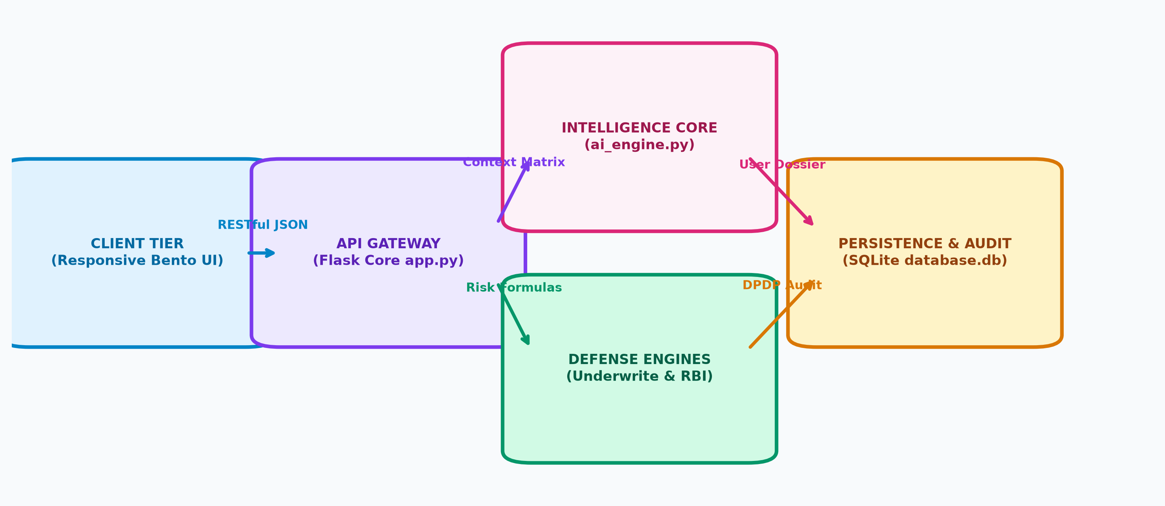
Figure: End-to-End Enterprise Platform Architecture & Secure Data Flow
• Application Server: Python 3.10+, Flask 3.1+ RESTful server with cryptographic session security.
• Persistence Engine: Zero-dependency, thread-safe SQLite database (database.db) managed via db.py.
• AI & Math Intelligence: ai_engine.py with proprietary reverse-underwriting matrices and legal dispute compilers.
• Frontend System: Neon-Bento glassmorphic CSS design system with @media print clean A4 PDF layouts.
• Dedicated Runner: server.py with automated port-collision resolution, LAN discovery, and auto-browser launch.

SECTION 04 — EXHAUSTIVE FUNCTION-BY-FUNCTION BREAKDOWN: WHY IT EXISTS & WHAT IT DOES

Every single feature in CreditFit 360 was engineered to solve a specific financial inefficiency. Below is the complete functional breakdown of all 15 modules:
MODULE 01: ENTERPRISE AUTHENTICATION & 1-CLICK DEMO PORTAL (/)
🎯 WHY IT IS NEEDED IN MARKET | Complex registration forms cause 60%+ drop-off. Evaluators and clients need instant access without creating throwaway email accounts.
⚡ WHAT IT ACTUALLY DOES | Secure tabbed authentication with a preloaded 1-Click Demo Login button populated with verified demo credentials.
🔬 UNDERLYING ENGINE / FORMULA | Werkzeug scrypt password hashing, session secret encryption, and instant session seeding (demo@creditfit360.com / Demo@123).
🏆 TANGIBLE OUTPUT / VALUE | Instant user session authentication, personalized dashboard greeting, and simulator access.

MODULE 02: FINANCIAL INTELLIGENCE COMMAND CENTER (/dashboard)
🎯 WHY IT IS NEEDED IN MARKET | Borrowers are paralyzed by disconnected numbers. They need a single executive dashboard prioritizing their debt risks.
⚡ WHAT IT ACTUALLY DOES | Displays dynamic 0–100 CreditFit Health Index, risk tiering (Prime/Near-Prime/Subprime), FOIR debt ratio, and active warning banners.
🔬 UNDERLYING ENGINE / FORMULA | Weighted index factoring FOIR debt burden (35%), credit utilization (25%), emergency runway (20%), and repayment track record (20%).
🏆 TANGIBLE OUTPUT / VALUE | Executive command center with real-time risk alerts (e.g. 'FOIR exceeds 45% ceiling', 'Emergency runway under 3 months').

MODULE 03: PERSONAL CREDITFIT ASSESSMENT WIZARD (/personal-credit)
🎯 WHY IT IS NEEDED IN MARKET | Standard bank loan forms are intimidating and complex. A guided 4-step wizard captures institutional metrics without cognitive overload.
⚡ WHAT IT ACTUALLY DOES | Step-by-step wizard capturing Basic Info, Monthly Living Cash Flows, Bureau Credit Limits, and Liquid Emergency Reserves.
🔬 UNDERLYING ENGINE / FORMULA | Calculates net disposable income, fixed debt obligations, credit utilization percentages, and emergency runway months.
🏆 TANGIBLE OUTPUT / VALUE | Comprehensive personal credit profile automatically synced into database.db.

MODULE 04: INDIA STACK ACCOUNT AGGREGATOR (AA) AUTO-FILL SANDBOX (/personal-credit (Modal))
🎯 WHY IT IS NEEDED IN MARKET | Manual data entry takes 10+ minutes and leads to typos and abandoned applications. Users demand instant automated bank data retrieval.
⚡ WHAT IT ACTUALLY DOES | Simulates RBI-regulated Account Aggregator (FIP/FIU) frameworks (HDFC, SBI, ICICI) to pull verified salary, debt, and balance data in 3 seconds.
🔬 UNDERLYING ENGINE / FORMULA | OTP simulation ('123456') validating user consent and auto-populating 18 form fields across all 4 stages of the wizard.
🏆 TANGIBLE OUTPUT / VALUE | Zero-friction 3-second auto-population of verified bank data demonstrating India Stack production readiness.

MODULE 05: SME CREDITSCORE MULTI-FACTOR ENGINE (/sme-credit-score)
🎯 WHY IT IS NEEDED IN MARKET | Over 63 million MSMEs lack audited balance sheets and get unfairly rejected by retail scoring algorithms.
⚡ WHAT IT ACTUALLY DOES | Dedicated alternative underwriting engine for small businesses and sole proprietorships evaluating non-bureau cash-flow data.
🔬 UNDERLYING ENGINE / FORMULA | Multi-dimensional scoring model analyzing operational vintage, profit margin consistency, vendor invoice discipline, and working capital buffers.
🏆 TANGIBLE OUTPUT / VALUE | SME Creditworthiness Score (0–100), operating stability rating, and recommended working capital limits.

MODULE 06: REVERSE UNDERWRITING SUITE (/defense-suite (Tab 1))
🎯 WHY IT IS NEEDED IN MARKET | Applying blindly for a loan damages credit scores through hard inquiries. Borrowers must test bank approval odds BEFORE applying.
⚡ WHAT IT ACTUALLY DOES | Stress-tests requested loan amount, proposed interest rate, and tenure against the applicant's existing debt-to-income limits.
🔬 UNDERLYING ENGINE / FORMULA | Evaluates resulting EMI against the standard 50% FOIR regulatory cap; models Tier-1 bank credit committee policies.
🏆 TANGIBLE OUTPUT / VALUE | Exact approval odds and specific restorative instructions (e.g. 'Pay off ₹45,000 in credit card debt to bring FOIR below 50%').

MODULE 07: RBI STATUTORY PENALTY ENFORCER & LEGAL NOTICE GENERATOR (/defense-suite (Tab 2))
🎯 WHY IT IS NEEDED IN MARKET | Banks and credit bureaus routinely delay resolving credit report disputes for months. 99% of consumers do not know they are entitled to ₹100/day compensation.
⚡ WHAT IT ACTUALLY DOES | Calculates mandatory statutory delay compensation under RBI Master Circular CEPC/2023-24 and generates a formal ready-to-dispatch legal grievance notice.
🔬 UNDERLYING ENGINE / FORMULA | Statutory calculation: Max(0, (Elapsed Days - 30) * ₹100/day); drafts legal notice citing Section 21 of the Credit Information Companies (Regulation) Act, 2005.
🏆 TANGIBLE OUTPUT / VALUE | Total accrued statutory claim in INR, ready-to-print legal grievance notice, and dispute persistence in database.db.

MODULE 08: INSTITUTIONAL LOAN READINESS DOSSIER & VERIFICATION ID (/dossier)
🎯 WHY IT IS NEEDED IN MARKET | Borrowers walking into banks without structured documentation get unfavorable interest rates or delayed processing. They need an official, verified financial summary.
⚡ WHAT IT ACTUALLY DOES | Executive financial dossier featuring a unique cryptographic verification ID (e.g. CF360-IND-202610-8921), max loan capacity, and bank pre-approval odds.
🔬 UNDERLYING ENGINE / FORMULA | Calculates maximum sanctionable loan under 50% FOIR ceiling over 60 months at prime interest rates.
🏆 TANGIBLE OUTPUT / VALUE | Institutional dossier suitable for presentation to bank loan managers and NBFC credit officers.

MODULE 09: 1-CLICK CLEAN A4 PDF EXPORT (/dossier (Print Action))
🎯 WHY IT IS NEEDED IN MARKET | Converting web pages into client-ready documents usually results in broken layouts, cut-off tables, and visible website buttons.
⚡ WHAT IT ACTUALLY DOES | High-fidelity, print-optimized A4 document rendering using dedicated @media print CSS rules.
🔬 UNDERLYING ENGINE / FORMULA | Automated CSS print engine that strips web navigation, buttons, and dark backgrounds, applying formal document typography and watermarks.
🏆 TANGIBLE OUTPUT / VALUE | Flawless, institutional A4 PDF ready for formal bank submission or digital sharing.

MODULE 10: FITAI FINANCIAL CO-PILOT (/assistant)
🎯 WHY IT IS NEEDED IN MARKET | Borrowers need instant, personalized answers to complex financial questions without paying expensive advisory fees.
⚡ WHAT IT ACTUALLY DOES | Natural language AI financial assistant that synchronizes with the user's active session data to deliver context-aware financial guidance.
🔬 UNDERLYING ENGINE / FORMULA | ai_engine.py contextual query engine with pre-programmed regulatory frameworks and prompt-chip accelerators.
🏆 TANGIBLE OUTPUT / VALUE | Conversational, tailored financial advice directly addressing the user's FOIR, credit score, and debt capacity.

MODULE 11: MONEYMAP CASH FLOW VISUALIZER (/moneymap)
🎯 WHY IT IS NEEDED IN MARKET | Most consumers do not understand where their monthly salary disappears, leading to accidental loan default risks.
⚡ WHAT IT ACTUALLY DOES | Visualizes monthly income flow across Fixed EMIs, Essential Living Expenses, Discretionary Costs, and Net Liquid Surplus.
🔬 UNDERLYING ENGINE / FORMULA | Cash-flow allocation engine categorizing monthly debits into structured financial health buckets.
🏆 TANGIBLE OUTPUT / VALUE | Clear visual breakdown highlighting overspending areas and liquid surplus available for loan repayment.

MODULE 12: FINANCIAL DECISION LAB (/decision-lab)
🎯 WHY IT IS NEEDED IN MARKET | Borrowers face difficult financial dilemmas (e.g., prepay home loan vs. invest in mutual funds) and have no mathematical tools to compare outcomes.
⚡ WHAT IT ACTUALLY DOES | A/B scenario testing engine that projects the 10-to-20-year net-wealth outcome of competing financial decisions.
🔬 UNDERLYING ENGINE / FORMULA | Compound interest and amortization calculation engine factoring inflation, interest savings, and investment returns.
🏆 TANGIBLE OUTPUT / VALUE | Side-by-side comparison tables and graphs showing total wealth difference between options.

MODULE 13: WHAT-IF FINTWIN 12-MONTH SIMULATOR (/what-if-simulator)
🎯 WHY IT IS NEEDED IN MARKET | Consumers hesitate to make financial moves because they cannot predict how it will affect their credit score.
⚡ WHAT IT ACTUALLY DOES | Interactive digital twin simulator with sliders allowing users to simulate debt paydowns, card closures, or new credit to forecast score trajectory.
🔬 UNDERLYING ENGINE / FORMULA | Dynamic credit score simulation model projecting monthly score changes over a 12-month horizon.
🏆 TANGIBLE OUTPUT / VALUE | Interactive score trajectory line chart showing projected score improvements based on simulated user actions.

MODULE 14: WEALTH PATH MILESTONE PLANNER (/wealth-path)
🎯 WHY IT IS NEEDED IN MARKET | Borrowers need a structured, inflation-adjusted plan to accumulate down payments for home or business asset purchases.
⚡ WHAT IT ACTUALLY DOES | Goal-based milestone planner that calculates required monthly SIP contributions to reach specific capital goals.
🔬 UNDERLYING ENGINE / FORMULA | Future-value capitalization formula with user-defined target date and expected annual rate of return.
🏆 TANGIBLE OUTPUT / VALUE | Clear milestone roadmap with recommended monthly savings targets and timeline projections.

MODULE 15: DPDP ACT 2023 PRIVACY & GOVERNANCE CENTER (/privacy-consent-center)
🎯 WHY IT IS NEEDED IN MARKET | Fintechs failing to comply with India's DPDP Act 2023 face statutory penalties up to ₹250 Crores. Users demand verifiable data control.
⚡ WHAT IT ACTUALLY DOES | Enterprise data governance center featuring Section 6 consent audit trails, Section 12 data portability, and Section 12 Right to Erasure.
🔬 UNDERLYING ENGINE / FORMULA | Immutable SQLite consent table, automated JSON data exporter, and irreversible user-record purge API.
🏆 TANGIBLE OUTPUT / VALUE | Verified consent audit log, downloadable JSON personal dossier, and verified 1-click complete data erasure.

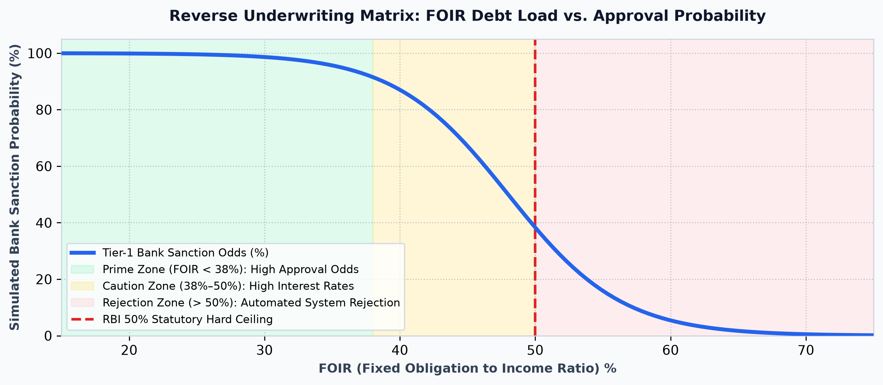
Figure: Reverse Underwriting Matrix: FOIR Sanction Probability Curves and Safe Ceilings
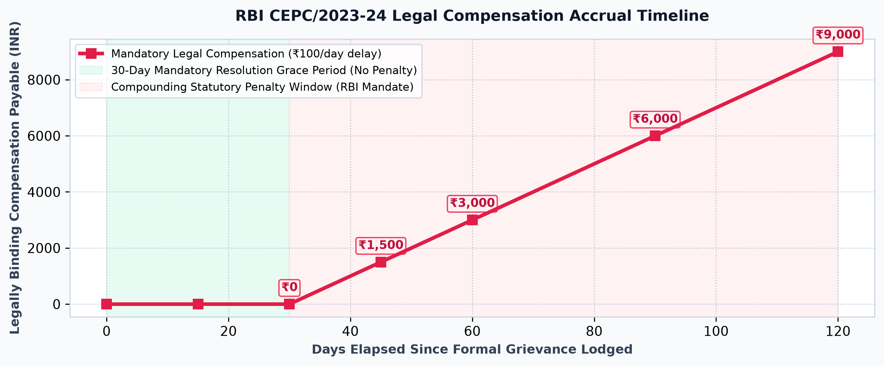
Figure: RBI Statutory Penalty Timeline: Compounding Delayed-Dispute Legal Claims (CEPC/2023-24)
SECTION 05 — STEP-BY-STEP 7-MINUTE LIVE CLIENT PRESENTATION SCRIPT

Follow this exact minute-by-minute script during your client pitch or investor demo to ensure a compelling, high-conversion presentation:
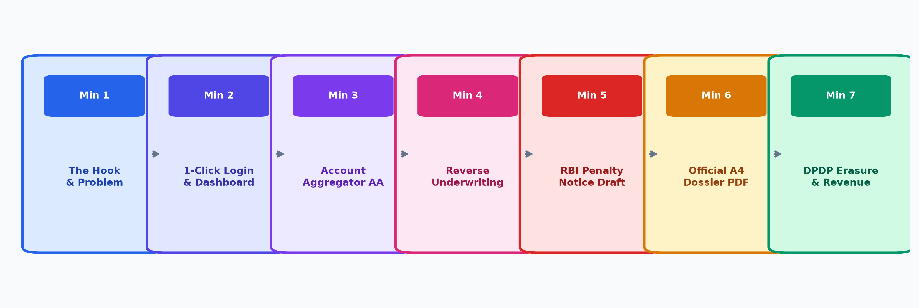
Figure: 7-Minute High-Impact Client Presentation Roadmap & Demonstration Stages
▶ MINUTE 1: THE HOOK & MARKET PROBLEM
💬 WHAT TO SAY: 'Good morning. In India today, over 150 million consumers and 60 million MSMEs interact with credit. But when they apply for a loan, they enter a total black box. Platforms like CRED or Paisabazaar are essentially loan distribution agents—they get paid when you borrow more. Nobody is in the borrower's corner. We created CreditFit 360 to be India's first Borrower Defense and Reverse-Underwriting Operating System.'
👉 LIVE DEMO ACTION: Open http://localhost:5000 in your browser; show the sleek landing page.

▶ MINUTE 2: 1-CLICK SIGN-IN & COMMAND DASHBOARD
💬 WHAT TO SAY: 'Let's enter the platform. We have built-in zero-friction access. With our 1-Click Demo Login, we instantly enter the Executive Dashboard. Rather than just showing a vanity 3-digit score, CreditFit 360 surfaces FOIR limits, emergency runway months, and predictive risk flags that bank credit managers actually evaluate.'
👉 LIVE DEMO ACTION: Click '⚡ 1-Click Demo Login'. Point to the dynamic Health Score gauge and active warning banners.

▶ MINUTE 3: ACCOUNT AGGREGATOR (AA) AUTO-FILL SANDBOX
💬 WHAT TO SAY: 'Normally, filling a 20-field financial form causes users to drop off. Watch this: we integrate with India's RBI Account Aggregator framework. The user chooses their bank, enters their mobile number, and confirms simulated OTP 123456. Instantly, our system securely pulls verified salary credits, existing EMIs, and liquid reserves, auto-filling all four stages of the underwriting engine in seconds.'
👉 LIVE DEMO ACTION: Navigate to 'Personal CreditFit' -> Click '🏦 Connect Bank via AA' -> Select Bank -> Click Send OTP -> Enter '123456' -> Click Verify & Auto-Fill.

▶ MINUTE 4: REVERSE UNDERWRITING ENGINE
💬 WHAT TO SAY: 'Here is where CreditFit 360 protects the consumer. Instead of submitting a loan application and triggering a score-damaging hard inquiry, our Reverse Underwriter stress-tests the applicant's profile against Tier-1 bank credit committee policies. If the FOIR is too high, it advises them on the exact amount of debt to pay off first to guarantee approval.'
👉 LIVE DEMO ACTION: Navigate to 'Defense & Approval' -> 'Reverse Underwriting'. Enter a loan amount (e.g. ₹25,00,000) and click 'Run Reverse Simulation'. Point to the odds and recommendations.

▶ MINUTE 5: RBI STATUTORY COMPENSATION ENFORCER
💬 WHAT TO SAY: 'This is our standout regulatory defense feature. Under RBI Circular CEPC/2023-24, banks must resolve credit report disputes within 30 days. If they fail, they owe the borrower ₹100 per day. Here, the borrower enters their dispute date, and CreditFit 360 computes the statutory penalty and produces a ready-to-dispatch legal notice under Section 21 of the CIC Act.'
👉 LIVE DEMO ACTION: Click the 'Statutory Defense & RBI Notice' tab. Enter a past date (e.g., 60 days ago) and click 'Calculate Statutory Penalty'. Show the legal letter and claim amount.

▶ MINUTE 6: OFFICIAL LOAN READINESS DOSSIER & CLEAN PDF EXPORT
💬 WHAT TO SAY: 'When a borrower is ready to apply, they don't walk into a bank empty-handed. CreditFit 360 generates this Institutional Loan Readiness Dossier, complete with verification ID, FOIR stress metrics, and bank approval probabilities. With a single click, it prints into a clean, professional A4 PDF.'
👉 LIVE DEMO ACTION: Click '📑 Export Dossier (PDF)' in the navigation bar. Show the formal A4 layout. Click 'Print / Save as PDF' to demonstrate clean export.

▶ MINUTE 7: DPDP ACT PRIVACY GOVERNANCE & BUSINESS SCALABILITY
💬 WHAT TO SAY: 'Finally, we take compliance seriously. Under India's Digital Personal Data Protection Act 2023, users can view their immutable consent audit trail, download their full data package, or execute the Right to Erasure to permanently purge their database records. As a business, CreditFit 360 monetizes via B2C subscriptions (₹399/yr), B2B SaaS licenses for CAs and Loan Agents (₹1,499/mo), and qualified lender referral payouts. Thank you.'
👉 LIVE DEMO ACTION: Navigate to '🛡️ DPDP Privacy Center'. Show the consent log and click 'Export My Personal Data (JSON)'. Conclude the presentation.

SECTION 06 — COMMERCIAL VIABILITY, REVENUE MODELS & BUSINESS SCALABILITY

CreditFit 360 features a diversified, highly lucrative revenue model spanning high-volume B2C subscriptions, recurring B2B professional SaaS, and high-ticket institutional lender referral fees:
Revenue Stream | Target Market | Pricing Model | Core Value Proposition
B2C Premium Defense | Retail Borrowers & Salaried Individuals | ₹399/year or ₹49/month | Auto-dispute letter generator, RBI statutory compensation tracker, unlimited What-If simulations.
B2B SaaS for CAs & DSAs | Direct Selling Agents, Loan Brokers, Accounting Firms | ₹1,499/month per license | Client loan readiness assessment dossiers, pre-qualification stress tests, rejection-prevention tools.
Pre-Underwritten Referral Marketplace | Tier-2 & Tier-3 NBFCs and Digital Lenders | 1.0% – 1.8% of loan sanction value | Routing pre-vetted applicants whose FOIR and credit profiles match exact lender underwriting criteria.

SECTION 07 — TOUGH CLIENT Q&A AND OBJECTION DEFENSE GUIDE

Q1: How does CreditFit 360 differ from CRED or Paisabazaar?
Answer: CRED and Paisabazaar are essentially credit distribution marketplaces. They monetize through lender affiliate commissions—they get paid when a user borrows more money. As a result, they cannot act as a neutral advocate for the borrower. CreditFit 360 is borrower-aligned: it helps users reduce debt obligations, reverse-underwrite loan readiness without hard inquiries, and enforce statutory penalty claims against non-compliant banks.
Q2: Is CreditFit 360 an authorized credit bureau like CIBIL?
Answer: No, and that is our explicit competitive advantage. Credit bureaus are historical data repositories that record past repayment behavior. CreditFit 360 is an analytical decision-support and defense platform. We ingest bureau data and bank statements via the Account Aggregator framework to evaluate real debt capacity and simulate institutional underwriting criteria.
Q3: What happens if a bank ignores the RBI statutory penalty notice?
Answer: The ₹100 per day penalty is not an informal request; it is legally binding under RBI Master Direction CEPC/2023-24. If a lender fails to remediate the credit error or pay compensation within 30 days of the notice generated by CreditFit 360, the borrower escalates the complaint to the RBI Banking Ombudsman (CMS Portal). Lenders face formal regulatory penalties and audit citations for unresolved ombudsman complaints.
Q4: How does CreditFit 360 comply with India's new data privacy laws?
Answer: CreditFit 360 was built specifically around the Digital Personal Data Protection (DPDP) Act 2023. We maintain an immutable Section 6 consent audit log recording every data access event with timestamps and IP addresses. We fulfill Section 12 Data Portability with instant JSON data exports, and enable users to execute the Right to Erasure, which permanently and irreversibly purges all personal records from our database.
SECTION 08 — PRODUCTION LOCAL SERVER OPERATIONS MANUAL

• One-Click Launch (Windows Explorer): Double-click 'run_server.bat' or 'start_localhost.bat' in the project folder. The script automatically verifies Python in PATH, installs dependencies, starts the server, and opens your default browser.
• Terminal Command Launch: Run 'python server.py' from PowerShell or Command Prompt. Optional flags include '--port 8080' (custom port) or '--no-browser' (headless mode).
• Automatic Port Collision Protection: If port 5000 is occupied by another application, server.py automatically detects the conflict and binds to the next available port (e.g. 5001) without crashing.
• LAN / Mobile Phone Testing: server.py automatically identifies your machine's local Wi-Fi IP address (e.g., http://192.168.1.4:5000), allowing seamless multi-device testing from a smartphone on the same network.

