1. First clear all data using below url

<https://3598y3s21l.execute-api.us-east-1.amazonaws.com/api/cleardata>

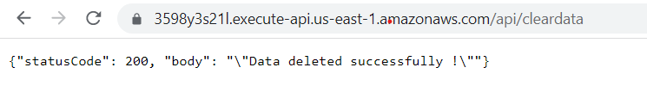

1. Hit following GET call to verify that all data is cleared

<https://3598y3s21l.execute-api.us-east-1.amazonaws.com/api/taxi>

<https://3598y3s21l.execute-api.us-east-1.amazonaws.com/api/customer>

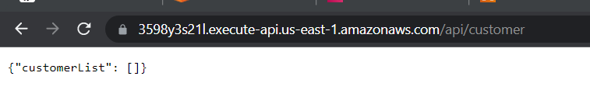

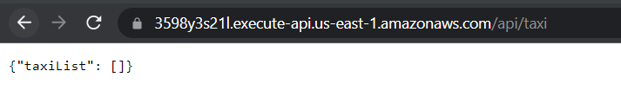

1. Run main.py to simulate 5 Customer and 50 Taxi registration

Local testing logs are attached with name “**latlong_updater_local_testing_logs.txt**”

**Based on our mentor’s advice we did not deploy client code on AWS EC2 instance and have chosen to run locally**

1. Hit following GET call again to verify that data is inserted

<https://3598y3s21l.execute-api.us-east-1.amazonaws.com/api/taxi>

<https://3598y3s21l.execute-api.us-east-1.amazonaws.com/api/customer>

1. **Single Taxi registration**. Use postman app to hit following

URI : <https://3598y3s21l.execute-api.us-east-1.amazonaws.com/api/taxi>

Request body : [{

"name": "SingleTaxi",

"location": {

"type": "Point",

"coordinates": [12.9099 , 77.7664]

},

"timestamp":"2022-05-30T16:08:09.957770",

"email":"smita.garg2022@gmail.com",

"hired":"N",

"type":"Luxury"

}]

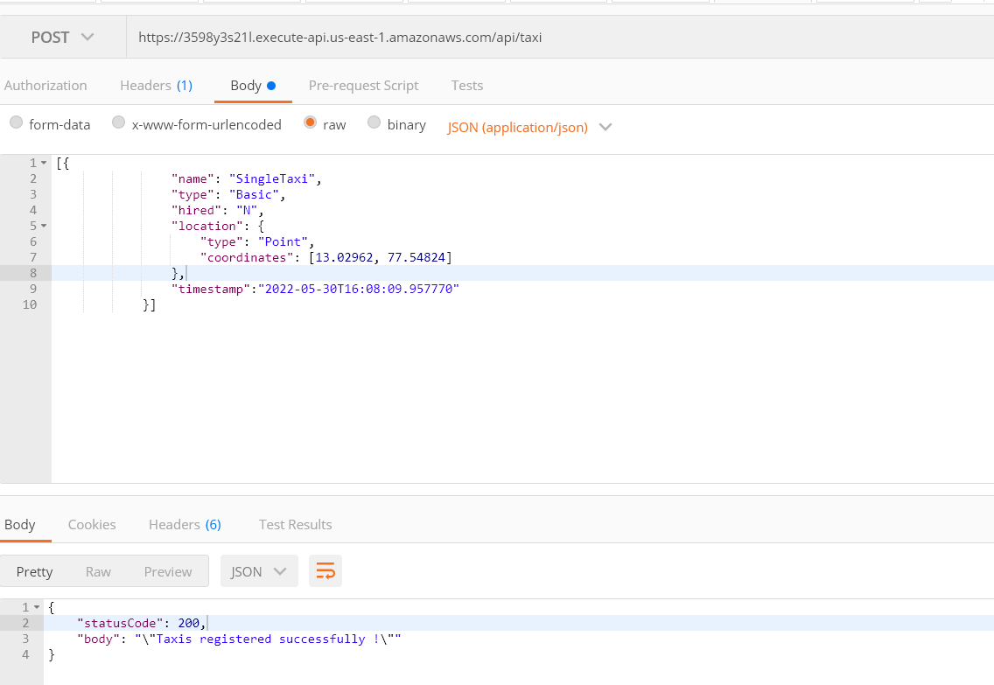

1. **Single Customer registration**. Use postman app to hit following

URI : https://3598y3s21l.execute-api.us-east-1.amazonaws.com/api/customer

**Request body :**  [{

"name": "SingleCustomer",

"location": {

"type": "Point",

"coordinates": [12.9099 , 77.7664]

},

"timestamp":"2022-05-30T16:08:09.957770",

"email":"smita.garg2022@gmail.com"

}]

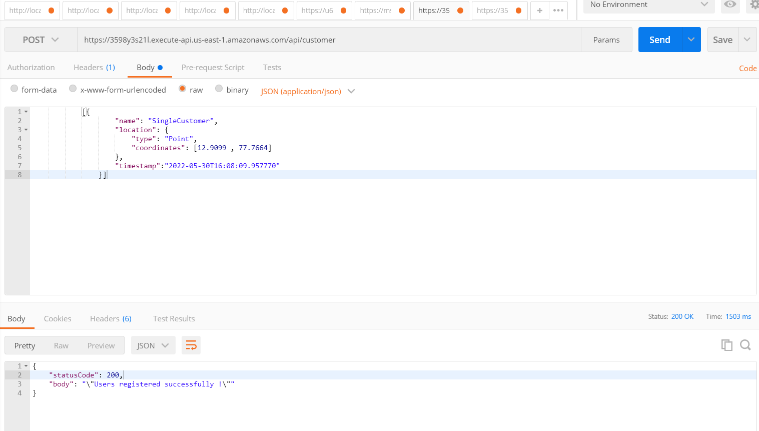

Hit following GET call again to verify that data is inserted

<https://3598y3s21l.execute-api.us-east-1.amazonaws.com/api/taxi>

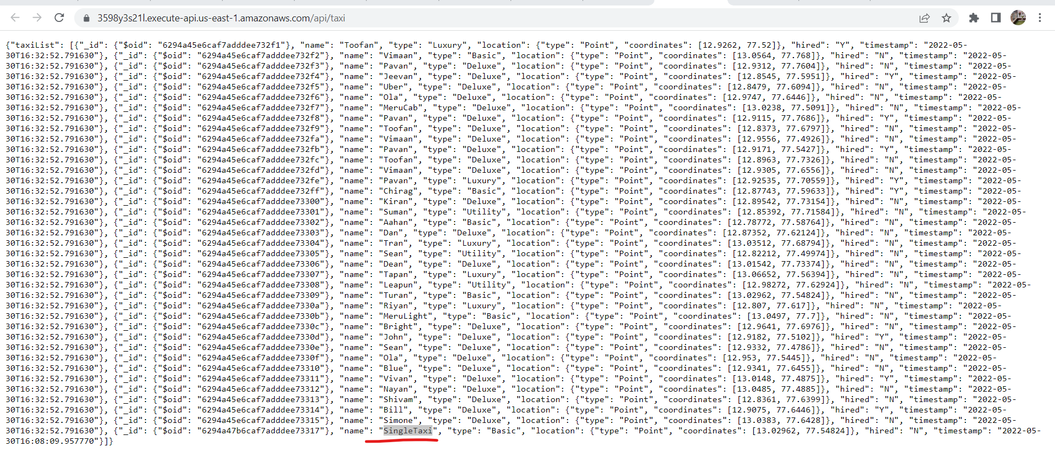

<https://3598y3s21l.execute-api.us-east-1.amazonaws.com/api/customer>

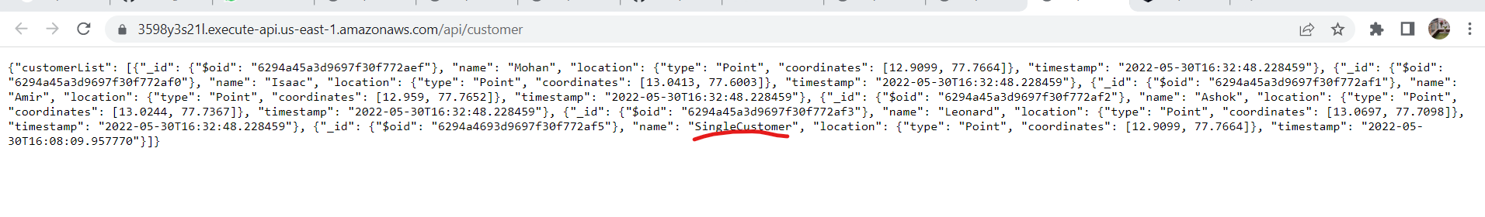

1. Run **main2.py** to start Lat/long update simulation per minute

This also shows how initial boundary creation happens.

Local testing logs are attached with name “**latlong_updater_local_testing_logs**.**txt**”

Keep hitting GET apis every 60 secs to notice change in lat/long and timestamp changes

1. Please hit following to visualise taxi and customer locations on UI

URL: <https://taxiaggregator.s3.amazonaws.com/index.html>

* Chart displays the location of customers vs taxis
* Chart refreshes every 30 secs
* User can manually refresh by clicking on refresh button  
  Below the chart we display the Taxi list and customer list (loads only once, no refresh)

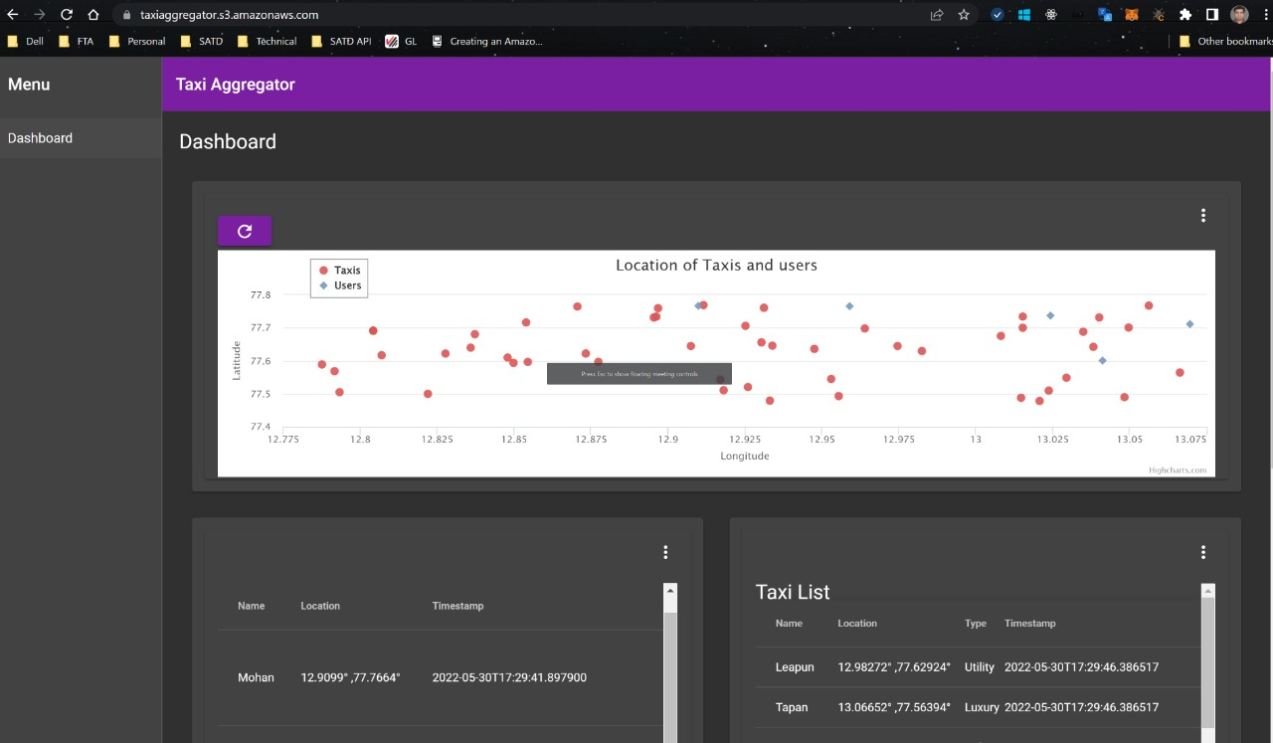

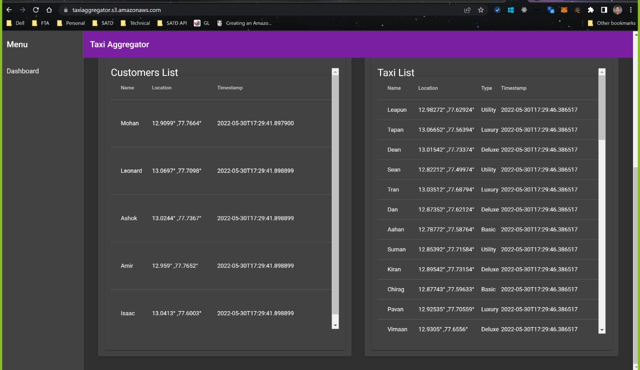

1. <https://3598y3s21l.execute-api.us-east-1.amazonaws.com/api/bookingdetails>
2. **Book taxi**: Hit following urls to book a taxi

Take any user_id from here

<https://3598y3s21l.execute-api.us-east-1.amazonaws.com/api/customer>

and hit following

<https://3598y3s21l.execute-api.us-east-1.amazonaws.com/api/booktaxi?userid=62a0b257e6a7360da3fc44e2>&type=ALL

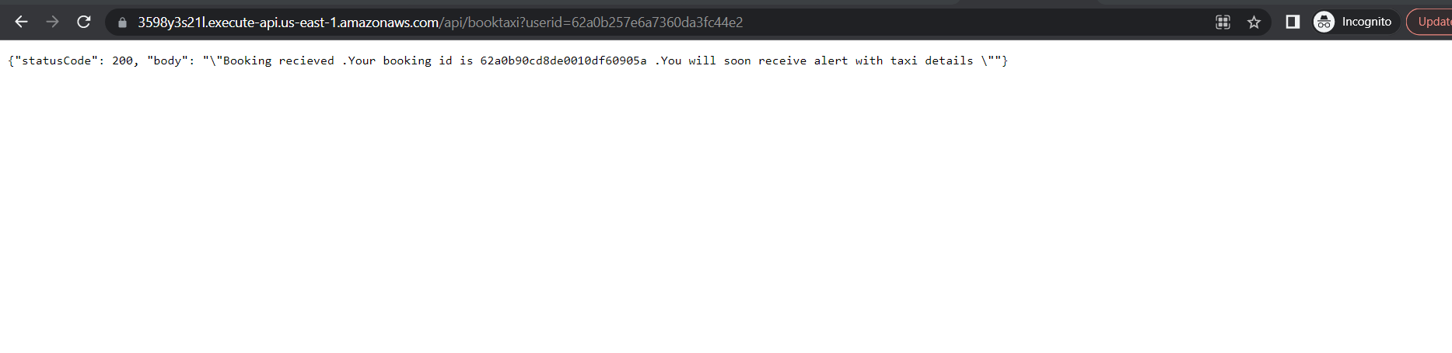

If no taxis found

<https://3598y3s21l.execute-api.us-east-1.amazonaws.com/api/booktaxi?userid=62a3712a4f92cbbbc142d8ba&type=Luxury>

{"statusCode": 200, "body": "\"No taxis found in your area\""}

Check booking details for above user

<https://3598y3s21l.execute-api.us-east-1.amazonaws.com/api/bookingdetails>

Received mail

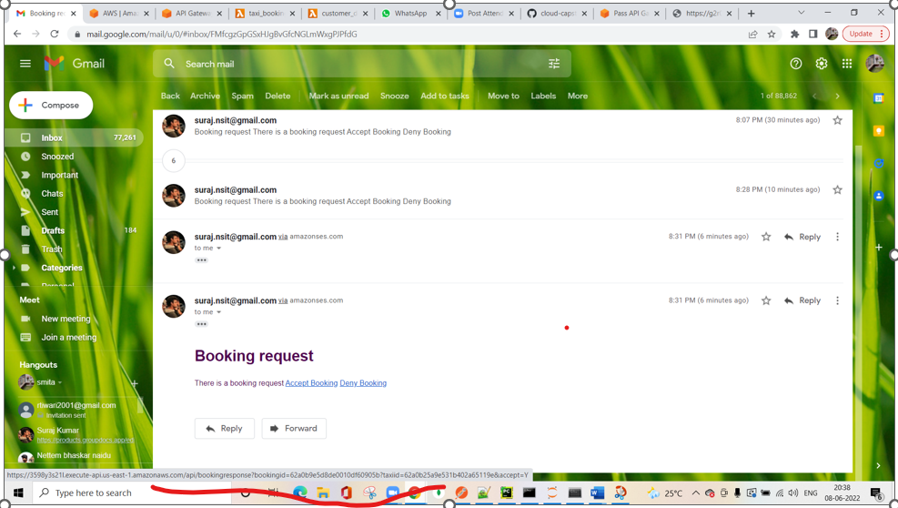

Accept link : <https://3598y3s21l.execute-api.us-east-1.amazonaws.com/api/bookingresponse?bookingid=62a0b9e5d8de0010df60905b&taxiid=62a0b25a9e531b402a65119e&accept=Y>

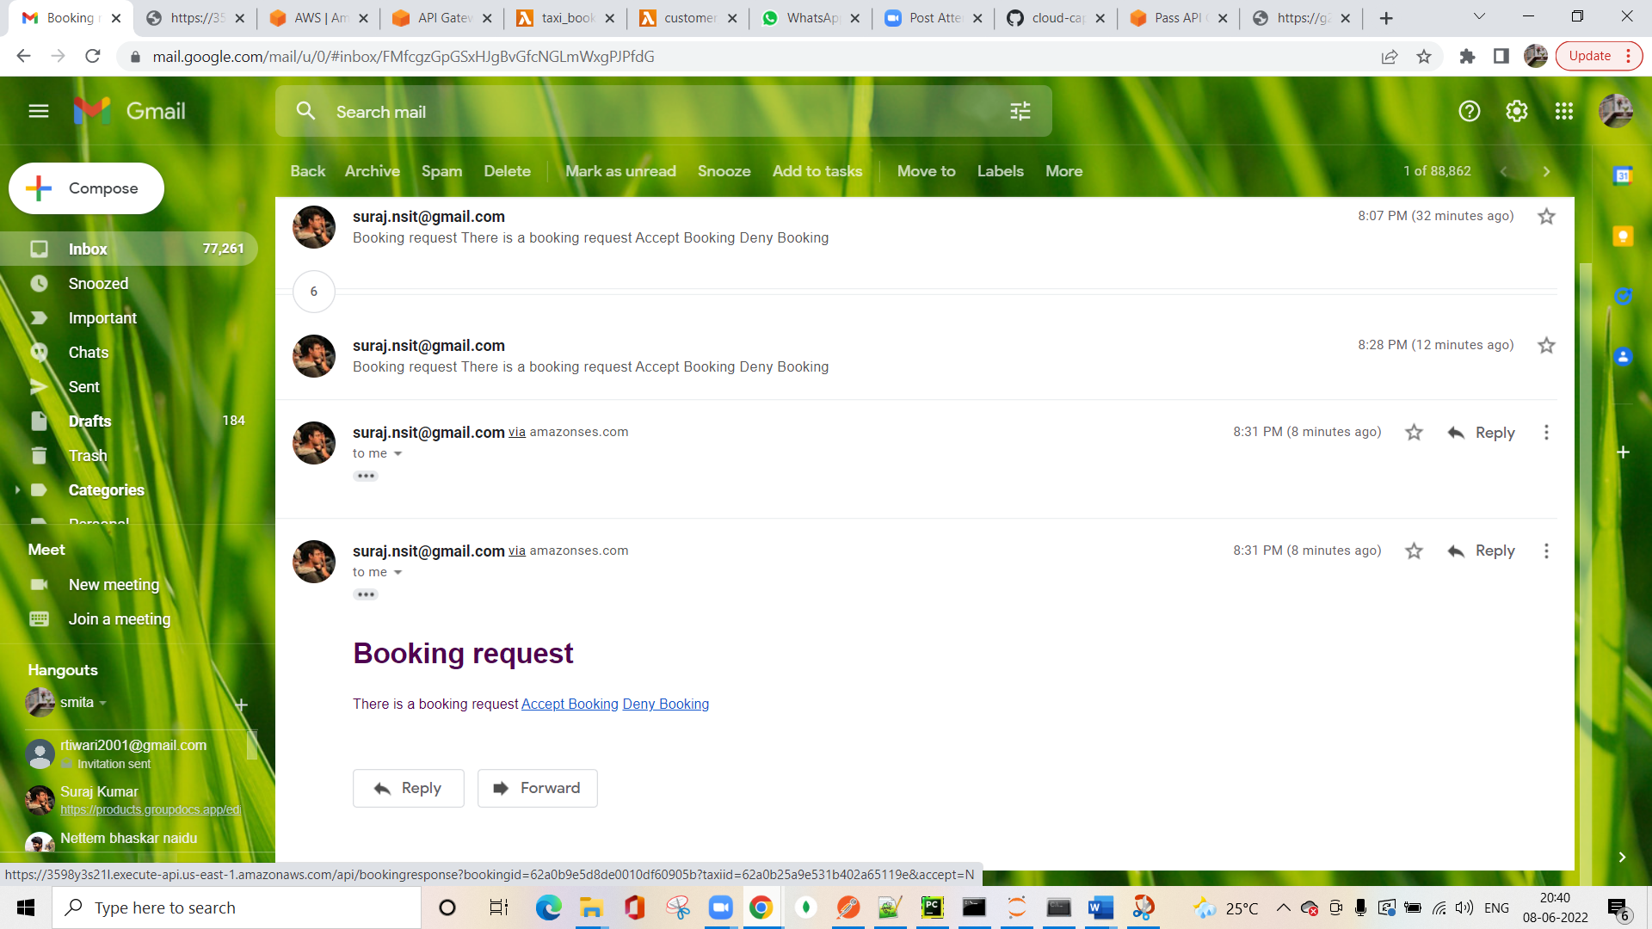

Deny Link :

<https://3598y3s21l.execute-api.us-east-1.amazonaws.com/api/bookingresponse?bookingid=62a0b9e5d8de0010df60905b?taxiid=62a0b25a9e531b402a65119e&accept=N>

{"msg": "you have accepted the booking .Customer has been notified ."}

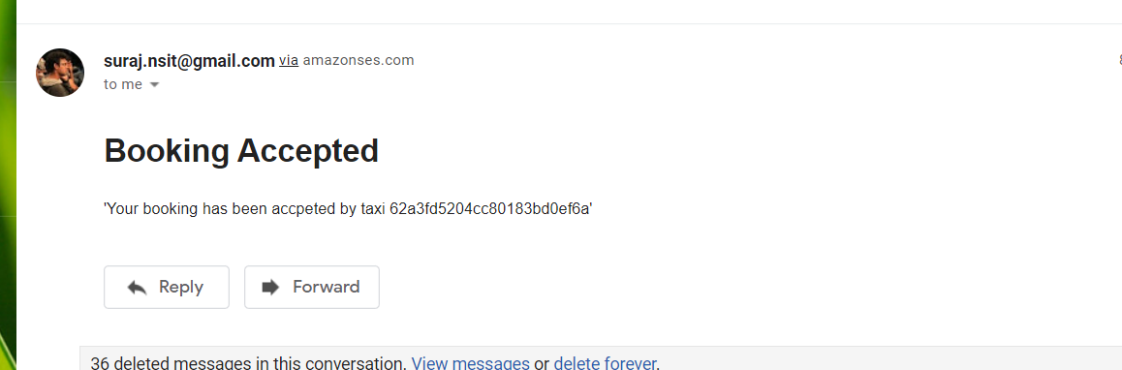

If trip already accepted by other taxi

{"msg": "Trip accepted by other driver"}

add trip testing