**Anti-lock braking system**

**Introduction:**

Anti-lock braking system (ABS) prevents the wheels from locking up and helps them maintain grip with the road below.

**How does it work?**

ABS is part of an overall stability system, commonly known as electronic stability control, which monitors wheels’ under heavy braking. Each wheel has a sensor attached to it.

If the intelligent sensors detect that a wheel is about to lock up and stop moving, the system will release the brake. The release is only for a moment.

ABS then continuously and repeatedly applies optimum braking pressure to each wheel, meaning the system will brake just enough to not lock the wheels.

When ABS is active you may feel pulsation through the brake pedal as you’re pressing it. The anti-lock system helps the driver remain in control of the vehicle rather than bringing the car to a stop.

It reduces the risk of skidding even when undertaking excessive evasive maneuvers. This is why it’s important to remember that the car’s braking distance may increase.

So, if you keep driving ahead straight into an obstacle, the car may not stop in time even if your instincts dictate otherwise. It’s a common misconception that ABS helps reducing stopping distance.

**Analysis and Physics**

The wheel rotates with an initial angular speed that corresponds to the vehicle speed before the brakes are applied. We used separate integrators to compute wheel angular speed and vehicle speed. We use two speeds to calculate slip, which is determined by Equation 1. Note that we introduce vehicle speed expressed as an angular velocity.

$$\omega_v = \frac{V}{R} \mbox{ (equals the wheel angular speed if there is no slip)}$$

Equation 1

$$ \omega_v = \frac{V_v}{R_r}$$

$$slip=1-\frac{\omega_w}{\omega_v}$$

$$\omega_v = \mbox{ vehicle speed divided by wheel radius}$$

$$ V_v = \mbox{ vehicle linear velocity}$$

$$ R_r = \mbox{ wheel radius}$$

$$ \omega_w = \mbox{ wheel angular velocity}$$

From these expressions,

We see that slip is zero when wheel speed and vehicle speed are equal, and slip equals one when the wheel is locked.

A desirable slip value is 0.2, which means that the number of wheel revolutions equals 0.8 times the number of revolutions under non-braking conditions with the same vehicle velocity. This maximizes the adhesion between the tire and road and minimizes the stopping distance with the available friction.

### Modeling

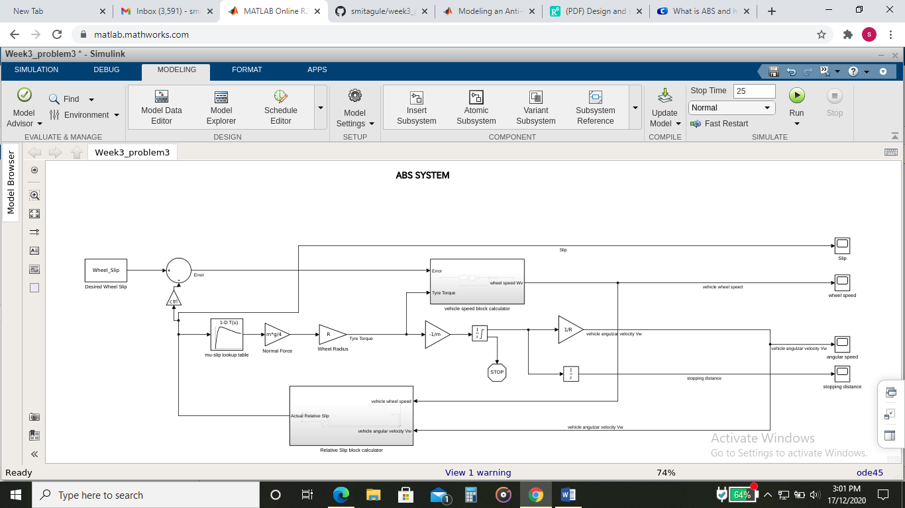

**Subsystem of vehicle speed block calculator**

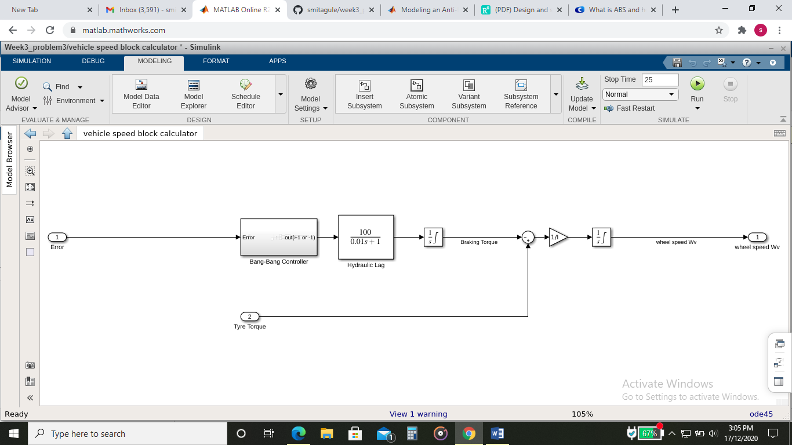

**Subsystem of Relative slip block calculator**

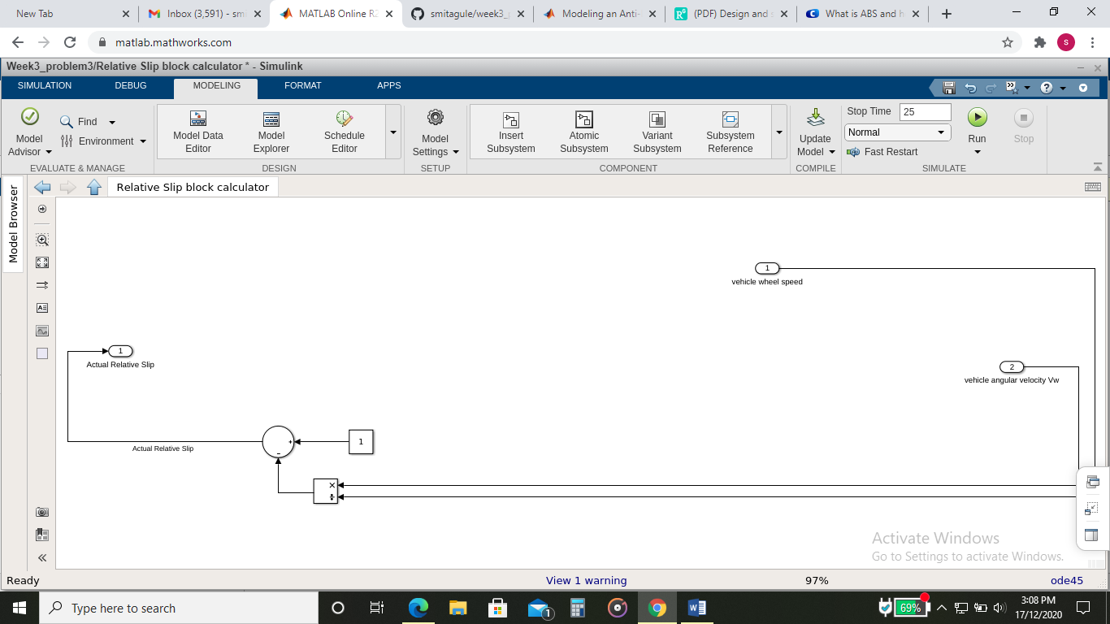

**Solver selection strategy**

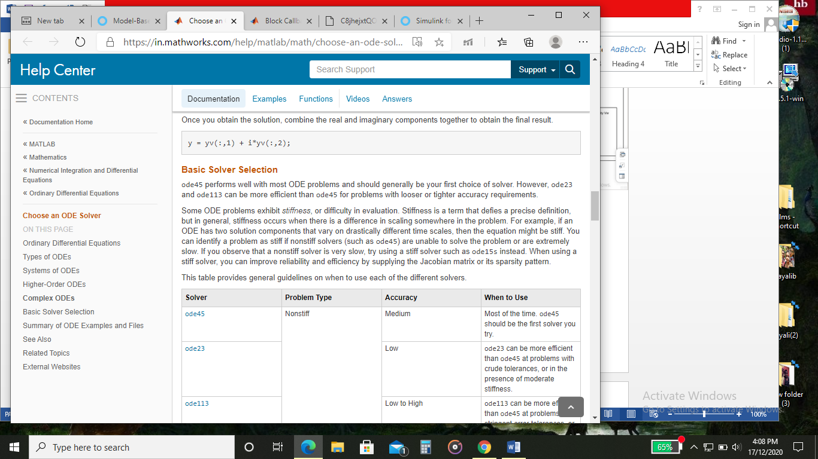

So we choose ode45 for this model.

**Callback**

### 

### TEST CONDITIONS:

### Running the Simulation in ABS Mode

### Vehicle speed and wheel speed

### 

### Slip

### The first plot shows the wheel angular velocity and corresponding vehicle angular velocity. This plot shows that the wheel speed stays below vehicle speed without locking up, with vehicle speed going to zero in less than 16 seconds.

### Running the Simulation without ABS

Consider the vehicle behavior without ABS. Set the model gain at error = 0. This disconnects the slip feedback from the controller, resulting in maximum braking.

Gain = 0; (controller output=0)

### Vehicle speed and wheel speed

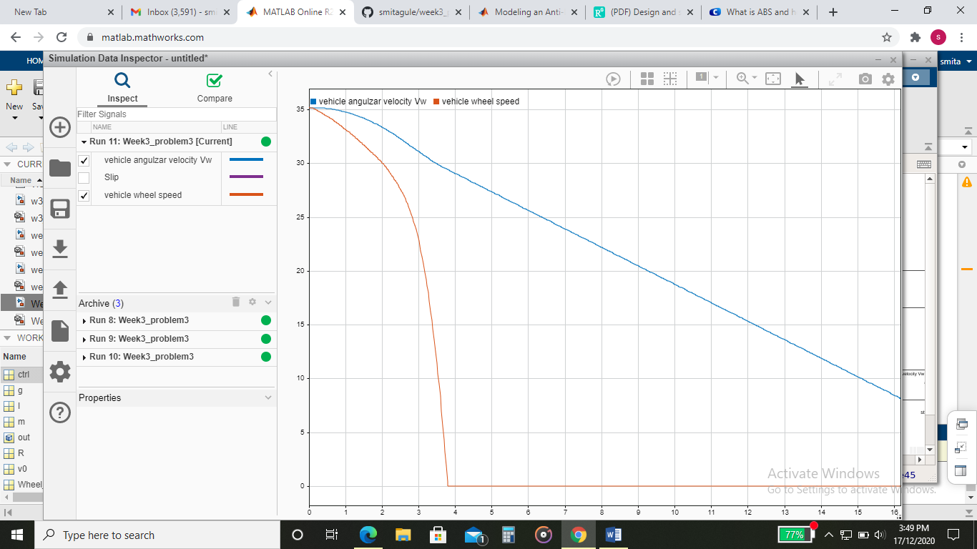

### Slip

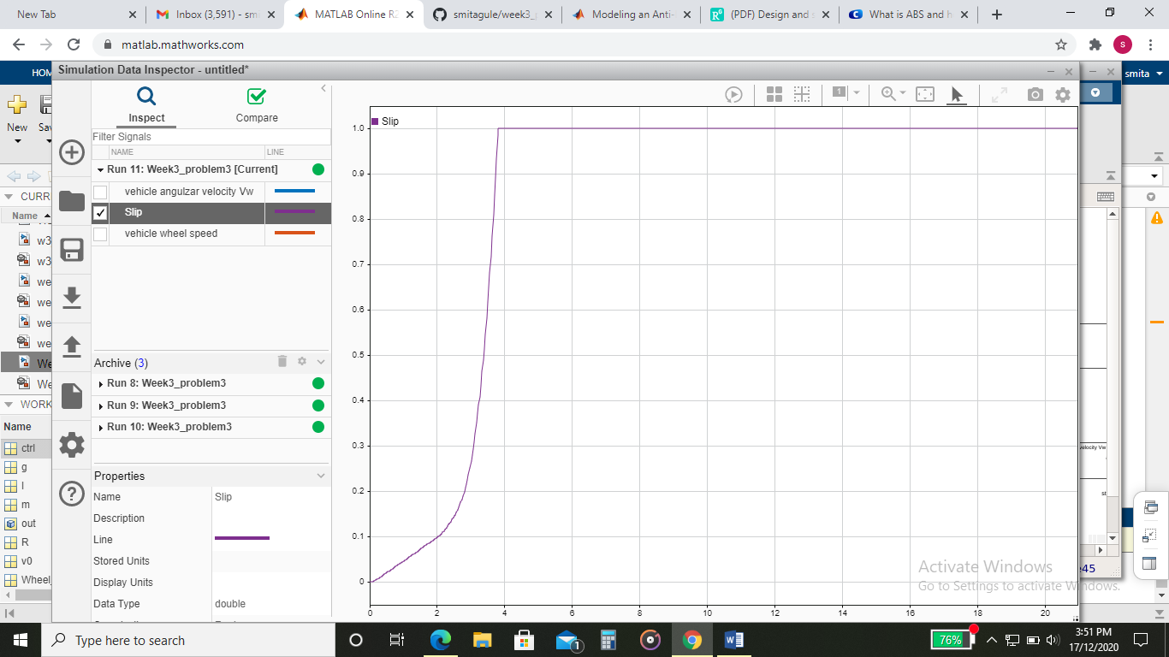

### Braking With ABS versus Braking Without ABS

In the plot showing vehicle speed and wheel speed, observe that the wheel locks up in about 16 seconds. The braking, from that point on, is applied in a less-than-optimal part of the slip curve. That is, when slip = 1, as the slip plot shows, the tire is skidding so much on the pavement that the friction force has dropped off.

This is, perhaps, more meaningful in terms of the comparison shown below. The distance traveled by the vehicle is plotted for the two cases. Without ABS, the vehicle skids about an extra 100 feet, taking about three seconds longer to come to a stop.

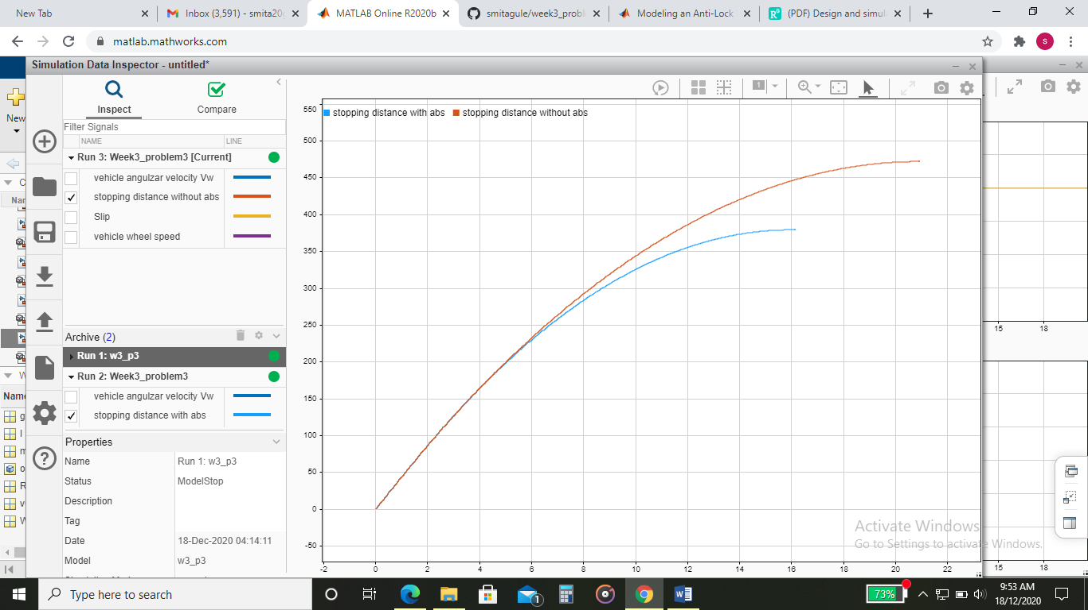

Test conditions as we change slip:

1. Slip=0.3

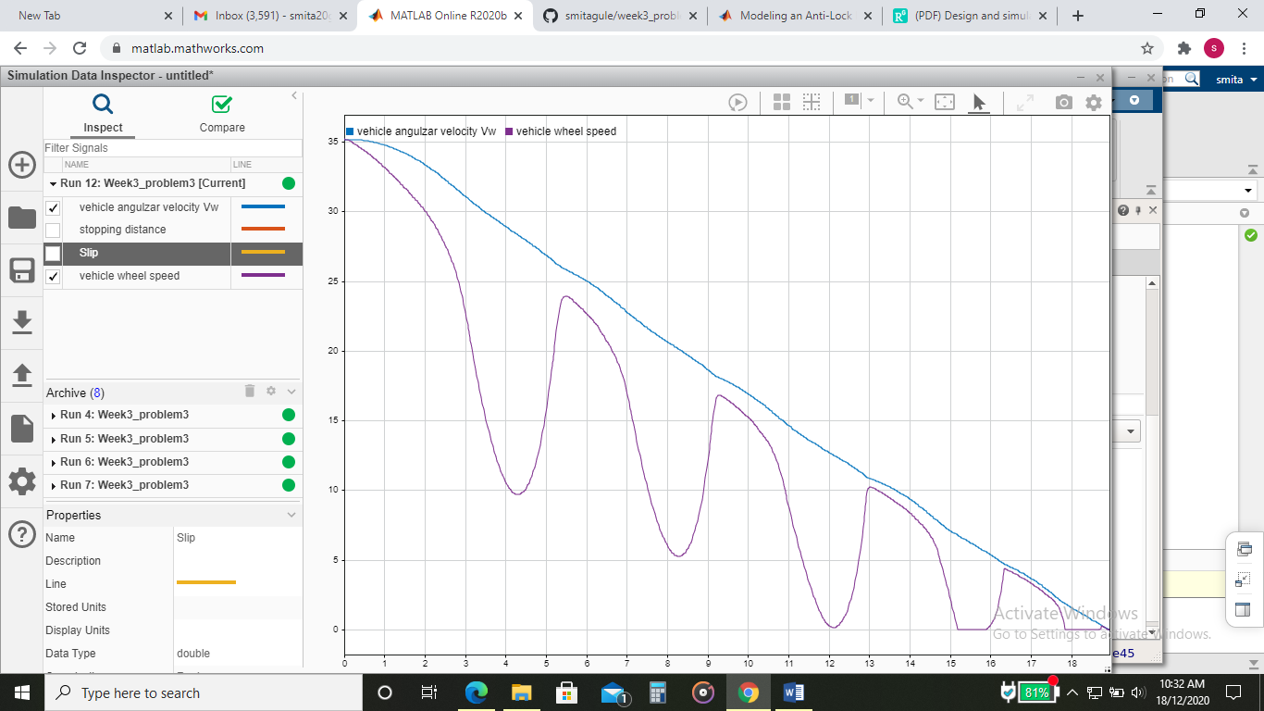

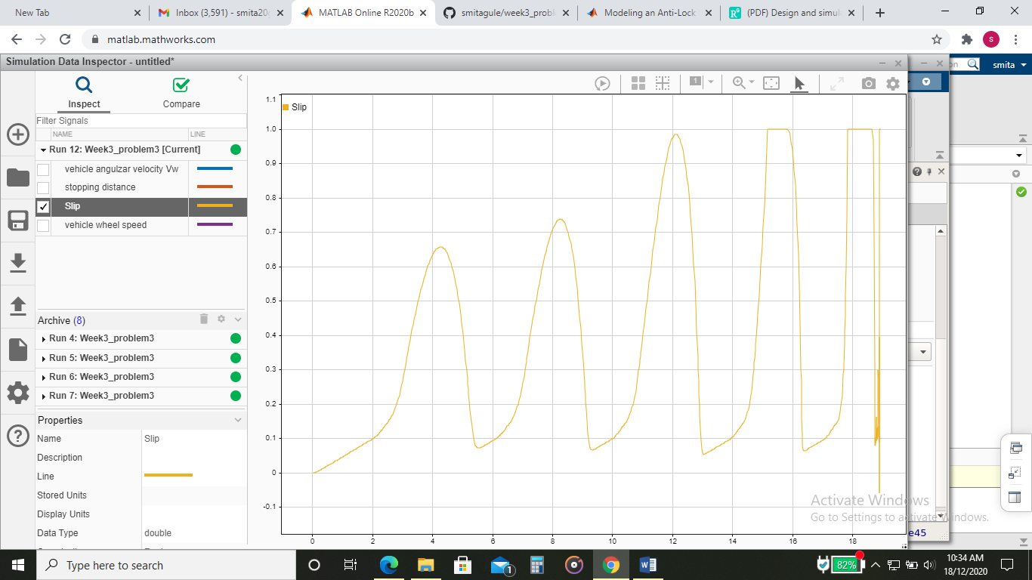

1. Slip=0.4

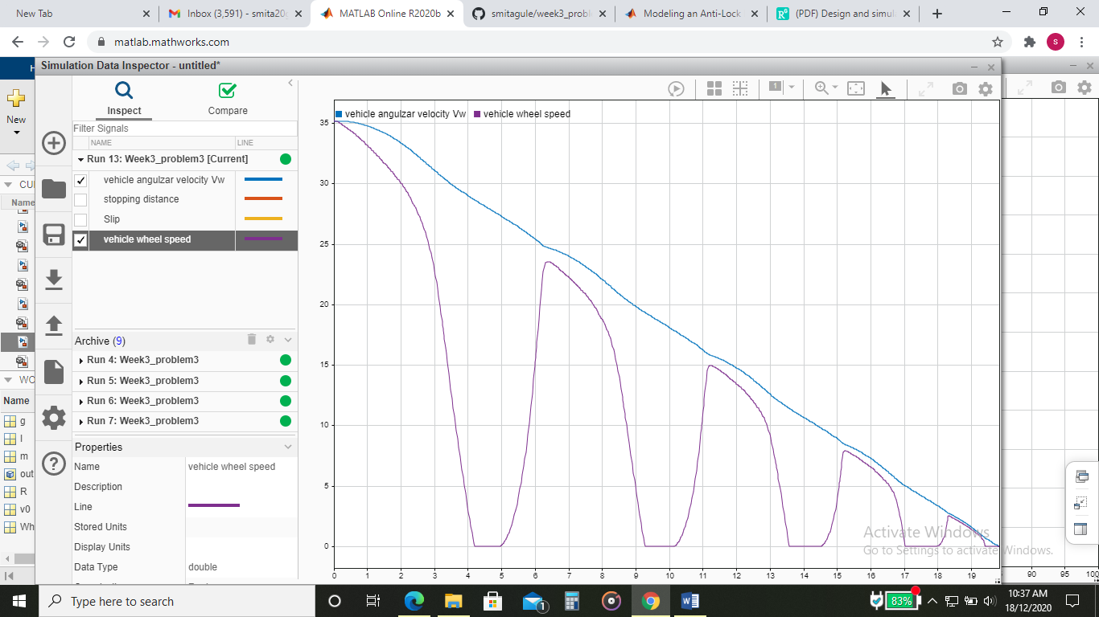

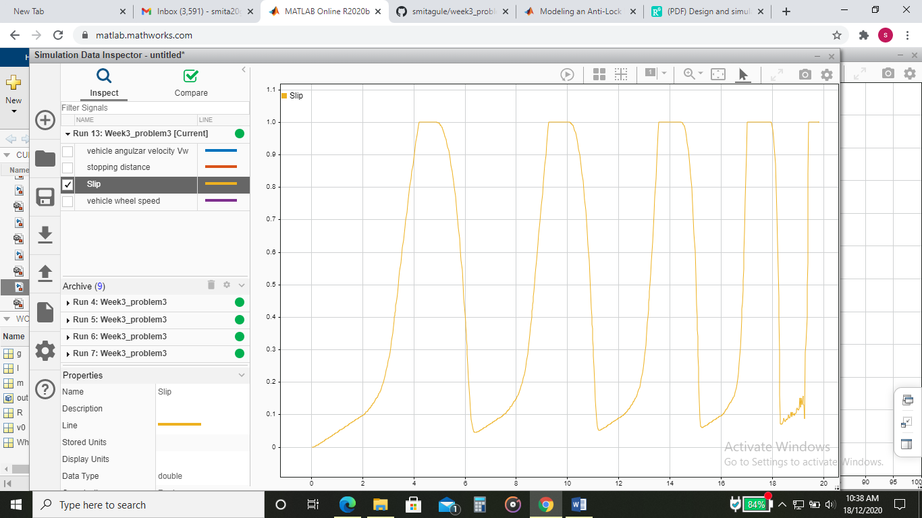

Stopping distance when slip=0.2 vs. stopping distance when slip=0.3 vs. Stopping distance when slip=0.4

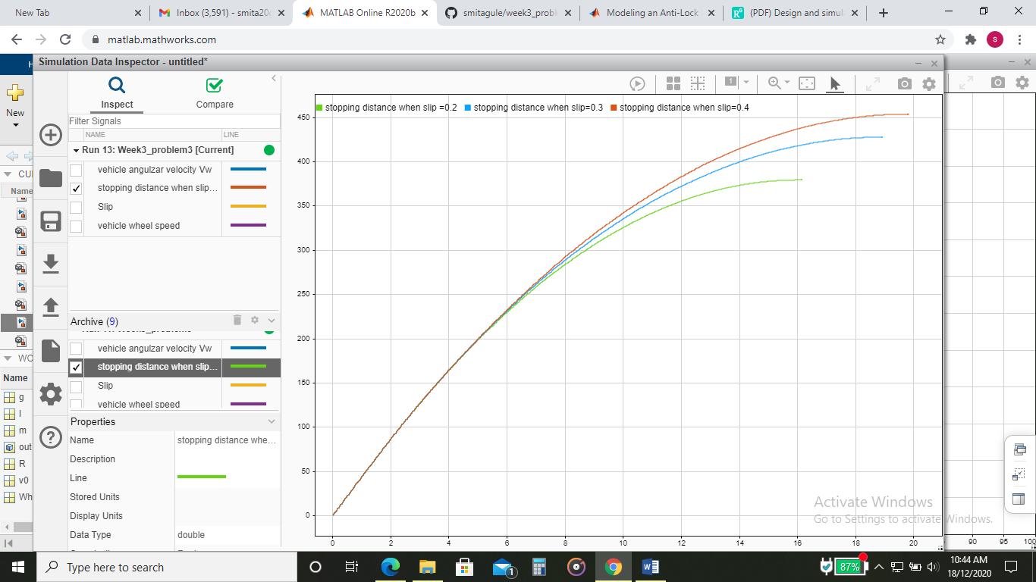

**Conclusion:**

The performance of vehicle braking with and without Bang-Bang controller was compared and analyzed. Braking with Bang-Bang Controls the wheel speed and the vehicle speed sets down at the same time and the slip distance, speed and relative slip of the vehicle is found.

The simulation results conclude that the Bang-Bang Controller has better braking performance as the wheel speed and the vehicle speed is controlled at the same time which avoids the vehicle skidding during the panic braking.