Quantil Log-monitoring System

* **To generate the logs**

Command is --- > ***sh generate.sh DATA_PATH***

Eg. sh generate.sh C:/Users/smitahirve/Desktop/Test

Where Test is the name of the folder where the log file will be generated.

* To query the generated logs

Command is ----> ***sh query.sh DATA_PATH***

Eg. sh query.sh C:/Users/smitahirve/Desktop/Test

* **SAMPLE_QUERY:**

QUERY 192.168.1.10 1 2016-05-28 00:10 2016-05-28 08:00

* To query for the logs of the IP address 192.168.1.10 cpu_id is 1 for the time interval mentioned

**Code Walk Through:**

**PROJECT 1: SIMULATOR [ It is used to generate the log file]**

FILE_NAME: Simulator.java

IP addresses

For which the logs will be generated will be:

192.168.0.0 to 192.168.3.231 with CPU id 1 and 0 which are randomly generated

Time generated:

The logs are generated for one day with an increment of 10 second. So there are around 19,000 log entries generated per day.

CPU Usage:

A number is randomly generated from 0 to 100 to denote the CPU usage

**PROJECT 2: Query_tool [ To query the log file to get the desired output]**

FILE1: logData.java

* This file creates a log object which represents one row of the log document where the IP address and CPU Id, CPU usage, time stamp are stored as one object.

FILE 2: mainQuery.java

* The values of the log file are read and the results are stored in a Hashmap where the IP address and CPU id form the key and the logData objects is stored in a in a form of Arraylist in the value field.

**SAMPLE RUN**

**1.** This is the sample run of the program to generate the log file named log_28-05-2016

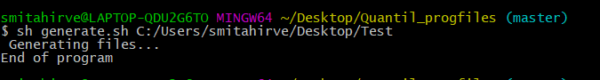

2. This is the sample run of the query – where the IP address and the time interval is specified and the search results are displayed. For two different IP addresses, it has been shown.

When the User enters the EXIT command the code exits.

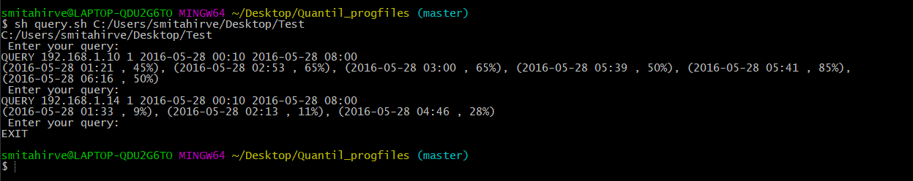

**Time Division**

**Total time: 6 Hours**

Time breakdown:

1. Understanding the question and brainstorming the solution: 1 Hour

2. Designing the classes and the methods: 1 hour minutes.

3. Creation of the log file and its methods: 1.5 hours

4. Creation of the query project: 1.5 hours.

5. Running the project and general debugging: 1hour

6. Creating the script to run and making the read me file 1 hour