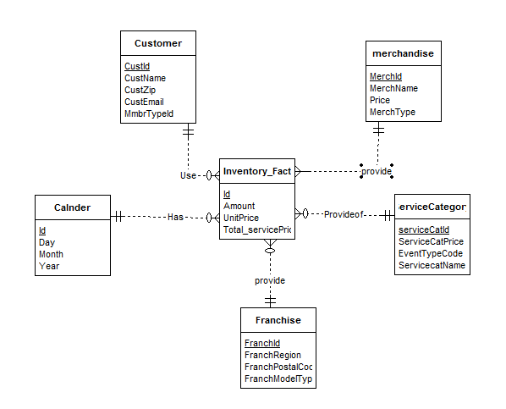

* create table customer(custid int primary key Not null,custname varchar(20) Not null,custzip int Not Null,custEmail varchar(20) ,MmbertypeId int )
* Create table merchandise(Merchid int primary key not null,MerchName varchar(20) Not Null,price int Not Null,MerchType varchar(20)Not Null);
* create table Calender(Id int primary key not null,Day int Not Null,Month int Not Null,Year int Not Null);
* Create table ServiceCategory(ServiceId int primary key not null,serviceCatprice int Not Null,EventTypecode varchar(20) Not Null,ServiceCatName varchar(20) Not Null);
* Create table Franchise(Franchid int primary key not null,FranchRegion varchar(20) Not Null,FranchPostalCode int Not Null,FranchModeType varchar(20) Not Null);
* create table Inventory_fact(Id int primary key not null,UnitPrice int Not Null,Total_ServicePrice int Not Null,Amount int Not Null,custid int not null,Merchid int Not Null,Id Not null,ServiceId Not Null,Franchid int Not Null);

custid Foreign key references customer(custid)

Merchid custid Foreign key references customer(custid)

id Foreign key references Calender(Id)

ServiceId Foreign key references ServiceCategory(ServiceId)

FranchId Foreign Key key references Franchise(ServiceId)