**Q1:**

Select l.location_id,l.location_name,c.Sales_class_id,c.sales_class_desc,t.time_year,t.time_month,c.base_price,sum(j.quantity_ordered),sum(j.quantity_ordered*j.quote_qty)

from w_location_d l,w_sales_class_d c,w_job_f j,w_time_d t

where j.sales_class_id=c.sales_class_id and

j.location_id=l.location_id

group by l.location_id,l.location_name,c.sales_class_id,c.sales_class_desc,c.base_price,t.time_year,t.time_month;

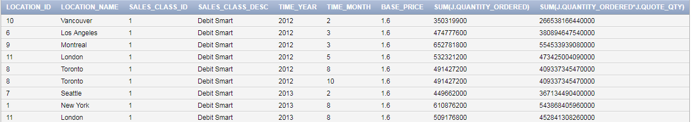

**Q2:**

create view BQ2 as

select j.job_id,j.location_id,j.unit_price,j.quantity_ordered,t.time_year,t.time_month,sum(i.invoice_amount)as suminvoiceamount,sum(invoice_quantity)as invoiceQuantity

from w_job_f j,w_time_d t,w_invoiceline_f i

where

j.location_id=i.location_id and

j.sales_class_id=i.sales_class_id and

j.sales_agent_id=i.sales_agent_id and

j.cust_id_ordered_by=i.cust_key and

t.time_id=j.contract_date

group by

j.job_id,j.location_id,j.unit_price,j.quantity_ordered,t.time_year,t.time_month

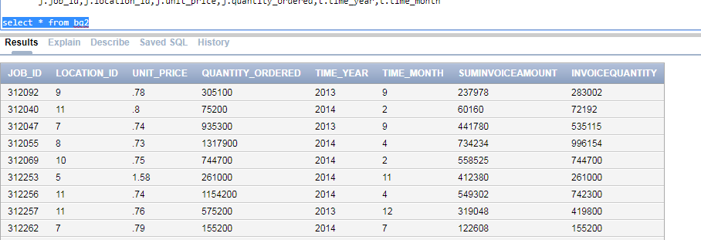

**Q3:**

create view BQ3

as

select j.job_id, j.location_id, l.location_name,

t.time_year, t.time_month,

sum(sj.cost_labor)as sumcost_labor,

sum(sj.cost_material)as sumcost_material,

sum(sj.machine_hours*m.rate_per_hour)as sumcost_machine,

sum(sj.cost_overhead)as sumcost_overhead,

sum(sj.cost_labor+sj.cost_material+(sj.machine_hours*m.rate_per_hour)+sj.cost_overhead)as total_costs,

sum(sj.quantity_produced)as quantity_prod,

sum((sj.cost_labor+sj.cost_material+(sj.machine_hours*m.rate_per_hour)+sj.cost_overhead)/sj.quantity_produced)as unit_cost

from w_job_f j, w_location_d l, w_time_d t, w_sub_job_f sj, w_machine_type_d m

where

t.time_id = j.contract_date and

sj.job_id = j.job_id and

j.location_id = l.location_id and

sj.machine_type_id = m.machine_type_id

group by

j.job_id, j.location_id, l.location_name,t.time_year,t.time_month

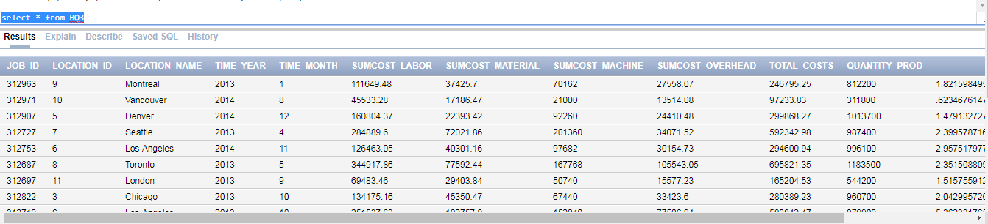

**Q4:**

create or replace view BQ4

as

select l.location_id, l.location_name,

c.sales_class_id, c.sales_class_desc,

t.time_year, t.time_month,

sum (i.quantity_shipped - i.invoice_quantity)as quantity_returned,

sum ((i.invoice_amount/i.invoice_quantity)*(i.quantity_shipped - i.invoice_quantity)) as amount_returned

from w_location_d l,w_invoiceline_f i, w_sales_class_d c, w_time_d t

where i.quantity_shipped>i.invoice_quantity and

l.location_id = i.location_id and

c.sales_class_id = i.sales_class_id and

t.time_id = i.invoice_sent_date

group by l.location_id, l.location_name,c.sales_class_id, c.sales_class_desc,t.time_year, t.time_month

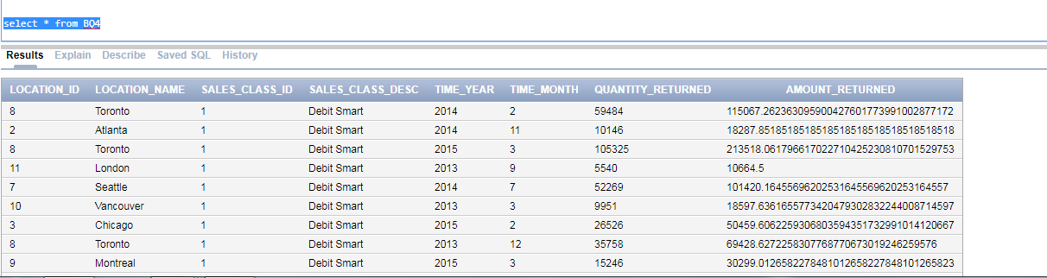

**Q5:**

create view BQ5 as

select j.job_id, j.location_id, l.location_name,c.sales_class_id, c.sales_class_desc,j.date_promised, x1.last_ship_date last_ship_date,j.quantity_ordered,

x1.delay_quantity,

(x1.last_ship_date-j.date_promised) AS BusDaysDiff

from w_location_d l,w_job_f j, w_sales_class_d c,

(select j.job_id, max(js.actual_ship_date) as last_ship_date, sum(js.actual_quantity)as delay_quantity

from w_sub_job_f sj, w_job_shipment_f js, w_job_f j

where js.sub_job_id = sj.sub_job_id

and sj.job_id = j.job_id

and js.actual_ship_date > j.date_promised

group by j.job_id) x1

where l.location_id = j.location_id

and c.sales_class_id = j.sales_class_id

and x1.job_id = j.job_id

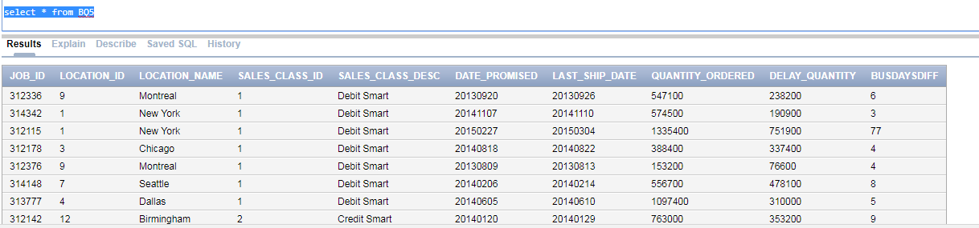

**Q6:**

create view BQ6 as

select j.job_id, j.location_id, l.location_name,c.sales_class_id, c.sales_class_desc,j.date_ship_by, x1.firstshipdate,

(x1.firstshipdate-j.date_ship_by) AS BusDaysDiff

from w_location_d l,w_job_f j, w_sales_class_d c,

( SELECT W_SUB_JOB_F.JOB_ID, MIN(Actual_Ship_Date) as FirstShipDate

FROM W_JOB_SHIPMENT_F, W_SUB_JOB_F

WHERE W_SUB_JOB_F.SUB_JOB_ID = W_JOB_SHIPMENT_F.SUB_JOB_ID

GROUP BY W_SUB_JOB_F.JOB_ID

) X1

where l.location_id = j.location_id

and c.sales_class_id = j.sales_class_id

and x1.job_id = j.job_id

