**AQ1:**

select l.location_name,t.time_year,t.time_month,sum(j.quantity_ordered*j.unit_price)as JobAmount,

sum(sum(j.quantity_ordered*j.unit_price))over(partition by l.location_name,t.time_year ordered by t.time_month

rows unbounded preceding)as cumalitiveSumAmount

from w_location_d l,w_job_f j,w_time_d t

where l.location_id=j.location_id and

j.contract_date=t.time_id

group by l.location_name,t.time_year,t.time_month

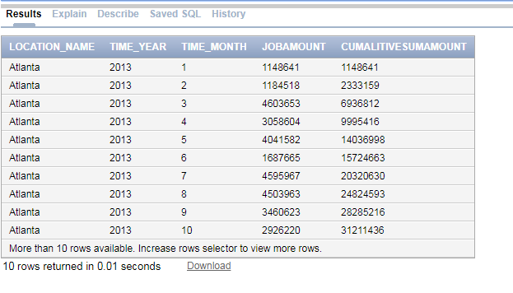

**AQ2:**

select l.location_name,t.time_year,t.time_month,avg(quantity_ordered*unit_price)as JobAmount,

avg(avg(quantity_ordered*unit_price))over(partition by l.location_name order by t.time_year,t.time_month ROWS BETWEEN 11 PRECEDING AND CURRENT ROW )as amountordered

from w_location_d l,w_job_f j,w_time_d t

where l.location_id=j.location_id and

j.contract_date=t.time_id

group by l.location_name,t.time_year,t.time_month

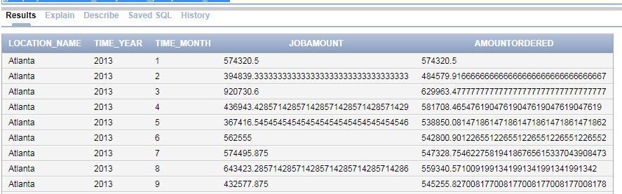

**AQ3:**

select b2.location_name,b2.time_year,sum(suminvoiceamount-total_costs),

rank()over(partition by b2.time_year order by(sum(SumInvoiceAmount - Total_Costs))desc)

from BQ2 b1,BQ3 b2

where b1.job_id=b2.job_id

group by b2.location_name,b2.time_year

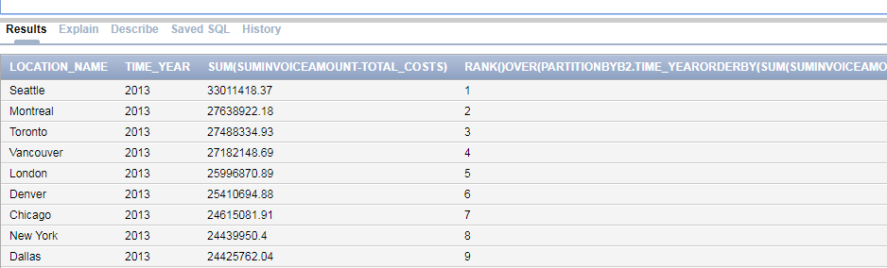

**AQ4:**

select b2.location_name, b2.time_year, b2.time_month, sum(b1.suminvoiceamount - b2.total_costs) / sum(suminvoiceamount) profit_margin,

rank() over(partition by b2.time_year order by (sum(b1.suminvoiceamount - b2.total_costs) / sum(suminvoiceamount))desc) profit_rank

from bq2 b1, bq3 b2

where b2.job_id = b2.job_id

and b1.time_year = b2.time_year

and b1.location_id = b2.location_id

group by b2.location_name, b2.time_year, b2.time_month;

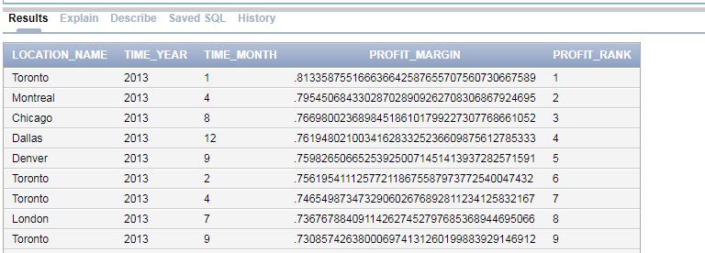

**AQ5:**

select b2.location_name, b2.time_year, b2.time_month, sum(b1.suminvoiceamount - b2.total_costs) / sum(suminvoiceamount) profit_margin,

percent_rank() over( order by (sum(b1.suminvoiceamount - b2.total_costs) / sum(suminvoiceamount))desc) profit_rank

from bq2 b1, bq3 b2

where b2.job_id = b2.job_id

and b1.time_year = b2.time_year

and b1.location_id = b2.location_id

group by b2.location_name, b2.time_year, b2.time_month;

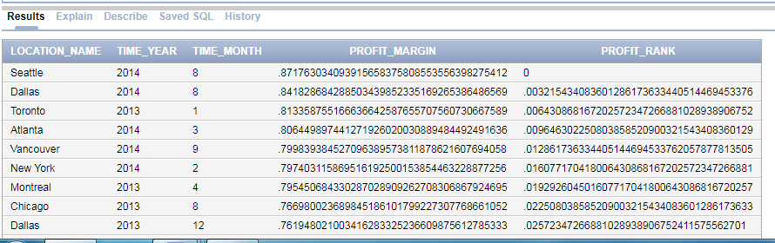

**AQ6:**

select location_name, time_year, time_month, profit_margin, profit_rank

from

(select b2.location_name, b2.time_year, b2.time_month, sum(b1.suminvoiceamount - b2.total_costs) / sum(suminvoiceamount) profit_margin,

percent_rank() over( order by (sum(b1.suminvoiceamount - b2.total_costs) / sum(suminvoiceamount))desc) profit_rank

from bq2 b1, bq3 b2

where b2.job_id = b2.job_id

and b1.time_year = b2.time_year

and b1.location_id = b2.location_id

group by b2.location_name, b2.time_year, b2.time_month)

where profit_rank<0.05

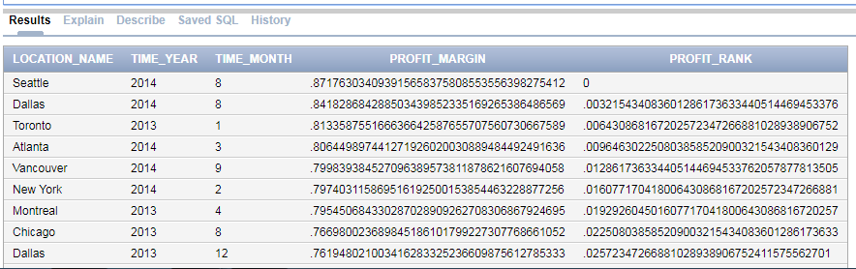

**Q7:**

select sales_class_desc, time_year, sum(quantity_returned),

rank() over (partition by time_year order by sum(quantity_returned))

from BQ4

group by sales_class_desc, time_year;

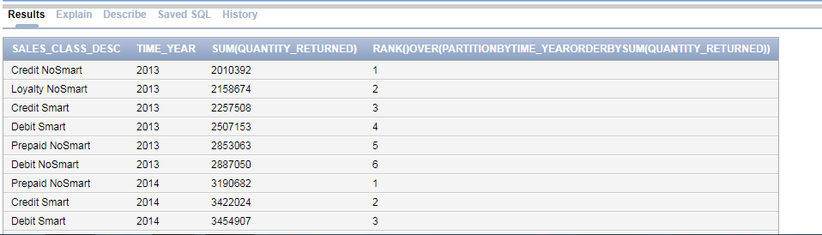

**Q8:**

select sales_class_desc, time_year, sum(quantity_returned),

ratio_to_report(sum(quantity_returned)) over (partition by time_year)

from BQ4

group by sales_class_desc, time_year;

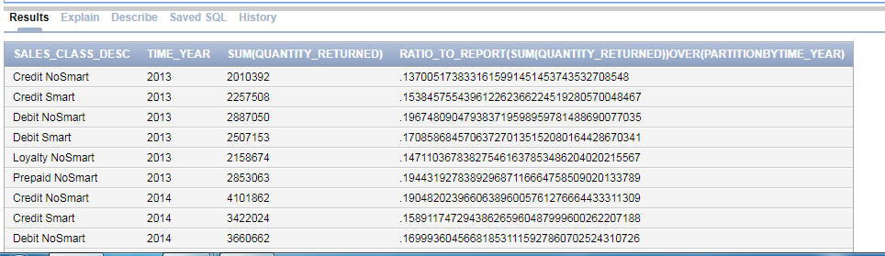

**Q9:**

select b.location_name,t.time_year, sum(busdaysdiff),

rank() over ( partition by t.time_year order by sum(busdaysdiff))as rank,

dense_rank over( partition by t.time_year order by sum(busdaysdiff))as denserank

from bq6 ,w_time_d t

where

t.time_id=b.date_ship_by

group by location_name,t.time_year;

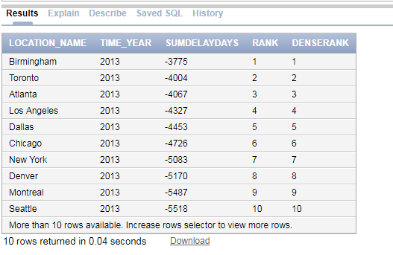

**Q10:**

select location_name, t.time_year,

count(*) as totaljobs,

sum(busdaysdiff) as,

sum(quantity_ordered - delay_quantity) / sum(quantity_ordered) ,

rank() over ( partition by t.time_year

order by sum(quantity_ordered -delay_quantity ) /

sum(quantity_ordered) desc) as rankdelay

from bq5 b, w_time_d t

where t.time_id = b.date_promised

group by location_name,t.time_year;

