Select \* from customer;

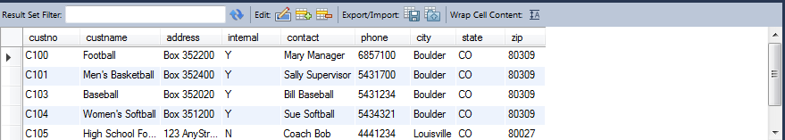

select distinct city,state,zip from customer;

