SELECT \* FROM EMPLOYEE;

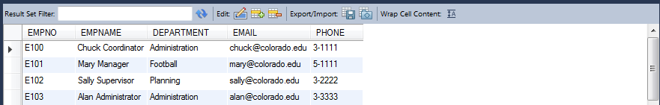

SELECT EMPNAME,DEPARTMENT,EMAIL,PHONE

FROM employee

WHERE PHONE LIKE '3%';

