SELECT \* FROM resourcetbl;

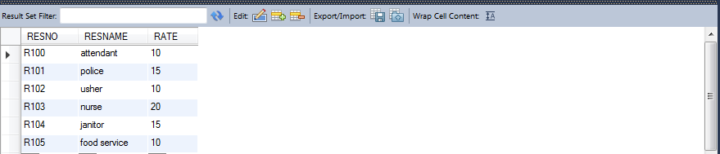

SELECT \* FROM resourcetbl

WHERE RATE BETWEEN 10 AND 20

ORDER BY RATE;

