SELECT \* FROM FACILITY;



SELECT \* FROM LOCATION;

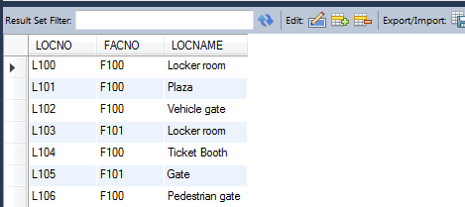

SELECT LOCATION.LOCNO,LOCATION.LOCNAME FROM LOCATION,facility

WHERE LOCATION.FACNO=FACILITY.FACNO AND FACILITY.FACNO='F101' GROUP BY('BASKETBALL ARENA');

