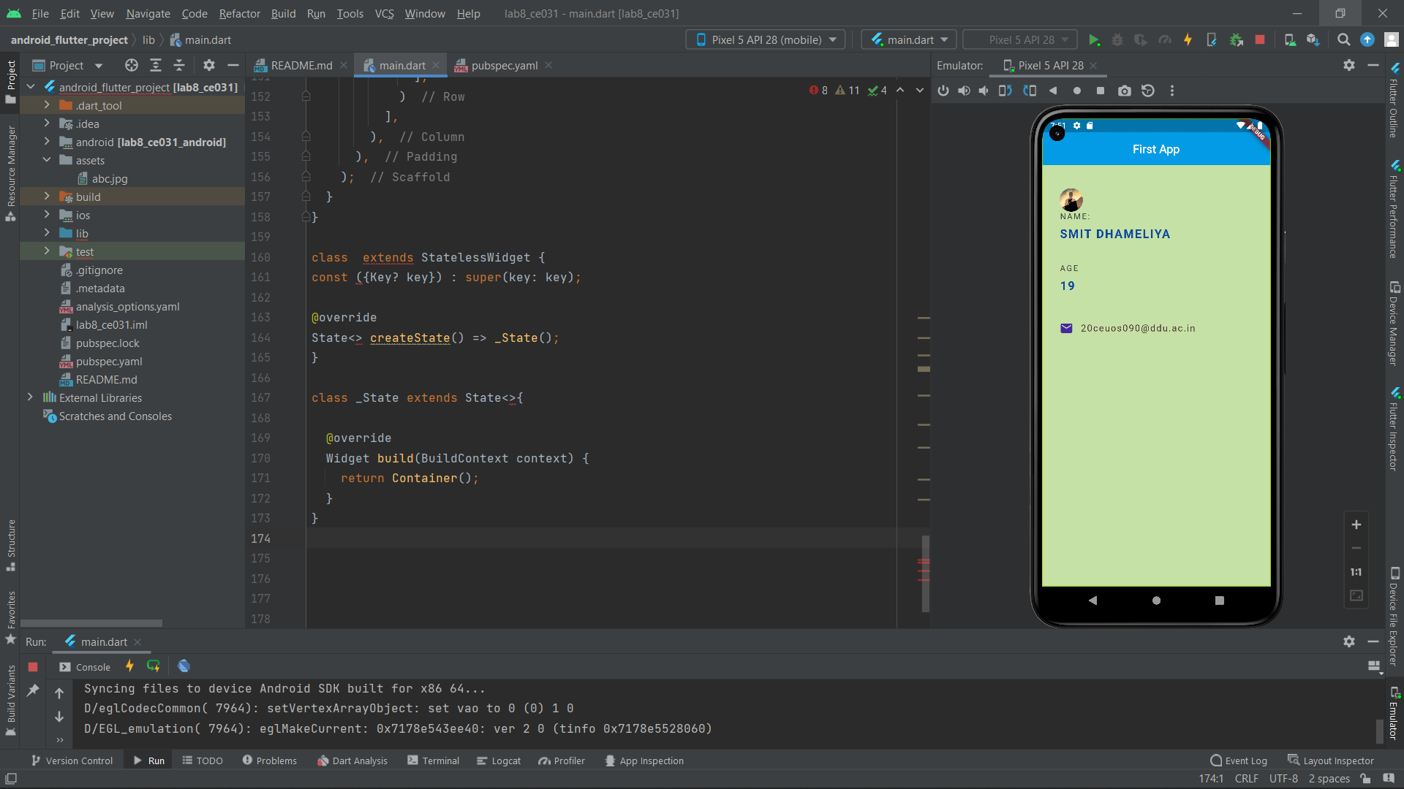

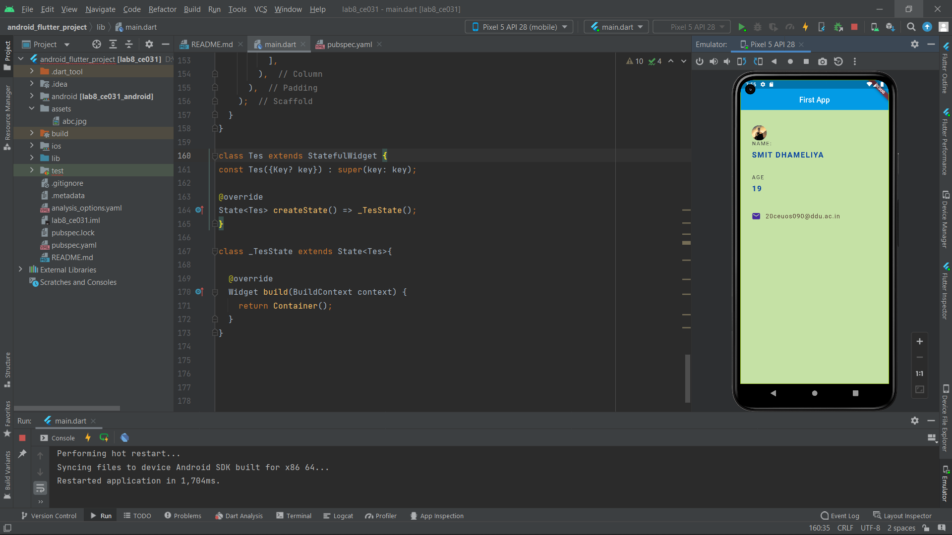

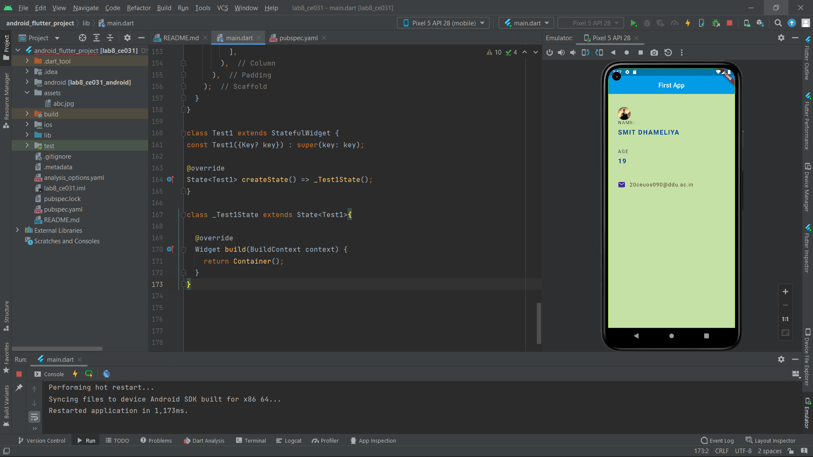

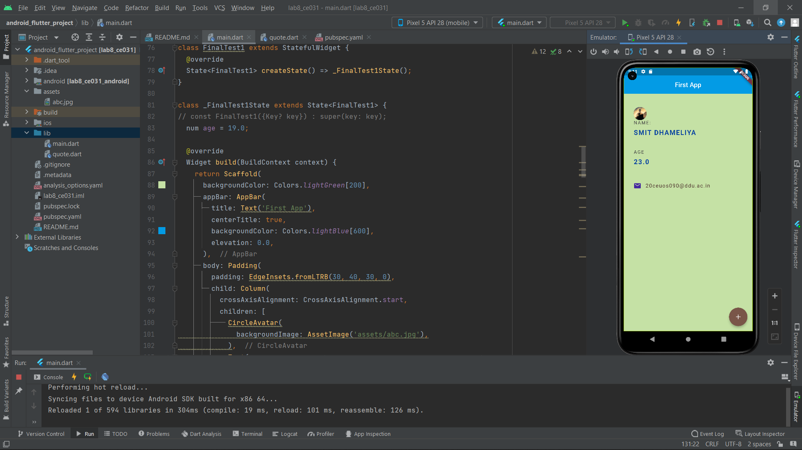

Code ::

import 'package:flutter/material.dart';

void main() => runApp(MaterialApp(

home: FinalTest1(),

));

class FinalTest1 extends StatefulWidget {

@override

State<FinalTest1> createState() => _FinalTest1State();

}

class _FinalTest1State extends State<FinalTest1> {

// const FinalTest1({Key? key}) : super(key: key);

num age = 19.0;

@override

Widget build(BuildContext context) {

return Scaffold(

backgroundColor: Colors.*lightGreen*[200],

appBar: AppBar(

title: Text('First App'),

centerTitle: true,

backgroundColor: Colors.*lightBlue*[600],

elevation: 0.0,

),

body: Padding(

padding: EdgeInsets.fromLTRB(30, 40, 30, 0),

child: Column(

crossAxisAlignment: CrossAxisAlignment.start,

children: [

CircleAvatar(

backgroundImage: AssetImage('assets/abc.jpg'),

),

Text(

'NAME: ',

style: TextStyle(

color: Colors.*grey*[800],

letterSpacing: 2.0,

),

),

SizedBox(height: 10),

Text(

'SMIT DHAMELIYA',

style: TextStyle(

color: Colors.*blue*[900],

letterSpacing: 2.0,

fontWeight: FontWeight.*bold*,

fontSize: 20.0,

),

),

SizedBox(height: 40),

Text(

'AGE',

style: TextStyle(

color: Colors.*grey*[800],

letterSpacing: 2.0,

),

),

SizedBox(height: 10),

Text(

'$age',

style: TextStyle(

color: Colors.*blue*[900],

letterSpacing: 2.0,

fontWeight: FontWeight.*bold*,

fontSize: 20.0,

),

),

SizedBox(height: 50),

Row(

children: [

Icon(

Icons.*email_rounded*,

color: Colors.*deepPurple*[800],

),

SizedBox(width: 12.0),

Text(

'20ceuos090@ddu.ac.in',

style: TextStyle(

color: Colors.*brown*[800],

fontSize: 16.0,

letterSpacing: 1.5,

),

)

],

)

],

),

),

floatingActionButton: FloatingActionButton(

onPressed: () {

setState(() {

age += 1;

});

},

child: Icon(Icons.*add*),

backgroundColor: Colors.*brown*,

),

);

}

}

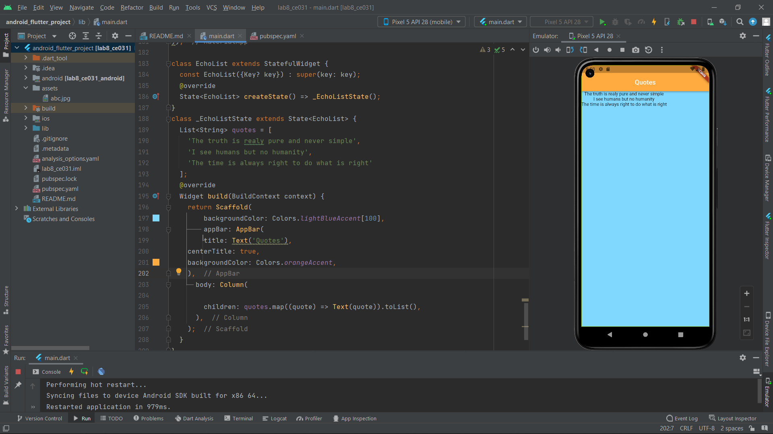

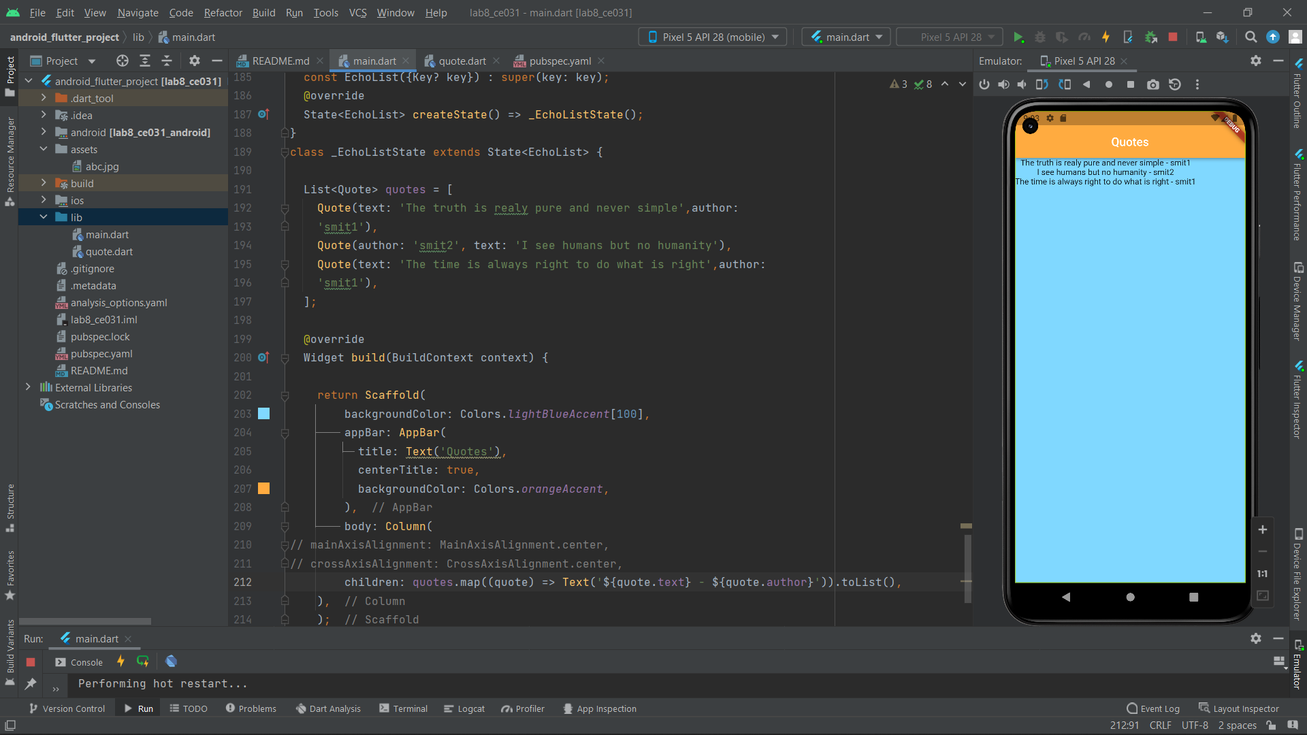

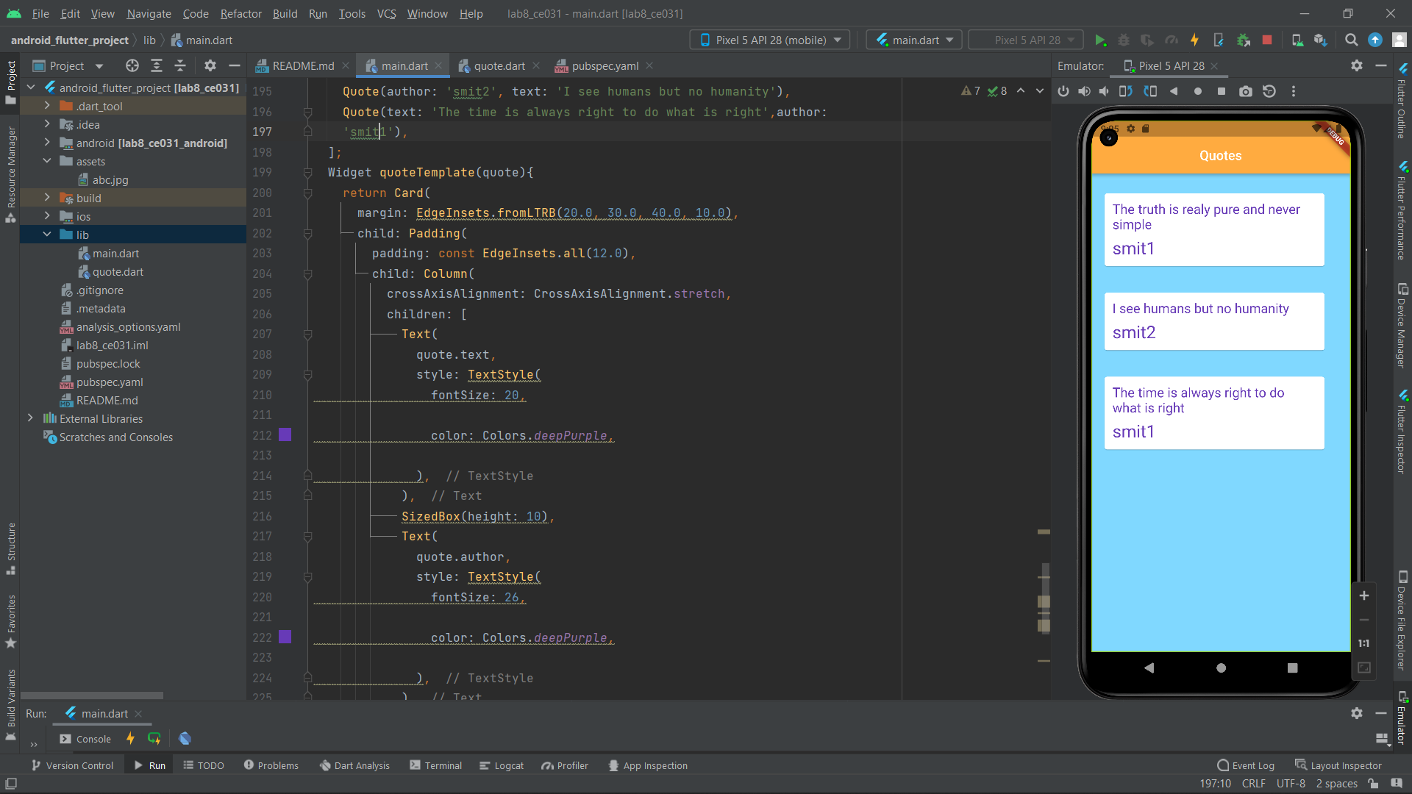

Code ::

import 'package:flutter/material.dart';

import 'quote.dart'; // due to same directory file no need path

void main() => runApp(MaterialApp(

home: EchoList(),

));

class EchoList extends StatefulWidget {

const EchoList({Key? key}) : super(key: key);

@override

State<EchoList> createState() => _EchoListState();

}

class _EchoListState extends State<EchoList> {

List<Quote> quotes = [

Quote(text: 'The truth is realy pure and never simple',author:

'smit1'),

Quote(author: 'smit2', text: 'I see humans but no humanity'),

Quote(text: 'The time is always right to do what is right',author:

'smit1'),

];

Widget quoteTemplate(quote){

return Card(

margin: EdgeInsets.fromLTRB(20.0, 30.0, 40.0, 10.0),

child: Padding(

padding: const EdgeInsets.all(12.0),

child: Column(

crossAxisAlignment: CrossAxisAlignment.stretch,

children: [

Text(

quote.text,

style: TextStyle(

fontSize: 20,

color: Colors.*deepPurple*,

),

),

SizedBox(height: 10),

Text(

quote.author,

style: TextStyle(

fontSize: 26,

color: Colors.*deepPurple*,

),

),

],

),

),

);

}

@override

Widget build(BuildContext context) {

return Scaffold(

backgroundColor: Colors.*lightBlueAccent*[100],

appBar: AppBar(

title: Text('Quotes'),

centerTitle: true,

backgroundColor: Colors.*orangeAccent*,

),

body: Column(

// mainAxisAlignment: MainAxisAlignment.center,

// crossAxisAlignment: CrossAxisAlignment.center,

children: quotes.map((quote) => quoteTemplate(quote)).toList(),

),

);

}

}