**Q1. Sheel script to check if given year is leap year**

#!/bin/bash

echo -n "Enter year : "

read year

if [ `expr $year % 4` -eq 0 -a `expr $year % 100` -ne 0 -o `expr $year % 400` -eq 0 ]

then

echo "$year is leap year"

else

echo "$year is not leap year"

fi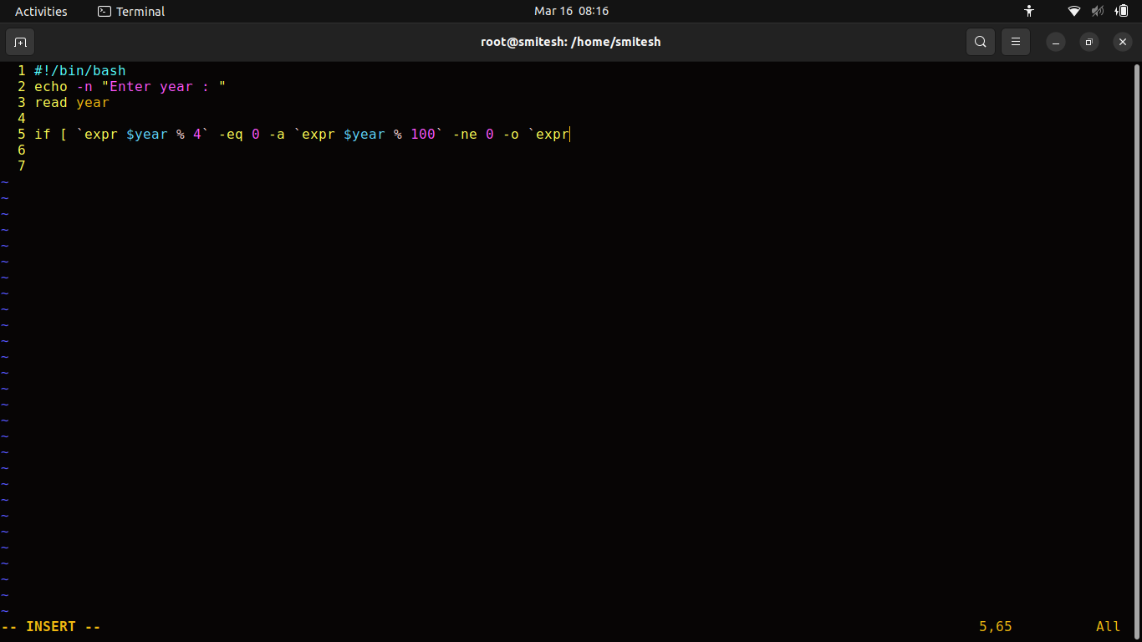

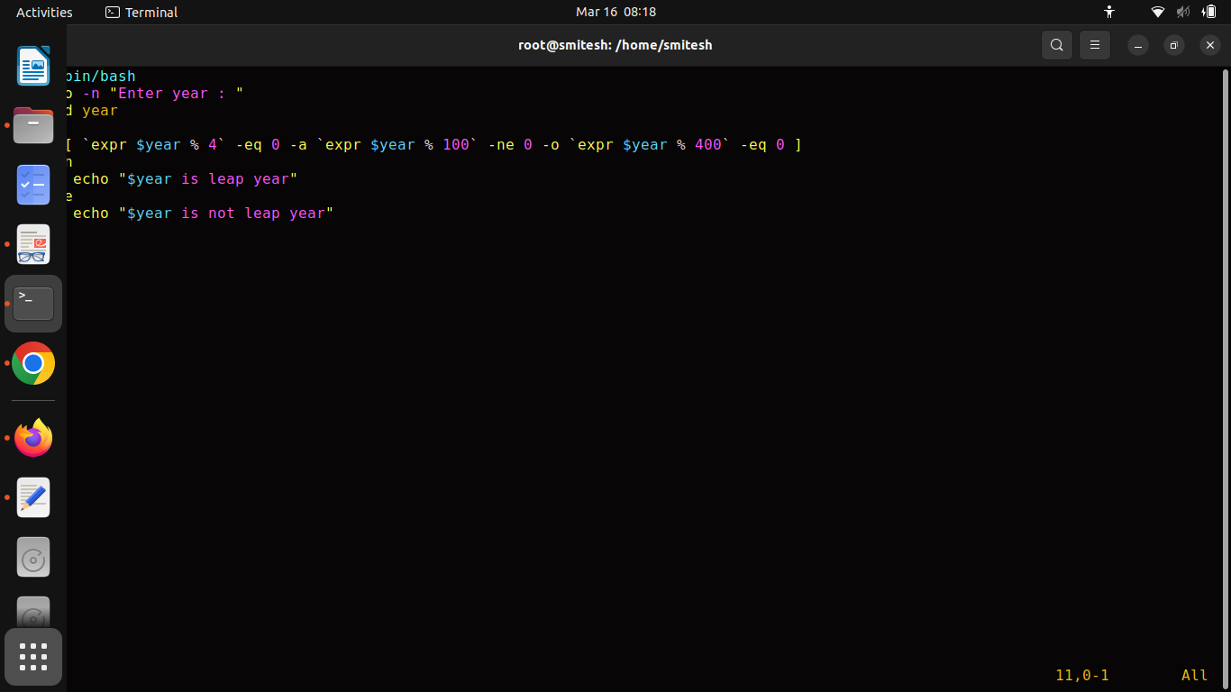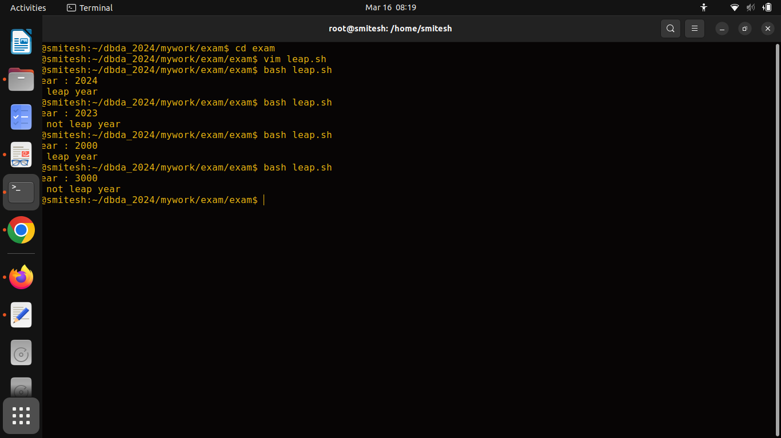

**Q2. Script for Fibonacci serie**

#!/bin/bash

read -p "enter the number upto which you want the series: " a

n1=0

n2=1

echo $n1 $n2

n3=0

for i in `seq 2 $a`

do

n3=`expr $n1 + $n2`

echo $n3

n1=$n2

n2=$n3

done

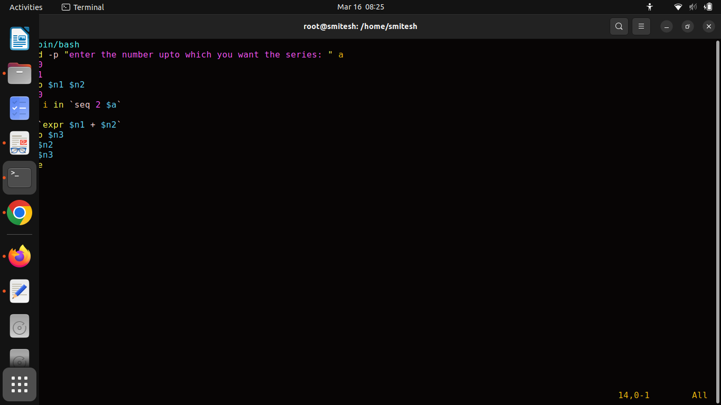

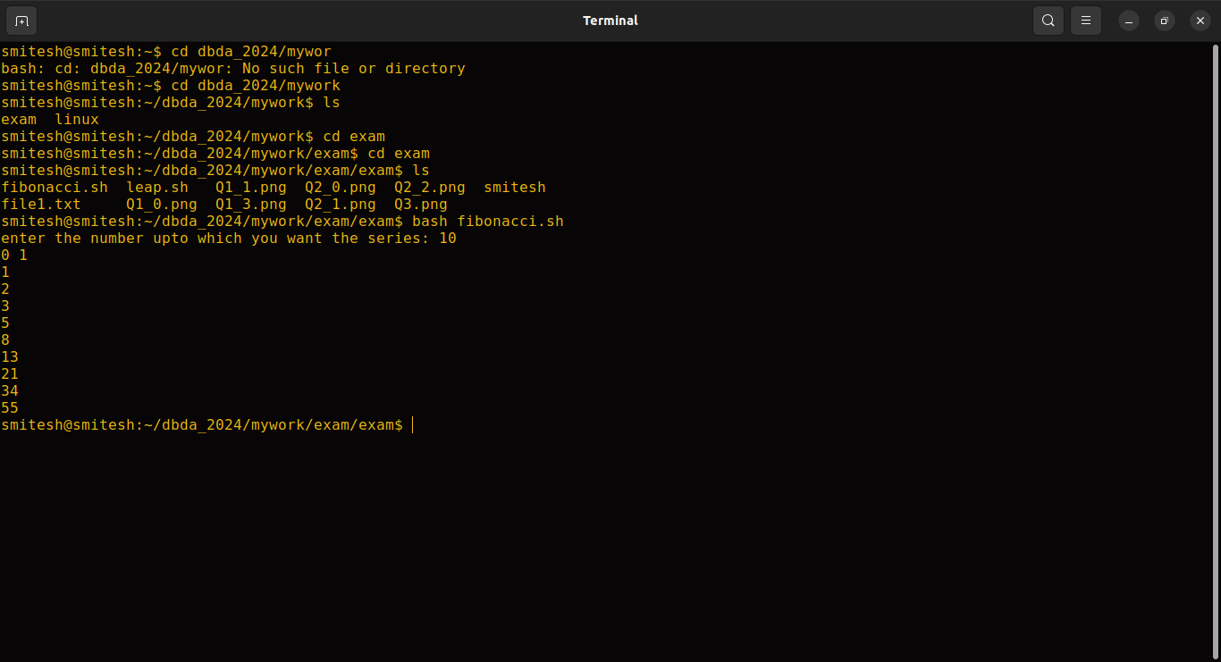

**Q3.**

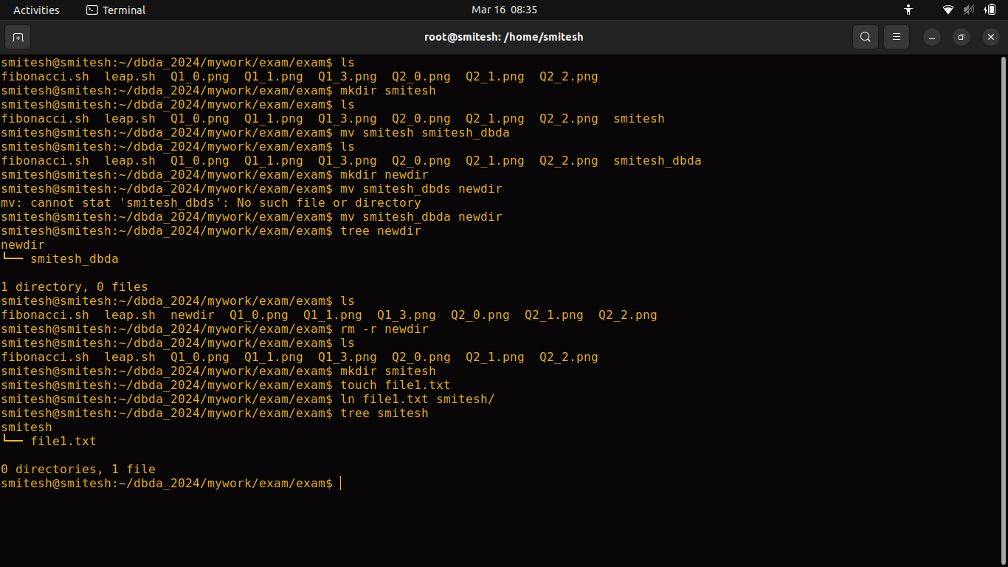

ls

1. **mkdir smitesh**

ls

1. **mv smitesh smitesh_dbda**

ls

1. mkdir newdir

**mv smites_dbda newdir**

tree newdir

1. **rm -r newdir**

ls

1. mkdir smitesh

touch file1.txt

**ln file1.xtx smitesh/**

tree smitesh

**EC2:**

**Step 1:**

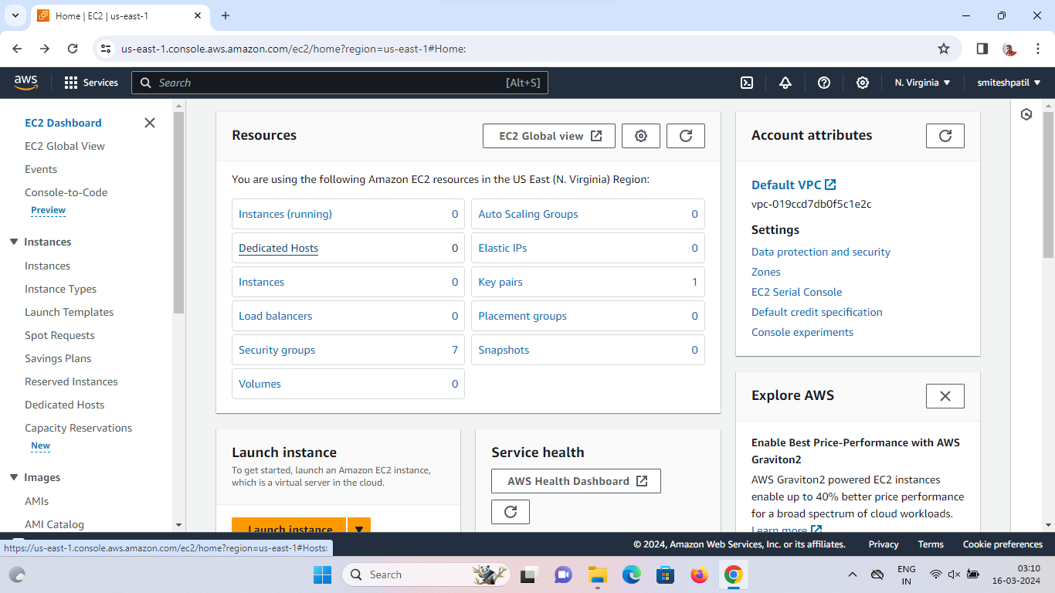Creating EC2 instance with name and key value pair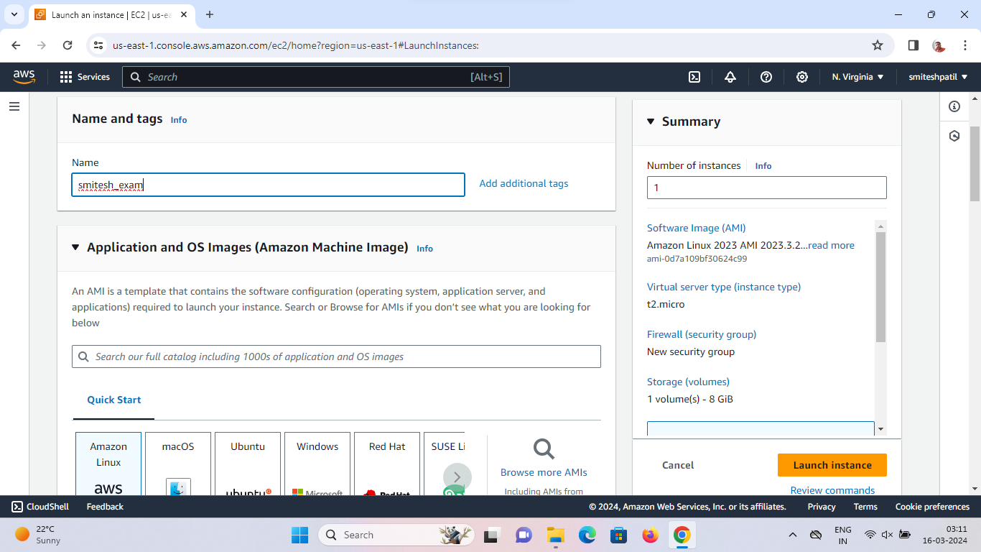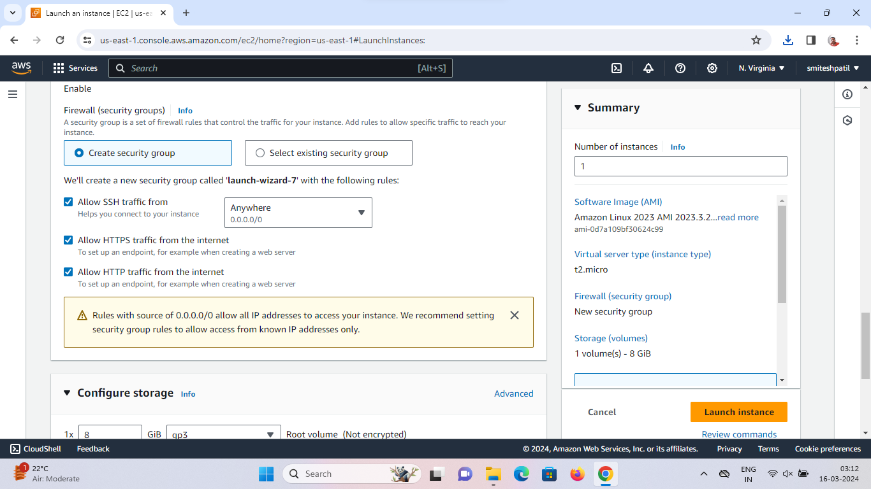



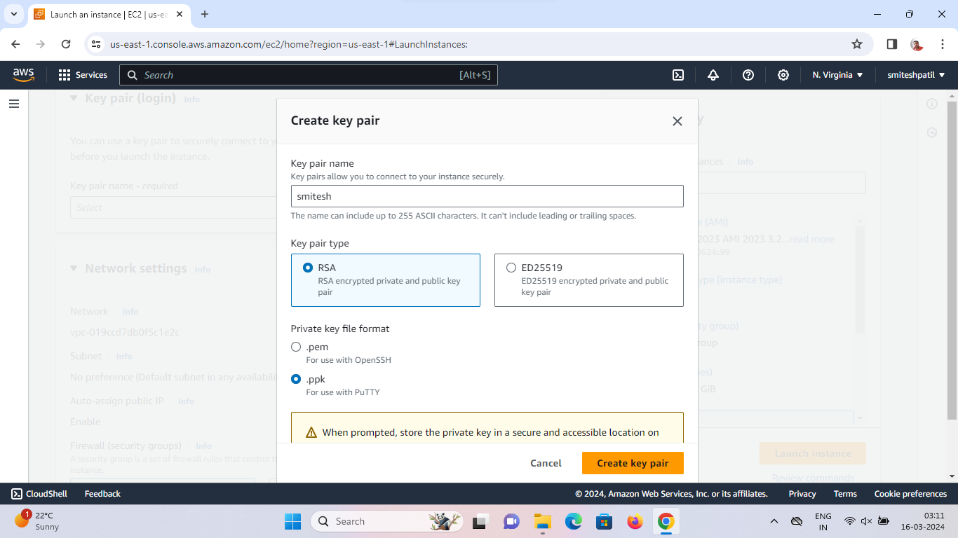



**Step 2:**

Connection putty and EC2 using ssh and public Ipv4 address

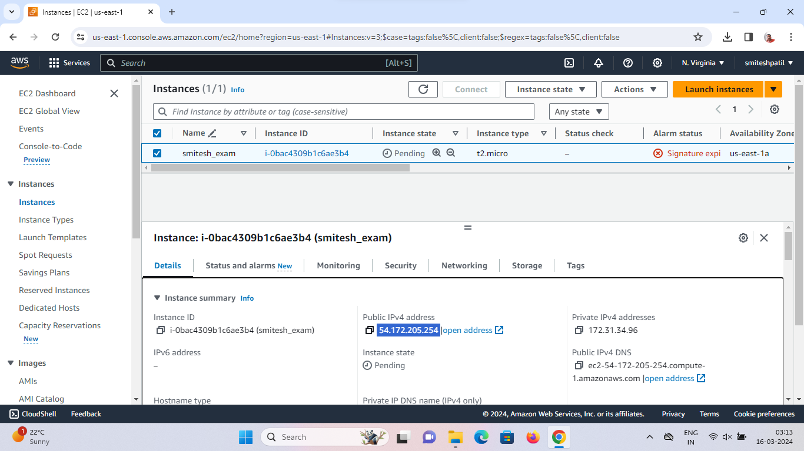

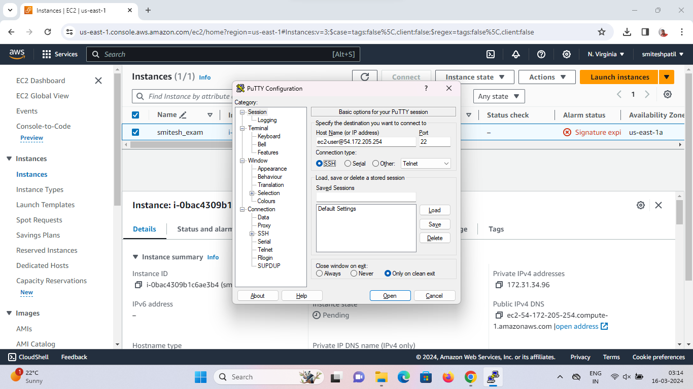

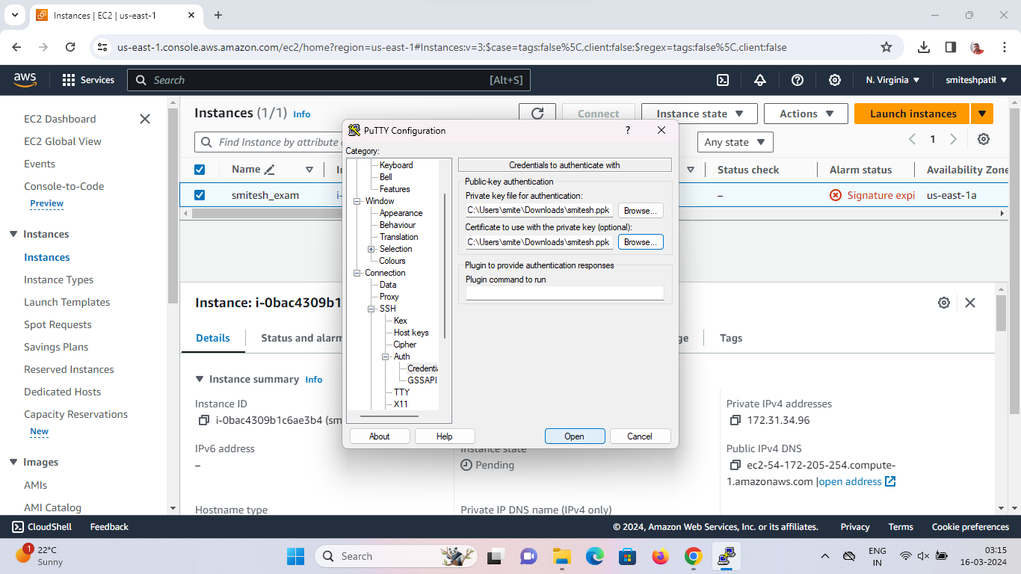

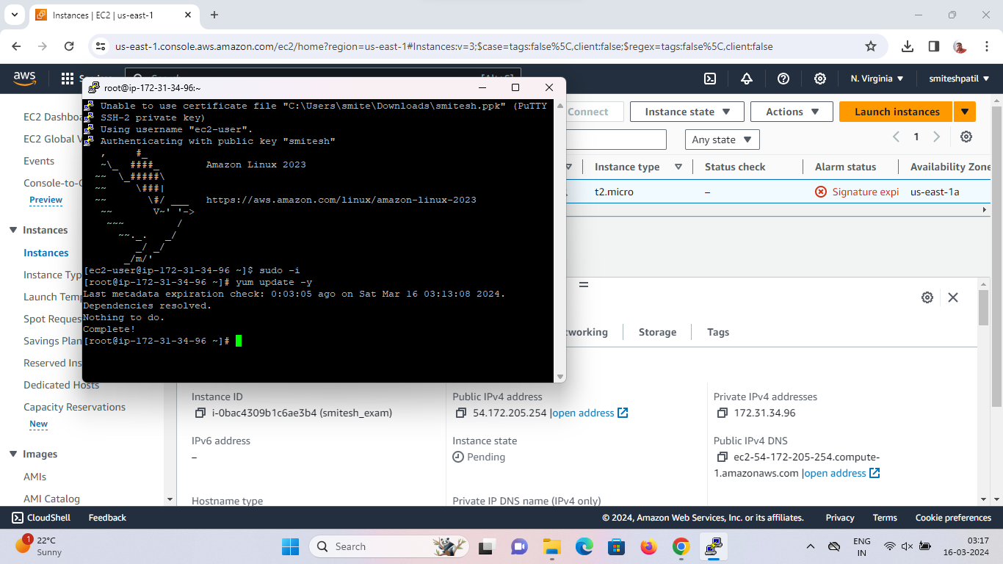

**Step 3:**

1. Move to root

Sudo -i

1. Update using yum package. Install httpd using yum package installer. Start httpd server and enable to start httpd server on boot

Yum update -y

yum install httpd -y

yum start httpd

yum enable httpd

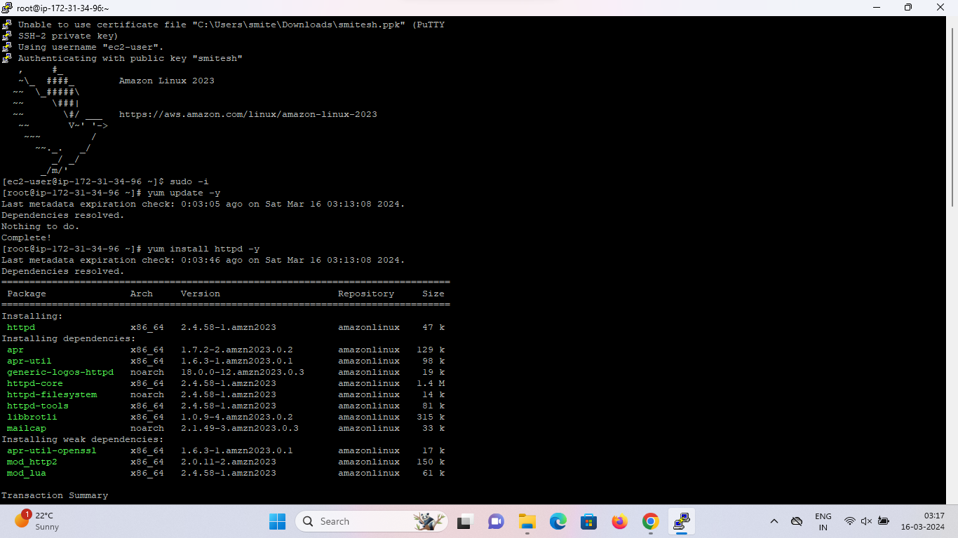

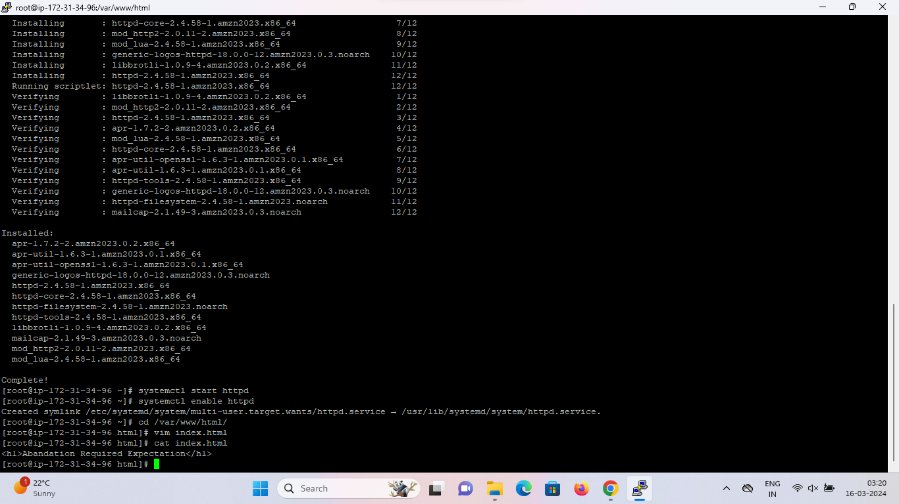

**Step 4:**

1. Move to cd /var/www/html
2. Create static web page named index.html using vim/vi

Vim index.html

1. Write in page

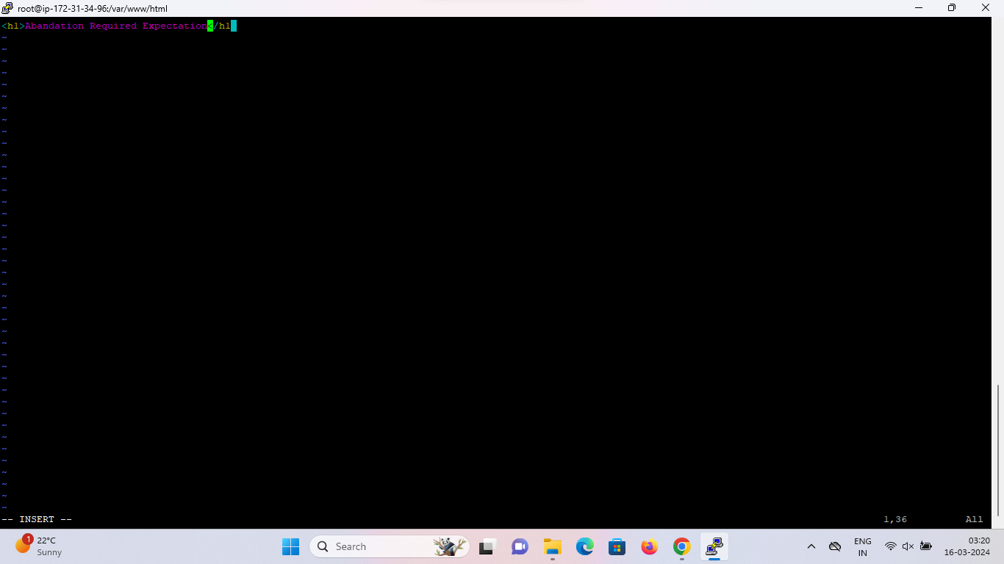

**Step 5:**

Run the web page using public Ipv4 address

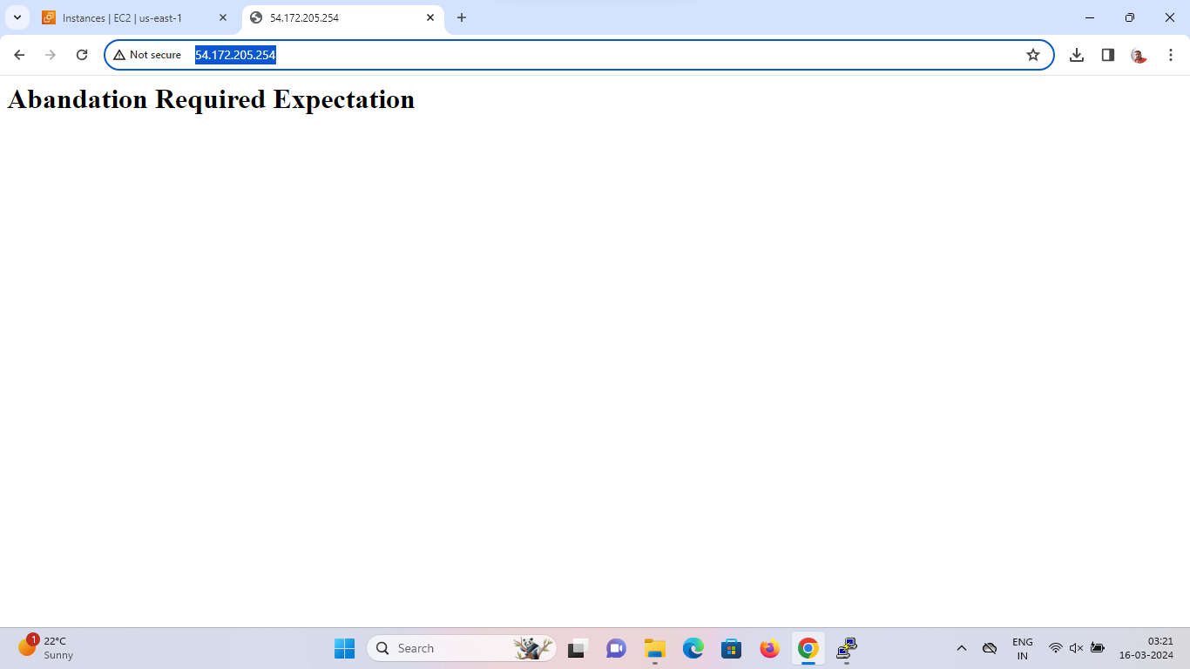

**VPC:**

1. on your console home, search for VPC and navigate to VPC Dashboard
2. On your VPC’s page, click on Create VPC
3. Once you land there, give your VPC a tag to identify it and then fill the IPv4 CIDR block with the IP prompted to you
4. Now, Hit on create VPC
5. …….