Low Level Design

# House Price Prediction

|  |  |
| --- | --- |
| **Written By** | Author 1, Author 2 |
| **Document Version** | 0.3 |
| **Last Revised Date** |  |

**DOCUMENT CONTROL**

## Change Record:

|  |  |  |  |
| --- | --- | --- | --- |
| **VERSION** | **DATE** | **AUTHOR** | **COMMENTS** |
| 0.1 | 19- May -  2021 | Author 1 | Introduction and architecture defined |
| 0.2 | 20 - May -  2021 | Author 2 | Architecture & Architecture description appended and  updated. |
|  |  |  |  |
|  |  |  |  |

**Reviews:**

|  |  |  |  |
| --- | --- | --- | --- |
| **VERSION** | **DATE** | **REVIEWER** | **COMMENTS** |
| 0.2 | 21- May -  2021 | Author 3 | Unit test cases to be added |

**Approval Status:**

|  |  |  |  |  |  |
| --- | --- | --- | --- | --- | --- |
| **VERSION** | **REVIEW**  **DATE** | **REVIEWED BY** |  | **APPROVED BY** | **COMMENTS** |
|  |  |  |  |  |  |

# Contents

#### Introduction 04

* 1. **What is Low-Level Design Document? 04**

|  |  |  |
| --- | --- | --- |
| **1.2** | | **Scope 04** |
| **2.** | **Architecture 05** | |
| **3.** | **Architecture Description 08** | |
|  | **3.1** | **Data Description 08** |
|  | **3.3** | **Data Transformation 08** |
|  | **3.5** | **Export Data from Excel file 12** |

# Introduction

## What is Low-Level design document?

The goal of the LDD or Low-level design document (LLDD) is to give the internal logic design of the actual program code for the House Price Prediction dashboard. LDD describes the class diagrams with the methods and relations between classes and programs specs. It describes the modules so that the programmer can directly code the program from the document.

## Scope

Low-level design (LLD) is a component-level design process that follows a step-by-step refinement process. The process can be used for designing data structures, required software architecture, source code and ultimately, performance algorithms. Overall, the data organization may be defined during requirement analysis and then refined during data design work.

# Architecture

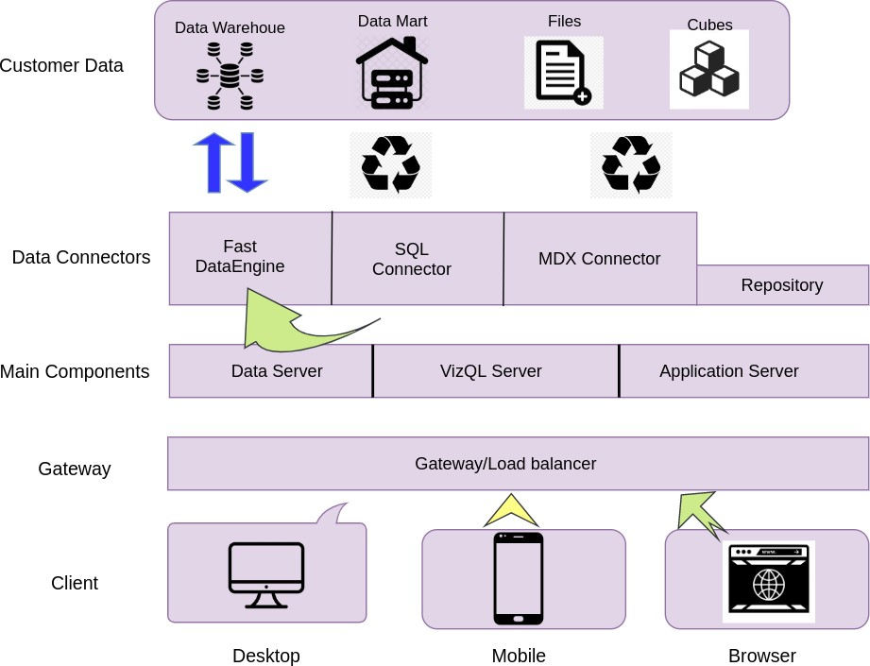

**LOW LEVEL DESIGN**

**6**

1. **Architecture Description**

## Data Description

The Dataset contains debt own by the countries.

* + 1. Country Name: Name of the country.
    2. Country code:Column contain country code.
    3. Series code: This column contain code .
    4. 1970-2027: 1970 to 2027 column contain amount detail

## Data Transformation

In the Transformation Process, we will convert our original datasets with other necessary attributes format. And will merge it with the Scrapped dataset.

## Export Data from Database

Data Export from Excel file - The data in a Excel file exported as a Data Frame to be used for Data Pre-processing.