High Level Design (HLD) Analyze Debt Statistics

Revision Number: 1.0

Last date of revision: 08/10/2021

Smitesh Sonawariya

# Document Version Control

|  |  |  |  |
| --- | --- | --- | --- |
| **Date Issued** | **Version** | **Description** | **Author** |
| **08th October 2021** | 1.0 | First Version of Complete HLD | Ravi Chaurasia |
|  |  |  |  |
|  |  |  |  |
|  |  |  |  |
|  |  |  |  |
|  |  |  |  |
|  |  |  |  |

**Contents**

Document Version Control 2

Abstract 3

1. Introduction 5
   1. Why this High-Level Design Document? 5
   2. Scope 5
2. General Description 6
   1. Product Perspective & Problem Statement 6

Housing prices are an important reflection of the economy, and housing price ranges are of great interest for both buyers and sellers. In this project, house prices will be predicted given explanatory variables that cover many aspects of residential houses. 6

* 1. Tools used 6

1. Design Details 7
   1. Functional Architecture 7
   2. Optimization 8

# Abstract

It's not that we humans only take debts to manage our necessities. A country may also

take debt to manage its economy.

In this project, we have analyze international debt data collected by The World

Bank. We have found the answers to questions like:

• What is the total amount of debt that is owed by the countries listed in the

dataset?

• Which country owns the maximum amount of debt and what does that amount

look like?

• What is the average amount of debt owed by countries across different debt indicators?.

# Introduction

## Why this High-Level Design Document?

The purpose of this High-Level Design (HLD) Document is to add the necessary detail to the current project description to represent a suitable model for coding. This document is also intended to help detect contradictions prior to coding, and can be used as a reference manual for how the modules interact at a high level.

The HLD will:

* + - Present all of the design aspects and define them in detail
    - Describe the user interface being implemented
    - Describe the hardware and software interfaces
    - Describe the performance requirements
    - Include design features and the architecture of the project
    - List and describe the non-functional attributes like:
      * Security
      * Reliability
      * Maintainability
      * Portability
      * Reusability
      * Application compatibility
      * Resource utilization
      * Serviceability

## Scope

The HLD documentation presents the structure of the system, such as the database architecture, application architecture (layers), application flow (Navigation), and technology architecture. The HLD uses non-technical to mildly-technical terms which should be understandable to the administrators of the system.

# General Description

## Product Perspective & Problem Statement

Housing prices are an important reflection of the economy, and housing price ranges are of great interest for both buyers and sellers. In this project, we have found total amount of debt owned by the country and which country owns maximum amount of debt .

The objective of the project is to perform data visualization techniques to understand the insight of the data. This project aims apply various Business Intelligence tools such as Tableau or Power BI to get a visual understanding of the data.

## Tools used

Business Intelligence tools and libraries works such as Numpy, Pandas, Excel are used to build the whole framework.



# Design Details

## Functional Architecture

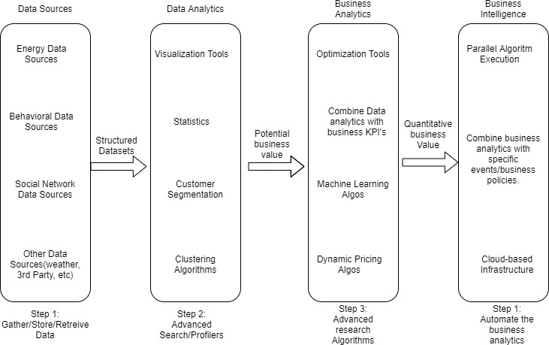

Figure 1: Functional Architecture of Business Intelligence

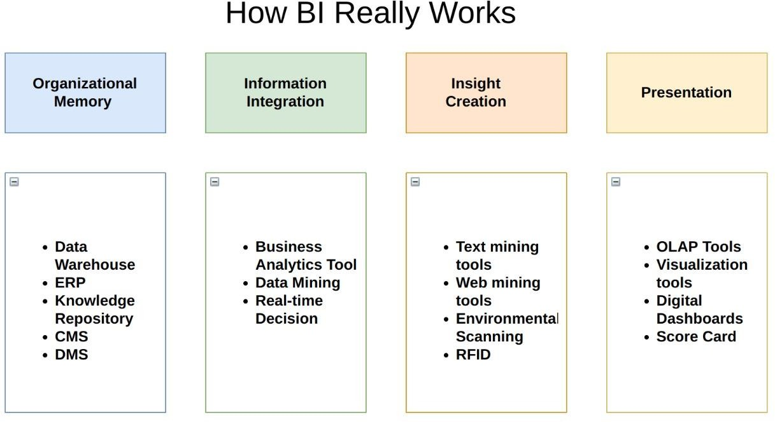

## Optimization

### Your data strategy drives performance

* + - Minimize the number of fields
    - Minimize the number of records
    - Optimize extracts to speed up future queries by materializing calculations, removing columns and the use of accelerated views

### Reduce the marks (data points) in your view

* + - Practice guided analytics. There’s no need to fit everything you plan to show in a single view. Compile related views and connect them with action filters to travel from overview to highly-granular views at the speed of thought.
    - Remove unneeded dimensions from the detail shelf.
    - Explore. Try displaying your data in different types of views.

### Limit your filters by number and type

* + - Reduce the number of filters in use. Excessive filters on a view will create a more complex query, which takes longer to return results. Double-check your filters and remove any that aren’t necessary.
    - Use an include filter. Exclude filters load the entire domain of a dimension, while include filters do not. An include filter runs much faster than an exclude filter, especially for dimensions with many members.
    - [Use a continuous date filter](http://onlinehelp.tableau.com/current/pro/online/mac/en-us/help.htm#filtering_add_dragfields_dates.html). Continuous date filters (relative and range-of-date filters) can take advantage of the indexing properties in your database and are faster than discrete date filters.
    - [Use Boolean or numeric filters](http://www.tableau.com/learn/tutorials/on-demand/logical-calculations). Computers process integers and Booleans (t/f) much faster than strings.
    - Use [parameters](http://onlinehelp.tableau.com/current/pro/online/en-us/help.htm#parameters.html) and [action filters](http://onlinehelp.tableau.com/current/pro/online/en-us/help.htm#actions.html). These reduce the query load (and work across data sources).

### Optimize and materialize your calculations

* + - Perform calculations in the database
    - Reduce the number of nested calculations.
    - Reduce the granularity of LOD or table calculations in the view. The more granular the calculation, the longer it takes.
      * LODs - Look at the number of unique dimension members in the calculation.
      * Table Calculations - the more marks in the view, the longer it will take to calculate.
    - [Where possible, use MIN or MAX instead of AVG](http://onlinehelp.tableau.com/current/pro/online/windows/en-us/help.htm#calculations_aggregation.html). AVG requires more processing than MIN or MAX. Often rows will be duplicated and display the same result with MIN, MAX, or AVG.
    - [Make groups with calculations](http://kb.tableau.com/articles/knowledgebase/creating-groups-using-calculated-fields). Like include filters, calculated groups load only named members of the domain, whereas Tableau’s group function loads the entire domain.
    - [Use Booleans or numeric calculations instead of string calculations](http://onlinehelp.tableau.com/current/pro/online/mac/en-us/help.htm#functions_functions_string.html). Computers can process integers and Booleans (t/f) much faster than strings. Boolean>Int>Float>Date>DateTime>String