**Conceptual Schema (Verison 1.1)**

**Based on analysis Version 1.1**

**Change Summary:** Fixed the title information. Order Entity has been fixed to reflect OrderDate and Vendor.

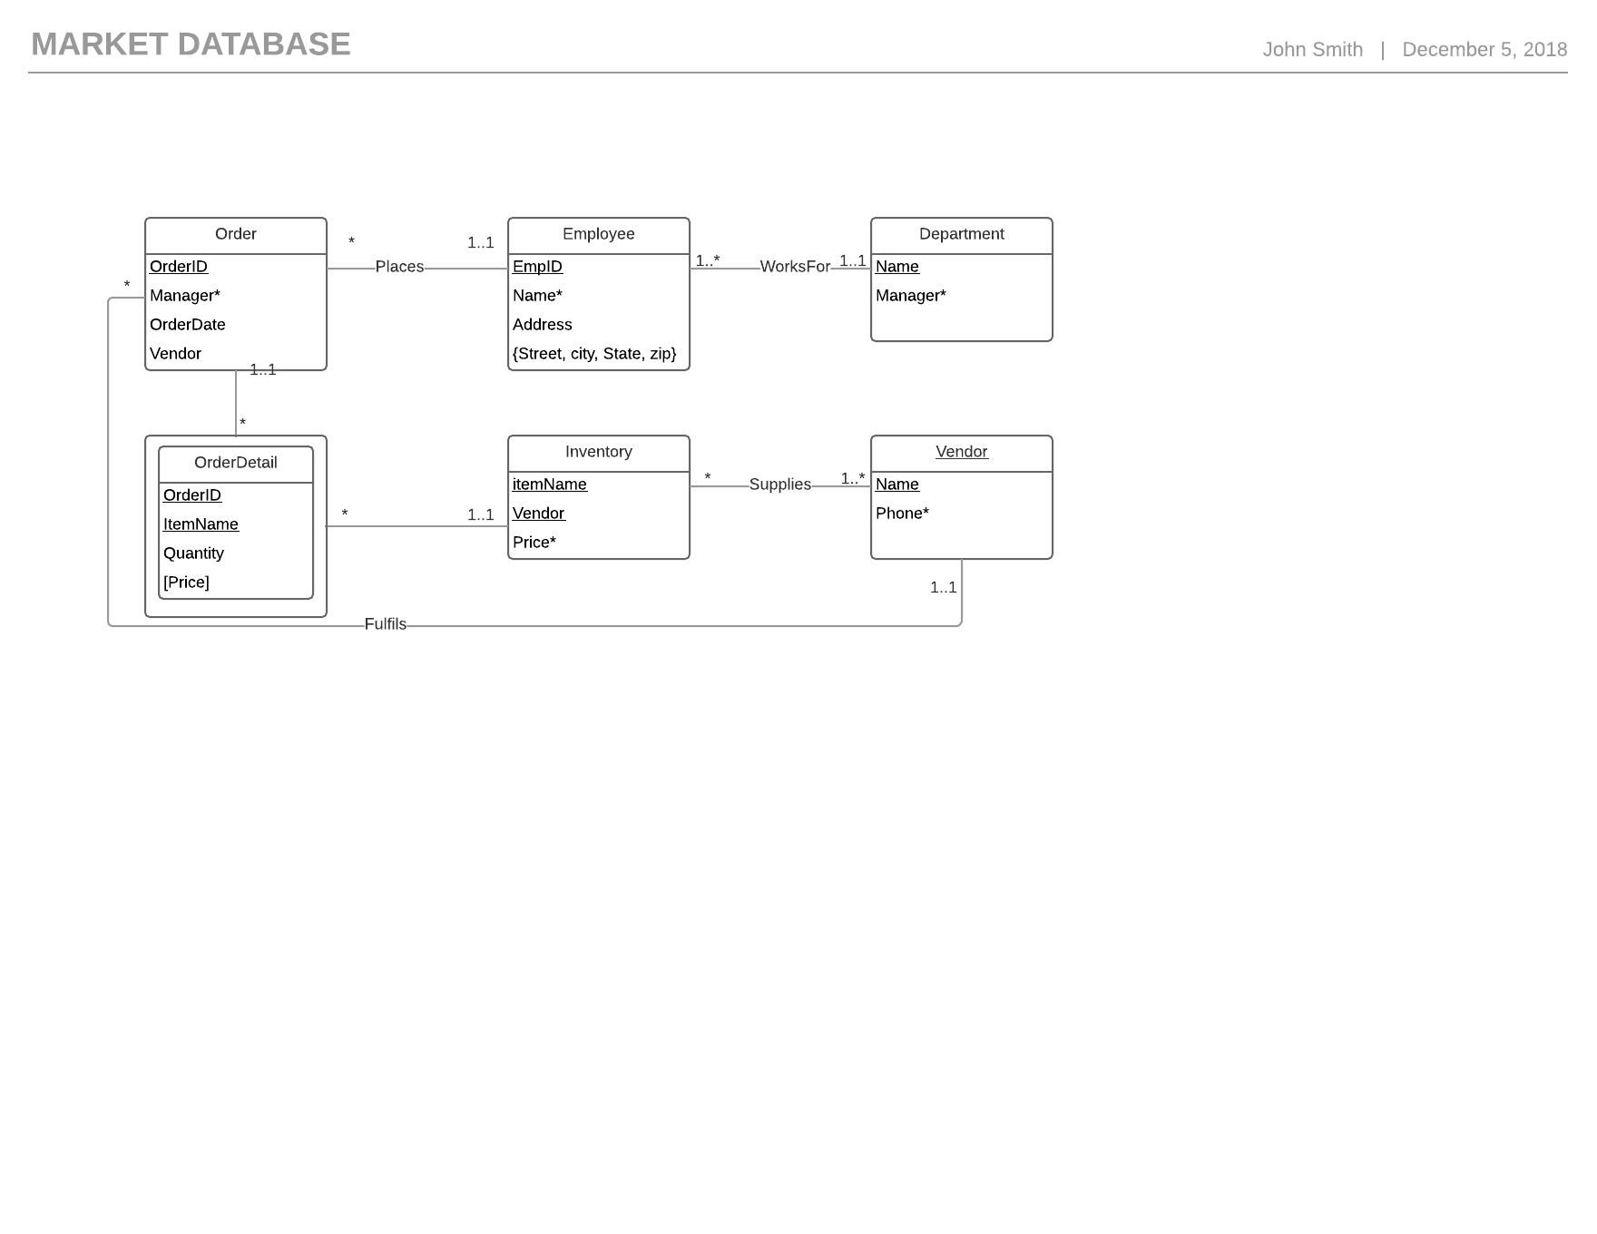

**Order:**

The order entity exists in order to maintain information of orders. This tracks the orderID, the ordering manager and the date of the order. This entity can participate in the relationships where an Employee places an Order and a Vendor fulfils an Order.

**Employee:**

The Employee entity exists in order to maintain employee information. The identifying attribute is the Employee ID and requires an employee name. The entity also includes the employee’s address. An Employee can place an Order and can work for a Department.

**Department:**

The department entity is identified by its name and must always have a manager. An Employee Works for a Department.

**OrderDetail:**

The order detail entity is an associative entity to link the Orders entity with the Inventory Entity. The OrderDetail contains the orderID, ItemName, item quantity and the total price.

**Inventory:**

The inventory entity contains information about an item, the name, the vendor of the item and the price of the item. An item can be supplied by a Vendor.

**Vendor:**

The vendor entity contains information about a vendor. The vendor is identified by their name and requires a phone number. A vendor supplies inventory.