Research Paper: Household Food Spending and Taxation: Evidence from State and Year Fixed Effects, 2020–2024

Research Aim
To examine whether changes in food-at-home (FAH) and food-away-from-home (FAFH) sales tax rates affect household food spending across U.S. states (2020–2024), controlling for state and year fixed effects, and to test whether this effect is regressive (disproportionately larger for households below 185% of the federal poverty line).
Why have we used 2020-2024
This period was chosen because it captures both pandemic shocks (2020–2021) and post-pandemic stabilization (2022–2024). Household food sales data are consistently available from USDA, and demographic variables are provided by CPS. SNAP policy variables are only available through 2020 and carried forward, which naturally limits the usable horizon.
Why the TWFE method was chosen with state and year fixed effects
We used state and year fixed effects because households are not tracked over time, making household fixed effects infeasible. State effects capture persistent differences across states, while year effects absorb nationwide shocks, ensuring credible tax estimates. One-way fixed effects (OWFE) was included only as a robustness check to show how results change when year variation is not controlled.
Hypothesis
- H1: Whether the FAFH and FAH tax rate increase over the years is associated with changes in household food spending.
- H2 (regressivity): Is this effect larger in magnitude for below-poverty households than for above-poverty households.
Regression Specification
- Model 1: Average Effect of FAFH and FAH Tax Rates on Food Expenditure
$l\left(Food_Expenditure_Last_Week_{ist}\right) =β_{1}FAFHTaxRate_{st}+β_{2}FAHTaxRate_{st}+β_{3\left(FAFHTaxRate_{st}×Poverty_{ist}\right)}+β_{4\left(FAHTaxRate_{st}×Poverty_{ist}\right)}+γ^{'}X_{ist}+α_{s}+δ_{t}+ε_{ist}$

- Model 2: FAFH and FAH Tax Rates × Poverty Interaction (Regressivity Test
$lnln \left(Food_Expenditure_Last_Week_{ist}\right) =β_{1}FAFHTaxRate_{st}+β_{2}FAHTaxRate_{st}+β_{3\left(FAFHTaxRate_{st}×Poverty_{ist}\right)}+β_{4\left(FAHTaxRate_{st}×Poverty_{ist}\right)}+γ^{'}X_{ist}+α_{s}+ε_{ist}$

Key Findings
- Restaurant tax (FAFH): No significant impact on food spending for either income group.
- Grocery tax (FAH): Spending rises with higher tax rates (the same groceries cost more as the tax rate rises); they cannot substitute such groceries. The FAH tax rate effect for below-poverty households (0.0097) is approximately 1.8 times larger than the effect for above-poverty households (0.0054), a difference of 0.0043 percentage points, which is the interaction coefficient itself (p = 0.023), confirming this gap is statistically significant rather than due to chance
- Method:
  - Two-way fixed effects (TWFE): Grocery (FAH) taxes are positive and significant. Restaurant (FAFH) taxes are insignificant.
  - One-way fixed effects: Restaurant (FAFH) taxes become positive and significant. Grocery (FAH) taxes turn negative.
  - The direction of results changes between models. This shows sensitivity to specification. TWFE is more credible because it controls for both state and year heterogeneity. One-way FE results should be treated with caution

Implications of Findings
- Below-poverty households' grocery (FAH) spending is roughly twice as sensitive to FAH tax rate changes as above-poverty households; no such differential exists for restaurant (FAFH) taxes.
- These findings come from a fixed-effects panel design, which controls for state and year differences but does not establish causality, as tax rate changes may correlate with unobserved state-level shifts occurring concurrently
Policy Implications
- Poorer households are more sensitive to grocery tax changes, bearing a heavier burden.
- Grocery taxes are regressive, while restaurant taxes are neutral.
- Policy debates should therefore focus on grocery taxation. Exemptions or targeted rebates could reduce the burden for poorer households.

Data Cleaning Process for Analysis
The final analytical sample is 74.1% above and 25.9% below 185% poverty
- Datasets considered for merging are state food sales with taxes and tips/ without taxes and tips from Food Expenditure Series | Economic Research Service; demographic variables from Current Population Survey from Food Security (data dictionary file: cpsdec24.pdf); and SNAP variables from SNAP Policy Data Sets | Economic Research Service (data dictionary file: SNAP Policy Database: Variable Definitions and Coding Descriptions.)
- SNAP policy data (Outreach, Reportsimple, Fingerprint) is available only through 2020 and was carried forward for later years, making it constant within each state and therefore absorbed by state fixed effects; Fingerprint is also constant at 0 across the whole sample. We exclude these variables from our model as a result. It must also be noted that in a TWFE, these variables get absorbed due to no variation.
- SNAP benefits receipt is excluded separately: eligibility mainly targets households below 185% of the poverty line, but 74.1% of our sample is above it
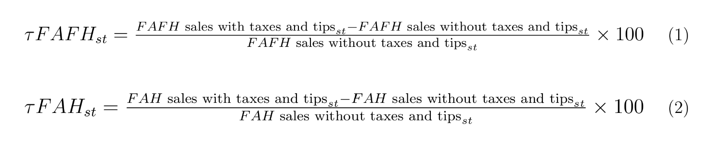
- We first loaded the file of state food sales data and then calculated the FAFH and FAH tax rates (have used the values measured in nominal US dollars) as two new columns using the formulas below. This is named as 'merged_state_sales_panel.csv'. Dropped other variables which is not considered for the study.

- Extracted the following demographic variables from the Current Population Survey (2020-2024) and named the dataset as ‘combined_demographics_20_24.csv’
  - 'HRYEAR4': 'Year',
  - 'GESTFIPS': 'State',
  - 'PRTAGE': 'Age',
  - ‘PESEX': 'Sex',
  - 'PTDTRACE': 'Race',
  - 'PEMARITL': 'Marriage',
  - 'PEEDUCA': 'College Degree',
  - 'HRPOOR': 'Poverty',
  - 'PRNMCHLD': 'Children',
  - 'GTMETSTA': 'Metropolitan Status',
  - 'PREMPNOT': 'Employment',
  - 'HETENURE': 'Living Quarter Status',
  - 'PUDIS': 'Disability',
  - 'PRCITSHP': 'Citizenship',
  - 'HESP1': 'Benefits',
  - 'HETS8O': 'Food Expenditure Last Week'

- We extracted the endogenous variables 'outreach', 'reportsimple', 'fingerprint' from SNAP Policy Database for the year 2020. As the data was not available for 2021, 2022, 2023 and 2024, performing LOCF on such variables (these values do not vary across years), as inferred from literature review is one of the methods used to dealt with.
  - Loads SNAP policy data, splits yearmonth into Year/Month, and isolates only the 2020 values for outreach, reportsimple, fingerprint.
  - Builds a full 2020–2024 monthly grid per state, then merges in the 2020 values by State+Month (ignoring Year) — carrying 2020's values forward to fill 2021–2024.
  - Saves the result as a complete 2020–2024 values of three variables held constant over time – the dataset named as ‘SNAP’.
  - Collapsed the monthly SNAP panel down to one row per state-year (255 rows = 51 states × 5 years) before merging, since the carried-forward values don't vary within a year — avoiding row duplication when joining with the household-level demographic data. Named this file as ‘SNAP_annual’.

- MERGING AS A FINAL DATASET
  - Attaches tax rates to each household: merges 'merged_state_sales_panel.csv' (one row per state-year) onto ‘combined_demographics_20_24.csv’ (one row per household), keeping ‘combined_demographics_20_24.csv’ as the base so the row count stays the same — each household just gets its state's tax rate added on.
  - Attaches SNAP policy values the same way: merges SNAP_annual (also one row per state-year) onto the result, again without adding extra rows — each household now also has its state's SNAP policy values.
The above steps preserves 638,589 rows of the demographic dataset of the CPS
Note: 'merged_state_sales_panel.csv' shape is (255,4)
‘combined_demographics_20_24.csv’ shape is (638589, 16)
‘SNAP.csv’ shape is (3060, 6)
- We then checked the file named ‘December 2024 Food Security Technical Documentation’ accessed through cpsdec24.pdf for data cleaning processes needed for analysis. After recoding demographic variables (marriage, race, education, age, disability, employment, benefits, citizenship, metropolitan status, poverty), the final dataset was saved as final_panel_with_taxes.csv.
The cleaned dataset has 276,077 rows and the following key distributions:
    - Age: valid values only (0 and -1 replaced with NaN).
    - Race: recoded to retain 1, 2, 4; others set to 0; -1 replaced with NaN.
    - Education: collapsed into “No Degree” (1) and “Degree” (2).
    - Marriage: recoded into married (1) vs. not married (2).
    - Employment: standardized categories, invalid codes set to NaN.
    - Disability, Benefits, Citizenship, Metropolitan Status, Poverty: invalid codes replaced with NaN.
    - 'Food Expenditure Last Week' was filtered from 8 to 600 that rounds to nearest 10 dollars, removing the invalid responses (I don’t know, no responses, etc)
    - 'Food Expenditure Last Week' is converted into its log form – household spending data is right skewed
The codes used to recode is given below
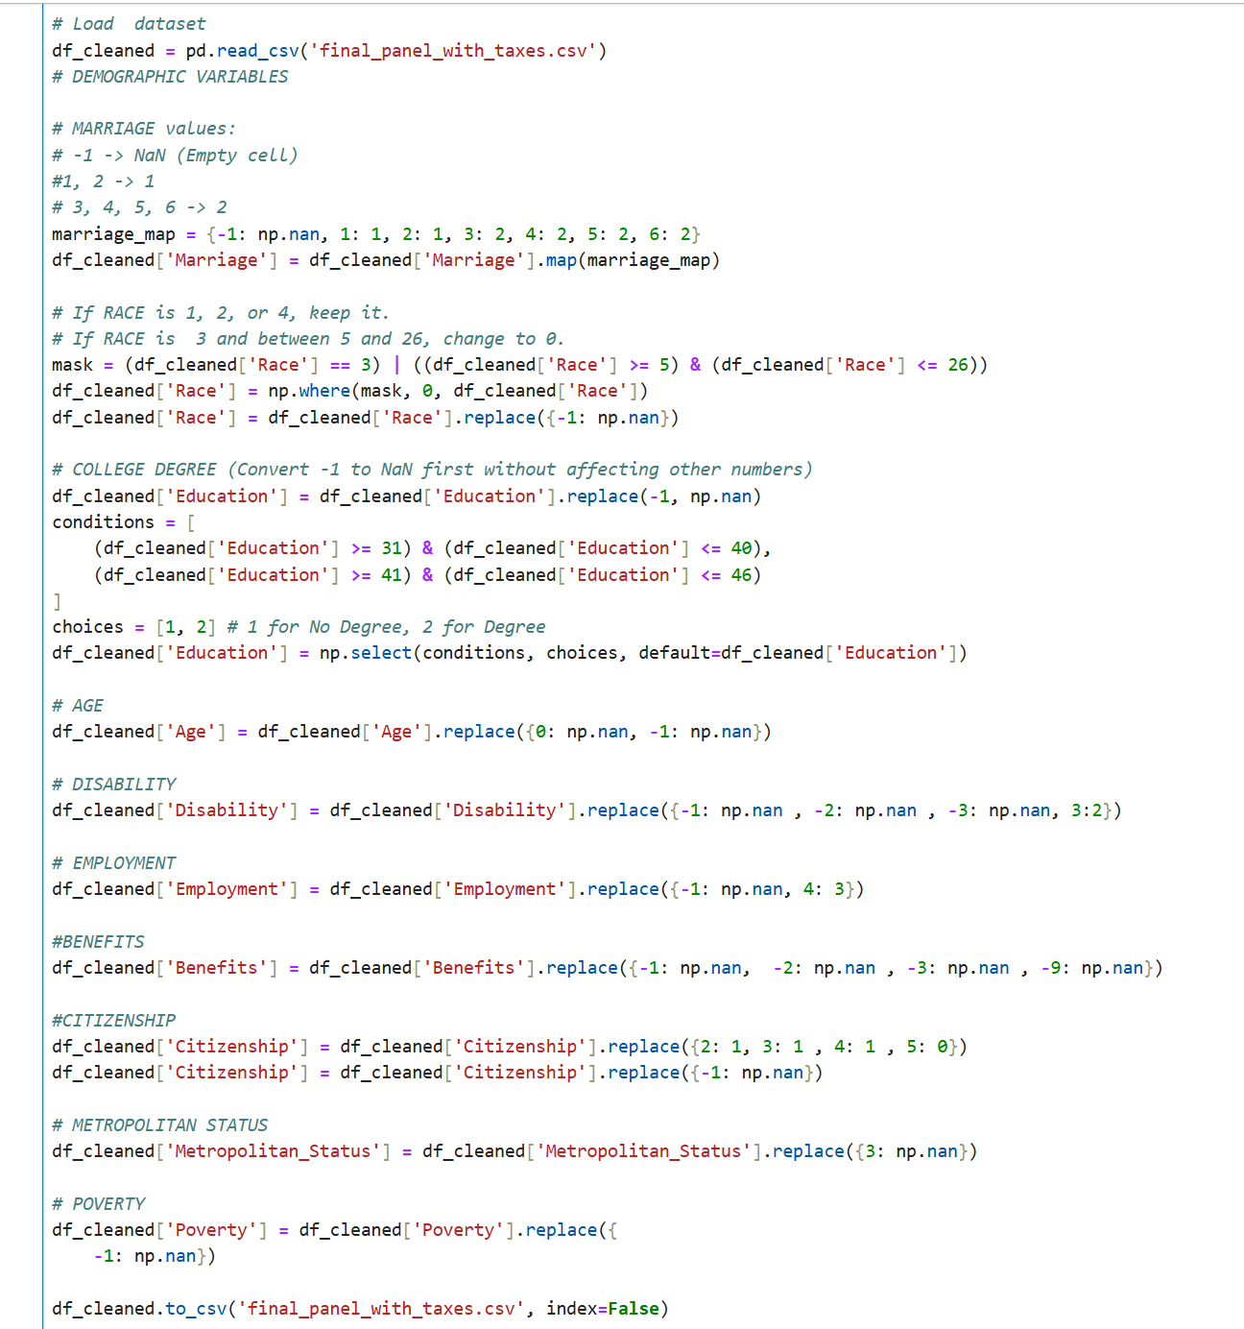
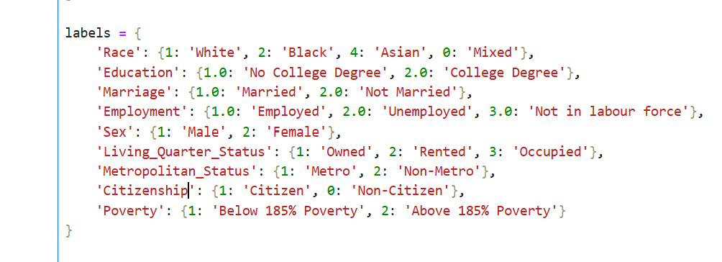


- After filtering out the NaN values, the final dataset has 276077 rows. The 'Benefits' and 'Disability' columns were dropped, as their high missingness (59.3% and 97.6% respectively) would have severely reduced the analytical sample if retained.
- The final dataset is ready for exploratory data analysis and regression analysis. Following are the results from regression analysis
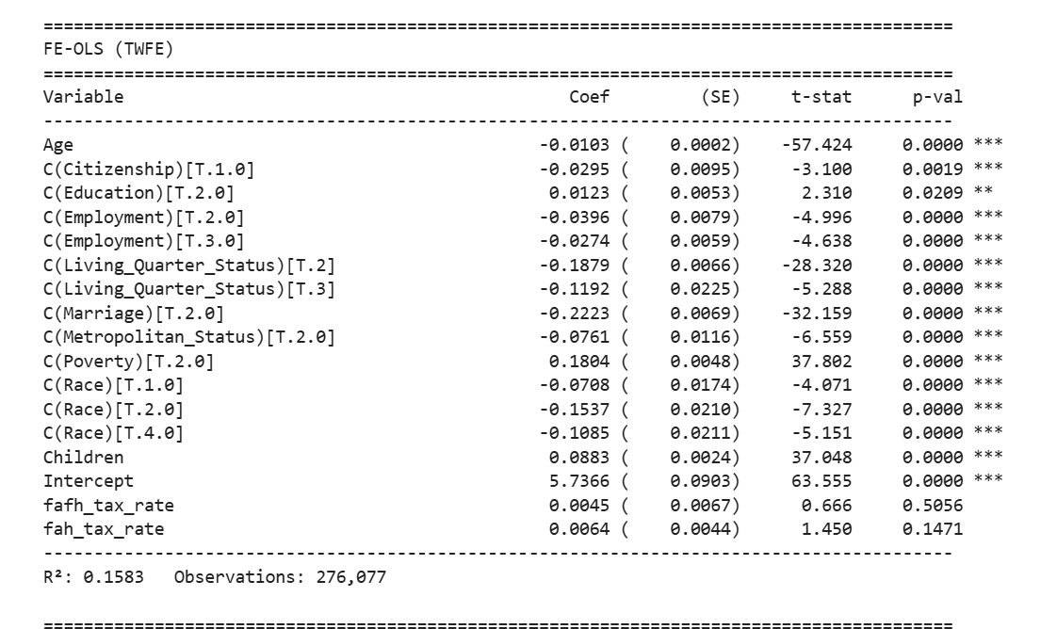

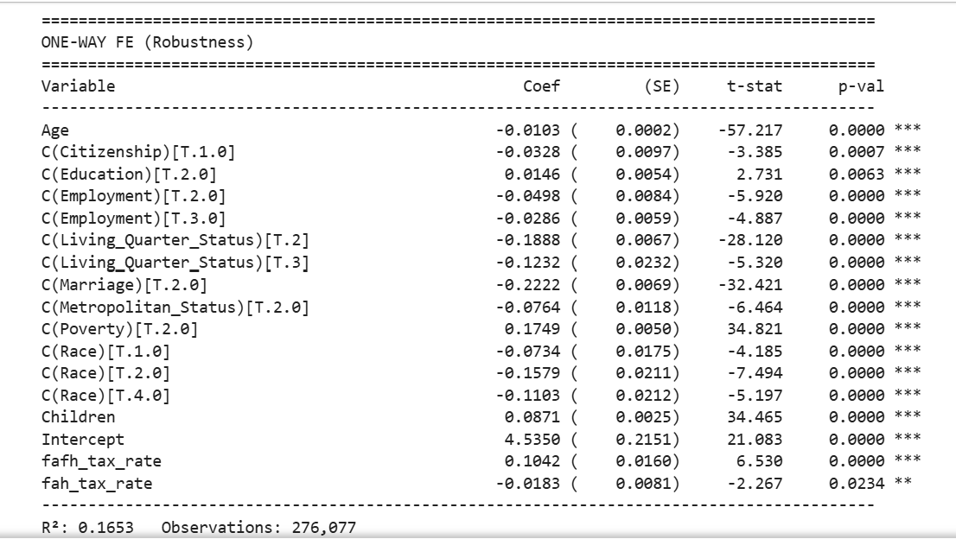

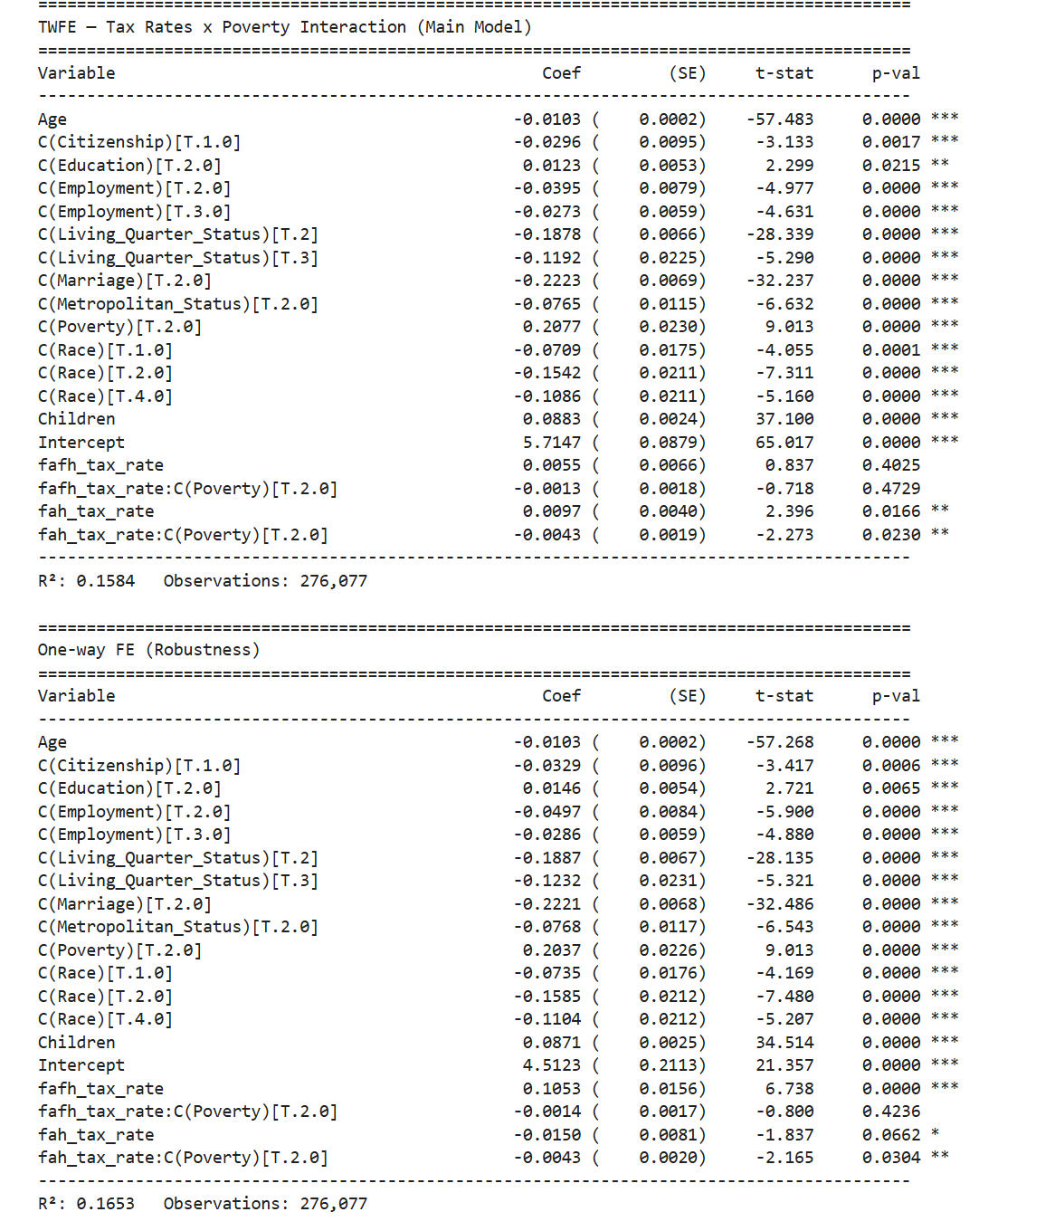

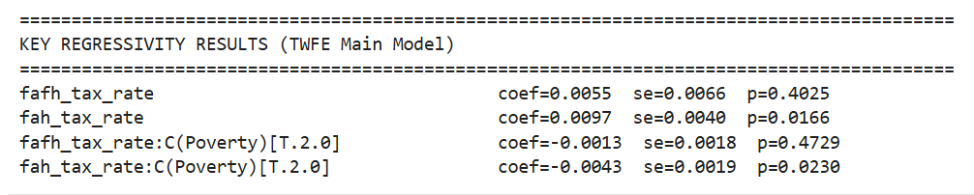

The codes used in the analysis are given below
1) Average Effect of FAFH and FAH Tax Rates on Food Expenditure (No Interaction)
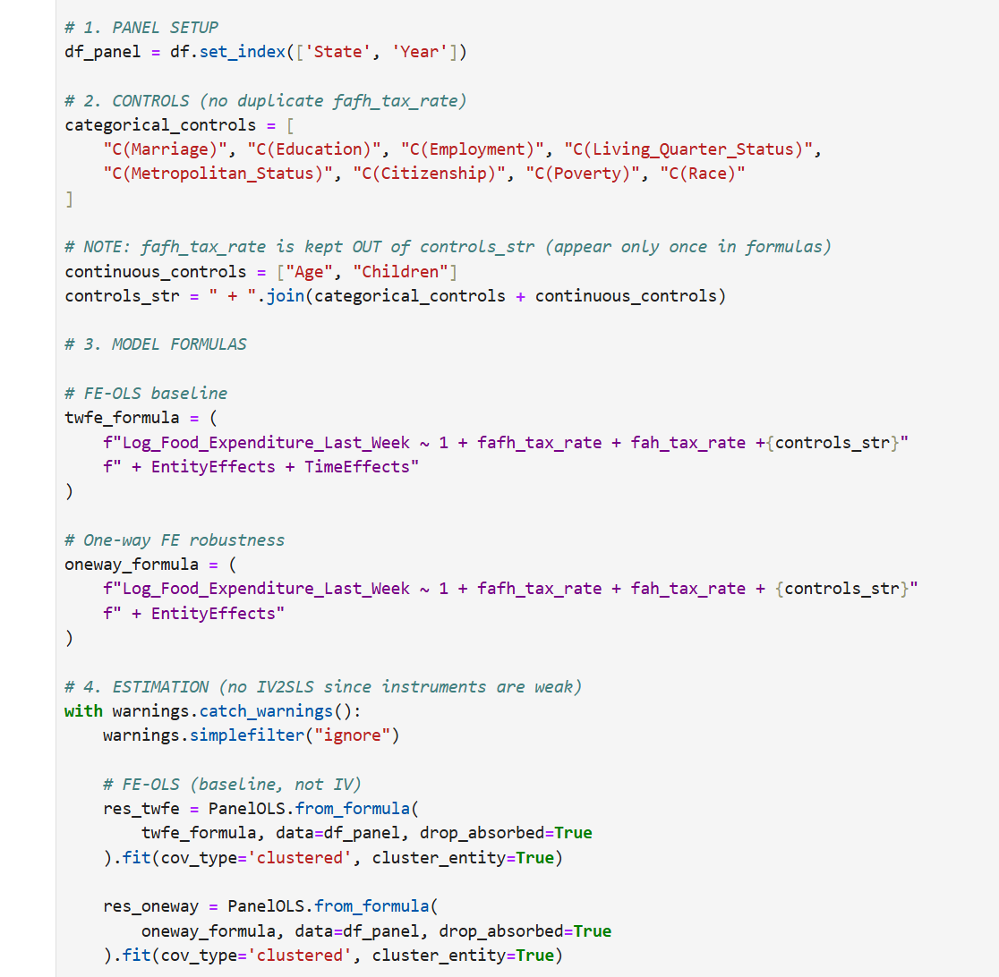
- Model Specification: Two-Way and One-Way Fixed Effects Regression (with Poverty Interaction)

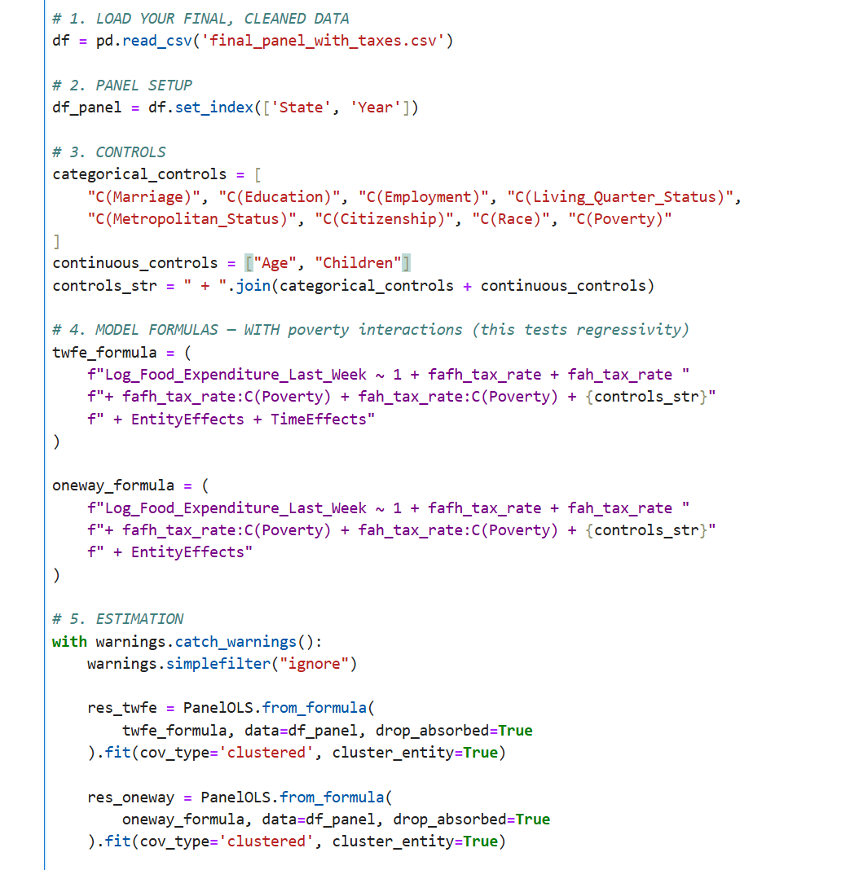

Figures generated for exploratory data analysis
