**Short term traffic flow forecasting model based on convolutional neural network**

Smitha Shetty (190980018)

Usha Rani A V (190980012)

* **Project Overview:**

With the rapid growth of vehicles and the progress of urbanization, the annual cost of traffic jams in urban cities is increasing rapidly, which causes the low efficiency of transportation networks, and results in the loss of time, waste of fuel and excessive air pollution. Therefore, research on the forecasting of urban traffic flow is crucial and it has been regarded as a key problem of intelligent transport management which is also an important means to guide the scientific decision-making of traffic management. Early diagnosis of congestion occurrence and forecast traffic flow evolution are considered to be a key measure to determine traffic bottlenecks, which can be used to support intelligent transport management in the auxiliary.

Short-term traffic flow prediction is the foundation of traffic control and guidance. The performance largely depends on the accuracy of real-time traffic information prediction. The accurate and timely traffic state information not only allows travelers to make better travel decisions, but also benefit transportation management. Because of its importance, traffic flow forecasting has generated great interest among researchers.

* **Problem Definition:**

To improve the forecasting accuracy, the time series data is preprocessed before predict the traffic flows.

* **Scope:**

It is built based on multi fractal characteristics of traffic flow time series. It decomposes into four different components, namely a periodic part, a trendy part, a stationary part, and a volatility part, to extract the traffic features hidden behind the data.

* **Objectives:**
* To improve traffic forecasting accuracy.
* To monitor a day by day traffic conditions.
* **Generic Project life cycle for the chosen technology:**

Hybrid model based on time series multifractal characteristics

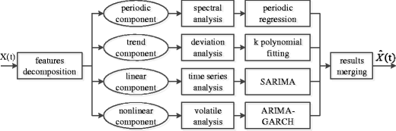

The figure shows, a hybrid model combining multiple modeling and analysis method is built to forecast traffic. This hybrid model first decomposes the traffic flow series into four components: a periodic part, a trend part, a linear part and a nonlinear part.