**METHODOLOGY**

**Architecture and explanation:**

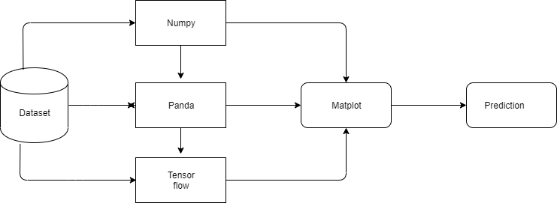

The traffic volume is our dataset. Artificial neural network will be implemented through tensor flow using RNN. Then Matplot will be used to generate visual predictions with respect to time series.

This section presents an empirical data based framework in modeling time series hybrid model prediction.

The process is summarized as follows.

Step 1. Construct three time series according to the characteristics of historical data.

Step 2. Develop the weekly, daily, and hourly models for their corresponding time series after correlation and analysis.

Step 3. Calibrate the time dependent transition probability matrix based on models’ performance using historical data.

The first step sets up three time series based on different dependencies between historical data (week, day, and hourly) and extract meaningful statistics characteristics of the data. The second step develops corresponding parametric models to capture the characteristics and output prediction series. The remainder of this section describes more details related to the above steps.

**Process flow and explanation:**

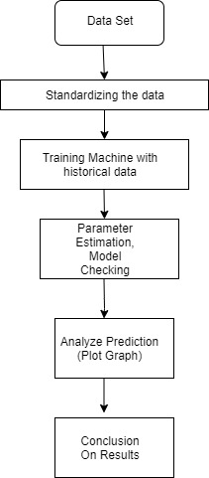

The dataset is collected from NHAI (National Highway Authorities, India) and then standardized as per our requirements. Then, the system will be trained with a set of historical data and parameter estimation is done using parametric model. The results or predictions thus obtained are analysed and predictions will be done with error correction (if required).

**Objective wise methodology:**

1. The count of vehicles moving at a point per unit time which comprises of a set of distinct variables over time is predicted. This is done using parametric technique.
2. Day to day forecast, maximum traffic during a particular hour of day will be predicted using time series methodology