# Users :

## To add users :

[**http://localhost:8888/users**](http://localhost:8888/users)

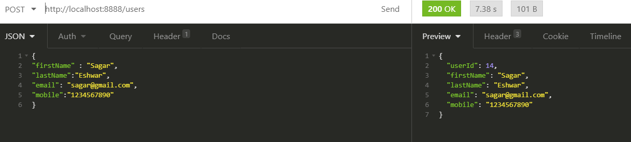

{

"firstName" : "Vishal",

"lastName":"Gupta",

"email": "vishal.gupta@gmail.com",

"mobile":"9739739730"

}

{

"firstName" : "Geetha",

"lastName":"Muniswamy",

"email": "geetha.muni@gmail.com",

"mobile":"8787878787"

}

{

"firstName" : "Goutham",

"lastName":"Sai",

"email": "sai.gou@gmail.com",

"mobile":"1234512345"

}

{

"firstName" : "Abhishek",

"lastName":"Roy",

"email": "roy@yahoo.com",

"mobile":"9999888898"

}

{

"firstName" : "Heena",

"lastName":"Patil",

"email": "patil@yahoo.com",

"mobile":"4546474849"

}

{

"firstName" : "Shiva",

"lastName":"Sharma",

"email": "sharma@yahoo.com",

"mobile":"6564676869"

}

# Delete users :

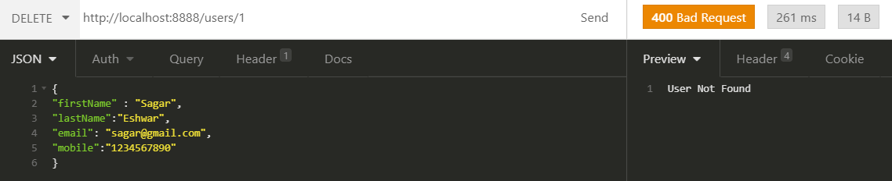

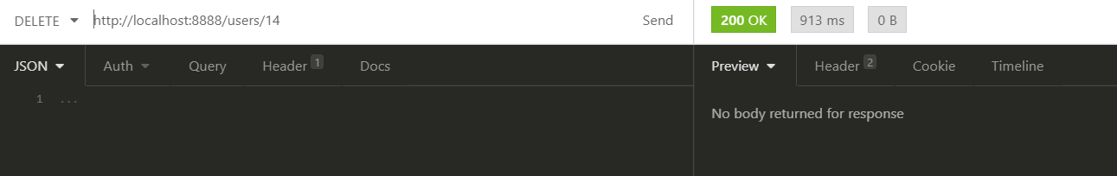

# Retrieve all users :

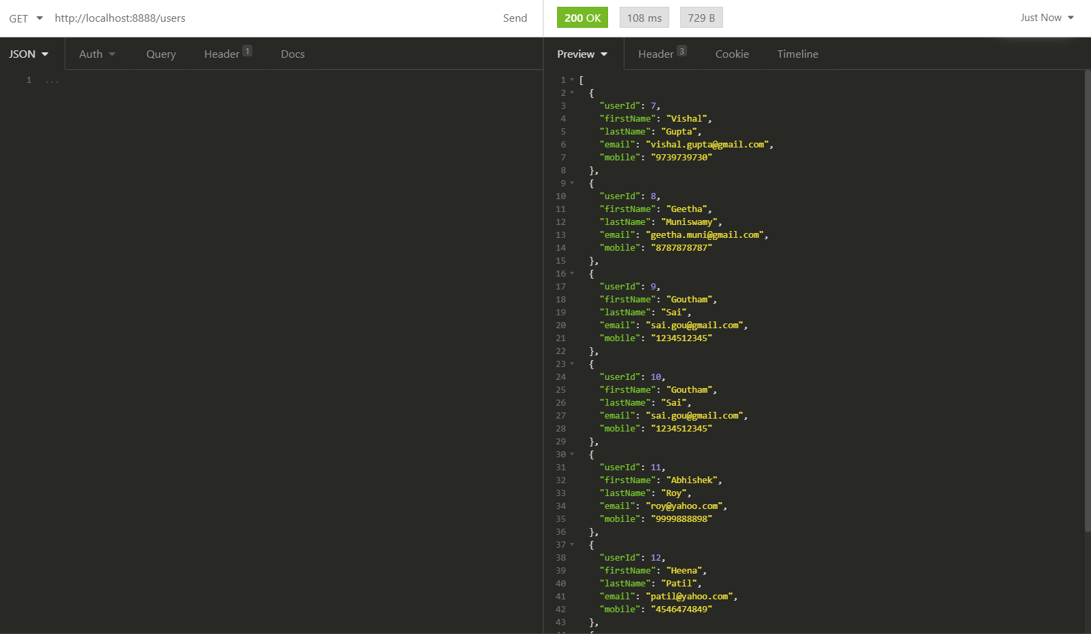

# Interviews

**http://localhost:8888/interviews**

{

"interviewerName":"Lakshmi",

"interviewName":"JavaFullStack",

"usersSkill":"java and spring mvc",

"interviewStatus":"Cleared",

"remarks":"Much appreciated",

"date":"2020-02-12"

}

{

"interviewerName":"Lakshmi",

"interviewName":"JavaFullStack",

"usersSkill":"java and spring mvc",

"interviewStatus":"On hold",

"remarks":"On hold due to budget issues",

"date" : "2020-12-12"

}

{

"interviewerName":"Anjinappa",

"interviewName":"Manual Testing",

"usersSkill":"manual testing, api testing",

"interviewStatus":"Opened",

"remarks":"No candidate with maching profile found"

}

{

"interviewerName":"Anjinappa",

"interviewName":"Web services",

"usersSkill":"rest full services",

"interviewStatus":"Opened",

"remarks":"Interviews are scheduled"

}

{

"interviewerName":"Anjinappa",

"interviewName":"Manual Testing",

"usersSkill":"looking for sdet role profiles",

"interviewStatus":"Waiting",

"remarks":"New position opened"

}

{

"interviewerName":"Jaffer",

"interviewName":"Humar resource",

"usersSkill":"people managements",

"interviewStatus":"Closed",

"remarks":"position is filled"

}

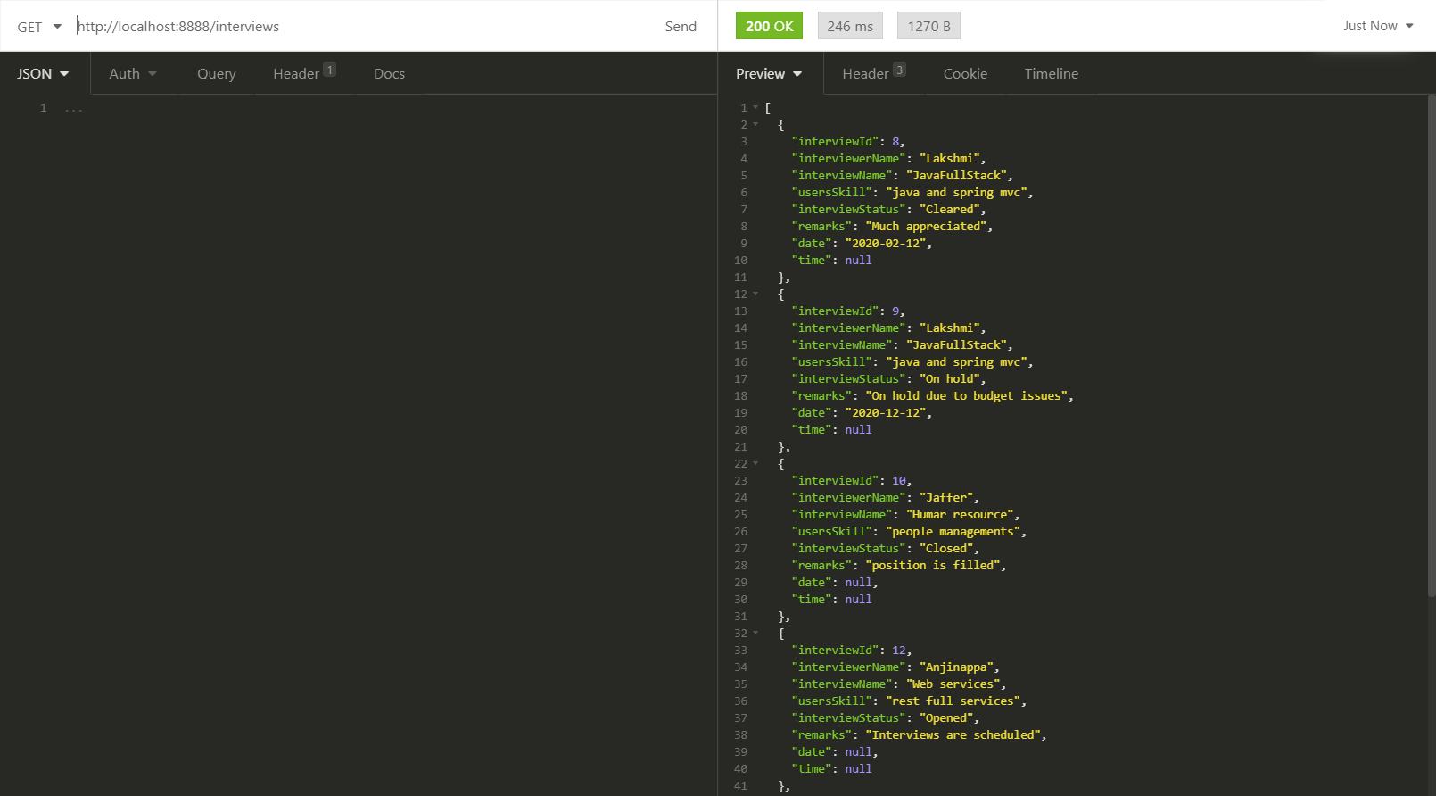

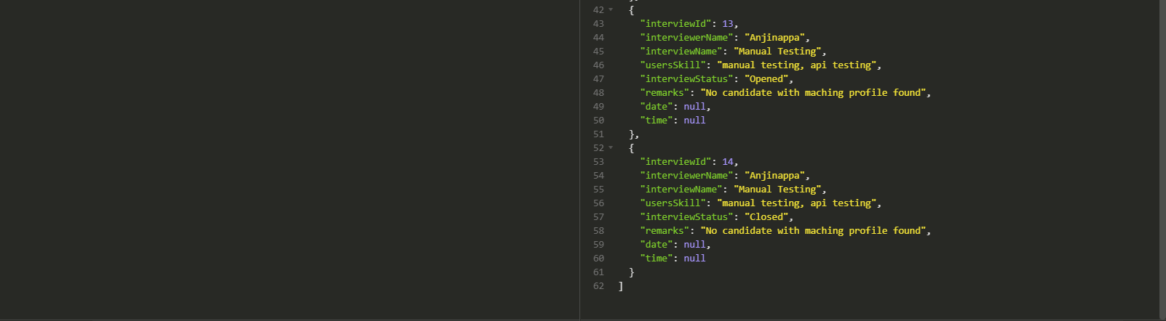

# Count

<http://localhost:8888/interviews/count>

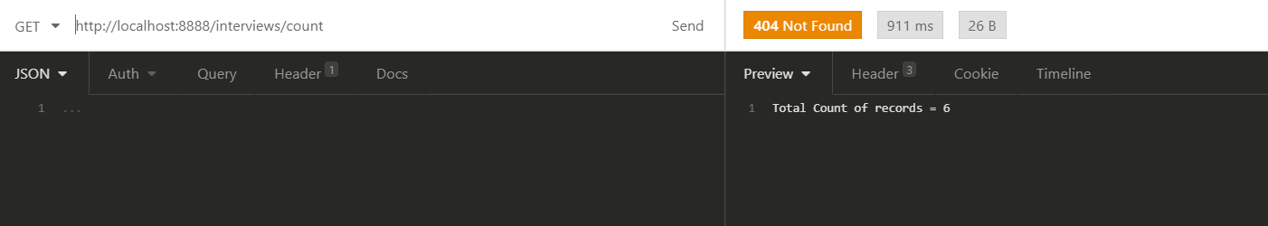

# Delete Interview

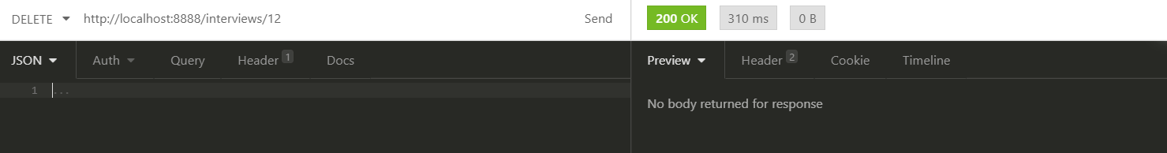

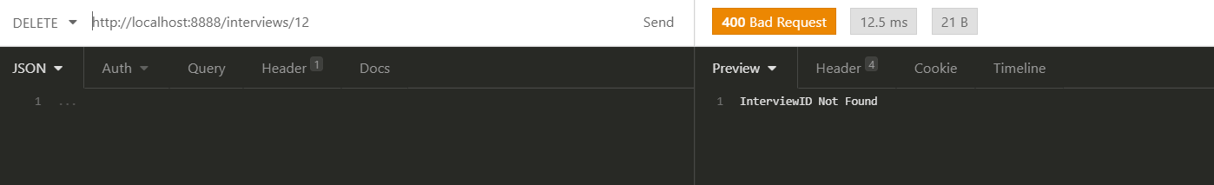

# Update Interview Status

update/{interviewId}/{interviewStatus}

http://localhost:8888/interviews/update/14/Closed

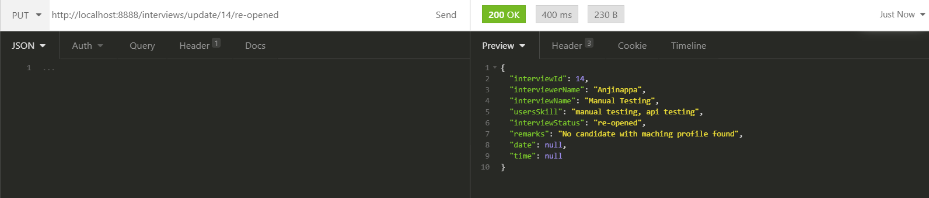

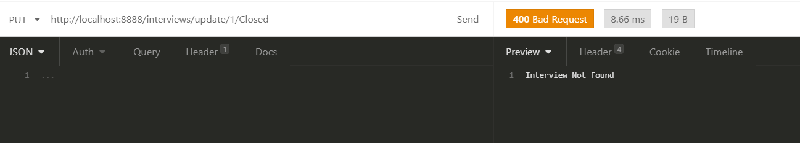

# Get Interviews by interview Name :

interviewName/{interviewName}

http://localhost:8888/interviews/interviewName/JavaFullStack

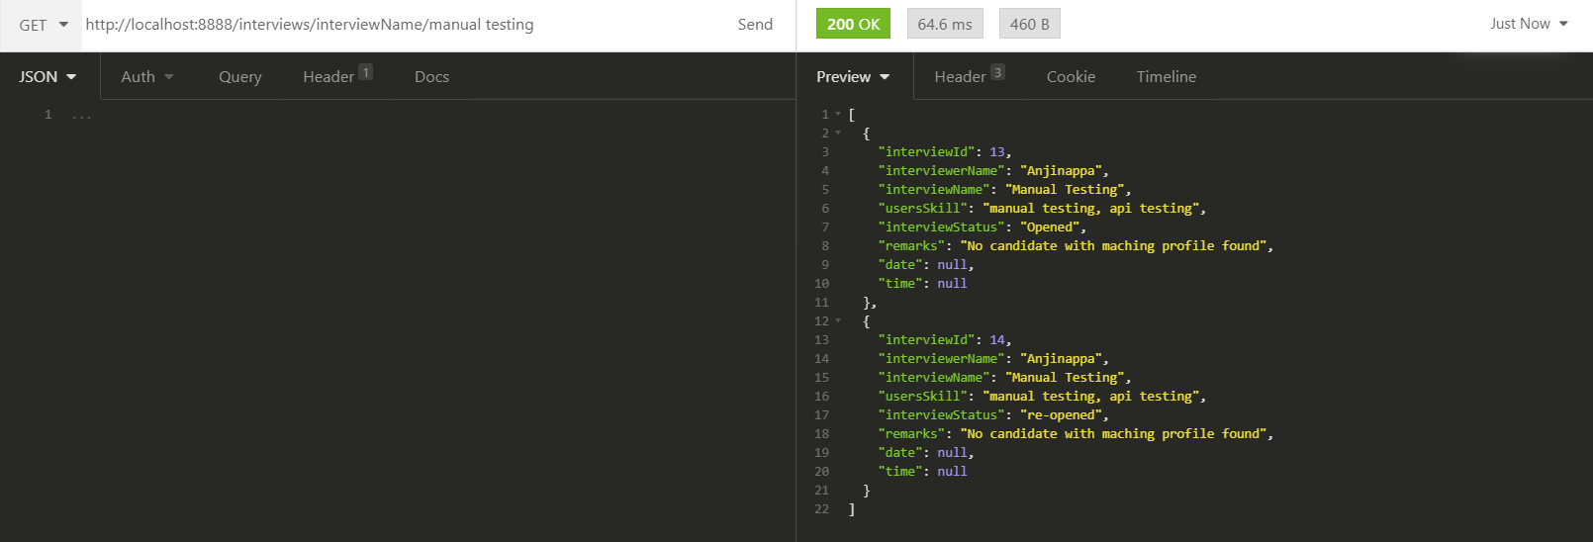

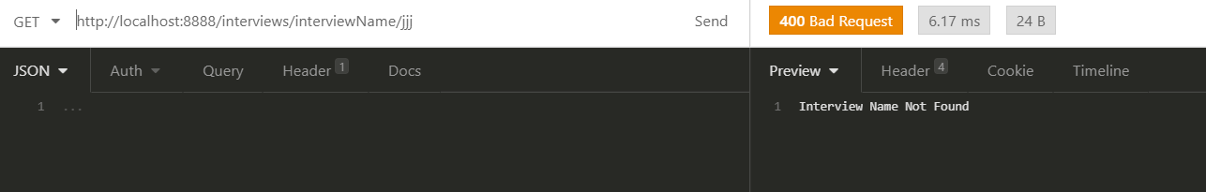

# Get Interviews by interviewer name :

interviewerName/{interviewerName}

http://localhost:8888/interviews/interviewerName/Anjinappa

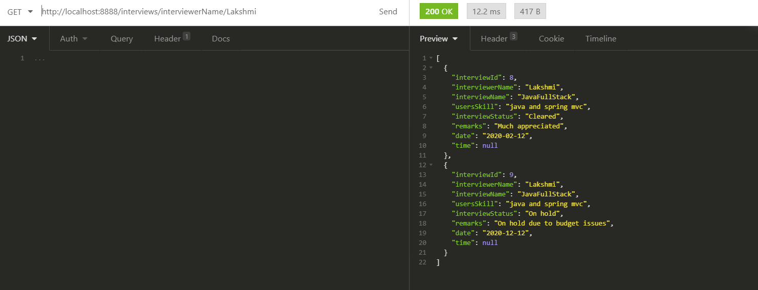

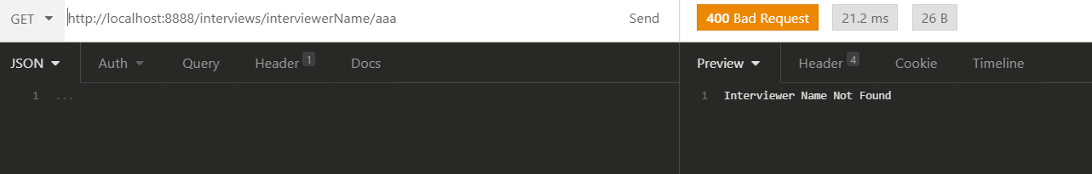

# Add attendee

add/{userId}/{interviewId}

<http://localhost:8888/attendee/add/10/14>

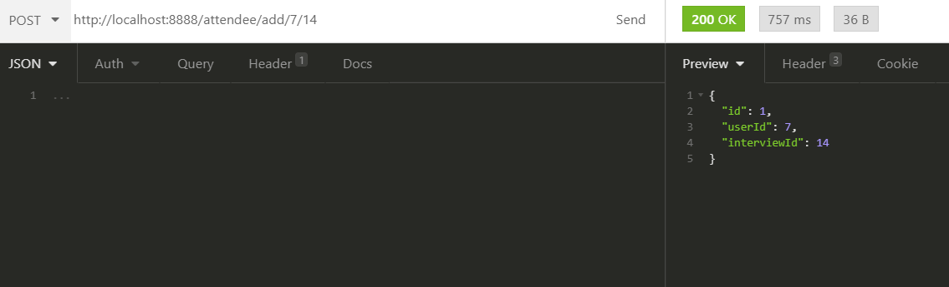

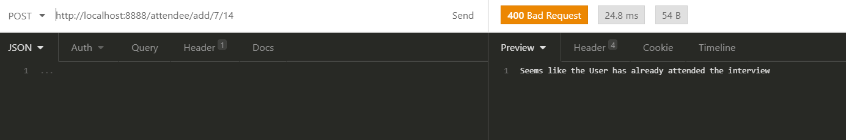

# Fetch Interviews Attended by User :

InterviewsAttendedByUser/{userId}

<http://localhost:8888/attendee/InterviewsAttendedByUser/8>

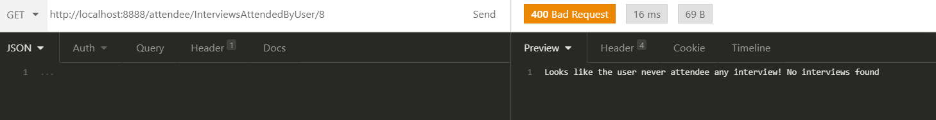

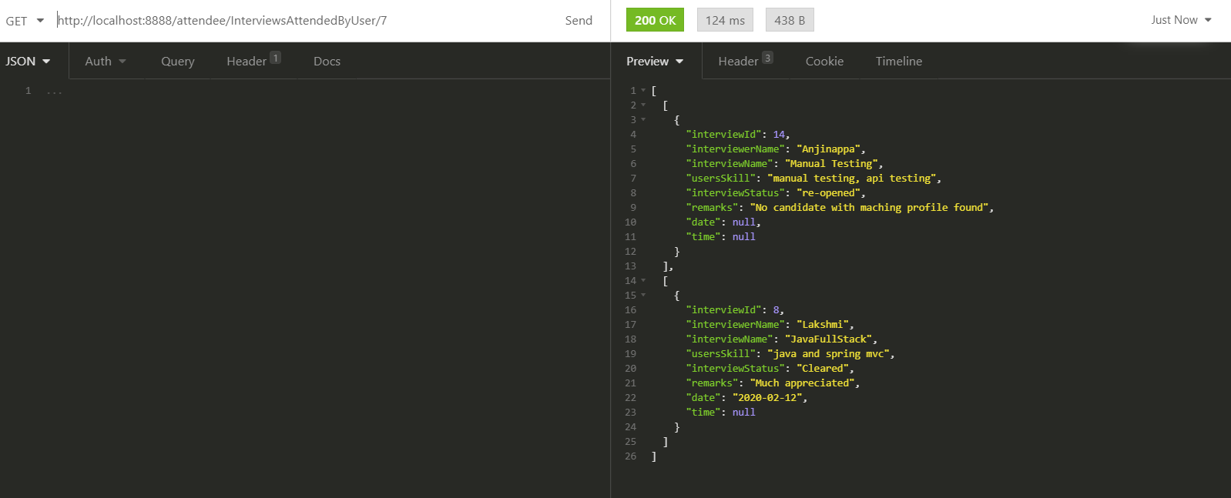

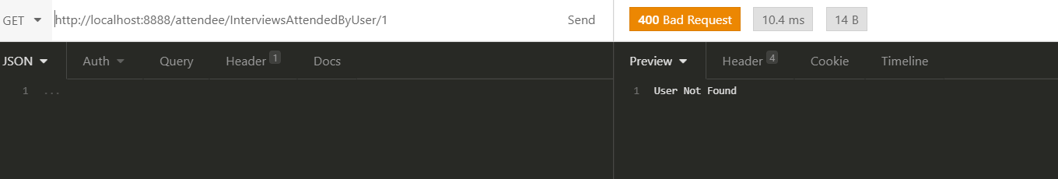

# Fetch the User who attended the Interview :

AttendeesOfAnInterview/{interviewId}

