Business Requirements Document (BRD)
  - Zion
  - March 2022
  - Version 1.00

Document Revisions
Date | Version Number | Document Changes
08/03/2022 | 1.0 | Initial Draft

Approvals
Role | Name | Title | Signature | Date
Project Sponsor
Business Owner
Project Manager
System Architect
Development Lead
User Experience Lead
Quality Lead
Content Lead

Introduction

Project Summary

Objectives
- Receive incoming invoices from Laserfiche or external source.
- Validate the number of documents received at a point in time.
- Extraction of Documents in ICR with Level 1 (L1) Validations.
- QR Code Utility to extract QR code data from Invoices.
- For unsuccessful QR Code extractions, IRN number in invoices to extract data from GSTN website
- Level 2 (L2) Validations of QR code extracted/IRN extracted vs ICR(Rossum) extracted invoice fields
in Project Code.
- User Review Screen to have two sections 1) Header – L1,L2,L3 2) Image. Upon click of a button on the Header section , the L1 or L2 or L3 validations appear in the Image Screen.

Background
The manual effort and time taken for invoice compliancy check by validating the 23 fields from the invoices against those extracted from Laserfiche is huge. In order the reduce the effort and time involved by the users in the compliancy check of invoices before its updated in Seller Portal. Also, not in all cases there is successful extraction of fields by Laserfiche which involves manual entry of the invoice fields.

Business Drivers
- Customers are looking for higher rate of extraction of the fields of Invoice.
- Easier means of validations of the fields.
- Easier means of review of the fields extracted from invoice

Project Scope

In Scope Functionality
- Creation of a Document Exchange module through
  - API
  - Target Email
  - Folder mapping
- Validation mechanism for number of documents received for processing.
- ICR(Rossum) extraction of the invoice fields and custom validations at the Rossum
which constitutes the Level 1(L1 Validation)
- Level 1 Validations include – 1. Amount Based 2. Vendor Name 3. GSTN Validations.
- QR Script to extract fields from detected QR Code.
- If QR Code undetected then IRN number extracted at ICR to be used to query and extract details of invoice from an external website. [Website – TBD]
- Level 2 Validations include – Invoice Fields extracted from QR Code/IRN against the Fields extracted from ICR(Rossum) in Project Code
- User Review Screen – Has Header and Image portions.
- Has 3 Tabs L1, L2, L3 with buttons on the Header tab.
- Clicking on L1 Tab shows a) Amount Validations b) Vendor Name Validations
c) GSTN Validations. – Image shows up in the Image Portion of the Screen.
- Clicking on L2 Tab shows - Rossum extracted to QR Code/IRN extracted – Image
Shows up the validation data.
- L3 - TBD

Out of Scope Functionality
- Handling the Extraction for all invoice types available.
- Handling all Seller Invoices.

System Perspective

Assumptions
- The Vendor and Seller Details are provided as a Master Excel sheet for validation purposes.
- Two Invoice Types will be selected.

Constraints
- Testing of the integration of all the components designed.

Risks
- Different Invoices format differ so training in ICR and custom extensions will vary.
- Additional required fields need to be extracted other than the 23 complaint fields for L1 validation purposes.

Issues
- Not all invoices are of a particular structure so training in ICR for types needs different handling.
- Line level Headers vary for some.
- GST Rates breakup provided in some invoices at line level and in some do not.

Business Process Overview

Current Business Process (As-Is)

Invoice Compliancy Processing in Laserfiche is a manual effort where the extracted Metadata of the Invoice Fields is manually compared to the Invoice Documents for further processing it in the Seller Portal. Not all fields are successfully extracted from the Invoices.

Invoice Compliancy Processing is a frequent activity for users at Invoice Metadata Management by Laserfiche , which happens as and when new invoices arrive from Fulfilment Centre(FC) to Laserfiche.
The current procedure is as follows:
- Fulfilment Centre(FC)/Drag and Drop Incoming Invoices to Laserfiche:
- The incoming invoices are received at Laserfiche either from Fulfilment Centre or by Drag and drop.

- Extraction of Metadata by Laserfiche:
  - The invoices pertaining to a specific seller is opened in Laserfiche by a user assigned to the ‘New Scan’ Folder in the Laserfiche folder structure.
  - Laserfiche shows the Metadata of the selected invoice in the ‘New Scan’ folder.
  - The invoice detail must be entered into the Metadata manually for the missing, not clear and incorrect fields.

- Invoice Compliancy Check:
  - Prior to Metadata update, the invoice should be pre-validated to meet the compliance criteria.
  - This pre-validation is done manually for the compliancy checks.
  - The incorrect, not clear or missing data the invoices are rejected at the Metadata level of the Laserfiche or further clarification by email from vendor.

Proposed Business Process (To-Be)

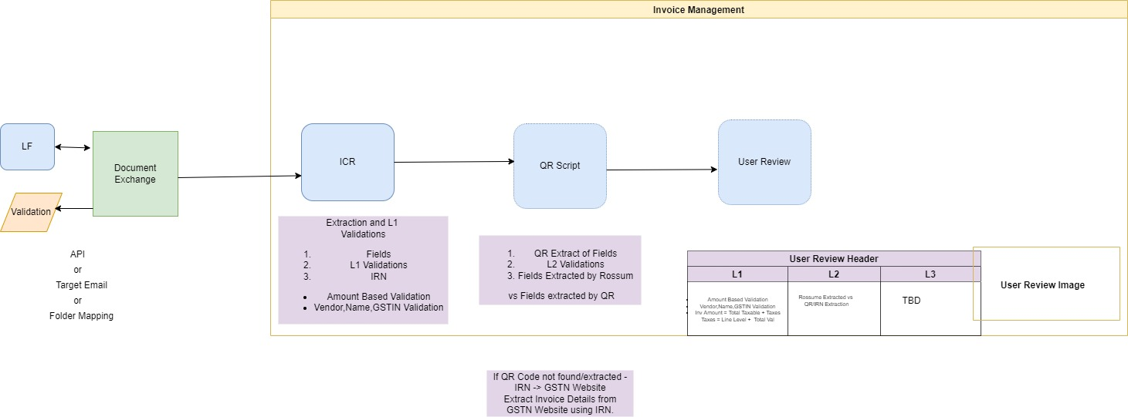

- Invoices are downloaded and number of Invoices downloaded are tracked.
- Incoming Invoices flow into ICR and QR Code.
- In ICR fields are extracted and Level 1 (L1 Validations) are handled.

ICR Extracted Fields | Matching Criteria
Invoice Header [TAX /RETAIL/INVOICE/Bill of Supply] | DocType in QR
Invoice belongs to Seller or not | Seller Name(7 )
Supplier name | Extracted from Invoice
Supplier State | Extracted from Invoice
Supplier TAX details | Extracted from Invoice - Matched against the Master Excel Sheet of Vendor In-built extension in ICR - QR Code Extracted SellerGSTIN -– CANNOT BE HANDLED CURRENTLY FOR VALIDATION
Seller name | Extracted from Invoice
Place of Supply | Should match 'Ship to' Field extracted from Invoice
Seller TAX details | Extracted from Invoice - Matched against the Master Excel Sheet of Seller - - Custom Extension in ICR -- QR Code Extracted BuyerGSTIN – CANNOT BE HANDLED CURRENTLY FOR VALIDATION
Cost base amount | In-built extension in ICR
Tax amount | In-built extension in ICR
Total amount | TotInvVal in QR code extraction - In-built extension in ICR
PO number [either on invoice or on mail] | Extracted from Invoice
Invoice should have vendor sign and stamp/business name | TBD - How to capture image in ICR ?  – CANNOT BE HANDLED CURRENTLY FOR VALIDATION
Barcode ID | FileName in QR code ( Matches for only 3 series invoice)
Unique Invoice number for that year | DocNo(Invoice Number) from QR Code
Invoice date | DocDt in QR Code extracted
Invoice quantity | Total Validated against line level invoice quantity- Custom Extension in ICR
GST rate line level | Individual GST rate at Line level should match the Total Tax Amount - Custom extension in ICR
Tax Total amount on Header level | Extracted from Invoice - should match 12
Line level Price | Extracted from Invoice
Line level Quantity in case of multiple lines | Extracted from Invoice along with Quatity Type
QR code and IRN- If Vendor is E-invoicing Eligible | QR Code extracted data if not use IRN to query an External Website [External Website - TBD]
POD- Proof of delivery | TBD - How to capture image in ICR ?  – CANNOT BE HANDLED CURRENTLY FOR VALIDATION
Ship To | Extracted from Invoice
IRN | Extracted from Invoice

- In QR Code , QR Code extracts 10 fields of QR code.

SellerGstin | BuyerGstin | DocNo | DocTyp | DocDt | TotInvVal | ItemCnt | MainHsnCode | Irn | IrnDt
29AAACM9840P1ZP | 29AADCV4254H1Z4 | 212816103 | INV | 10/01/2022 | 94622.78 | 9 | 85123010 | 89280414b7431ef4e61b16a52d317f01336e8b18b9e589c43434b584f9e3ca3b | 2022-01-10 16

- If QR code undetected/Decode Error then IRN extracted at L1 is used to extract invoice details from
An external website. [External Website – TBD]
- Level 2 (L2) Validations of fields extracted by QR Code/IRN against ICR extracted fields to be done In Project Code.
- User Review Screen – Has Header and Image portions.
- Has 3 Tabs L1, L2, L3 with buttons on the Header tab.
- Clicking on L1 Tab shows a) Amount Validations b) Vendor Name Validations
- GSTN Validations. – Image shows up in the Image Portion of the Screen.
- Clicking on L2 Tab shows - Rossum extracted to QR Code/IRN extracted – Image
Shows up the validation data.
- L3 - TBD
- User confirms the validation checks on the User Review Screen.

Business Requirements
The requirements in this document are prioritized as follows:
Value | Rating | Description
1 | Critical | This requirement is critical to the success of the project. The project will not be possible without this requirement.
2 | High | This requirement is high priority, but the project can be implemented at a bare minimum without this requirement.
3 | Medium | This requirement is somewhat important, as it provides some value but the project can proceed without it.
4 | Low | This is a low priority requirement, or a “nice to have” feature, if time and cost allow it.
5 | Future | This requirement is out of scope for this project, and has been included here for a possible future release.

Functional Requirements
Req# | Priority | Description | Rationale | Use Case Reference | Impacted Stakeholders
General / Base Functionality
Security Requirements
FR-S-001 | 1 | Widget creation in the repository shall be limited to users with Team Lead or System Administrator,
Reporting Requirements
Usability Requirements
Audit Requirements

Non-Functional Requirements

ID | Requirement

Appendices

List of Acronyms
[If needed, create a list of acronyms used throughout the BRD document to aid in comprehension.]

Glossary of Terms
[If needed, identify and define any terms that may be unfamiliar to readers, including terms that are unique to the organization, the technology to be employed, or the standards in use.]

Related Documents
[Provide a list of documents or web pages, including links, which are referenced in the BRD.]

