**​ User Manual (Instalation and build instructions)**

 The Apartment Rater is a java web app is licensed under the MIT  license  Please see the file LICENSE

<https://github.com/01akanksha/AppartmentRater/blob/master/LICENSE> for license term

Build Instructions:

1.  Make sure you have JDK 8 and NetBeans 8.1 installed in your machine

2. Install the Ucan Access Drivers version -3.0.6 into the Project library as well as in the jdk folder.

It is an open source bridge for the java 8 as java 8 doesnot have jdbc bridge any more.

Put the libraries from library folder of the ucan access in the below location-

C:\Program Files\Java\jdk1.8.0_73\jre\lib\ext

Also from net beans add the libraries by going to Project Properties and then to the libraries tab and then adding these libraries

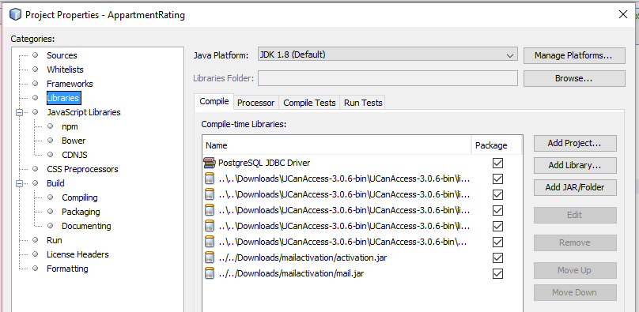

3. Download as zip or clone the code for ApartmentRater from

<https://github.com/01akanksha/AppartmentRater> and  launch(open) it in the netBeans

4.Please make sure you are having GlassFish version 4.1.1 server installed on your machine and don’t forget to set the projects running server as GlassFish.

It is also available under the open source.

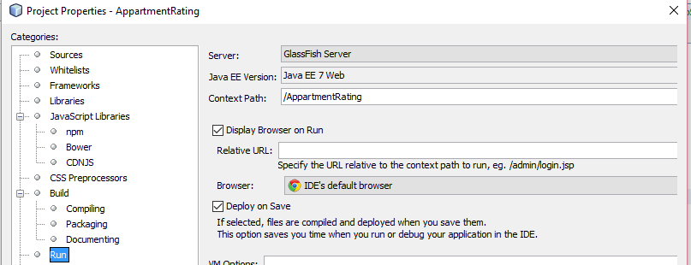

5) After all the above things are set you can run the application from the net beans by clicking the run button. After the successful deploy it will open it in the web browser.