Andrew Smith

HW1 ROB-534 SDM

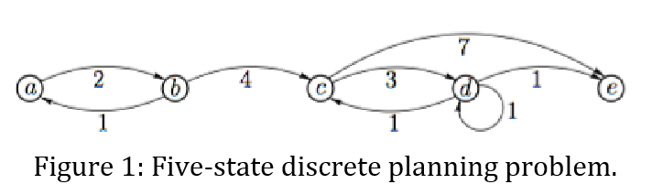

Backward value iteration:

|  |  |  |  |  |  |
| --- | --- | --- | --- | --- | --- |
|  | a | b | c | d | e |
| 1 | N | n | n | n | 0 |
| 2 | n | n | 7 | 1 | 0 |
| 3 | N | 11 | 4 | 1 | 0 |
| 4 | 12 | 8 | 4 | 1 | 0 |
| 5 | 10 | 8 | 4 | 1 | 0 |

Forward value iteration:

|  |  |  |  |  |  |
| --- | --- | --- | --- | --- | --- |
|  | a | B | c | d | e |
| 1 | 0 | N | n | n | N |
| 2 | 0 | 2 | N | n | n |
| 3 | 0 | 2 | 6 | n | n |
| 4 | 0 | 2 | 6 | 9 | 13 |
| 5 | 0 | 2 | 6 | 9 | 10 |

B: 8-Puzzle Problem

i,iii,,v are admissible – ii obviously over estimates in almost every case, iv overestimates when 1 tile is in the wrong place by a large amount

in order: iii,i,v

2-Configuration Space and RRT

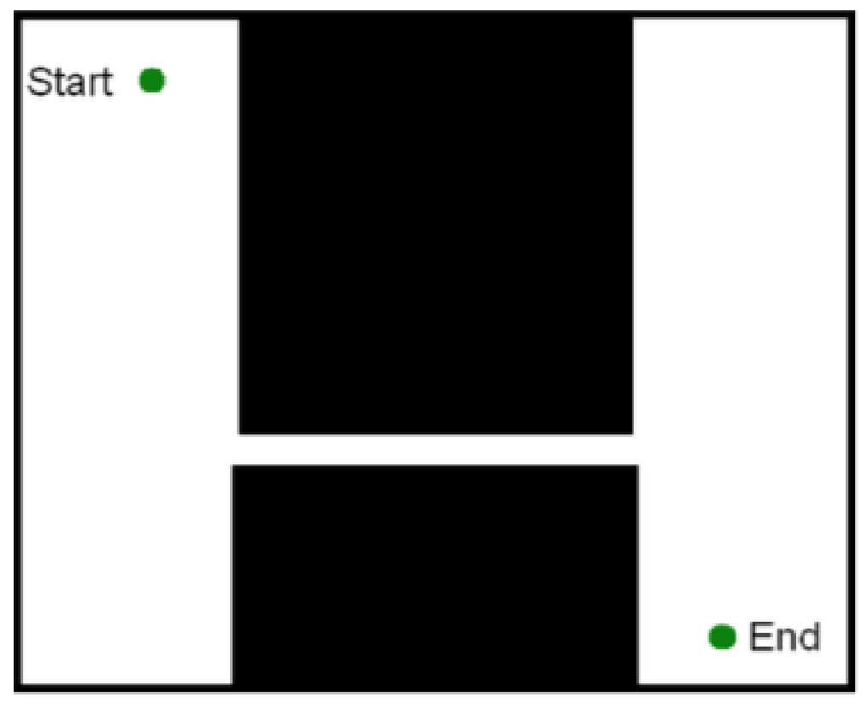

The pictured environment may cause problems because it requires repeatedly sampling in the narrow passage to find a solution. As the passage is narrow and a small portion of the space, this will take a large number of samples (most of which do not contribute to the solution) to find a path that works. Using A* would avoid this problem because it would widely search the open area and then upon finding the narrow passage would move across it quickly guided by the heuristic. Then it would widen the search in the open area while looking for the goal. The disadvantage of A* would be the time wasted in the open area which RRT solves quickly. The advantage of A* is how quickly it makes it through the narrow passage. As the image is small and 2D I would assume that A* would be advantageous in memory an computation time as RRT would require a large number of samples to find a path.

A*

Heuristic = abs(sx-gx) + abs(sy-gy)

Maze1

|  |  |  |  |
| --- | --- | --- | --- |
| Time | Final Epsilon | Length | Nodes |
| 1.0 | 1.001 | 48 | 49 |
| 0.25 | 1.001 | 48 | 49 |
| 0.05 | 3.25 | 48 | 49 |

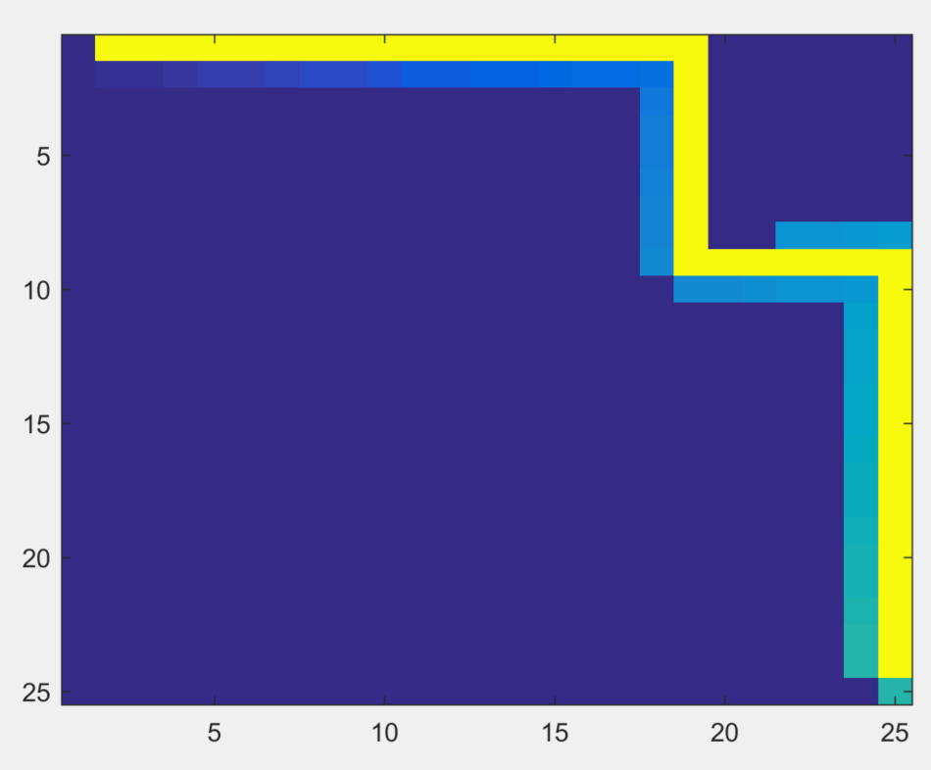

Maze2

|  |  |  |  |
| --- | --- | --- | --- |
| Time | Final Epsilon | Length | Nodes |
| 1.0 | 1.001 | 48 | 233 |
| 0.25 | 1.001 | 48 | 233 |
| 0.05 | 5.5 | 54 | 109 |

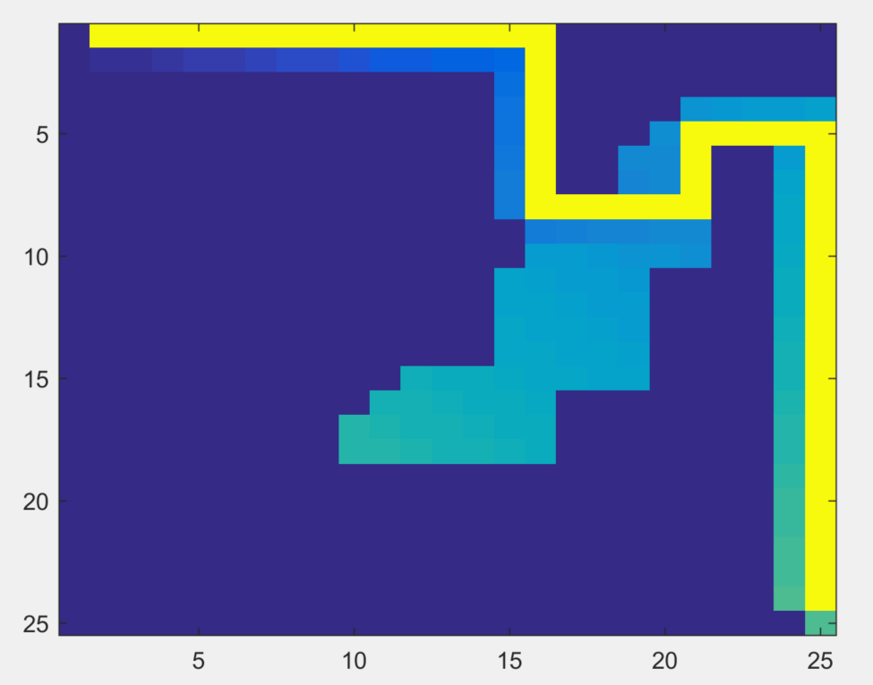

RRT map1

Length = 47.1534

Time = 0.8281

Nodes = 684

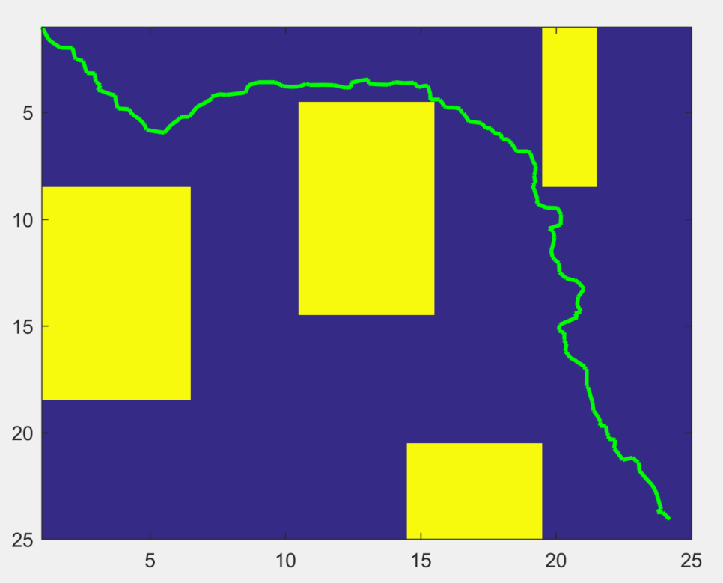

RRT map2

Length = 51.2658

Time = 5.370

Nodes = 2131

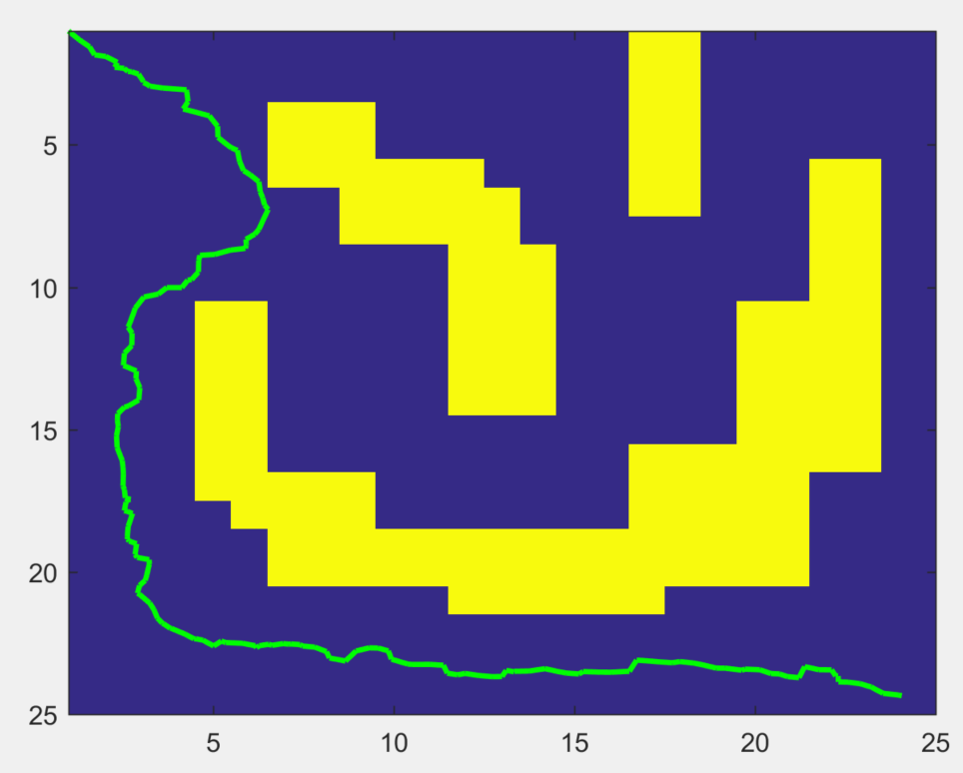

A* 4D

Heuristic = sqrt((sx-gx)^2 + (sy-gy)^2 + (sdx-gdx)^2 + (sdy-gdy)^2)

Maze1

|  |  |  |  |
| --- | --- | --- | --- |
| Time | Final Epsilon | Length | Nodes |
| 1.0 | 1.001 | 21 | 1094 |
| 0.25 | 1.0352 | 21 | 910 |
| 0.05 | 10 | 21 | 30 |

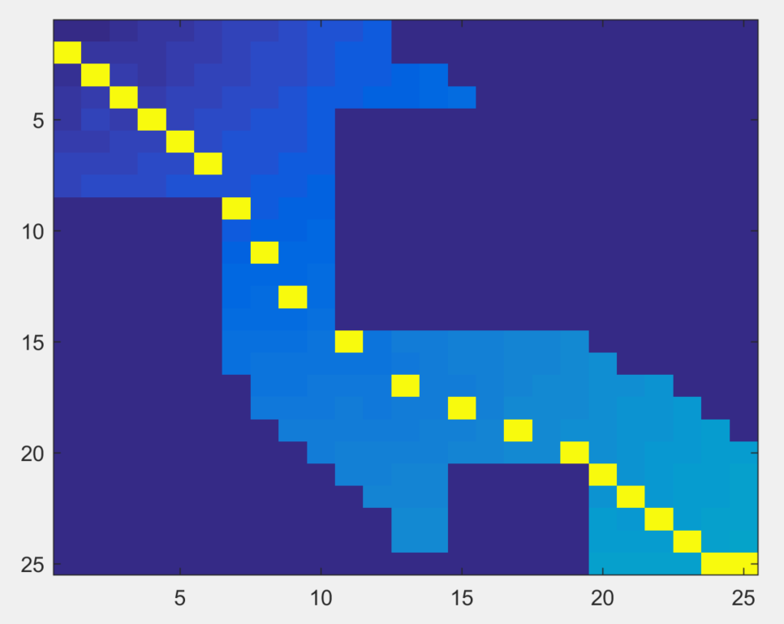

Maze2

|  |  |  |  |
| --- | --- | --- | --- |
| Time | Final Epsilon | Length | Nodes |
| 1.0 | 1.0176 | 27 | 1963 |
| 0.25 | 2.1250 | 24 | 528 |
| 0.05 | 10 | 25 | 525 |

