Situation Report

Your Name

2024-05-22

## Introduction

This report provides a comprehensive analysis of the current epidemiological situation using the provided linelist data. Key metrics and visualizations are included to facilitate understanding of the outbreak dynamics and support decision-making processes.

## Data Import and Analysis

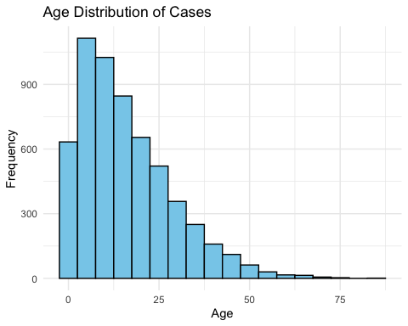

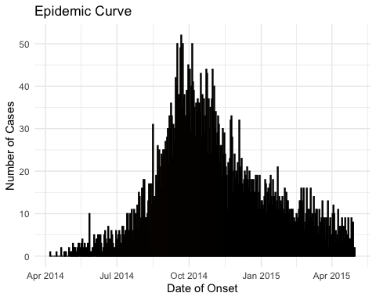

# Symptoms Analysis  
symptoms <- linelist_data %>%   
 select(fever, cough, chills, aches, vomit) %>%  
 pivot_longer(cols = everything(), names_to = "symptom", values_to = "presence") %>%  
 filter(presence == "yes")  
  
ggplot(symptoms, aes(x = symptom)) +  
 geom_bar(fill = 'purple', color = 'black') +  
 labs(title = 'Symptom Analysis', x = 'Symptom', y = 'Count') +  
 theme_minimal()

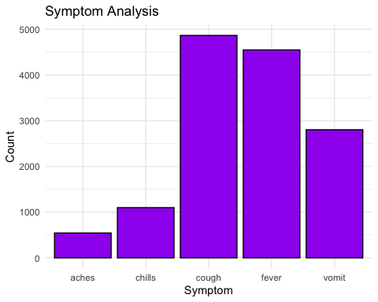

# Case Fatality Rate by Age Group  
case_fatality <- linelist_data %>%  
 group_by(age) %>%  
 summarize(  
 total_cases = n(),  
 total_deaths = sum(outcome == "Death", na.rm = TRUE),  
 case_fatality_rate = (total_deaths / total_cases) * 100  
 )  
  
ggplot(case_fatality, aes(x = age, y = case_fatality_rate)) +  
 geom_line(color = 'red') +  
 geom_point(color = 'blue') +  
 labs(title = 'Case Fatality Rate by Age Group', x = 'Age', y = 'Case Fatality Rate (%)') +  
 theme_minimal()

## Warning: Removed 1 row containing missing values (`geom_line()`).

## Warning: Removed 1 rows containing missing values (`geom_point()`).

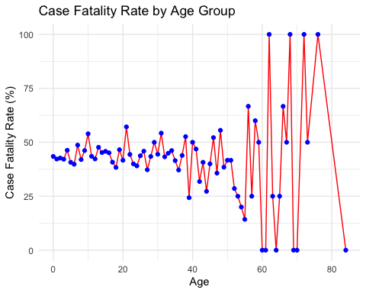

# Time Series Analysis: Infection to Hospitalization  
time_series <- linelist_data %>%  
 filter(!is.na(date_infection) & !is.na(date_hospitalisation)) %>%  
 mutate(time_to_hospital = as.numeric(date_hospitalisation - date_infection))  
  
ggplot(time_series, aes(x = time_to_hospital)) +  
 geom_histogram(binwidth = 1, fill = 'blue', color = 'black') +  
 labs(title = 'Time from Infection to Hospitalization', x = 'Days', y = 'Number of Cases') +  
 theme_minimal()

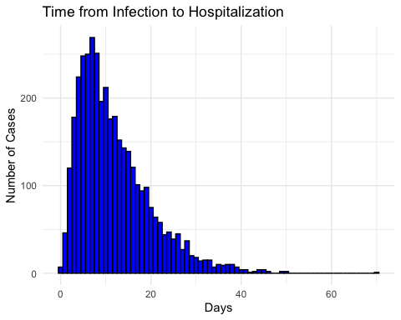

# Hospital Stay Duration  
linelist_data <- linelist_data %>%  
 mutate(hospital_stay_duration = as.numeric(date_outcome - date_hospitalisation))  
  
ggplot(linelist_data, aes(x = hospital_stay_duration)) +  
 geom_histogram(binwidth = 1, fill = 'green', color = 'black') +  
 labs(title = 'Hospital Stay Duration', x = 'Days', y = 'Number of Cases') +  
 theme_minimal()

## Warning: Removed 936 rows containing non-finite values (`stat_bin()`).

