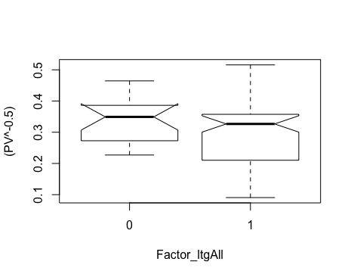

t.test(PV^-0.5~Factor_ltgAll)

Welch Two Sample t-test

data: PV^-0.5 by Factor_ltgAll

t = 1.9887, df = 31.777, p-value = 0.0554

alternative hypothesis: true difference in means is not equal to 0

95 percent confidence interval:

-0.001032049 0.085191784

sample estimates:

mean in group 0 mean in group 1

0.3381822 0.2961024

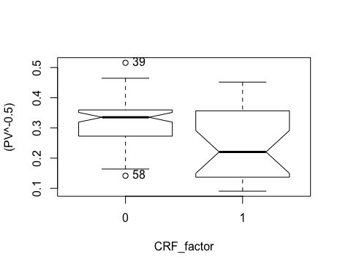

t.test(PV^-0.5~CRF_factor)

Welch Two Sample t-test

data: PV^-0.5 by CRF_factor

t = 2.4575, df = 29.574, p-value = 0.02008

alternative hypothesis: true difference in means is not equal to 0

95 percent confidence interval:

0.01119124 0.12166435

sample estimates:

mean in group 0 mean in group 1

0.3203468 0.2539190

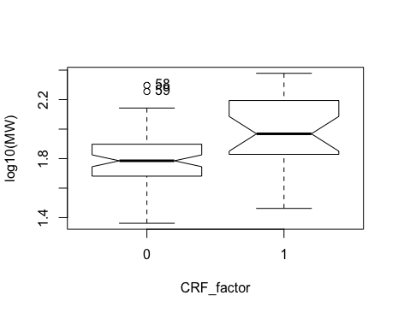

> t.test(log10(MW)~CRF_factor)

Welch Two Sample t-test

data: log10(MW) by CRF_factor

t = -3.1758, df = 31.219, p-value = 0.003354

alternative hypothesis: true difference in means is not equal to 0

95 percent confidence interval:

-0.30338212 -0.06613985

sample estimates:

mean in group 0 mean in group 1

1.781821 1.966582

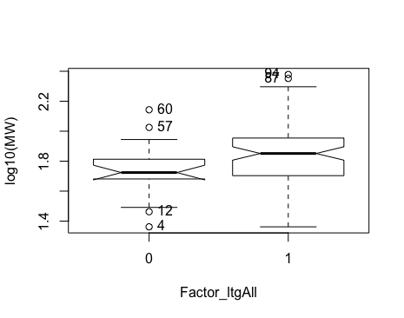

> t.test(log10(MW)~Factor_ltgAll)

Welch Two Sample t-test

data: log10(MW) by Factor_ltgAll

t = -2.2599, df = 28.85, p-value = 0.03155

alternative hypothesis: true difference in means is not equal to 0

95 percent confidence interval:

-0.22304124 -0.01109644

sample estimates:

mean in group 0 mean in group 1

1.732191 1.849259

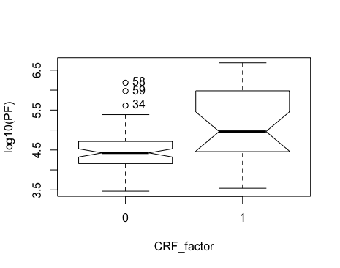

> t.test(log10(PF)~CRF_factor)

Welch Two Sample t-test

data: log10(PF) by CRF_factor

t = -3.2937, df = 27.591, p-value = 0.002716

alternative hypothesis: true difference in means is not equal to 0

95 percent confidence interval:

-1.0593391 -0.2466037

sample estimates:

mean in group 0 mean in group 1

4.478059 5.131030

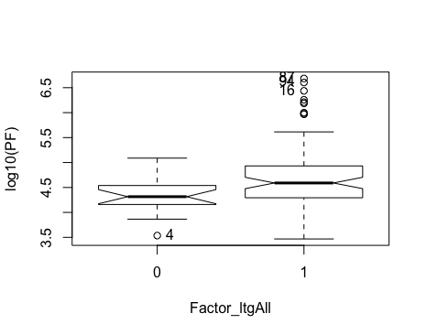

> t.test(log10(PF)~Factor_ltgAll)

Welch Two Sample t-test

data: log10(PF) by Factor_ltgAll

t = -3.2349, df = 50.791, p-value = 0.002143

alternative hypothesis: true difference in means is not equal to 0

95 percent confidence interval:

-0.6293506 -0.1473065

sample estimates:

mean in group 0 mean in group 1

4.323351 4.711679

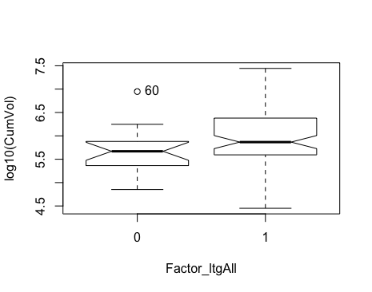

> t.test(log10(CumVol)~Factor_ltgAll)

Welch Two Sample t-test

data: log10(CumVol) by Factor_ltgAll

t = -2.6006, df = 30.999, p-value = 0.01413

alternative hypothesis: true difference in means is not equal to 0

95 percent confidence interval:

-0.63645227 -0.07695395

sample estimates:

mean in group 0 mean in group 1

5.656498 6.013201

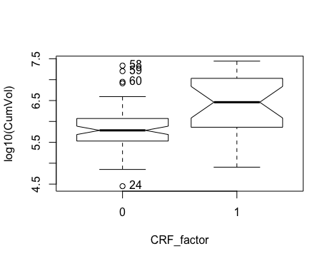

> t.test(log10(CumVol)~CRF_factor)

Welch Two Sample t-test

data: log10(CumVol) by CRF_factor

t = -3.3681, df = 30.43, p-value = 0.002067

alternative hypothesis: true difference in means is not equal to 0

95 percent confidence interval:

-0.8883049 -0.2179279

sample estimates:

mean in group 0 mean in group 1

5.810156 6.363272

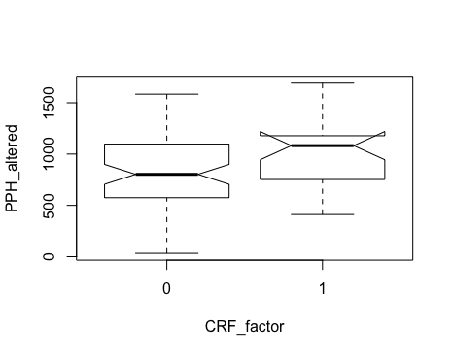

> t.test(PPH_altered~CRF_factor)

Welch Two Sample t-test

data: PPH_altered by CRF_factor

t = -2.2856, df = 35.989, p-value = 0.02827

alternative hypothesis: true difference in means is not equal to 0

95 percent confidence interval:

-342.3321 -20.4310

sample estimates:

mean in group 0 mean in group 1

834.1153 1015.4969

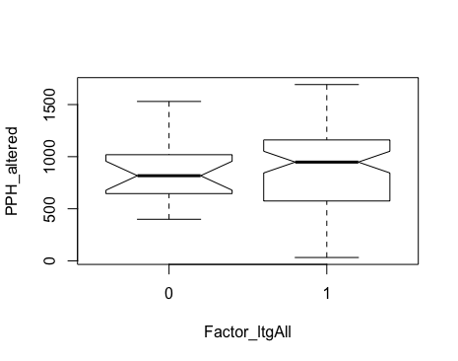

> t.test(PPH_altered~Factor_ltgAll)

Welch Two Sample t-test

data: PPH_altered by Factor_ltgAll

t = -0.67455, df = 30.16, p-value = 0.5051

alternative hypothesis: true difference in means is not equal to 0

95 percent confidence interval:

-203.5554 102.4587

sample estimates:

mean in group 0 mean in group 1

837.8250 888.3734

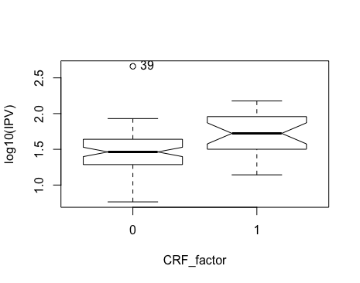

> t.test(log10(IPV)~CRF_factor)

Welch Two Sample t-test

data: log10(IPV) by CRF_factor

t = -4.103, df = 42.928, p-value = 0.0001787

alternative hypothesis: true difference in means is not equal to 0

95 percent confidence interval:

-0.4210315 -0.1435262

sample estimates:

mean in group 0 mean in group 1

1.445502 1.727780

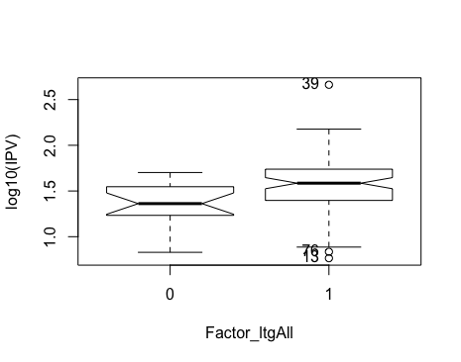

> t.test(log10(IPV)~Factor_ltgAll)

Welch Two Sample t-test

data: log10(IPV) by Factor_ltgAll

t = -2.8726, df = 35.331, p-value = 0.006843

alternative hypothesis: true difference in means is not equal to 0

95 percent confidence interval:

-0.32869968 -0.05653652

sample estimates:

mean in group 0 mean in group 1

1.358469 1.551087