1st Level Logistic

> summary(g2)

Call:

glm(formula = Electrical_Factor ~ L_VASR + L_Infra + L_Seis +

Sq_Sdur + Sq_Idur, family = binomial(link = logit), subset = -c(591,

752))

Deviance Residuals:

Min 1Q Median 3Q Max

-2.9844 -0.8765 -0.5090 1.0214 2.5824

Coefficients:

Estimate Std. Error z value Pr(>|z|)

(Intercept) -10.00635 0.70047 -14.285 < 2e-16 ***

L_VASR -0.52433 0.12489 -4.198 2.69e-05 ***

L_Infra 0.63257 0.11131 5.683 1.32e-08 ***

L_Seis 0.07963 0.11632 0.685 0.493582

Sq_Sdur 0.51278 0.15432 3.323 0.000891 ***

Sq_Idur -0.37327 0.13892 -2.687 0.007211 **

---

Signif. codes: 0 ‘***’ 0.001 ‘**’ 0.01 ‘*’ 0.05 ‘.’ 0.1 ‘ ’ 1

(Dispersion parameter for binomial family taken to be 1)

Null deviance: 2037.8 on 1511 degrees of freedom

Residual deviance: 1681.1 on 1506 degrees of freedom

AIC: 1693.1

Pseudo R2 = 1-residual/null = 1-(1681.1/ 2037.8) = 0.1750417

Number of Fisher Scoring iterations: 4

> Anova(g2)

Analysis of Deviance Table (Type II tests)

Response: Electrical_Factor

LR Chisq Df Pr(>Chisq)

L_VASR 18.536 1 1.668e-05 ***

L_Infra 35.159 1 3.038e-09 ***

L_Seis 0.465 1 0.4954042

Sq_Sdur 11.221 1 0.0008088 ***

Sq_Idur 7.278 1 0.0069786 **

---

Signif. codes: 0 ‘***’ 0.001 ‘**’ 0.01 ‘*’ 0.05 ‘.’ 0.1 ‘ ’ 1

> vif(g2)

L_VASR L_Infra L_Seis Sq_Sdur Sq_Idur

5.218457 8.057613 5.169318 22.112779 22.339534

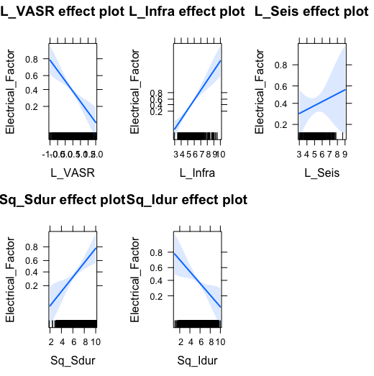

After removing LSeis

> summary(bothways2)

Call:

glm(formula = Electrical_Factor ~ L_Infra + L_VASR + Sq_Sdur +

Sq_Idur, family = binomial(link = logit), subset = -c(591,

752))

Deviance Residuals:

Min 1Q Median 3Q Max

-2.9706 -0.8733 -0.5113 1.0127 2.6141

Coefficients:

Estimate Std. Error z value Pr(>|z|)

(Intercept) -9.8635 0.6652 -14.828 < 2e-16 ***

L_Infra 1.6075 0.1325 12.133 < 2e-16 ***

L_VASR -1.3651 0.1730 -7.891 2.99e-15 ***

Sq_Sdur 0.5185 0.1543 3.359 0.000781 ***

Sq_Idur -0.3717 0.1391 -2.672 0.007533 **

---

Signif. codes: 0 ‘***’ 0.001 ‘**’ 0.01 ‘*’ 0.05 ‘.’ 0.1 ‘ ’ 1

(Dispersion parameter for binomial family taken to be 1)

Null deviance: 2037.8 on 1511 degrees of freedom

Residual deviance: 1681.5 on 1507 degrees of freedom

AIC: 1691.5

Pseudo R2 = 1-residual/null = 1-(1681.5/ 2037.8) = 0.1748454

Number of Fisher Scoring iterations: 4

> Anova(bothways2)

Analysis of Deviance Table (Type II tests)

Response: Electrical_Factor

LR Chisq Df Pr(>Chisq)

L_Infra 190.088 1 < 2.2e-16 ***

L_VASR 68.416 1 < 2.2e-16 ***

Sq_Sdur 11.468 1 0.000708 ***

Sq_Idur 7.203 1 0.007280 **

---

Signif. codes: 0 ‘***’ 0.001 ‘**’ 0.01 ‘*’ 0.05 ‘.’ 0.1 ‘ ’ 1

> vif(bothways2)

L_Infra L_VASR Sq_Sdur Sq_Idur

2.161620 1.894133 22.123992 22.402891

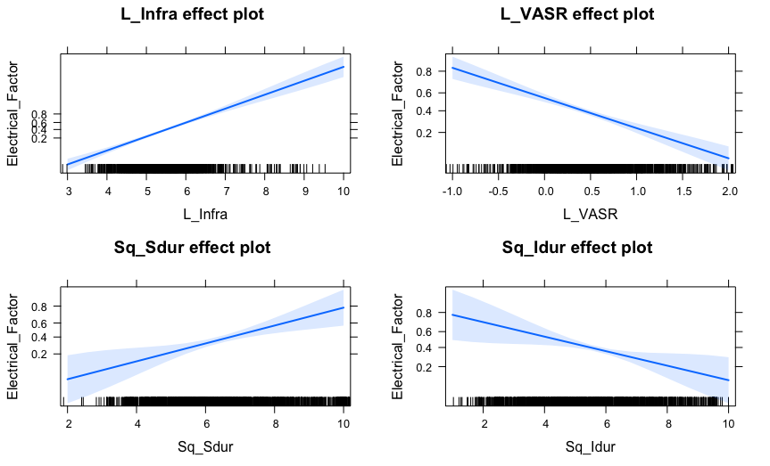

2nd Level Log CRF y/n

m.log_CRFyn_short_o

> summary(m.log_CRFyn_short_o)

Call:

glm(formula = CRF_yn2 ~ L_VASR + L_Seis, family = binomial(link = logit),

subset = -c(590, 87, 141, 188, 9, 8, 594))

Deviance Residuals:

Min 1Q Median 3Q Max

-2.2596 -0.4912 -0.3925 -0.2936 2.6584

Coefficients:

Estimate Std. Error z value Pr(>|z|)

(Intercept) -10.3896 1.1975 -8.676 < 2e-16 ***

L_VASR 0.6799 0.2757 2.466 0.0137 *

L_Seis 1.4321 0.2121 6.752 1.45e-11 ***

---

Signif. codes: 0 ‘***’ 0.001 ‘**’ 0.01 ‘*’ 0.05 ‘.’ 0.1 ‘ ’ 1

(Dispersion parameter for binomial family taken to be 1)

Null deviance: 456.27 on 600 degrees of freedom

Residual deviance: 379.38 on 598 degrees of freedom

AIC: 385.38

Number of Fisher Scoring iterations: 5

Pseudo R2 = 1-residual/null = 1-(379.38/456.27) = 0.1685186

> Anova(m.log_CRFyn_short_o)

Analysis of Deviance Table (Type II tests)

Response: CRF_yn2

LR Chisq Df Pr(>Chisq)

L_VASR 6.323 1 0.01192 *

L_Seis 53.914 1 2.095e-13 ***

---

Signif. codes: 0 ‘***’ 0.001 ‘**’ 0.01 ‘*’ 0.05 ‘.’ 0.1 ‘ ’ 1

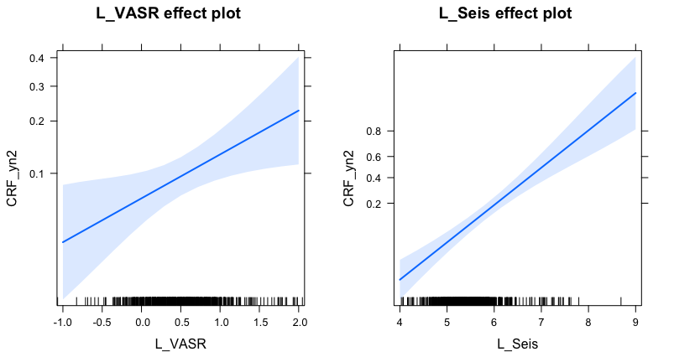

2nd Level Log Ltg y/n

m.log_LTGyn_short_o)

> summary(m.log_LTGyn_short_o)

Call:

glm(formula = Factor_ltgAll ~ L_Infra + Sq_Idur, family = binomial(link = logit),

subset = -c(590, 87, 141, 188, 9, 8, 594))

Deviance Residuals:

Min 1Q Median 3Q Max

-2.3350 -1.2831 0.7098 0.8263 1.3472

Coefficients:

Estimate Std. Error z value Pr(>|z|)

(Intercept) -2.58474 0.77486 -3.336 0.000851 ***

L_Infra 0.50667 0.14655 3.457 0.000546 ***

Sq_Idur 0.09994 0.04913 2.034 0.041922 *

---

Signif. codes:

0 ‘***’ 0.001 ‘**’ 0.01 ‘*’ 0.05 ‘.’ 0.1 ‘ ’ 1

(Dispersion parameter for binomial family taken to be 1)

Null deviance: 708.38 on 600 degrees of freedom

Residual deviance: 679.88 on 598 degrees of freedom

AIC: 685.88

Number of Fisher Scoring iterations: 4

Pseudo R2 = 1-residual/null = 1-(679.88/708.38) = 0.04023264

> Anova(m.log_LTGyn_short_o)

Analysis of Deviance Table (Type II tests)

Response: Factor_ltgAll

LR Chisq Df Pr(>Chisq)

L_Infra 13.649 1 0.0002203 ***

Sq_Idur 4.179 1 0.0409289 *

---

Signif. codes:

0 ‘***’ 0.001 ‘**’ 0.01 ‘*’ 0.05 ‘.’ 0.1 ‘ ’ 1

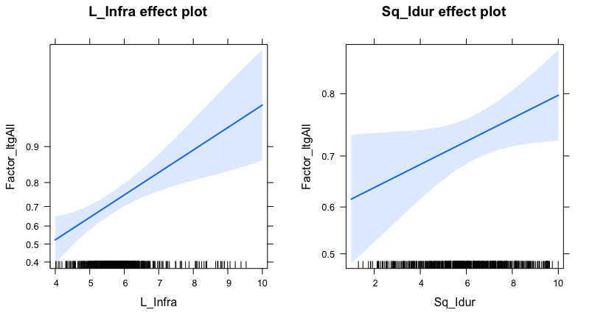

2nd Level Linear Electrical Activity Duration

m.lin_EA_short_interact_o_sqrtTy

> summary(m.lin_EA_short_interact_o_sqrtTy)

Call:

lm(formula = sqrt(start_ElectricActivity) ~ L_Seis * Sq_Idur,

subset = -c(590, 87, 141, 188, 9, 8, 594))

Residuals:

Min 1Q Median 3Q Max

-6.3650 -2.1807 -0.3997 1.1060 16.4597

Coefficients:

Estimate Std. Error t value Pr(>|t|)

(Intercept) 11.08594 3.68876 3.005 0.002764 **

L_Seis -1.70024 0.70918 -2.397 0.016814 *

Sq_Idur -1.68313 0.51988 -3.238 0.001273 **

L_Seis:Sq_Idur 0.35300 0.09665 3.652 0.000283 ***

---

Signif. codes: 0 ‘***’ 0.001 ‘**’ 0.01 ‘*’ 0.05 ‘.’ 0.1 ‘ ’ 1

Residual standard error: 3.037 on 597 degrees of freedom

Multiple R-squared: 0.07679, Adjusted R-squared: 0.07215

F-statistic: 16.55 on 3 and 597 DF, p-value: 2.418e-10

> Anova(m.lin_EA_short_interact_o_sqrtTy)

Anova Table (Type II tests)

Response: sqrt(start_ElectricActivity)

Sum Sq Df F value Pr(>F)

L_Seis 92.3 1 10.0063 0.0016393 **

Sq_Idur 75.5 1 8.1878 0.0043649 **

L_Seis:Sq_Idur 123.1 1 13.3389 0.0002828 ***

Residuals 5507.4 597

---

Signif. codes: 0 ‘***’ 0.001 ‘**’ 0.01 ‘*’ 0.05 ‘.’ 0.1 ‘ ’ 1

> residualPlots(m.lin_EA_short_interact_o_sqrtTy)

Test stat Pr(>|t|)

L_Seis -1.387 0.166

Sq_Idur 2.373 0.018

Tukey test 0.066 0.948

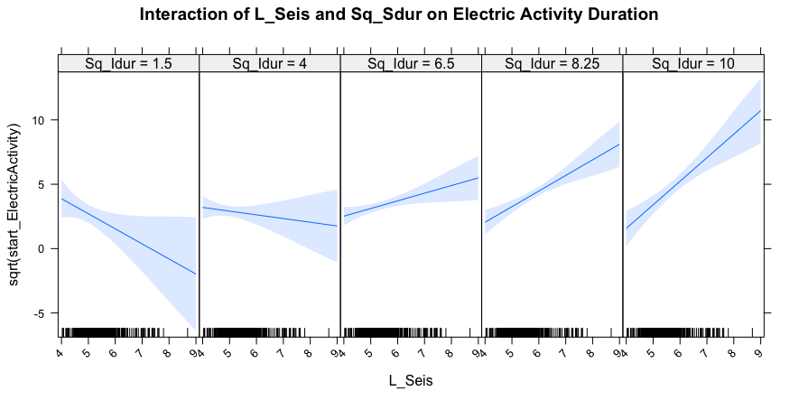

Adding Poly Terms

> summary(m.lin_EA_short_interact_o_sqrtTy_polyID)

Call:

lm(formula = sqrt(start_ElectricActivity) ~ L_Seis * poly(Sq_Idur,

2), subset = -c(590, 87, 141, 188, 9, 8, 594))

Residuals:

Min 1Q Median 3Q Max

-6.3821 -2.3067 -0.4033 1.1821 15.9745

Coefficients:

Estimate Std. Error t value Pr(>|t|)

(Intercept) -0.2632 1.3004 -0.202 0.83966

L_Seis 0.6930 0.2404 2.882 0.00409 **

poly(Sq_Idur, 2)1 -36.5642 32.8995 -1.111 0.26685

poly(Sq_Idur, 2)2 -20.5921 27.0974 -0.760 0.44760

L_Seis:poly(Sq_Idur, 2)1 8.3311 6.1973 1.344 0.17936

L_Seis:poly(Sq_Idur, 2)2 5.7109 5.1739 1.104 0.27013

---

Signif. codes: 0 ‘***’ 0.001 ‘**’ 0.01 ‘*’ 0.05 ‘.’ 0.1 ‘ ’ 1

Residual standard error: 3.025 on 595 degrees of freedom

Multiple R-squared: 0.0873, Adjusted R-squared: 0.07963

F-statistic: 11.38 on 5 and 595 DF, p-value: 1.661e-10

> Anova(m.lin_EA_short_interact_o_sqrtTy_polyID)

Anova Table (Type II tests)

Response: sqrt(start_ElectricActivity)

Sum Sq Df F value Pr(>F)

L_Seis 98.5 1 10.7599 0.001098 **

poly(Sq_Idur, 2) 228.0 2 12.4598 5.001e-06 ***

L_Seis:poly(Sq_Idur, 2) 33.3 2 1.8176 0.163320

Residuals 5444.7 595

---

Signif. codes: 0 ‘***’ 0.001 ‘**’ 0.01 ‘*’ 0.05 ‘.’ 0.1 ‘ ’ 1

> residualPlots(m.lin_EA_short_interact_o_sqrtTy_polyID)

Test stat Pr(>|t|)

L_Seis -0.747 0.455

poly(Sq_Idur, 2) NA NA

Tukey test -0.141 0.888

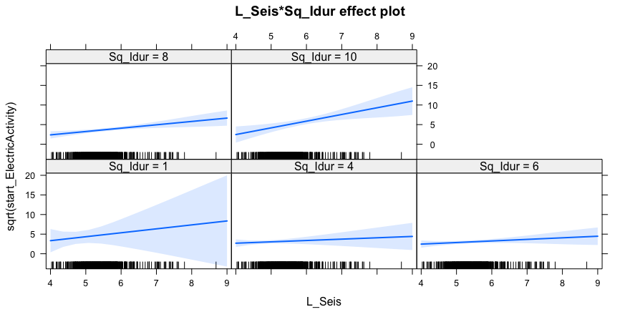

2nd Level Linear NLS

m.lin_NLS_short_interact_o_sqrtTy

> summary(m.lin_NLS_short_interact_o_sqrtTy)

Call:

lm(formula = sqrt(NLS) ~ L_Seis * L_Infra + Sq_Sdur, subset = -c(590,

87, 141, 188, 9, 8, 594))

Residuals:

Min 1Q Median 3Q Max

-46.072 -3.053 -1.205 1.121 66.406

Coefficients:

Estimate Std. Error t value Pr(>|t|)

(Intercept) 94.4283 15.4157 6.125 1.64e-09 ***

L_Seis -19.5394 2.8345 -6.893 1.39e-11 ***

L_Infra -16.9981 2.5607 -6.638 7.16e-11 ***

Sq_Sdur 0.3674 0.2271 1.618 0.106

L_Seis:L_Infra 3.5866 0.4120 8.705 < 2e-16 ***

---

Signif. codes: 0 ‘***’ 0.001 ‘**’ 0.01 ‘*’ 0.05 ‘.’ 0.1 ‘ ’ 1

Residual standard error: 8.645 on 596 degrees of freedom

Multiple R-squared: 0.3456, Adjusted R-squared: 0.3412

F-statistic: 78.7 on 4 and 596 DF, p-value: < 2.2e-16

> Anova(m.lin_NLS_short_interact_o_sqrtTy)

Anova Table (Type II tests)

Response: sqrt(NLS)

Sum Sq Df F value Pr(>F)

L_Seis 886 1 11.8541 0.0006157 ***

L_Infra 3169 1 42.4075 1.576e-10 ***

Sq_Sdur 196 1 2.6166 0.1062788

L_Seis:L_Infra 5663 1 75.7810 < 2.2e-16 ***

Residuals 44542 596

---

Signif. codes: 0 ‘***’ 0.001 ‘**’ 0.01 ‘*’ 0.05 ‘.’ 0.1 ‘ ’ 1

> residualPlots(m.lin_NLS_short_interact_o_sqrtTy)

Test stat Pr(>|t|)

L_Seis -5.375 0.000

L_Infra 4.841 0.000

Sq_Sdur 1.911 0.056

Tukey test -2.296 0.022

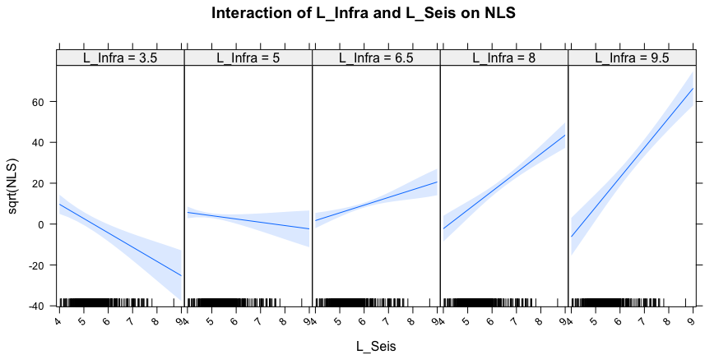

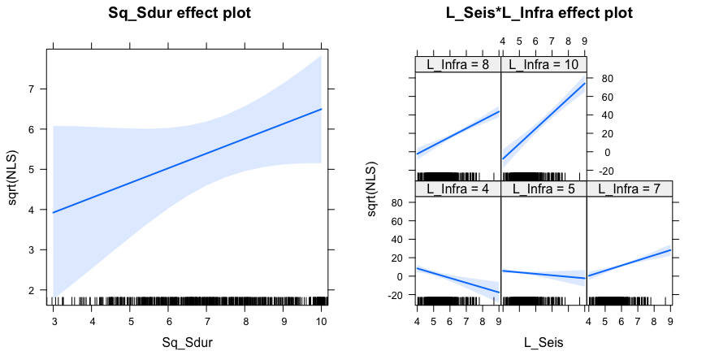

Adding Poly Terms

> summary(m.lin_NLS_short_interact_o_sqrtTy_polyS)

Call:

lm(formula = sqrt(NLS) ~ poly(L_Seis, 2) * L_Infra + Sq_Sdur,

subset = -c(590, 87, 141, 188, 9, 8, 594))

Residuals:

Min 1Q Median 3Q Max

-35.147 -3.126 -0.965 1.538 67.407

Coefficients:

Estimate Std. Error t value Pr(>|t|)

(Intercept) -7.7440 4.4362 -1.746 0.0814 .

poly(L_Seis, 2)1 -699.0124 86.8436 -8.049 4.56e-15 ***

poly(L_Seis, 2)2 -10.9008 59.1160 -0.184 0.8538

L_Infra 1.6427 0.7283 2.255 0.0245 *

Sq_Sdur 0.2598 0.2225 1.167 0.2435

poly(L_Seis, 2)1:L_Infra 121.5417 13.5745 8.954 < 2e-16 ***

poly(L_Seis, 2)2:L_Infra -16.8597 7.9088 -2.132 0.0334 *

---

Signif. codes: 0 ‘***’ 0.001 ‘**’ 0.01 ‘*’ 0.05 ‘.’ 0.1 ‘ ’ 1

Residual standard error: 8.424 on 594 degrees of freedom

Multiple R-squared: 0.3807, Adjusted R-squared: 0.3744

F-statistic: 60.85 on 6 and 594 DF, p-value: < 2.2e-16

> Anova(m.lin_NLS_short_interact_o_sqrtTy_polyS)

Anova Table (Type II tests)

Response: sqrt(NLS)

Sum Sq Df F value Pr(>F)

poly(L_Seis, 2) 3029 2 21.3420 1.120e-09 ***

L_Infra 2294 1 32.3198 2.052e-08 ***

Sq_Sdur 97 1 1.3628 0.2435

poly(L_Seis, 2):L_Infra 5905 2 41.6016 < 2.2e-16 ***

Residuals 42157 594

---

Signif. codes: 0 ‘***’ 0.001 ‘**’ 0.01 ‘*’ 0.05 ‘.’ 0.1 ‘ ’ 1

> residualPlots(m.lin_NLS_short_interact_o_sqrtTy_polyS)

Test stat Pr(>|t|)

poly(L_Seis, 2) NA NA

L_Infra 1.638 0.102

Sq_Sdur 1.531 0.126

Tukey test 2.530 0.011

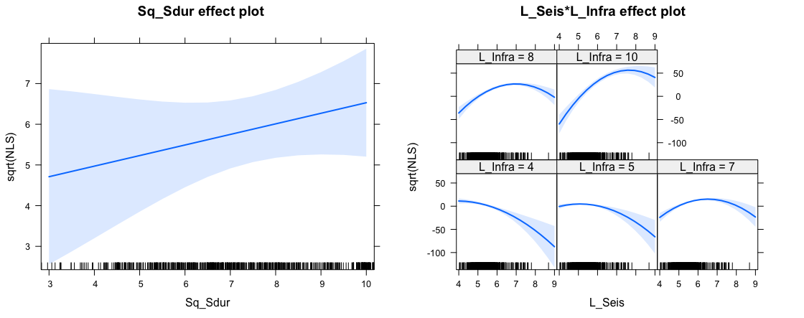

3rd Level Linear Ltg #

Call:

lm(formula = (ltgAll^(-1/3)) ~ L_Seis * poly(L_Infra, 2))

Residuals:

Min 1Q Median 3Q Max

-0.51906 -0.16315 -0.00539 0.18212 0.58697

Coefficients:

Estimate Std. Error t value Pr(>|t|)

(Intercept) 1.36192 0.14760 9.227 < 2e-16 ***

L_Seis -0.11557 0.02703 -4.276 2.35e-05 ***

poly(L_Infra, 2)1 -8.31745 3.16523 -2.628 0.00890 **

poly(L_Infra, 2)2 -5.70674 1.53145 -3.726 0.00022 ***

L_Seis:poly(L_Infra, 2)1 1.15856 0.50420 2.298 0.02205 *

L_Seis:poly(L_Infra, 2)2 0.71890 0.24729 2.907 0.00384 **

---

Signif. codes: 0 ‘***’ 0.001 ‘**’ 0.01 ‘*’ 0.05 ‘.’ 0.1 ‘ ’ 1

Residual standard error: 0.2023 on 429 degrees of freedom

Multiple R-squared: 0.1693, Adjusted R-squared: 0.1596

F-statistic: 17.49 on 5 and 429 DF, p-value: 8.974e-16

> Anova(m3.lin_ltg_short_interact_neg13T_polyI2)

Anova Table (Type II tests)

Response: (ltgAll^(-1/3))

Sum Sq Df F value Pr(>F)

L_Seis 0.6159 1 15.0499 0.0001211 ***

poly(L_Infra, 2) 0.1858 2 2.2696 0.1045948

L_Seis:poly(L_Infra, 2) 0.5827 2 7.1185 0.0009093 ***

Residuals 17.5576 429

---

Signif. codes: 0 ‘***’ 0.001 ‘**’ 0.01 ‘*’ 0.05 ‘.’ 0.1 ‘ ’ 1

