CPE301 – SPRING 2019

Design Assignment 3B

Student Name: Eric Smith
Student #: 2000543940
Student Email: smithe4@unlv.nevada.edu
Primary Github address: smitheas95
Directory: Repository

- COMPONENTS LIST AND CONNECTION BLOCK DIAGRAM w/ PINS

Xplained ATmega mini 328pb, jumper cables, LM35, FTDI Chip
- INITIAL/MODIFIED/DEVELOPED CODE OF TASK 3/B

/*
* DA_3B_T1.c
*
* Created: 3/31/2019 9:35:23 AM
* Author : ERIC SMITH

The goal of the assignment is to modify the above codes to do the following:
1. Write a C AVR program that will monitor the LM34/35 connected to an Analog pin
(PC5) to display the temperature in F on the serial terminal every 1 sec. Use a timer
with interrupt for the 1 sec delay. Use a FTDI chip for serial to USB conversion.
2. Use the ATMEL Studio Data Visualizer or any Charting program to display the values
in time.
*/

#define F_CPU 16000000UL // 16 MHz
#define BAUDRATE 9600 // SET BAUD RATE 9600
#define BAUD_PRESCALLER ((((F_CPU / BAUDRATE * 16UL)))-1) // BAUD PRESCALER

// LIBRARY
#include <avr/io.h>
#include <util/delay.h>
#include <stdio.h>

void read_adc(void); // Function Declarations
void adc_init(void);
void USART_init( unsigned int ubrr );
void USART_tx_string( char *data );

volatile unsigned int adc_temp;
char outs[20]; // ARRAY

int main(void) {
adc_init(); // INITIALIZE ADC )
USART_init(BAUD_PRESCALLER); // INITIALIZE USART
USART_tx_string("Connected!\r\n");
_delay_ms(125); // WAIT PERIOD

while(1) // WHILE LOOP
{
read_adc();
_delay_ms(1000); // WAIT PERIOD
}
}
void adc_init(void)
{
// SET UP AND ENABLE ADC
ADMUX = (0<<REFS1)| // REFERENCE SELECTION BITS
(1<<REFS0)| // AVcc - external cap at AREF
(0<<ADLAR)| // ADC Left Adjust
// SET FOR PC5
(1<<MUX2)| // ANALOG CHANNEL SELECTION BITS
(0<<MUX1)|
(1<<MUX0);

ADCSRA = (1<<ADEN)| // ADC ENABLE
(0<<ADSC)| // ADC Start Conversion
(0<<ADATE)| // ADC AUTO TRIGGER ENABLE
(0<<ADIF)| // ADC INTERRUPT FLAG
(0<<ADIE)| // ADC INTERRUPT ENABLE
(1<<ADPS2)| // ADC PRESCALER SELECT BITS
(0<<ADPS1)|
(1<<ADPS0);

// USING TIMER1
TIMSK1 = (1<<TOIE1); // ENABLE OVERFLOW INTERRUPT
TCCR1B |= (1<<CS11)|(1<<CS10); // PRESCALER
TCNT1 = 49911; // CALCULATED/NEEDED VALUE
}
/* READ ADC PINS */
// METHOD
void read_adc(void)
{
unsigned char i =4;
adc_temp = 0;
while (i--) {
ADCSRA |= (1<<ADSC);
while(ADCSRA & (1<<ADSC));
adc_temp+= ADC;
_delay_ms(50);
}
adc_temp = adc_temp / 4; // AVG. FEW SAMPLES
int tempf= (adc_temp*5*100)/1024;
snprintf(outs,sizeof(outs),"%3d\r\n", tempf); // KEY PRINT FUNCTION
USART_tx_string(outs);
}
void USART_init( unsigned int ubrr ) {
UBRR0H = (unsigned char)(ubrr>>8);
UBRR0L = (unsigned char)ubrr;
UCSR0B = (1 << TXEN0); // ENABLE RECEIVER, TRANSMITTER & RX INTERRUPT
UCSR0C = (3 << UCSZ00); // ASYNCHRONOUS
}
/* SEND A STRING TO THE RS-232 */
void USART_tx_string( char *data ) {
while ((*data != '\0')) {
while (!(UCSR0A & (1 <<UDRE0)));
UDR0 = *data;
data++;
}
}

ISR(TIMER1_OVF_vect)
{
read_adc(); // ADC FUNCTION CALLED
snprintf(outs,sizeof(outs), "%3d\r\n", adc_temp); // KEY PRINT FUNCTION
USART_tx_string(outs); // STRING OUTPUT
_delay_ms(1000);
TCNT1 = 49911; // TIMER COUNTER RESET
}

- DEVELOPED MODIFIED CODE OF TASK 3B

/*
* DA_3B_T1.c
*
* Created: 3/31/2019 9:35:23 AM
* Author : ERIC SMITH

The goal of the assignment is to modify the above codes to do the following:
1. Write a C AVR program that will monitor the LM34/35 connected to an Analog pin
(PC5) to display the temperature in F on the serial terminal every 1 sec. Use a timer
with interrupt for the 1 sec delay. Use a FTDI chip for serial to USB conversion.
2. Use the ATMEL Studio Data Visualizer or any Charting program to display the values
in time.
*/

#define F_CPU 16000000UL // 16 MHz
#define BAUDRATE 9600 // SET BAUD RATE 9600
#define BAUD_PRESCALLER ((((F_CPU / BAUDRATE * 16UL)))-1) // BAUD PRESCALER

// LIBRARY
#include <avr/io.h>
#include <util/delay.h>
#include <stdio.h>

void read_adc(void); // Function Declarations
void adc_init(void);
void USART_init( unsigned int ubrr );
void USART_tx_string( char *data );

volatile unsigned int adc_temp;
char outs[20]; // ARRAY

int main(void) {
adc_init(); // INITIALIZE ADC )
USART_init(BAUD_PRESCALLER); // INITIALIZE USART
USART_tx_string("Connected!\r\n");
_delay_ms(125); // WAIT PERIOD

while(1) // WHILE LOOP
{
read_adc();
_delay_ms(1000); // WAIT PERIOD
}
}
void adc_init(void)
{
// SET UP AND ENABLE ADC
ADMUX = (0<<REFS1)| // REFERENCE SELECTION BITS
(1<<REFS0)| // AVcc - external cap at AREF
(0<<ADLAR)| // ADC Left Adjust
// SET FOR PC5
(1<<MUX2)| // ANALOG CHANNEL SELECTION BITS
(0<<MUX1)|
(1<<MUX0);

ADCSRA = (1<<ADEN)| // ADC ENABLE
(0<<ADSC)| // ADC Start Conversion
(0<<ADATE)| // ADC AUTO TRIGGER ENABLE
(0<<ADIF)| // ADC INTERRUPT FLAG
(0<<ADIE)| // ADC INTERRUPT ENABLE
(1<<ADPS2)| // ADC PRESCALER SELECT BITS
(0<<ADPS1)|
(1<<ADPS0);

// USING TIMER1
TIMSK1 = (1<<TOIE1); // ENABLE OVERFLOW INTERRUPT
TCCR1B |= (1<<CS11)|(1<<CS10); // PRESCALER
TCNT1 = 49911; // CALCULATED/NEEDED VALUE
}
/* READ ADC PINS */
// METHOD
void read_adc(void)
{
unsigned char i =4;
adc_temp = 0;
while (i--) {
ADCSRA |= (1<<ADSC);
while(ADCSRA & (1<<ADSC));
adc_temp+= ADC;
_delay_ms(50);
}
adc_temp = adc_temp / 4; // AVG. FEW SAMPLES
int tempf= (adc_temp*5*100)/1024;
snprintf(outs,sizeof(outs),"%3d\r\n", tempf); // KEY PRINT FUNCTION
USART_tx_string(outs);
}
void USART_init( unsigned int ubrr ) {
UBRR0H = (unsigned char)(ubrr>>8);
UBRR0L = (unsigned char)ubrr;
UCSR0B = (1 << TXEN0); // ENABLE RECEIVER, TRANSMITTER & RX INTERRUPT
UCSR0C = (3 << UCSZ00); // ASYNCHRONOUS
}
/* SEND A STRING TO THE RS-232 */
void USART_tx_string( char *data ) {
while ((*data != '\0')) {
while (!(UCSR0A & (1 <<UDRE0)));
UDR0 = *data;
data++;
}
}

ISR(TIMER1_OVF_vect)
{
read_adc(); // ADC FUNCTION CALLED
snprintf(outs,sizeof(outs), "%3d\r\n", adc_temp); // KEY PRINT FUNCTION
USART_tx_string(outs); // STRING OUTPUT
_delay_ms(1000);
TCNT1 = 49911; // TIMER COUNTER RESET
}
- SCHEMATICS
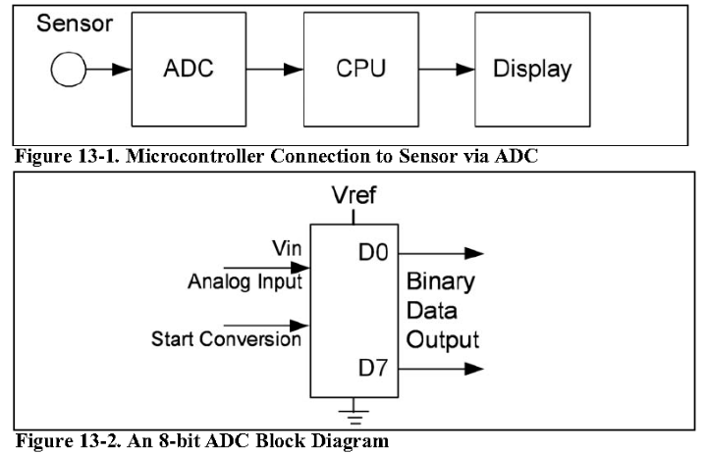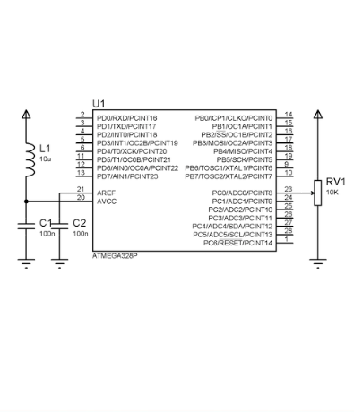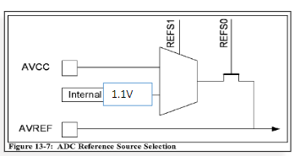

- SCREENSHOTS OF EACH TASK OUTPUT (ATMEL STUDIO OUTPUT)

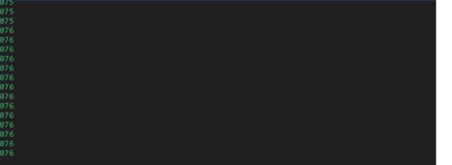

- SCREENSHOT OF EACH DEMO (BOARD SETUP)/MATERIALS NEEDED

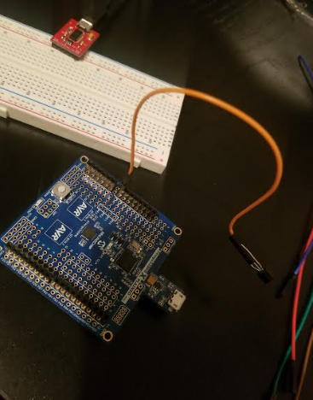

- VIDEO LINKS OF EACH DEMO

https://www.youtube.com/watch?v=1mTHR71gs1c&feature=youtu.be

- GITHUB LINK OF THIS DA

https://github.com/smitheas95/submission_da

Student Academic Misconduct Policy
http://studentconduct.unlv.edu/misconduct/policy.html

“This assignment submission is my own, original work”.
Eric Smith

