CPE301 – SPRING 2019

Design Assignment 4A

Student Name: Eric Smith
Student #: 2000543940
Student Email: smithe4@unlv.nevada.edu
Primary Github address: smitheas95
Directory: Repository

- COMPONENTS LIST AND CONNECTION BLOCK DIAGRAM w/ PINS

List: UNLV ECE BOARD, DC motor, male to male jumper wires, female to male jumper wires, L293D

- INITIAL/MODIFIED/DEVELOPED CODE OF Task 1 for DA4A

/*
* DA_4A.c
*
* Created: 4/13/2019 4:15:36 PM
* Author : Eric Smith
*/

#define F_CPU 16000000UL

// NEEDED LIBRARIES
#include <avr/io.h>
#include <util/delay.h>
#include <stdio.h>
#include <avr/interrupt.h>

// UART BAUDRATE
#define BAUDRATE 9600
#define BAUD_PRESCALLER (((F_CPU / (BAUDRATE * 16UL))) - 1)

// DECLARATION OF KEY FUNCTIONS
void adc_init(void);
void read_adc(void);

void USART_init( unsigned int ubrr );
void USART_tx_string( char *data );

char outs[20];

volatile unsigned int adc_temp;
volatile unsigned int adc_value;

int main(void)
{
adc_init(); // ADC INITIALIZATION

USART_init(BAUD_PRESCALLER); // USART INITIALIZATION
USART_tx_string("Connected!\r\n");

_delay_ms(250); // WAIT A LITTLE BIT

// INITIALIZING PWM (PULSE WIDTH MODULATION)
DDRD = 0xFF; // OUTPUT THE PWM, SET PORTD AS OUTPUT DIRECTION

TCCR2A = _BV(COM2A1) | _BV(COM2B1) | _BV(WGM21) | _BV(WGM20); // SET NEEDED BITS HIGH ( WGM21, WGM20, COM2A1, COM2B1 )
TCCR2B = _BV(WGM22) | _BV(CS20) | _BV(CS21) | _BV(CS22); // SET BIT WGM22 TO HIGH (FAST PWM MODE 7 RESET COUNTER) , SET CS20 TO HIGH

OCR2A = 255; // SET FOR WHEN COUNTER HITS 255, IT RESETS
OCR2B = 0; // REPRESENTS DUTY CYCLE

// PIN CHANGE INITILAIZER INTERRUPT
PCMSK1 |= (1 << PCINT10); // ENABLE PCINT10
PCICR |= (1 << PCIE1); // SET PIN CHANGE INTERRUPT, ENABLE REGISTER 1

sei(); // GLOBAL INTERRUPT SET

while (1) // WHILE LOOP NEEDED
{
read_adc();
_delay_ms(250

adc_value = adc_value / 4;
snprintf(outs,sizeof(outs),"%3d\r\n", adc_value); // PRINT
USART_tx_string(outs); // ADC VALUE PRINTED
OCR2B = adc_value; // ADC VALUE REPLACED
}
}

void adc_init(void)
{
// SETUP & ENABLE ADC
ADMUX = (0<<REFS1)| // REFERENCE SELECTION BITS
(1<<REFS0)| // AVcc - EXTERNAL CAP AT AREF
(0<<ADLAR)| // ADC LEFT ADJUST RESULT

// ADJUST MUX
(0<<MUX2)| // ANALOG CHANNEL SELECTION BITS
(0<<MUX1)| // ADC0 - (PC0 PIN27)
(0<<MUX0);
ADCSRA = (1<<ADEN)| // ADC ENABLE
(0<<ADSC)| // ADC START CONVERSION ADC
(0<<ADATE)| // ADC AUTO TRIGGER ENABLE
(0<<ADIF)| // ADC INTERRUPT FLAG
(0<<ADIE)| // ADC INTERRUPT ENABLE
(1<<ADPS2)| // ADC PRESCALER SELECT BITS
(0<<ADPS1)|
(1<<ADPS0);
}

void read_adc(void)
{
unsigned char i = 4;
adc_temp = 0;
while (i--)
{
ADCSRA |= (1<<ADSC);
while(ADCSRA & (1<<ADSC));
adc_temp+= ADC;
_delay_ms(100); // DELAY
}
adc_value = adc_value / 4; // FEW SAMPLES SAMPLED
}

// SEND STRING TO RS-232
void USART_tx_string( char *data )
{
while ((*data != '\0'))
{
while (!(UCSR0A & (1 <<UDRE0)));
UDR0 = *data;
data++;
}
}

// INIT USART (RS-232)
void USART_init( unsigned int ubrr )
{
UBRR0H = (unsigned char)(ubrr >> 8);
UBRR0L = (unsigned char)ubrr;
UCSR0B = (1 << TXEN0); // ENABLE RX, TX & RX INTERRUPT
UCSR0C = (3 << UCSZ00); // ASYNCHRONOUS 8 N 1
}

ISR(PCINT1_vect)
{
DDRD ^= 0xFF; // XOR DIRECTION REGISTER, TURN MKOTOR ON/OFF XOR
_delay_ms(1000); // BOUNCE GND

char check = " Pin Change ";
USART_tx_string(check); // PRINT AT SAME TIME OF PIN CHANGE
}

- DEVELOPED MODIFIED CODE OF TASK 1 for DA4A

(This portion covered by #2)

- SCHEMATICS

Key schematics:
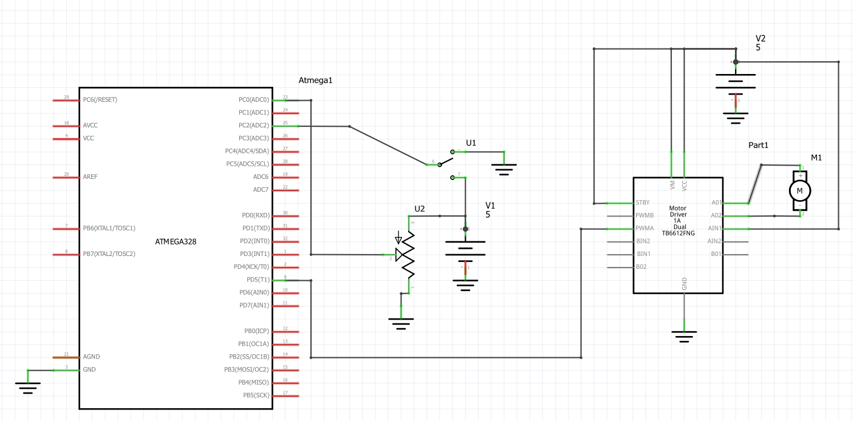

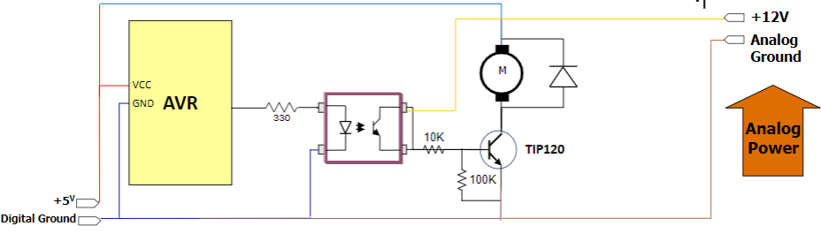

- SCREENSHOTS OF EACH TASK OUTPUT (ATMEL STUDIO/UART PRINT ADC OUTPUT)

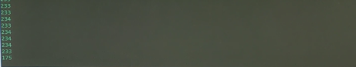

- SCREENSHOT OF EACH DEMO (BOARD SETUP)

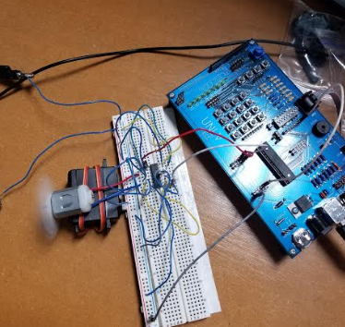

- VIDEO LINKS OF EACH DEMO

https://youtu.be/VgW2OAu4ODM

- GITHUB LINK OF THIS DA

https://github.com/smitheas95/submission_da

Student Academic Misconduct Policy
http://studentconduct.unlv.edu/misconduct/policy.html

“This assignment submission is my own, original work”.
Eric Smith

