CPE301 – SPRING 2019

Design Assignment 4B

Student Name: Eric Smith
Student #: 2000543940
Student Email: smithe4@unlv.nevada.edu
Primary Github address: smitheas95
Directory: Repository

- COMPONENTS LIST AND CONNECTION BLOCK DIAGRAM w/ PINS

UNLV ECE BOARD
Stepper Motor, wires, servo motor, UNL2003 motor driver
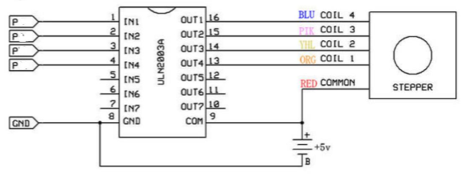

- INITIAL/MODIFIED/DEVELOPED CODE OF TASK 1 (DA4B)

/*
* DA4B_T1.c
*
* Created: 4/21/2019 12:37:30 AM
* Author : ERIC SMITH

1. Write an AVR C program to control the speed of the Stepper Motor using a
potentiometer connected to PC0. Use a timer in CTC mode to control the delay.
*/

#define F_CPU 16000000UL

// NEEDED LIBRARIES
#include <avr/io.h>
#include <stdio.h>
#include <util/delay.h>
#include <avr/interrupt.h>

void read_adc(void);
void adc_init(void);

volatile int OVFCOUNT;
volatile int RPMVALUE;
volatile double float_value;
volatile unsigned int adc_value;

int start_value = 1699; // TIMER 1 INITIALIZED
float c = 1699; // OFFSETS AFFINE TRANSFORMATION
char outs[20]; // CHARACTER OUTS, 20

int main(void)
{
adc_init(); // ADC INITIALIZATION
_delay_ms(150); // WAIT A BIT

TCCR1B |= (1<<WGM12)|(1<<CS11); // CTC MODE, PPRESCALER FOR 8
TIMSK1 |= (1<<OCIE1A); // MASK INTERRUPT

OCR1A = start_value; // 20,000us
DDRD = 0xFF; // PORTD AS OUTPUT
OVFCOUNT = 0; // GLOBAL OVERFLOW COUNTER SET TO 0

sei(); // GLOABL INTERRUPT

while (1)
{
// THIS LOOP CONSISTS OF AFFINE TRANSFORMATION
// KEY CALCULATION (PWM): (39999-1699) * adc_value / (1024-0) + 1699
read_adc();

float_value = adc_value;
RPMVALUE = (float_value * 37.4033) + c;
OCR1A = RPMVALUE; // NEWEST TIME MEASUREMENT LOADED
}
}

void adc_init(void)
{
ADMUX = (0<<REFS1)| // Reference Selection Bits
(1<<REFS0)| // AVcc - external cap at AREF
(0<<ADLAR)| // ADC Left Adjust Result
(0<<MUX2)| // Analog Channel Selection Bits
(0<<MUX1)| // ADC0 (PC0 PIN23)
(0<<MUX0);
ADCSRA = (1<<ADEN)| // ADC ENable
(0<<ADSC)| // ADC Start Conversion
(0<<ADATE)| // ADC Auto Trigger Enable
(0<<ADIF)| // ADC Interrupt Flag
(0<<ADIE)| // ADC Interrupt Enable
(1<<ADPS2)| // ADC Prescaler Select Bits
(0<<ADPS1)|
(1<<ADPS0);
}

void read_adc(void)
{
unsigned char i = 4;
adc_value = 0;
while (i--)
{
ADCSRA |= (1<<ADSC);
while(ADCSRA & (1<<ADSC));
adc_value+= ADC;
_delay_ms(100);
}
adc_value = adc_value / 4; // AVG FEW SAMPLES
}

ISR(TIMER1_COMPA_vect)
{
OVFCOUNT++; // OVERFLOW FLAG COUNTER INCREMENT
int count; // LOCAL COUNTER INITIALIZED
count = OVFCOUNT; // GO HAND IN HAND, BOTH COUNT SIMILARLY

// 8 NECESSARY STEPS

if(count == 1){
PORTD = 0xE;
}

if(count == 2) {
PORTD = 0xC;
}

if(count == 3) {
PORTD = 0xD;
}

if(count == 4) {
PORTD = 0x9;
}

if(count == 5) {
PORTD = 0xB;
}

if(count == 6) {
PORTD = 0x3;
}

if(count == 7) {
PORTD = 0x7;
}

if(count == 8) {
PORTD = 0x6;
}
// COUNTER RESET IF COMPLETED
if(count == 8){
OVFCOUNT = 0; // STEPPER COUNTER RESTART
}
}

- DEVELOPED INITIAL/MODIFIED/DEVELOPED CODE OF TASK 2 (DA4B)

/*
* DA4B_T2.c
*
* Created: 4/21/2019 1:49:04 AM
* Author : ERIC SMITH

2. Write an AVR C program to control the position of the Servo Motor using a
potentiometer connected to PC0. When pot value is 0 the servo is at position 0 deg.
and when pot value is max (approx. 5V) the servo is at position 180 deg.
*/

#define F_CPU 16000000UL

// NEEDED LIBRARIES
#include <avr/io.h>
#include <util/delay.h>
#include <stdio.h>

#define BAUDRATE 9600
#define BAUD_PRESCALLER (((F_CPU / (BAUDRATE * 16UL))) - 1)

void read_adc(void);
void adc_init(void);

void USART_init( unsigned int ubrr );
void USART_tx_string( char *data );

volatile int PWMVALUE; // PWM VALUE
volatile unsigned int adc_value; // ADC VALUE
volatile double float_value; // FLOAT VALUE

float c = 97; // AFFINE TRANSFORMATION, OFFSET NEEDED
char outs[20]; // CHARACTER OUTS, 20

int main(void)
{

TCCR1A |= (1 << COM1A1)|(1 << COM1B1)|(1 << WGM11); // TIMER 1 CONFIGURATED
TCCR1B|= (1 << WGM13)|(1 << WGM12)|(1 << CS11)|(1 << CS10); // PRESCALAR 64, WGM MODE 14, NON-INVERTED PWM

ICR1 = 4999; // KEY NUMBER
// SERVO MOTOR OPERATION STANDARD AT 20ms
DDRB |= (1<<PORTB1);

adc_init(); // ADC INITIALIZED

USART_init(BAUD_PRESCALLER); // USART INITIALIZED
USART_tx_string("Connected!\r\n");

_delay_ms(150); // WAIT A BIT

while(1)
{
read_adc();

// KEY CALCULATION: adc_value * (535-97) / (1024 - 0) + 97

float_value = adc_value;
PWMVALUE = (float_value*0.4277343) + c;

snprintf(outs,sizeof(outs),"%3d\r\n", PWMVALUE); // PRINT
USART_tx_string(outs);

OCR1A = PWMVALUE;
_delay_ms(150); // WAIT A BIT
}
}

void adc_init(void)
{
ADMUX = (0<<REFS1)| // Reference Selection Bits
(1<<REFS0)| // AVcc - external cap at AREF
(0<<ADLAR)| // ADC Left Adjust Result
(0<<MUX2)| // Analog Channel Selection Bits
(0<<MUX1)| // ADC0 (PC0 PIN23)
(0<<MUX0);
ADCSRA = (1<<ADEN)| // ADC ENable
(0<<ADSC)| // ADC Start Conversion
(0<<ADATE)| // ADC Auto Trigger Enable
(0<<ADIF)| // ADC Interrupt Flag
(0<<ADIE)| // ADC Interrupt Enable
(1<<ADPS2)| // ADC Prescaler Select Bits
(0<<ADPS1)|
(1<<ADPS0);
}

void read_adc(void)
{
unsigned char i = 4;
adc_value = 0;
while (i--)
{
ADCSRA |= (1<<ADSC);
while(ADCSRA & (1<<ADSC));
adc_value+= ADC;
_delay_ms(50);
}
adc_value = adc_value / 4; // AVG FEW SAMPLES
}

void USART_tx_string( char *data )
{
while ((*data != '\0'))
{
while (!(UCSR0A & (1 <<UDRE0)));
UDR0 = *data;
data++;
}
}

void USART_init( unsigned int ubrr )
{
UBRR0H = (unsigned char)(ubrr>>8);
UBRR0L = (unsigned char)ubrr;
UCSR0B = (1 << TXEN0); // Enable RX, TX & RX interrupt
UCSR0C = (3 << UCSZ00); // ASYNCHRONOUS 8 N 1
}

- SCHEMATICS

Key Schematics respectively:
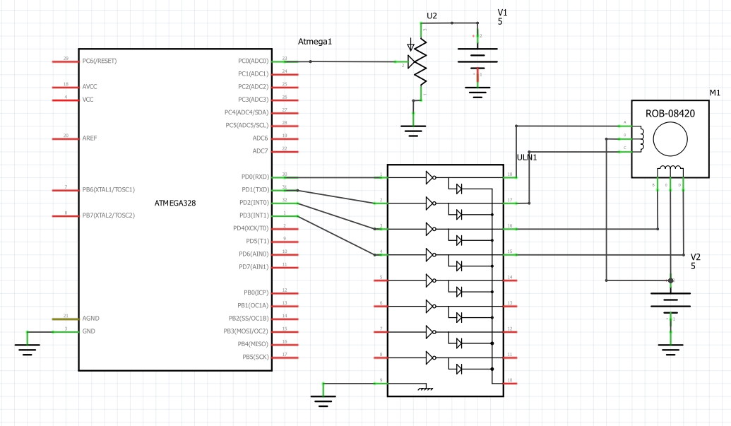
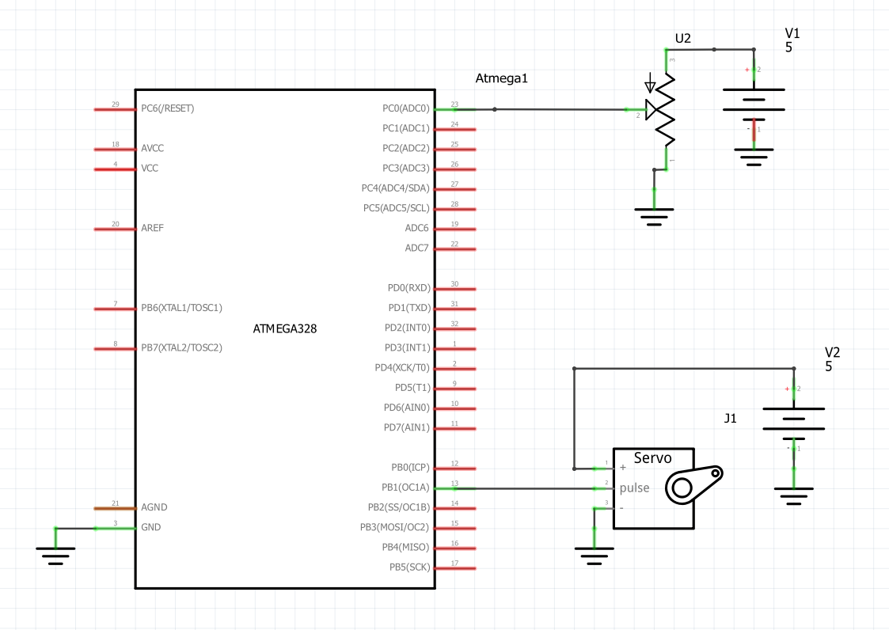
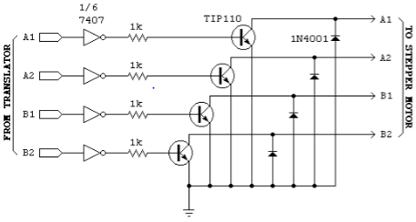

- SCREENSHOTS OF EACH TASK OUTPUT

Task 1:
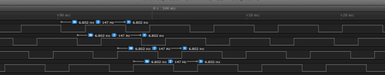

Task 2:


- SCREENSHOT OF EACH DEMO (BOARD SETUP)

Task 1:
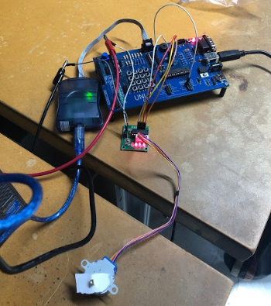

Task 2:
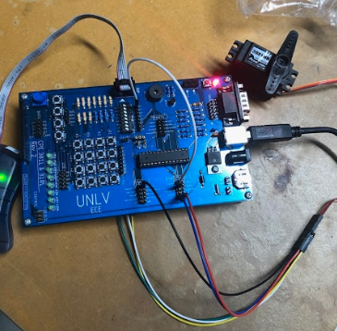

- VIDEO LINKS OF EACH DEMO

https://youtu.be/LF9_cKeLAUA

- GITHUB LINK OF THIS DA

https://github.com/smitheas95/submission_da

Student Academic Misconduct Policy
http://studentconduct.unlv.edu/misconduct/policy.html

“This assignment submission is my own, original work”.
Eric Smith

