CPE301 – SPRING 2019

Design Assignment 1A

Student Name: Eric Smith
Student #: 2000543940
Student Email: smithe4@unlv.nevada.edu
Primary Github address: smitheas95
Directory: Repository

- COMPONENTS LIST AND CONNECTION BLOCK DIAGRAM w/ PINS

N/A

- INITIAL/MODIFIED/DEVELOPED CODE OF TASK 1/A

; Assignment_1A.asm
; Author : Eric Smith
; This program will perform a multiplication of a 16-bit multiplicand with a 8-bit multiplier without using the MUL instruction.
; This program will demomstrate iterative addition.
; (Breakpoint placed at end:)

.SET var1 = 0x08AB

main:

LDI R22, 0xFF ; values of 0xFF loaded into register R22
LDI R24, low(var1) ; LOW part of 0x08AB loaded into register R24
LDI R25, high(var1) ; HIGH part of 0x08AB loaded into register 25
LDI R26, 0x0 ; initialize register 26 to zero
LDI R18, 0x0 ; initialize register 18 to zero
LDI R19, 0x0 ; initialize register 19 to zero
LDI R20, 0x0 ; initialize register 20 to zero

MOV R27, R22 ; makes copy of register 22 to register 27

loop:
ADD R18, R24 ; register 24 added with register 18
ADC R19, R25 ; register 25 added with register 19 with carry
ADC R20, R26 ; register 26 added with register 20 with carry

DEC R27 ; decrement from 27
CPI R27, 0 ; compares register 27 to immediate value 0, signifying there is nothing else to multiply by
BRNE loop ; branch when not equal to the loop

jmp end ; jump to end

end:

; Assignment1_1AMUL.asm
; This program will verify the performance of the multiplication of a 16 bit number with a 8 bit multiplier WITH using the MUL instruction
; Note: Goal involves demonstrating two multiplications and adding both results

.def Res18 = R18 ; setting a symbolic name on a register 18, allows register to be referred to as symbols
.def Res19 = R19 ; setting a symbolic name on a register 19, allows register to be referred to as symbols
.def Res20 = R20 ; setting a symbolic name on a register 20, allows register to be referred to as symbols
.def m1A = R24 ; setting a symbolic name on register 24, will be considered for LOW part in calculations
.def m1B = R25 ; setting a symbolic name on register 25, will be considered for HIGH part in calculations
.def m2 = R22 ; setting a symbolic name on register 22, represents multiplier

; Loading Registers, setting up situation of 16 bit being multiplied by 8 bit multiplier

.SET m1 = 0x08AB ; 16 bit constant to be tested

LDI m1B,HIGH(m1) ; Load immediate of upper 8 bits of m1 to m1B
LDI m1A,LOW(m1) ; Load immediate of lower 8 bits of m1 to m1A
LDI m2,0xFF ; Load immediate of 8-bit constant to m2

; Quick Breakdown: As R25 and R24 gets multiplied by R22, R24 and R22 produce a 16 bit result.
; Then, R25 gets multiplied by R22, it produces a result that is a 16 bit as well.
; So, the HIGH part of the number produced by the multiplication of R24 and R22 is added to the LOW part produced by the multiplication of R25 and R22.

MUL m1A,m2 ; Multiplying the least significant bits
MOV Res18,R0 ; copying result to register 18 which is a result register
MOV Res19,R1 ; copying result to register 19 which is a result register

MUL m1B,m2 ; Multiplying the most significant bits

MOV Res20,R1 ; copying most significant result to result
ADD Res19,R0 ; adding least significant bit result to result
BRCC NoInc ; jump if there is no carry
INC Res20 ; increment for when there is a 1 carried over
NoInc: ; jump occurs when there is no carry

- DEVELOPED MODIFIED CODE OF TASK 2/A from TASK 1/A

Respective Screenshots
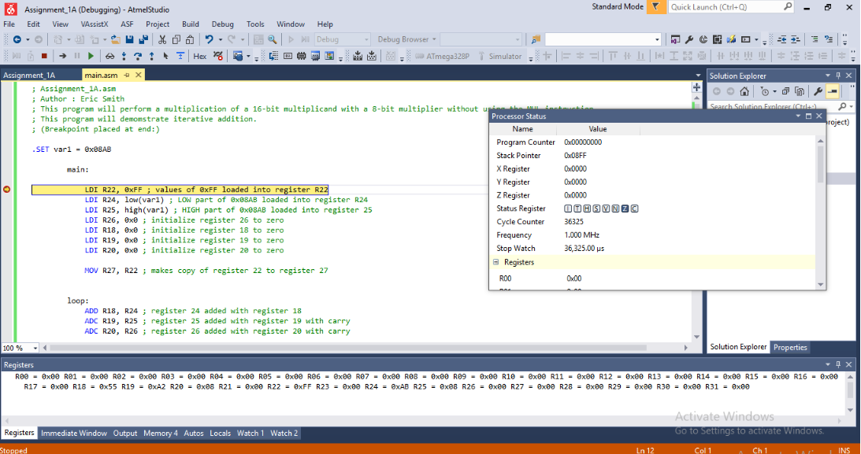
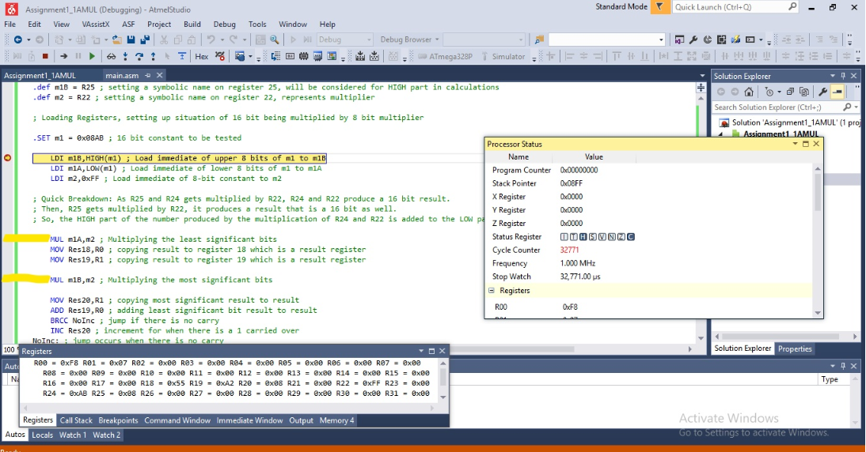
- SCHEMATICS

N/A

- SCREENSHOTS OF EACH TASK OUTPUT (ATMEL STUDIO OUTPUT)

N/A

- SCREENSHOT OF EACH DEMO (BOARD SETUP)

N/A

- VIDEO LINKS OF EACH DEMO

N/A

- GITHUB LINK OF THIS DA

https://github.com/smitheas95/submission_da

Student Academic Misconduct Policy
http://studentconduct.unlv.edu/misconduct/policy.html

“This assignment submission is my own, original work”.
NAME OF THE STUDENT

