CPE301 – SPRING 2019

Design Assignment 1B

Student Name: Eric Smith
Student #: 2000543940
Student Email: smithe4@unlv.nevada.edu
Primary Github address: smitheas95
Directory: Repository

- COMPONENTS LIST AND CONNECTION BLOCK DIAGRAM w/ PINS

N/A

- INITIAL/MODIFIED/DEVELOPED CODE OF TASK 1/B

Code:
;
; Lab1B-S19.asm
;
; Created: 2/23/2019 6:04:17 PM
; Author : Eric Smith

; Breakpoint used at RJMP END
; Chose consecutive numbers option instead of random numbers

; process of storing 99 numbers

RESET:

.SET STARTADDS = 0x0200
.SET COUNT = 99

.ORG 0

; POINTER SITUATION

LDI XL, LOW(STARTADDS) ; initializes [X] = 0x0200
LDI XH, HIGH(STARTADDS)

LDI YL, LOW(0x0400) ; initializes [Y] = 0x0400
LDI YH, HIGH(0x0400)

LDI ZL, LOW(0x0600) ; initializes [Z] = 0x0600
LDI ZH, HIGH(0x0600)

; COUNT REGISTER INITIALIZATION

LDI R21, COUNT ; R21 = 99
LDI R22, 10 ; R22 = 10 is starting point of counter
LDI R20, 3 ; R20 = 3

; CLEARING REGISTERS FOR SUMS

CLR R0
CLR R16
CLR R17
CLR R18
CLR R19

; ADDING LOWER ANDS HIGHER ADDRESS BITS TO BE STORED

START:

MOV R1, XL ; R1 = XL
ADD R1, XH ; R1 = XH + XL
MOV R3, R1 ; R3 = R1
ADD R3, R22 ; R3 = 10 + R3
ST X+, R3 ; stores values of R3 into incremented "X" register

DIVBYTHREE: ; divide by 3 loop

CP R1, R20 ; compare R20 to R1
BRLO DIVBAD ; if R1 < 3 go to DIVBAD
SUB R1, R20 ; R1 - 3
CP R1, R0 ; compare R0 to R1
BREQ DIVGOOD ; if R1 = 0 go to DIVGOOD
RJMP DIVBYTHREE

DIVGOOD: ; divide by 3 is good loop

SUB R3, R23 ; subtract R23 from R3
ST Y+, R3 ; stores value of R3 into incremented "Z" register
ADD R16, R3 ; R16 = ZH + ZL
ADC R17, R0 ; R17 = carry value from previous line
RJMP DONE

DIVBAD: ; divide by 3 is not good loop

SUB R3, R23 ; subtract R23 from R3
ST Z+, R3 ; stores value of R3 into incremented "Y" register
ADD R18, R3 ; R18 = YH + YL
ADC R19, R0 ; R19 = carry value from previous line
RJMP DONE

DONE:

CP R21, R0 ; compare R0 to R21
BREQ END ; if R21 = 0 go back to finish
SUBI R21, 1 ; R21 = 21 - 1
BRNE START ; if R21 != 0 go back to START

FINALVAL: ; final value part

ADD R3, R23 ; add R23 with r3
ADD R18, R3 ; add R3 with R18
ADC R19, R0 ; add with carry for R0 with R19

END:
RJMP END

- DEVELOPED MODIFIED CODE RESULTS

Thought process: If the numbers put in/used are consecutive rather than random, there will be the same final values in the registers at the end (despite the possible/multiple times of running the code)
Screenshot:
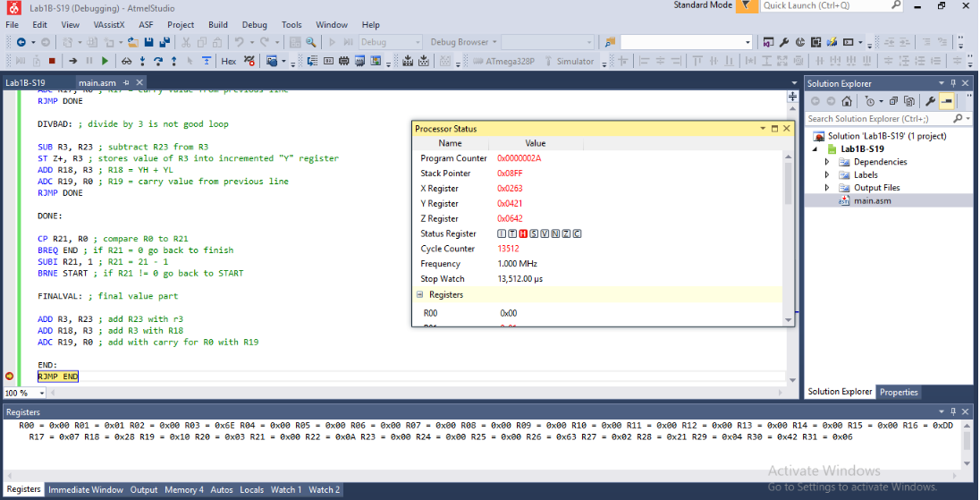

- SCHEMATICS

N/A

- SCREENSHOTS OF EACH TASK OUTPUT (ATMEL STUDIO OUTPUT)

N/A

- SCREENSHOT OF EACH DEMO (BOARD SETUP)

N/A

- VIDEO LINKS OF EACH DEMO

N/A

- GITHUB LINK OF THIS DA

https://github.com/smitheas95/submission_da

Student Academic Misconduct Policy
http://studentconduct.unlv.edu/misconduct/policy.html

“This assignment submission is my own, original work”.
NAME OF THE STUDENT

