CPE301 – SPRING 2019

Design Assignment 2B

Student Name: Eric Smith
Student #: 2000543940
Student Email: smithe4@unlv.nevada.edu
Primary Github address: smitheas95
Directory: Repository

- COMPONENTS LIST AND CONNECTION BLOCK DIAGRAM w/ PINS

Components used were: UNLV ECE board, USB AVRISP XPII, and jumper cable.

- INITIAL/DEVELOPED/MODIFIED/ CODE OF TASK 2/B ASM CODE

; DA_2B_T1.asm

; Created: 3/9/2019 6:59:15 PM
; Author : Eric Smith

.include <m328pdef.inc>
.ORG 0x02 ; LOCATION FOR RESET
RJMP EXO_ISR

START:
LDI R16, 0x04 ; LOAD BINARY 0b00000100 INTO R16
OUT DDRB, R16 ; DIRECTION IS SET FOR R16 AS OUTPUT
OUT PORTB, R16 ; PULL-UP RESISTOR SET AT PIN3
LDI R17, 0x00 ; LOAD IMMEDIATE VALUE 0x00 INTO R17
OUT DDRD, R17 ; DIRECTION IS SET FOR R17 AS INPUT FOR ALL
SBI PORTD, 2 ; SET BIT, PULL-UP RESISTOR
NOP ; WAIT

; INTERRUPT INITIALIZATION

LDI R20, 0x2 ; MAKE INT0 FALLING EDGE TRIGGERED
STS EICRA, R20 ; CONFIGURE LOADED INTO R20
LDI R20, 1 << INT0 ; ENABLE INT0
OUT EIMSK, R20 ; (MASK) LOAD ENABLE INTO R20
SEI ; ENABLE GLOBAL INTERRUPTS

HERE: JMP HERE

EXO_ISR:
LDI R21, 0xFB ; LOAD BINARY 0b11111011 TO R21
OUT PORTB, R21 ; LED TURNED ON
RCALL DELAY_GO ; RUN THROUGH DELAY(S)
RCALL DELAY_100MS
RCALL DELAY_50MS
OUT PORTB, R16 ; LED TURNED OFF
RETI

; PROCESS OF USING DELAYS TO CALCULATE/GET 1.25 SECONDS

DELAY_GO:
RCALL DELAY_100MS ; 0.1 SECONDS
RCALL DELAY_100MS ; 0.2 SECONDS
RCALL DELAY_100MS ; 0.3 SECONDS
RCALL DELAY_100MS ; 0.4 SECONDS
RCALL DELAY_100MS ; 0.5 SECONDS
RCALL DELAY_100MS ; 0.6 SECONDS
RCALL DELAY_100MS ; 0.7 SECONDS
RCALL DELAY_100MS ; 0.8 SECONDS
RCALL DELAY_100MS ; 0.9 SECONDS
RCALL DELAY_100MS ; 1 SECOND
RCALL DELAY_100MS ; 1.1 SECONDS
RCALL DELAY_100MS ; 1.2 SECONDS
RET

DELAY_100MS:
RCALL DELAY_50MS ; 1.25 SECONDS
RET

DELAY_50MS:
PUSH R16
PUSH R18
LDI R16, 255 ; LOAD IMMEDIATE 255 TO R16
LDI R18, 6 ; LOAD IMMEDIATE 6 TO R18

DELAY_1A:
DELAY_1B:
NOP ; WAIT
DEC R16 ; DECREMENT R16
BRNE DELAY_1B
DEC R18 ; DECREMENT R18
BRNE DELAY_1B
POP R18 ; POP REGISTER FROM STACK
POP R16 ; POP REGISTER FROM STACK
RET

- INITIAL/DEVELOPED/MODIFIED CODE OF TASK 2/B C CODE

/*
* DA_2B_T2.c
* Created: 3/9/2019 3:38:11 PM
* Author : Eric Smith

Goal of assignment is to use GPIO Interrupts
Use INT0 (PD2 pin/LED3) Interrupt mechanism
*/

#define F_CPU 16000000UL
#include <avr/io.h>
#include <util/delay.h>
#include <avr/interrupt.h>

int main(void)
{
DDRB |= (1 << DDB2); // DIRECTION IS SET FOR PORTB2 AS OUTPUT
PORTB |= (1 << PORTB2); // PULL-UP RESISTOR IS TURNED ON FOR PORTB2
DDRD &= (0 << DDD2); // DIRECTION IS SET FOR PORTD2 AS INPUT
PORTD |= (1 << PORTD2); // PULL-UP RESISTOR IS TURNED ON FOR PORTD2
EICRA = 0x00; // INTERRUPT IS SET/ACTIVATED ON LOW LEVEL

EIMSK = (1 << INT0); // ENABLE EXTERNAL INTERRUPT
sei (); // ENABLES GLOBAL INTERRUPT

while (1); // WAIT HERE FOR INTERRUPT SITUATION
}

ISR (INT0_vect) // ISR FOR EXTERNAL INTERRUPT
{
PORTB &= (0 << PORTB2); // LED IS TURNED ON
_delay_ms(1250); // 1.25 SECOND DELAY (SAME AS DESIGN ASSIGNMENT 2A TIME DELAY)
PORTB |= (1 << PORTB2); // LED IS TURNED ON AFTER MANUAL INTERRUPT
}

- SCHEMATICS

Key Schematic:

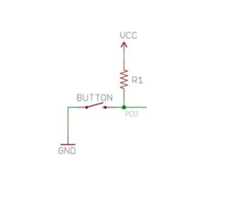
Key Diagram:
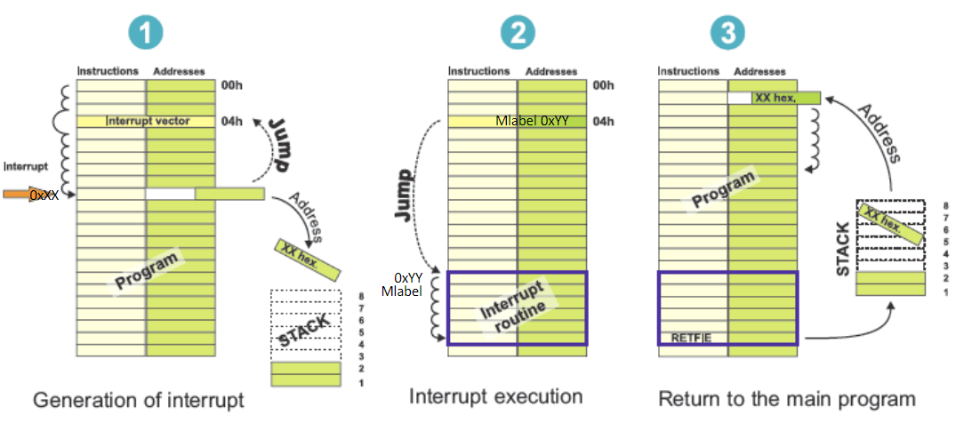

- SCREENSHOTS OF EACH TASK OUTPUT (ATMEL STUDIO OUTPUT)

Assembly Code Atmel Studio Output:
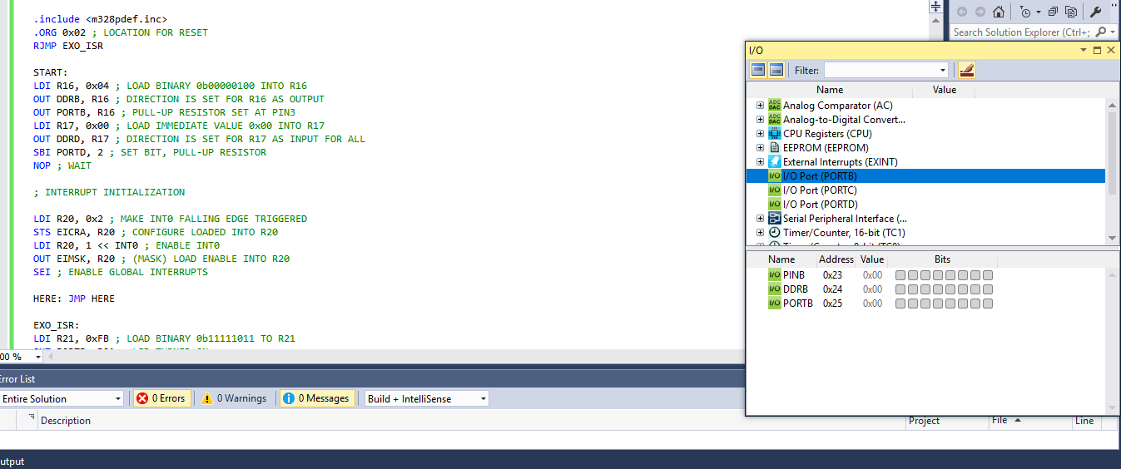

C Code Atmel Studio Output:
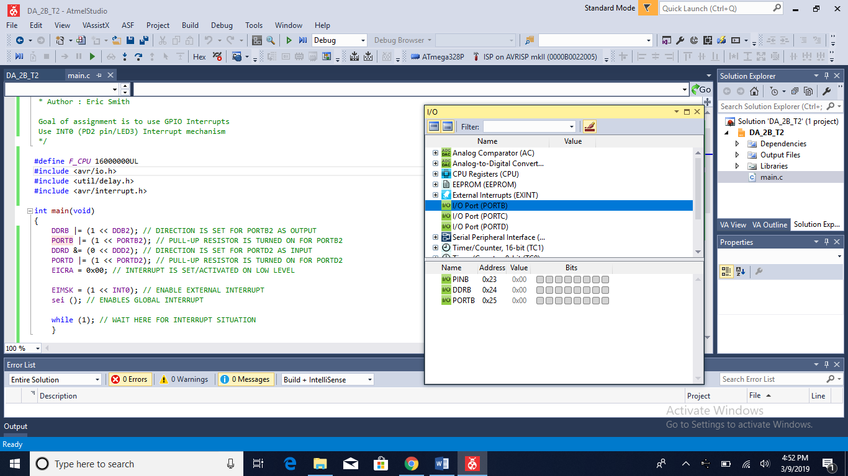

- SCREENSHOT OF DEMO (BOARD SETUP)

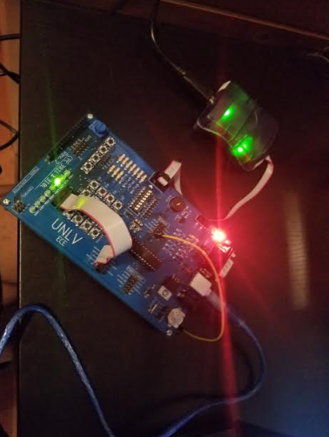

- VIDEO LINK OF DEMONSTRATION

https://youtu.be/309Nv3_379g

- GITHUB LINK OF THIS DA

https://github.com/smitheas95/submission_da

Student Academic Misconduct Policy
http://studentconduct.unlv.edu/misconduct/policy.html

“This assignment submission is my own, original work”.
Eric Smith

