CPE301 – SPRING 2019

Design Assignment 2A

Student Name: Eric Smith
Student #: 2000543940
Student Email: smithe4@unlv.nevada.edu
Primary Github address: smitheas95
Directory: Repository

- COMPONENTS LIST AND CONNECTION BLOCK DIAGRAM w/ PINS
Components used were: atmega328p xplained mini, multi- function shield, and the cpe 301 board. LED pins were used alongside D1 through D4 on the multi function shield.

- INITIAL/MODIFIED/DEVELOPED CODE OF TASK 2/A
Assembly:
;
; Lab2A1-S19.asm
;
; Created: 3/2/2019 10:38:26 PM
; Author : eas7w

.ORG 0
LDI R20, 0xFF ; load immediate value of 0xFF into register R20

OUT DDRB, R20 ; set as output alongside values of 0xFF

LDI R17, 0x01 ; load immediate 0x01 into R17
LDI R18, 0x00 ; load immediate 0x00 into R18
LDI R22, .435 ; load immediate timing into R22
LDI R21, .435 ; load immediate timing
LDI R23, 48 ; load immediate timing into R23

L1:
DELAY1:
INNERDELAY1: ; represents inner delay
DEC R22 ; decrement R22
BRNE INNERDELAY1 ; branch when not equal to innerdelay1
DEC R21 ; decrement R21
BRNE DELAY1 ; branch when not equal to delay1
DEC R23 ; decrement R23
BRNE L1 ; branch when not equal to L1
OUT PORTB, R17 ; output R17 for portb
LDI R22, .435 ; load immediate timing
LDI R21, .435 ; load immediate timing
LDI R23, 48 ; load immediate timing
L2:
DELAY2:
INNERDELAY2: ; represents inner delay 2
DEC R22 ; decrement R22
BRNE INNERDELAY2 ; branch when not equal to innerdelay 2
DEC R21 ; decrement R21
BRNE DELAY2 ; branch when not equal to delay 2
DEC R23 ; decrement R23
BRNE L2 ; branch when not equal to L2
OUT PORTB, R18 ; output R18 into portb

C:
*
* Lab2A2-S19.c
*
* Created: 3/2/2019 10:56:00 PM
* Author : Eric Smith
*/
#define F_CPU 1600000000UL
#include <avr/io.h>
#include <util/delay.h>

// LED CONNECTED TO PORTB.2 (D4)
// SWITCH CONNECTED TO PORTC.2
// PINB5 WAS MALFUNCTIONING ON SHIELD, WOULD STAY ON REGARDLESS OF EFFORT TO TURN IT OFF
// UPON TRYING TO RECORD A VIDEO FOR THIS CODE, ATMEL STUDIO DID RECOGNIZE MY XPLAINED MINI BOARD BEING PLUGGED IN

int main(void)
{
// SET PORTB FOR OUTPUT

DDRB |= (1<<PB2); // SET ONLY THAT LED TO BE ON WHEN NEEDED (AS OUTPUT)
PORTB |= (1<<PB2); // TURN LED OFF

// SET PORTC FOR INPUT

DDRC &= (0 << 1);
PORTC = 0xFF; // ACTIVATES PULL-UP RESISTANCE ON PORTC

while (1) // INFINITE LOOP
{
// POLLING
if (!(PINC & (1<<PINC))) // COMPLIMENT ENTIRE PART, CHECK FOR PIN C FOR A VALUE 1 & THEN COMPLIMENT
{
PORTB &= ~(1<<PB2); // INVERTS LOGIC LEVEL ON PORTB
_delay_ms(1250); // LED ON FOR 1250 ms
}
else
PORTB |= (1<<PB2);
}
return 0;
}

- DEVELOPED MODIFIED CODE OF TASK 2/A from TASK 2/A
N/A
- SCHEMATICS
Key Schematics:
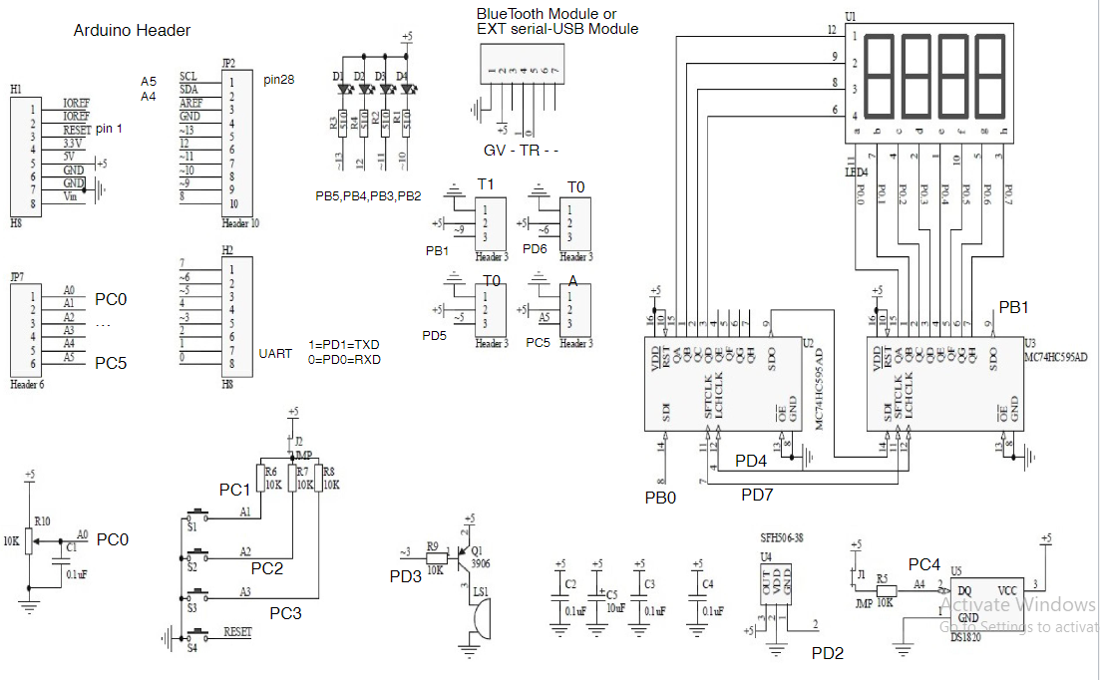
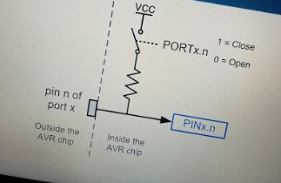

- SCREENSHOTS OF EACH TASK OUTPUT (ATMEL STUDIO OUTPUT)
Screenshot:
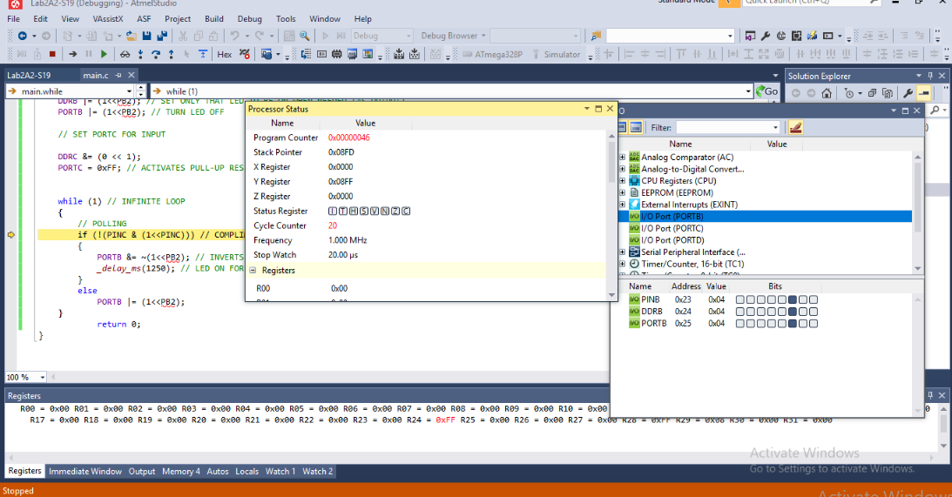

- SCREENSHOT OF EACH DEMO (BOARD SETUP)
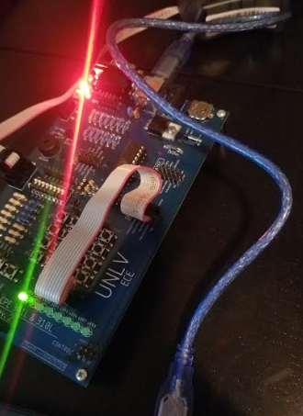

- VIDEO LINKS OF EACH DEMO
https://youtu.be/B779ZgBOPQc

- GITHUB LINK OF THIS DA
https://github.com/smitheas95/submission_da

Student Academic Misconduct Policy
http://studentconduct.unlv.edu/misconduct/policy.html

“This assignment submission is my own, original work”.
NAME OF THE STUDENT

