CPE301 – SPRING 2019

Design Assignment 2C

Student Name: Eric Smith
Student #: 2000543940
Student Email: smithe4@unlv.nevada.edu
Primary Github address: smitheas95
Directory: Repository

- COMPONENTS LIST AND CONNECTION BLOCK DIAGRAM w/ PINS

Components used were: UNLV ECE board, USB AVRISP XPII, and jumper cable.

- INITIAL/DEVELOPED CODE OF TASK 2A C Codes 1, 2 RESPECTIVELY

* DA_2A_C.c
*
* Created: 3/4/2019 8:44:34 PM
* Author : Eric Smith
*/

#define F_CPU 16000000UL // NOTE THAT CLOCK WILL RUN AT 16MHz

#include <avr/io.h>
#include <util/delay.h>

int main(void)
{
DDRB = 0x04; // PORTB SET AS OUTPUT

while(1) // INFINITE LOOP
{
PORTB = (1 << 2); // PB2 SET HIGH
_delay_ms(435); // REPRESENTS TIME THAT LED IS ON DUE TO 0.725 * THE 60% DC

PORTB = (1 << 2); // OUTPUT DISPLAY
_delay_ms(290); // TIME THAT LED IS ON DUE TO 0.725 - 0.435 (REPRESENTS 40% DC)
}
return 0;

}

* DA_2A_C.c
*
* Created: 3/4/2019 9:00:33 PM
* Author : Eric Smith
*/
#define F_CPU 16000000UL // CLOCK WILL RUN AT 16MHz

#include <avr/io.h>
#include <util/delay.h>

int main(void)
{
// SETTING PORTB AS OUTPUT
DDRB |= (1 << 2);
PORTB |= (1 << 2);

// SETTING PORTC AS INPUT
DDRC &= (0 << 2);
PORTC |= (1 << 2); // PULL-UP ENABLED (TURN ON THE PULL UP TRANSISTOR)

while (1)
{
if (!(PINC & (1 << PINC))) // CHECKING FOR COMPLIMENT SITUATION AND IF PINC IS HIGH
{
PORTB &= ~(1 << 2); // LED WILL TURN ON DUE TO 'ZERO' BEING SENT
_delay_ms(1250); // CREATES THE 1.25 SECOND DELAY
}
else
PORTB |= (1 << 2); // PORTB2 STAYS HIGH
}
return 0;
}

- DEVELOPED MODIFIED CODE OF TASK 2C CODES 1,2,3 RESPECTIVELY

TIMER0 – NORMAL MODE
/*
* DA_2C_T1.c
*
* Created: 3/24/2019 4:46:43 AM
* Author : eas7w
*/

#define F_CPU 16000000UL
#include <avr/io.h>
#include <util/delay.h>

int main(void)
{
unsigned char count = 0; // COUNT FOR KEEPING TRACK OF TIMER0
DDRB |= (1 << 2); // CONNECTION OF LED TO PIN B2
PORTB = 0; // PIN B2 LED OFF

// NORMAL MODE & TIMER0 WITH PRESCALER 64
while (1)
TCCR0A = 0;
TCCR0B |= (1 << CS01) | (1 << CS00);

TCNT0 = 0; // COUNTER INITIALIZATION

while ( ( TIFR0 & 0x1) == 0) // WAIT FOR OVERFLOW FLAG
TCCR0B = 0; // DISABLE TIMER0
TIFR0 |= 1; // CLR OVERFLOW FLAG

if (count == 20)
{
PORTB ^= 0x04; // TOGGLE PIN B2
count = 0; // RESET COUNTER
}
else
count++; // INCREMENT COUNTER
}

TIMER0_OVF_VECT (INTERRUPT)

/*
* DA_2C_T2.c
*
* Created: 3/24/2019 5:37:50 AM
* Author : eas7w
*/

#define F_CPU 16000000UL
#include <avr/io.h>
#include <avr/interrupt.h>

volatile int count;

int main(void)
{
count = 0; // COUNT IS INITIALIZED
DDRB |= (1 << 2); // CONNECTION OF LED TO PIN B2

// NORMAL MODE & TIMER0 WITH PRESCALER OF 64
TCCR0A = 0;
TCCR0B |= (1 << CS00) | (1 << CS01);

TCNT0 = 0; // TIME COUNTER INITIALIZATION
TIMSK0 |= (1 << TOIE0); // OVERFLOW INTERRUPT ENABLED
sei(); // GLOBAL INTERRUPT ENABLED

while (1); // INFINITE LOOP

}

ISR (TIMER0_OVF_vect) // INTERRUPT SERVICE ROUTINE
{
if (count == 20)
{
PORTB ^= (1 << 2); // TOGGLE PIN B5
count = 0; // COUNT REINITIALIZED
}
else
count++; // INCREMENT COUNT

}

TIMER0_COMPA_VECT (CTC)
/*
* DA_2C_T3.c
*
* Created: 3/24/2019 6:08:43 AM
* Author : eas7w
*/

#define F_CPU 16000000UL
#include <avr/io.h>
#include <avr/interrupt.h>

int main(void)
{
DDRB |= (1 << DDB2); // PB2 AS OUTPUT
OCR0A = 63; ; // LOAD COMPARE REGISTER
TCCR0A |= (1 << WGM21); // SET TO CTC MODE
TIMSK0 |= (1 << OCIE0A); // SET INTERRUPT ON COMPARE MATCH
TCCR0B |= (1 << CS22); // SET PRESCALER TO 64 AND STARTS PWM
sei(); // INTERRUPT ENABLED

while (1) // MAIN LOOP
{
}
}
ISR (TIMER0_COMPA_vect)
{
PORTB ^= (1 << DDRB2); // OUTPUT DESIRED
}

- SCHEMATICS
Key schematics:

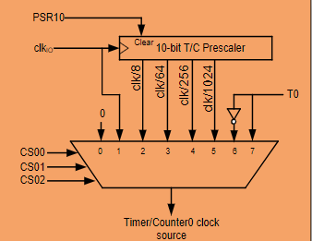
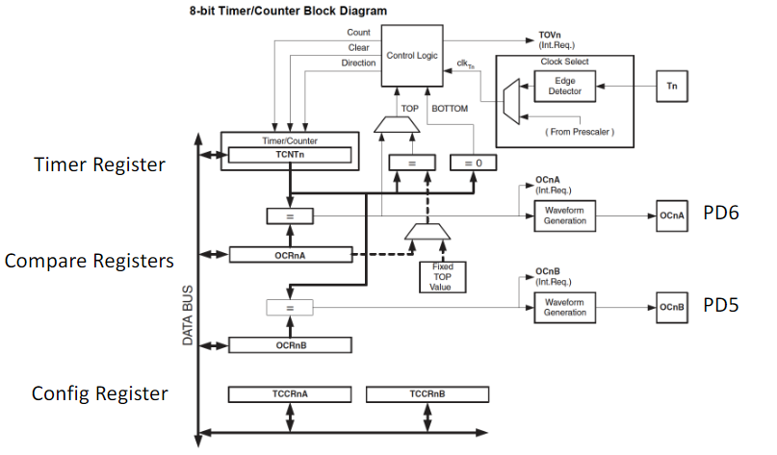

- SCREENSHOTS OF EACH TASK OUTPUT (ATMEL STUDIO OUTPUT)

N/A

- SCREENSHOT OF EACH DEMO (BOARD SETUP)

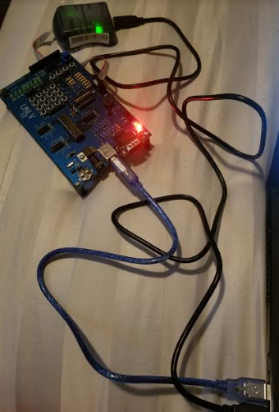

- VIDEO LINKS OF EACH DEMO

N/A

- GITHUB LINK OF THIS DA

https://github.com/smitheas95/submission_da

Student Academic Misconduct Policy
http://studentconduct.unlv.edu/misconduct/policy.html

“This assignment submission is my own, original work”.
Eric Smith

