CPE301 – SPRING 2019

Design Assignment 3A

Student Name: Eric Smith
Student #: 2000543940
Student Email: smithe4@unlv.nevada.edu
Primary Github address: smitheas95
Directory: Repository

- COMPONENTS LIST AND CONNECTION BLOCK DIAGRAM w/ PINS

Components used were: UNLV ECE board, USB AVRISP XPII, and jumper cables

- INITIAL DEVELOPED C CODE OF TASK 3/A

GOAL OF ASSIGNMENT: to modify the above codes to do the following: 1. Write a C AVR program that will display a string, random integer and floating point values on the serial terminal every 1 sec. Use a timer with interrupt for the 1 sec delay. Use a FTDI chip for serial to USB conversion.

/*
* DA_3A_T1.c
*
* Created: 3/27/2019 6:25:30 PM
* Author : ERIC SMITH
*/

#define F_CPU 8000000UL

#include <avr/io.h>
#include <util/delay.h>
#include <avr/interrupt.h>
#include <stdio.h>

#define BAUDRATE 9600
#define BAUD_PRESCALLER (((F_CPU / (BAUDRATE * 16UL))) - 1)

volatile int Count;

int n;
float PI;
char outs[30];
char str[] = "UNLV IS THE BEST";
char empty[] = " ";
void USART_init( unsigned int ubrr );
void USART_TX_string(char *data);

int main(void)
{
Count = 0;

USART_init(BAUD_PRESCALLER);
USART_TX_string("Connected!\r\n");
TIMSK0 |= (1 << TOIE0);
sei();
TCCR0A = 0x00;
TCCR0B = 0x05;

while(1);
}

void USART_TX_string(char *data)
{

while (*data != '\0') {
while (!(UCSR0A & (1 << UDRE0)));
UDR0 = *data;
data++;

}
}

void USART_init(unsigned int ubrr)
{

UBRR0H = (unsigned char)(ubrr >> 8);
UBRR0L = (unsigned char)ubrr;
UCSR0B = (1 << TXEN0);
UCSR0C = (3 << UCSZ00);

}

ISR (TIMER0_OVF_vect)
{

while (Count < 61)
{
if ((TIFR0 & 0x01) == 1)
{
TIFR0 = 0x01;
Count++;
}
}

if (Count > 60)
{
USART_TX_string(str);
USART_TX_string(empty);

n = rand();
PI = 3.1415;

dtostrf(PI, 6, 6, outs);
USART_TX_string(outs);
USART_TX_string(empty);

snprintf(outs, sizeof(outs), "%5d\r\n");

USART_TX_string(outs);
USART_TX_string(empty);
USART_TX_string(str);
USART_TX_string(empty);

Count = 0;
}
}

- DEVELOPED MODIFIED/COMMENTED C CODE OF DA 3A from TASK

/*
* DA_3A_T1.c
*
* Created: 3/27/2019 6:25:30 PM
* Author : ERIC SMITH
*/

#define F_CPU 8000000UL // 8MHz

#include <avr/io.h>
#include <util/delay.h>
#include <avr/interrupt.h>
#include <stdio.h>

#define BAUDRATE 9600 // DEFINITION REGARDING BAUDRATE
#define BAUD_PRESCALLER (((F_CPU / (BAUDRATE * 16UL))) - 1) // CONFIRMATION OF BAUDRATE PRESCALER

volatile int Count; // ESTABLISHMENT OF INTEGER COUNT NEEDED

int n; // VARIABLE N INTEGER
float PI; // FLOAT PI REPRESENTATION
char outs[30]; // CHARACTER ARRAY USED TO STORE RESPECTIVE AMOUNT
char str[] = "UNLV IS THE BEST"; // STRING TO BE DISPLAYED
char empty[] = " "; // EMPTY STRING FOR SPACE

void USART_init( unsigned int ubrr ); // VOID FUNCTION
void USART_TX_string(char *data); // VOID FUNCTION

int main(void)
{
Count = 0; // COUNT SET AT ZERO

USART_init(BAUD_PRESCALLER); // FOR USART, SETS BAUD PRESCALER
USART_TX_string("Connected!\r\n"); // FOR USART, SETS TEXT STRING
TIMSK0 |= (1 << TOIE0); // SETS INTERRUPT ACTIVATION
sei(); // ENABLES GLOBAL INTERRUPT
TCCR0A = 0x00; // NORMAL MODE REGARDING TIMER
TCCR0B = 0x05;

while(1);
}

void USART_TX_string(char *data) // VOID FUNCTION FOR STRING
{

while (*data != '\0') {
while (!(UCSR0A & (1 << UDRE0)));
UDR0 = *data;
data++;

}
}

void USART_init(unsigned int ubrr // VOID FUNCTION FOR USART_INIT
{

UBRR0H = (unsigned char)(ubrr >> 8);
UBRR0L = (unsigned char)ubrr;
UCSR0B = (1 << TXEN0); // INTERRUPT FOR TX ENABLED
UCSR0C = (3 << UCSZ00); // ASYNCHRONOUS

}

ISR (TIMER0_OVF_vect) // FLAG INTERRUPT FOR TV0V
{

while (Count < 61) // LOOP WHEN LESS THAN 61
{
if ((TIFR0 & 0x01) == 1)
{
TIFR0 = 0x01;
Count++;
}
}

if (Count > 60) // PERFORM/EXECUTE WHEN COUNT GREATER THAN 60
{
USART_TX_string(str); // PRINT STRING
USART_TX_string(empty); // BLANK SPACE PRINTED

n = rand(); // RANDOM NUMBER GENERATED
PI = 3.1415; // CHOSE PI

dtostrf(PI, 6, 6, outs); // DOUBLE VALUE PASSED IS CONVERTED IN VAL INTO ASCII REPRESENTATION TO BE STORED UNDER S
USART_TX_string(outs);
USART_TX_string(empty);

snprintf(outs, sizeof(outs), "%5d\r\n"); // CONVERTS FLOATING VALUE

USART_TX_string(outs); // WRITES STRING
USART_TX_string(empty);
USART_TX_string(str);
USART_TX_string(empty); // BLANK SPACE TO SERIAL

Count = 0; // RESETS COUNTER
}
}

- SCHEMATICS

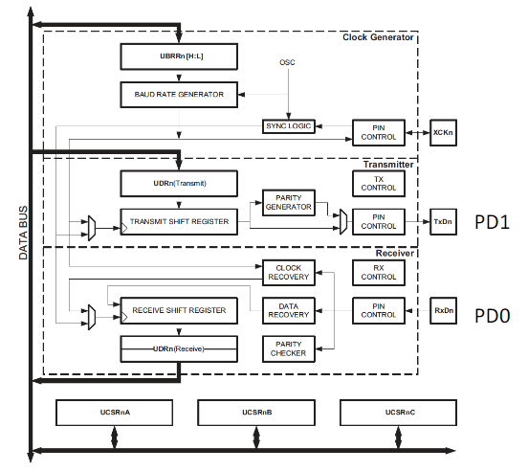

- SCREENSHOTS OF EACH TASK OUTPUT (ATMEL STUDIO OUTPUT)

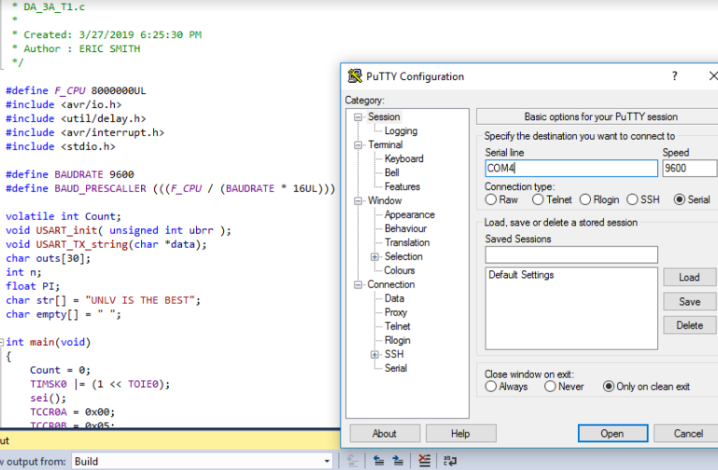
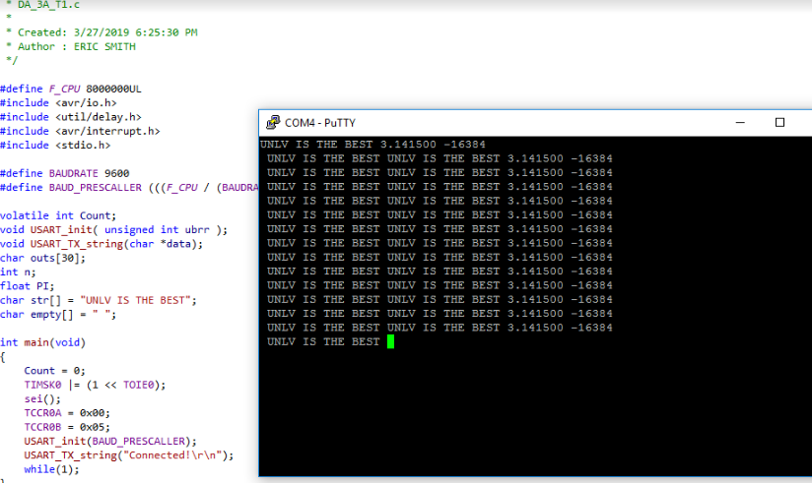

- SCREENSHOT OF EACH DEMO (BOARD SETUP)

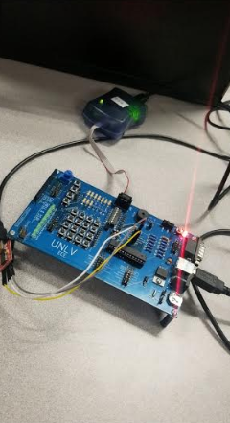
- VIDEO LINKS OF EACH DEMO

https://www.youtube.com/watch?v=NZbKV6-F2Ow&feature=youtu.be

- GITHUB LINK OF THIS DA

https://github.com/smitheas95/submission_da

Student Academic Misconduct Policy
http://studentconduct.unlv.edu/misconduct/policy.html

“This assignment submission is my own, original work”.
Eric Smith

