CPE301 – SPRING 2019

Design Assignment 5A

Student Name: Eric Smith
Student #: 2000543940
Student Email: smithe4@unlv.nevada.edu
Primary Github address: smitheas95
Directory: Repository

- COMPONENTS LIST AND CONNECTION BLOCK DIAGRAM w/ PINS

List:
Nrf24L01
ATMega328p
LM34
Male to female jumper wires
Pin Out:
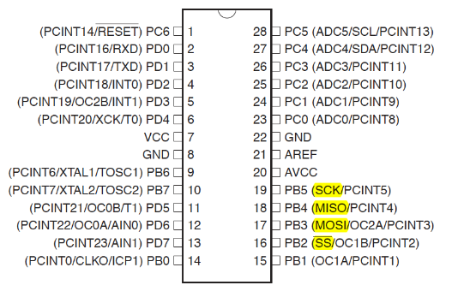

- INITIAL/MODIFIED/DEVELOPED CODE OF DA5A

Main Code:
/*
* DA_5A.c
*
* Created: 4/27/2019 9:19:57 PM
* Author : Eric Smith

Interface the provided NRF24L01+ RF Module to the ATmega328p using the SPI
interface. Using the earlier developed code for ADC, transmit the ADC value of the
internal temperature sensor, or LM35 sensor between two RF Modules. The
ATmega328p interfacing the RF Modules should alternate between TX and RX modes
every 0.5 secs (hopefully they are not both at TX and RX modes in the same interval).
The temperature of both ATmega328p’s should be displayed on both ATmega328p’s.
*/

#ifndef F_CPU
#define F_CPU 16000000UL
#endif

// NEDDED LIBRARIES
#include <avr/io.h>
#include <util/delay.h>
#include <avr/interrupt.h>
#include <stdbool.h>
#include <stdio.h>
#include <string.h>

// SET UP UART FOR PRINTF();
#ifndef BAUD
#define BAUD 9600
#endif
#include "inctest/STDIO_UART.h"

// NRF24L01+ LIBRARY INCLUDED
#include "inctest/nrf24l01.h"
#include "inctest/nrf24l01-mnemonics.h"
#include "inctest/spi.h"

// IRQ ISR
volatile bool message_received = false;
volatile bool status = false;

// CLICHE MESSAGE TO SEND
char tx_message[32]; // ARRAY STRING DEFINED

int main(void)
{
strcpy(tx_message, " Hi, This message is from Eric Smith!"); // COPY STRING INTO ARRAY
// UART INITIALIZED
uart_init();

// Initialize nRF24L01+ and print configuration info
nrf24_init();

// PRINT_CONFIGU();
// BEGIN LISTENING TO INCOMING MESSAGES
nrf24_start_listening();
status = nrf24_send_message(tx_message);
if (status == true)
{
printf("Connection Established\n");
}
while(1)
{
if(message_received)
{
// MESSAGE TO BE RECEIVED, PRINT IT
message_received = false; // Reset to false
printf("Received Temperature: %s\n", nrf24_read_message());
// RESPONSE AS A MESSAGE
_delay_ms(500);
// PERFORM ADC EXECUTION, STORE IN TX_MESSAGE
status = nrf24_send_message(tx_message);
if(status == true)
{
printf("Temperature Transmitted\n");
}
}
}
}

// IRQ pin INTERRUPT
ISR(INT0_vect)
{
message_received = true;
}

Nrf24L01 Code:

// Set clock frequency
#ifndef F_CPU
#define F_CPU 16000000UL
#endif

#include <avr/io.h>
#include <avr/interrupt.h>
#include <util/delay.h>
#include <stdio.h>
#include <stdbool.h>
#include <string.h>

// nRF24L01+ include files
#include "nrf24l01.h"
#include "nrf24l01-mnemonics.h"
#include "spi.h"

// Settings
uint8_t rx_address[5] = { 0x55, 0x55, 0x55, 0x55, 0x55 }; // Read pipe address
uint8_t tx_address[5] = { 0x66, 0x66, 0x66, 0x66, 0x66 }; // Write pipe address
#define READ_PIPE 0 // Number of read pipe
//
// -AUTO_ACK can be disabled when running on 2MBPS @ <= 32 byte messages.
// -250KBPS and 1MBPS with AUTO_ACK disabled lost many packets
// if the packet size was bigger than 4 bytes.
// -If AUTO_ACK is enabled, tx_address = rx_address.
//
#define AUTO_ACK false // Auto acknowledgment
#define DATARATE RF_DR_2MBPS // 250kbps, 1mbps, 2mbps
#define POWER POWER_MAX // Set power (MAX 0dBm..HIGH -6dBm..LOW -12dBm.. MIN -18dBm)
#define CHANNEL 0x74 // 2.4GHz-2.5GHz channel selection (0x01 - 0x7C)
#define DYN_PAYLOAD true // Dynamic payload enabled
#define CONTINUOUS false // Continuous carrier transmit mode (not tested)
//
// ISR(INT0_vect) is triggered depending on config (only one can be true)
//
#define RX_INTERRUPT true // Interrupt when message is received (RX)
#define TX_INTERRUPT false // Interrupt when message is sent (TX)
#define RT_INTERRUPT false // Interrupt when maximum re-transmits are reached (MAX_RT)
//
// -PIN map.
// -If CE or CSN is changed to different PIN e.g. PC0
// then change DDRB -> DDRC, PORTB -> PORTC and so on
//
// CE
#define CE_DDR DDRB
#define CE_PORT PORTB
#define CE_PIN DDB1 // CE connected to PB1
// CSN
#define CSN_DDR DDRB
#define CSN_PORT PORTB
#define CSN_PIN DDB2 // CSN connected to PB2
// IRQ
#define IRQ_DDR DDRD
#define IRQ_PORT PORTD
#define IRQ_PIN DDD2 // IRQ connected to PD2
// MOSI
#define MOSI_DDR DDRB
#define MOSI_PORT PORTB
#define MOSI_PIN DDB3
// MISO
#define MISO_DDR DDRB
#define MISO_PORT PORTB
#define MISO_PIN DDB4
// SCK
#define SCK_DDR DDRB
#define SCK_PORT PORTB
#define SCK_PIN DDB5

// PIN toggling
#define setbit(port, bit) (port) |= (1 << (bit))
#define clearbit(port, bit) (port) &= ~(1 << (bit))
#define ce_low clearbit(CE_PORT,CE_PIN)
#define ce_high setbit(CE_PORT,CE_PIN)
#define csn_low clearbit(CSN_PORT,CSN_PIN)
#define csn_high setbit(CSN_PORT,CSN_PIN)

// Used to store SPI commands
uint8_t data;

uint8_t nrf24_send_spi(uint8_t register_address, void *data, unsigned int bytes)
{
uint8_t status;
csn_low;
status = spi_exchange(register_address);
for (unsigned int i = 0; i < bytes; i++)
((uint8_t*)data)[i] = spi_exchange(((uint8_t*)data)[i]);
csn_high;
return status;
}

uint8_t nrf24_write(uint8_t register_address, uint8_t *data, unsigned int bytes)
{
return nrf24_send_spi(W_REGISTER | register_address, data, bytes);
}

uint8_t nrf24_read(uint8_t register_address, uint8_t *data, unsigned int bytes)
{
return nrf24_send_spi(R_REGISTER | register_address, data, bytes);
}

void nrf24_init(void)
{
// Interrupt on falling edge of INT0 (PD2) from IRQ pin
cli(); // Disable interrupts
EICRA |= (1 << ISC01);
EIMSK |= (1 << INT0);
sei(); // Enable interrupts

// CSN and CE as outputs and initial states
setbit(CE_DDR,CE_PIN);
setbit(CSN_DDR,CSN_PIN);
csn_high;
ce_low;

// Initialize SPI
spi_master_init();
_delay_ms(100); // Power on reset 100ms

// Start nRF24L01+ config
data =
(!(RX_INTERRUPT) << MASK_RX_DR) | // IRQ interrupt on RX (0 = enabled)
(!(TX_INTERRUPT) << MASK_TX_DS) | // IRQ interrupt on TX (0 = enabled)
(!(RT_INTERRUPT) << MASK_MAX_RT) | // IRQ interrupt on auto retransmit counter overflow (0 = enabled)
(1 << EN_CRC) | // CRC enable
(1 << CRC0) | // CRC scheme
(1 << PWR_UP) | // Power up
(1 << PRIM_RX); // TX/RX select
nrf24_write(CONFIG,&data,1);

// Auto-acknowledge on all pipes
data =
(AUTO_ACK << ENAA_P5) |
(AUTO_ACK << ENAA_P4) |
(AUTO_ACK << ENAA_P3) |
(AUTO_ACK << ENAA_P2) |
(AUTO_ACK << ENAA_P1) |
(AUTO_ACK << ENAA_P0);
nrf24_write(EN_AA,&data,1);

// Set retries
data = 0xF0; // Delay 4000us with 1 re-try (will be added in settings)
nrf24_write(SETUP_RETR,&data,1);

// Disable RX addresses
data = 0;
nrf24_write(EN_RXADDR, &data, 1);

// Set channel
data = CHANNEL;
nrf24_write(RF_CH,&data,1);

// Setup
data =
(CONTINUOUS << CONT_WAVE) | // Continuous carrier transmit
((DATARATE >> RF_DR_HIGH) << RF_DR_HIGH) | // Data rate
((POWER >> RF_PWR) << RF_PWR); // PA level
nrf24_write(RF_SETUP,&data,1);

// Status - clear TX/RX FIFO's and MAX_RT by writing 1 into them
data =
(1 << RX_DR) | // RX FIFO
(1 << TX_DS) | // TX FIFO
(1 << MAX_RT); // MAX RT
nrf24_write(STATUS,&data,1);

// Dynamic payload on all pipes
data =
(DYN_PAYLOAD << DPL_P0) |
(DYN_PAYLOAD << DPL_P1) |
(DYN_PAYLOAD << DPL_P2) |
(DYN_PAYLOAD << DPL_P3) |
(DYN_PAYLOAD << DPL_P4) |
(DYN_PAYLOAD << DPL_P5);
nrf24_write(DYNPD, &data,1);

// Enable dynamic payload
data =
(DYN_PAYLOAD << EN_DPL) |
(AUTO_ACK << EN_ACK_PAY) |
(AUTO_ACK << EN_DYN_ACK);
nrf24_write(FEATURE,&data,1);

// Flush TX/RX
// Clear RX FIFO which will reset interrupt
uint8_t data = (1 << RX_DR) | (1 << TX_DS) | (1 << MAX_RT);
nrf24_write(FLUSH_RX,0,0);
nrf24_write(FLUSH_TX,0,0);

// Open pipes
nrf24_write(RX_ADDR_P0 + READ_PIPE,rx_address,5);
nrf24_write(TX_ADDR,tx_address,5);
nrf24_write(EN_RXADDR,&data,1);
data |= (1 << READ_PIPE);
nrf24_write(EN_RXADDR,&data,1);
}

void nrf24_write_ack(void)
{
const void *ack = "A";
unsigned int length = 1;
csn_low;
spi_send(W_ACK_PAYLOAD);
while (length--) spi_send(*(uint8_t *)ack++);
csn_high;
}

void nrf24_state(uint8_t state)
{
uint8_t config_register;
nrf24_read(CONFIG,&config_register,1);

switch (state)
{
case POWERUP:
// Check if already powered up
if (!(config_register & (1 << PWR_UP)))
{
data = config_register | (1 << PWR_UP);
nrf24_write(CONFIG,&data,1);
// 1.5ms from POWERDOWN to start up
_delay_ms(2);
}
break;
case POWERDOWN:
data = config_register & ~(1 << PWR_UP);
nrf24_write(CONFIG,&data,1);
break;
case RECEIVE:
data = config_register | (1 << PRIM_RX);
nrf24_write(CONFIG,&data,1);
// Clear STATUS register
data = (1 << RX_DR) | (1 << TX_DS) | (1 << MAX_RT);
nrf24_write(STATUS,&data,1);
break;
case TRANSMIT:
data = config_register & ~(1 << PRIM_RX);
nrf24_write(CONFIG,&data,1);
break;
case STANDBY1:
ce_low;
break;
case STANDBY2:
data = config_register & ~(1 << PRIM_RX);
nrf24_write(CONFIG,&data,1);
ce_high;
_delay_us(150);
break;
}
}

void nrf24_start_listening(void)
{
nrf24_state(RECEIVE); // Receive mode
//if (AUTO_ACK) nrf24_write_ack(); // Write acknowledgment
ce_high;
_delay_us(150); // Settling time
}

uint8_t nrf24_send_message(const void *tx_message)
{
// For printf();
char temp[32];
memset(temp,0,32);
strcpy(temp,tx_message);

// Message length
uint8_t length = strlen(tx_message);

// Transmit mode
nrf24_state(TRANSMIT);

// Flush TX/RX and clear TX interrupt
nrf24_write(FLUSH_RX,0,0);
nrf24_write(FLUSH_TX,0,0);
data = (1 << TX_DS);
nrf24_write(STATUS,&data,1);

// Disable interrupt on RX
nrf24_read(CONFIG,&data,1);
data |= (1 << MASK_RX_DR);
nrf24_write(CONFIG,&data,1);

// Start SPI, load message into TX_PAYLOAD
csn_low;
if (AUTO_ACK) spi_send(W_TX_PAYLOAD);
else spi_send(W_TX_PAYLOAD_NOACK);
while (length--) spi_send(*(uint8_t *)tx_message++);
spi_send(0);
csn_high;

// Send message by pulling CE high for more than 10us
ce_high;
_delay_us(15);
ce_low;

// Wait for message to be sent (TX_DS flag raised)
nrf24_read(STATUS,&data,1);
while(!(data & (1 << TX_DS))) nrf24_read(STATUS,&data,1);
printf("Message sent: %s\n",temp);

// Enable interrupt on RX
nrf24_read(CONFIG,&data,1);
data &= ~(1 << MASK_RX_DR);
nrf24_write(CONFIG,&data,1);

// Continue listening
nrf24_start_listening();

return 1;
}

unsigned int nrf24_available(void)
{
uint8_t config_register;
nrf24_read(FIFO_STATUS,&config_register,1);
if (!(config_register & (1 << RX_EMPTY))) return 1;
return 0;
}

const char * nrf24_read_message(void)
{
// Message placeholder
static char rx_message[32];
memset(rx_message,0,32);

// Write ACK message
if (AUTO_ACK) nrf24_write_ack();

// Get length of incoming message
nrf24_read(R_RX_PL_WID,&data,1);

// Read message
if (data > 0) nrf24_send_spi(R_RX_PAYLOAD,&rx_message,data+1);

// Check if there is message in array
if (strlen(rx_message) > 0)
{
// Clear RX interrupt
data = (1 << RX_DR);
nrf24_write(STATUS,&data,1);

return rx_message;
}

// Clear RX interrupt
data = (1 << RX_DR);
nrf24_write(STATUS,&data,1);

return "failed";
}

- DEVELOPED MODIFIED CODE OF DA5A

(Not needed, covered in question 2)

- SCHEMATICS

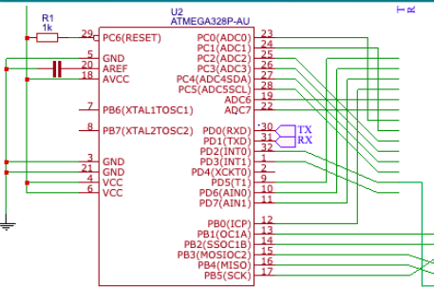
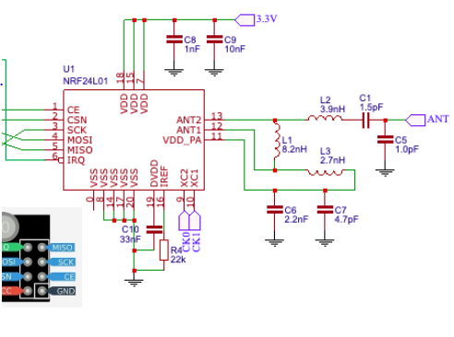

- SCREENSHOTS OF EACH TASK OUTPUT (ATMEL STUDIO OUTPUT)

Sending and Receiving Outputs Via Data Visualizer:
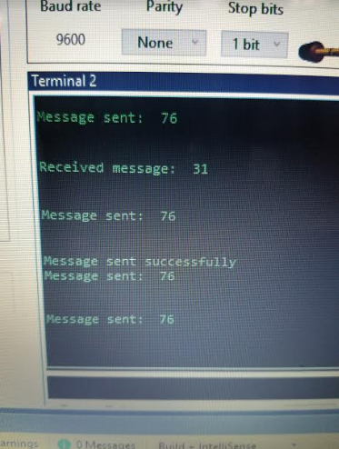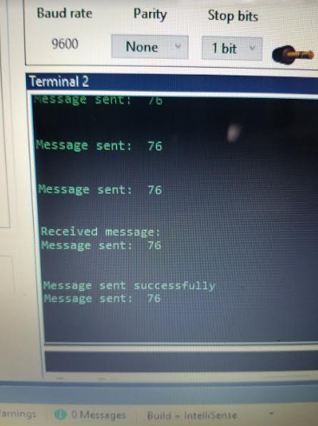

NOTE: My partner was Matt Tomljenovic. We adjusted our address values to make for successful completion of the sending and receiving process.
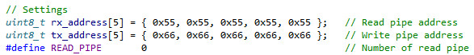

- SCREENSHOT OF EACH DEMO (BOARD SETUP)

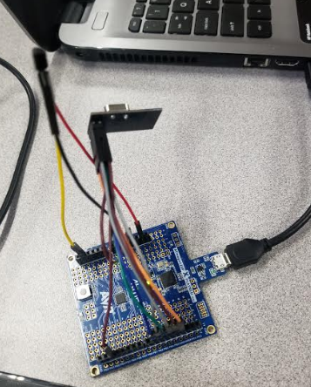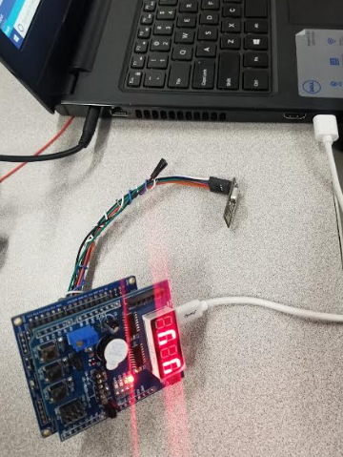

- VIDEO LINKS OF EACH DEMO

https://youtu.be/-_NiYpt7hv8

- GITHUB LINK OF THIS DA

https://github.com/smitheas95/submission_da

Student Academic Misconduct Policy
http://studentconduct.unlv.edu/misconduct/policy.html

“This assignment submission is my own, original work”.
Eric Smith

