RP-Growth Algorithm

# Transaction Database

|  |  |  |
| --- | --- | --- |
| TransactionID | Items | RP-Ordered Itemset |
| 1 | a,c,d | c,a,d |
| 2 | b,c,e | b,c,e |
| 3 | a,b,c,e | b,c,e,a |
| 4 | b,e | b,e |

# Rare Items

Maximum Support = 3, 75%

|  |  |
| --- | --- |
| b | 3 |
| c | 3 |
| e | 3 |
| a | 2 |
| d | 1 |

Maximum Support=2, 50%

|  |  |
| --- | --- |
| a | 2 |
| d | 1 |

# RP-Tree

Maxsup=3

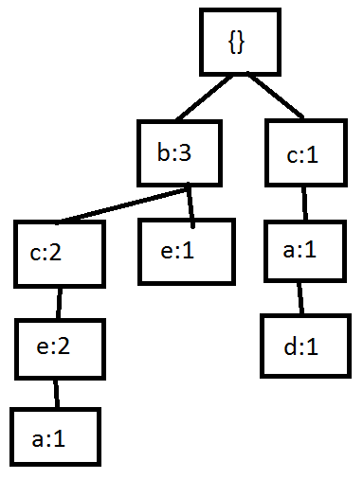

Maxsup=2

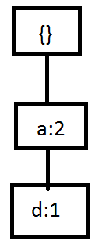

(There’s no need to do projections with this tree)

# Projections

{a}-projected: (c:2}

{a,c}-projected: ()

{c}-projected: (b:2)