FP-Growth Algorithm

# Transaction Database

|  |  |  |
| --- | --- | --- |
| TransactionID | Items | Ordered Frequent Items |
| 1 | a,b,c | b,c,a |
| 2 | a,b,c,d,e | b,c,e,a,d |
| 3 | b,c,e | b,c,e |
| 4 | c,e | c,e |
| 5 | b,d,e | b,e,d |

Minimum Support = 2 (40%)

# Support

|  |  |
| --- | --- |
| a | 2 |
| b | 4 |
| c | 4 |
| d | 2 |
| e | 4 |

# FP-Tree

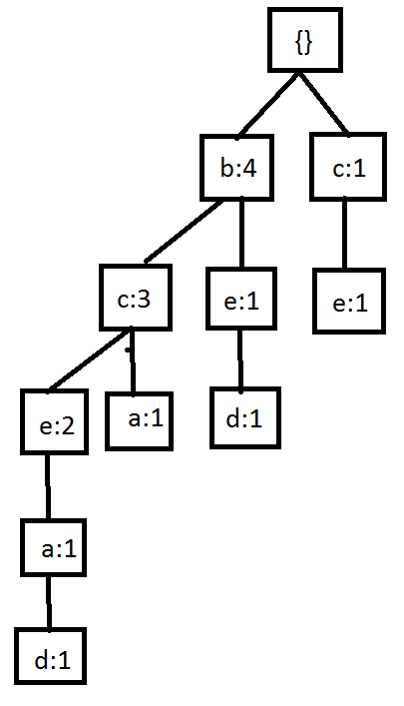

# Projections

{a}-projected FP-tree: (b:2)-(c:2)

{a,c}-projected: (b:2)

{a,b}-projected: ()

{a,b,c}-projected: ()

{d}-projected: (b:2)-(e:2)

{d,e}-projected: (b:2)

{b,d}-projected: ()

{d,e,b}-projected: ()