**Name :-** Smit Hingarajiya

**ID NO :-** 21EL042

**Division :-** 04

**Year :-** 2023-24

**Subject :-** Digital System Design (3EL42)

**Branch :-** Electronics (EL)

**Assignment: - 2**

**Q-1:-** Design 4-bit Ripple Carry Adder with the help of 1-bit adder

**VERILOG CODE:-**

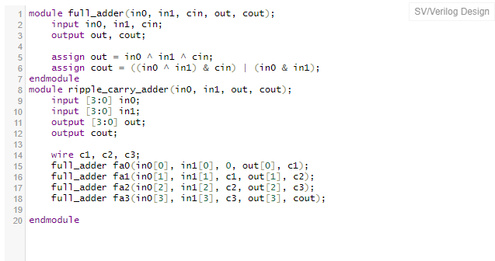

**TEST BENCH:-**

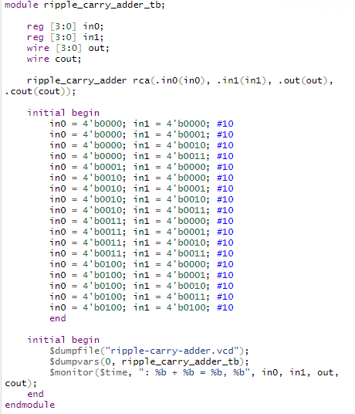

**OUTPUT: -**

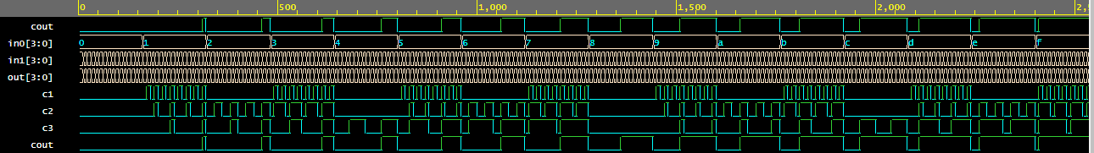

**Q-2: -** Design D-flipflop and reuse it to implement 4- bit Johnson Counter

**Verilog code :-**

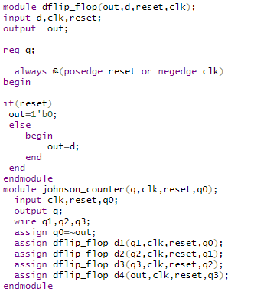

**TEST BENCH:-**

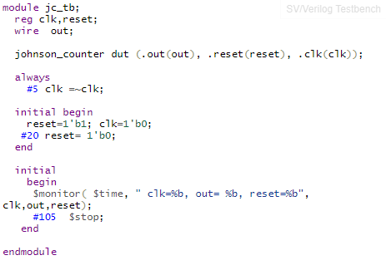

**OUTPUT:-**

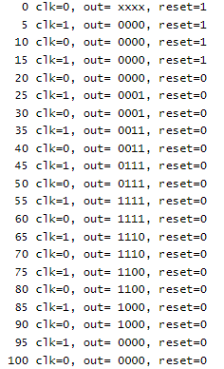

**Q-3: -** Reuse 2:1 Mux code to implement 8:1 Mux

**VERILOG CODE:-**

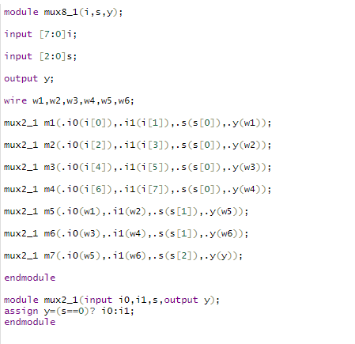

**TEST BENCH:-**

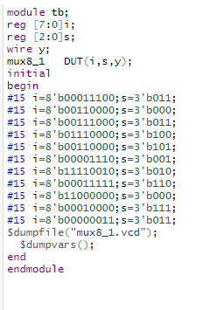

**OUTPUT:-**

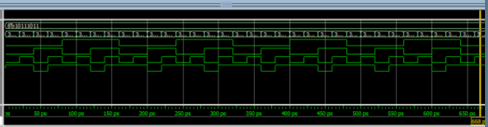

**Q-4: -** Design a Full Subtractor with Gate Level Modelling Style. (Use primitive gates)

**VERILOG CODE:-**

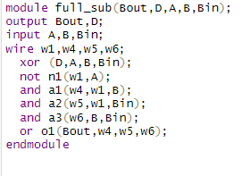

**TEST BENCH:-**

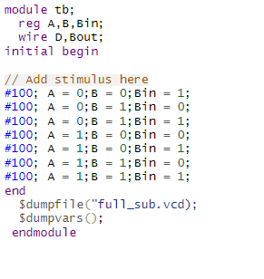

**OUTPUT:-**

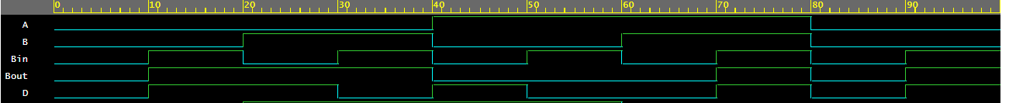

**Q-5: -** Design a 2X4 decoder using gate level modelling

**VERILOG CODE:-**

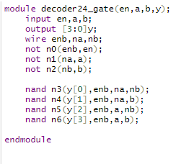

TEST BENCH:-

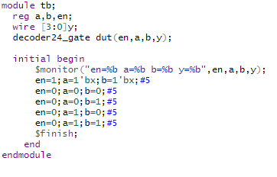

**OUTPUT:-**

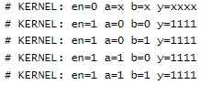

**Q-6: -** Design a 4x1 mux using operators. (Use data flow)

**VERILOG CODE: -**

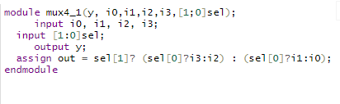

**TEST BENCH: -**

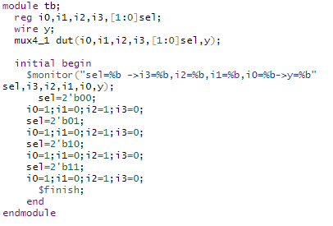

**OUTPUT: -**

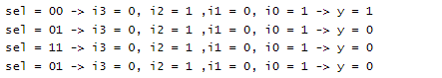

**Q-7: -** Design a Full adder using half adder.

**VERILOG CODE:-**

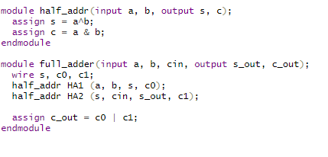

**TEST BENCH: -**

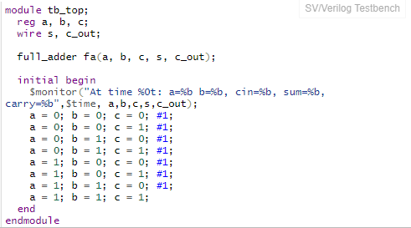

**OUTPUT: -**

