Design 1

What Makes Us Happy?



Circle represents average happiness score of continent

Person clicks on continent to get dashboard of aggregrate graphs that show different information across the whole continent

See next page for proposed dashboard

Design 2

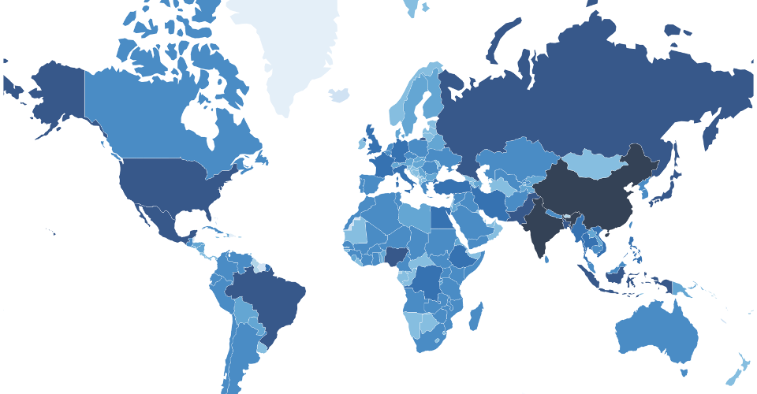

Visualization opens on a flat map of the continents with an accompanying description. Clicking on one of the continents takes you to a color coded map