Monthly Zoom Account Utilization Report

Shambhala Global Services

# Overview

This report covers the period between 2022-08-01 and 2022-08-31.

# Large meetings (more than 50 participants)

| Date | Topic | Participants |
| --- | --- | --- |
| 2022-08-01 | Compassion for Ukraine - Daily |  |
| Tonglen | 58 |  |
| 2022-08-02 | Compassion for Ukraine - Daily |  |
| Tonglen | 120 |  |
| 2022-08-03 | Compassion for Ukraine - Daily |  |
| Tonglen | 64 |  |
| 2022-08-04 | Compassion for Ukraine - Daily |  |
| Tonglen | 56 |  |
| 2022-08-04 | Shambhala Conversations’s |  |
| Personal Meeting Room | 67 |  |
| 2022-08-05 | Compassion for Ukraine - Daily |  |
| Tonglen | 65 |  |
| 2022-08-06 | Compassion for Ukraine - Daily |  |
| Tonglen | 51 |  |
| 2022-08-06 | 103 Room’s Personal Meeting |  |
| Room | 69 |  |
| 2022-08-07 | Compassion for Ukraine - Daily |  |
| Tonglen | 66 |  |
| 2022-08-08 | Compassion for Ukraine - Daily |  |
| Tonglen | 58 |  |
| 2022-08-09 | Compassion for Ukraine - Daily |  |
| Tonglen | 71 |  |
| 2022-08-09 | Shambhala Conversations’s |  |
| Personal Meeting Room | 53 |  |
| 2022-08-10 | Compassion for Ukraine - Daily |  |
| Tonglen | 59 |  |
| 2022-08-10 | Individual Liberation to |  |

Social Liberation - Resource Guide mtg | 80| |2022-08-11 |Compassion for Ukraine - Daily Tonglen | 68| |2022-08-12 |Compassion for Ukraine - Daily Tonglen | 57| |2022-08-14 |Compassion for Ukraine - Daily Tonglen | 65| |2022-08-15 |Compassion for Ukraine - Daily Tonglen | 56| |2022-08-16 |Compassion for Ukraine - Daily Tonglen | 56| |2022-08-17 |Compassion for Ukraine - Daily Tonglen | 54| |2022-08-18 |Compassion for Ukraine - Daily Tonglen | 54| |2022-08-19 |Compassion for Ukraine - Daily Tonglen | 59| |2022-08-20 |Compassion for Ukraine - Daily Tonglen | 54| |2022-08-21 |Compassion for Ukraine - Daily Tonglen | 70| |2022-08-21 |Shambhala Sunday Gatherings: June-Sept 2022 | 75| |2022-08-22 |Compassion for Ukraine - Daily Tonglen | 94| |2022-08-23 |Compassion for Ukraine - Daily Tonglen | 68| |2022-08-24 |Compassion for Ukraine - Daily Tonglen | 70|

This report shows the accounts that were used as well as some that were not. It depicts the length of meetings and the range of meeting size during the reporting period.

# Utilization of active accounts

| dept | host_email | meeting_count | total_minutes | total_participants | name |
| --- | --- | --- | --- | --- | --- |
| Code of Conduct | irenewoodard24@gmail.com | 13 | 696 | 35 | Irene Woodard |
| Process Team | jfladmark@gmail.com | 18 | 311 | 32 | Jim Fladmark |
| Process Team | kris@mcyork.com | 32 | 1421 | 104 | Kristine McCutcheon |
| Process Team | susannevincent@outlook.com | 5 | 92 | 6 | Susanne Vincent |
| SGS | alice.toohey@shambhala.info | 24 | 870 | 99 | Alice Toohey |
| SGS | claudia.arnau@shambhala.info | 10 | 469 | 25 | Claudia Arnau de Frutos |
| SGS | shambhala.dbrown@gmail.com | 7 | 426 | 33 | David Brown |
| SGS | david.maclellan@shambhalaglobal.org | 4 | 173 | 9 | David MacLellan |
| SGS | janet.bronstein@shambhala.info | 8 | 934 | 245 | Janet Bronstein |
| SGS | jeff.scott@shambhalaglobal.org | 13 | 1116 | 33 | Jeff Scott |
| SGS | john.smith@shambhalaglobal.org | 43 | 1787 | 159 | John David Smith |
| SGS | natasha.west@shambhala.info | 46 | 1321 | 105 | Natasha West |
| SGS | irina.migliari@shambhala.info | 8 | 383 | 20 | Nina Migliari |
| SGS | taratemplin80@gmail.com | 32 | 2169 | 252 | Tara Templin |
| Shambhala | alexandria.m.barnes@gmail.com | 18 | 627 | 53 | Alexandria |
| Shambhala | dk@shambhalaonline.org | 6 | 247 | 17 | Dorje Kasung |
| Shambhala | dk2@shambhalaonline.org | 1 | 62 | 2 | Dorje Kasung-2 |
| Shambhala | dragon@shambhalaonline.org | 3 | 342 | 10 | Shambhala Community |
| Shambhala Board | lglillypad@gmail.com | 3 | 65 | 4 | Lilly Gleich |
| Shambhala Board | mark.d.blumenfeld@gmail.com | 8 | 461 | 26 | Mark Blumenfeld |
| Shambhala Board | paulinavaras15@gmail.com | 1 | 77 | 2 | Paulina Varas |
| Shambhala Board | peter.ewa.nowak@gmail.com | 5 | 207 | 9 | Peter Nowak |
| Shambhala Board | susan802902@gmail.com | 16 | 26 | 16 | Susan Engel |
| Shambhala Board | susans.ryan@comcast.net | 8 | 792 | 37 | Susan Ryan |
| Shambhala Online | 101room@shambhalaonline.org | 60 | 2885 | 1688 | 101 Room |
| Shambhala Online | 102room@shambhalaonline.org | 3 | 185 | 13 | 102 Room |
| Shambhala Online | 103room@shambhalaonline.org | 7 | 356 | 78 | 103 Room |
| Shambhala Online | 105room@shambhalaonline.org | 1 | 43 | 7 | 105 Room |
| Shambhala Online | director@shambhalaonline.org | 60 | 606 | 95 | Eve R |
| Shambhala Online | dean@shambhalaonline.org | 24 | 1311 | 71 | Mimi Valiulis |
| Shambhala Online | 104room@shambhalaonline.org | 9 | 355 | 29 | Room 104 Shambhala Online |
| Shambhala Online | 202room@shambhalaonline.org | 5 | 450 | 25 | Virtual Chöling |

# Inactive accounts

Of the 40 Zoom accounts, 8 were **not** used during the month:

| dept | name | host_email |
| --- | --- | --- |
| Code of Conduct | Jan Snyder | coc.jan.snyder@shambhala.info |
| Code of Conduct | Vincent Dummer | coc.vincent.dummer@shambhala.info |
| SGS |  | john.murphy@shambhalaglobal.org |
| SGS | John Shaw | john.shaw@shambhala.info |
| SGS | Zoom Webinars | webinars@shambhala.info |
| Shambhala | 201 Room | shambhalachristchurch@gmail.com |
| Shambhala Online | 106 Room | 106room@shambhalaonline.org |
| Shambhala Online | 108 Room | 108room@shambhalaonline.org |

# Meeting characteristics

## How long do meetings last?

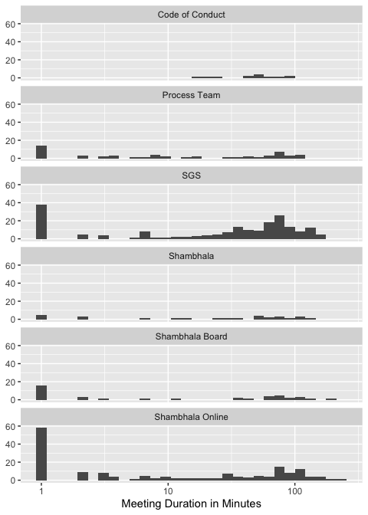

## How many people in a meeting?

Most meetings held this month were for very small groups:

Top 10 most-frequent meeting sizes