French Bob

The French bob is a chic, timeless cut typically cut just above the chin with sot, textured ends. Often paired with bangs, this style offers a relaxed. Parisian-inspired, sophasticated, and playful look. It’s ideal for women who want a low-maintenance yet stylish cut that exudes fortless elegance.

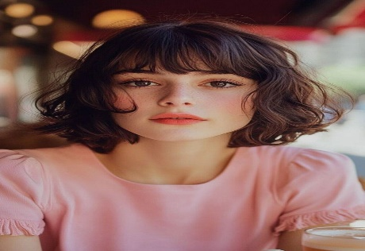

Bubble cut

The bubble cut is a retro-inspired style where the hair is cut into rounded,voluminous layers, creating a bubble-like effect. This fun and playful cut works well with medium to thick hair, adding a full-bodied shape and plenty of bounce. It’s a perfect for those looking for a vintage, high-fashion hairstyle with a lot of personality.

Invisible layers

Invisible layers are a subtle, soft layering technique where the layers blend seamlessly into the hair, making them almost undetectable. This cut adds texture and movement without sacrificing length, making it ideal for women who want a natural, flowing look. It’s perfect for those who want volume without noticeable layers.

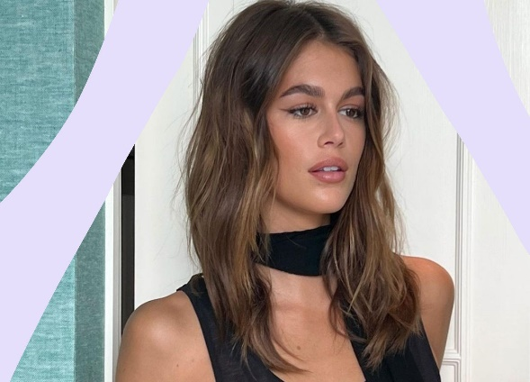

Baby Bangs

Baby bangs are a bold, youthful choice. The fringe is cut to sit ust above the eyebrows. This short, blunt fringe adds a quirty and playful element to the hairstyle, creating, creating a bold contrast with the rest of the hair. Baby bangs work best with shorter haircuts, adding a dramatic, attention-grabbing touch.

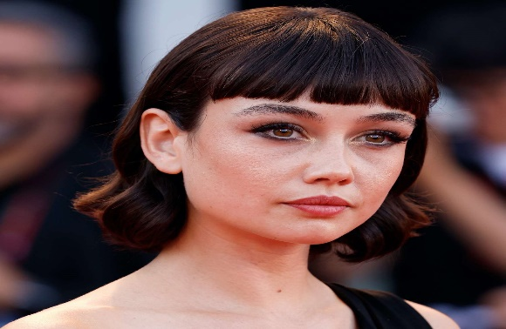

Mermaid cut

The mermaid cut is about long, flowing layers with plenty of volume and movement, resembling the ocean’s waves. It’s a soft, romantic style that blends layers to create an effortlessly beautiful, beachy look. Perfect for women with long hair, this cut adds volume and a carefree vibe for those who love the natural texture.

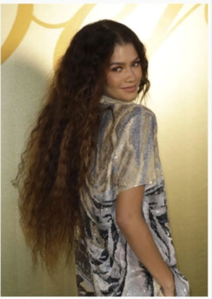

Hime cut

Hime cut is a traditional Japanese hairstyle that features straight, blunt bangs that reach the eyebrows, with the rest of the hair cut in long, smooth layers. The result is a striking contrast between the sharp fringe and the flowing locks, giving the style an elegant, regal feel. This cut is perfect for women who want a dramatic yet sophisticated look.

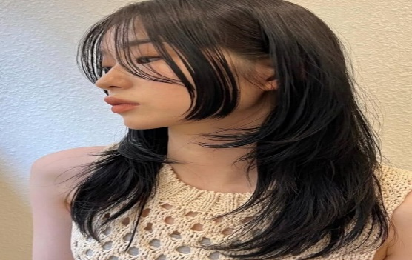

Clipped ends

The Indian women hair cut style is a modern, edgy style where the tips of the hair are cut at an angle or blunty clipped for a clean, sharp finish. This cut is ideal for those who want a no-fuss, low-maintenance style that still excudes confidence. It works particularly well with straight hair, creating a sleek and structured look.

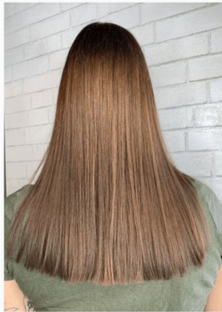

Bardot bangs

Bardot bangs inspired by Brigitte Bardot’s iconic 1960s look, are voluminous, side-swept bangs that frame the face softly. The bangs are typically cut long and blended into the hair for a carefree, youthful vibe. This style adds a touch off glamour and sophistication, making it perfect for women seeking a vintage yet modern look.

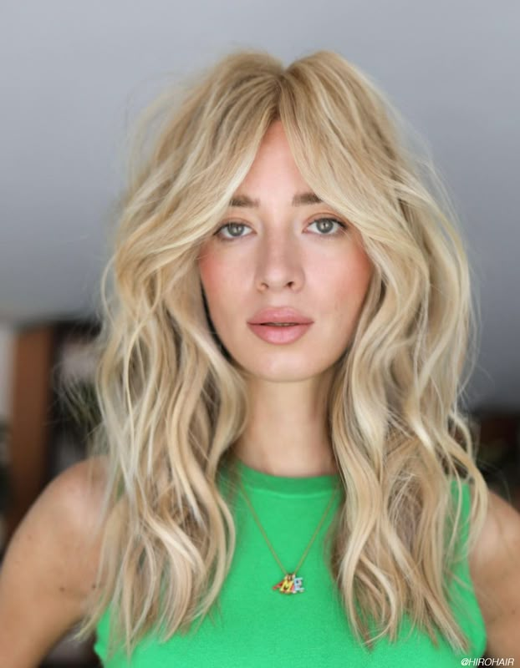

Russian Tapered Haircut

The Russian Tapered Haircut is a unique, fashion-forward style where the hair gradually shortens from the crown to the nape of the neck. This cut provides a sleek, elongated look while maintaining volume and structure. It’s a great choice for women who want a bold, contemporary style with an edge.

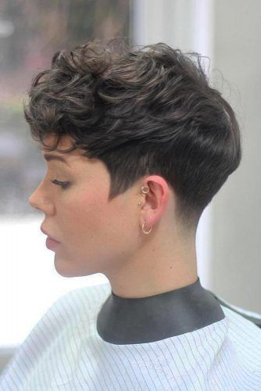

Face-Framing Volume layers

face-framing volume layers are strategically placed to highlight the cheekbones and jawline while creating a voluminous, layered look. The layers add bounce and texture to the hair, with the front sections designed to soften and define facial features. This cut is ideal for women seeking volume and a flattering frame for their face.

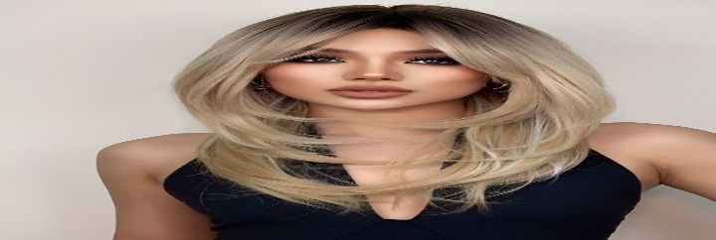

Bottleneck bangs

Bottleneck bangs are a contemporary variation of fringe, cut to gradually narrow toward the center. This style creates a soft, face-framing look that’s subtle yet chic. It’s perfect for women who want bangs with a more refined, elegant appearance that still adds a dramatic touch.

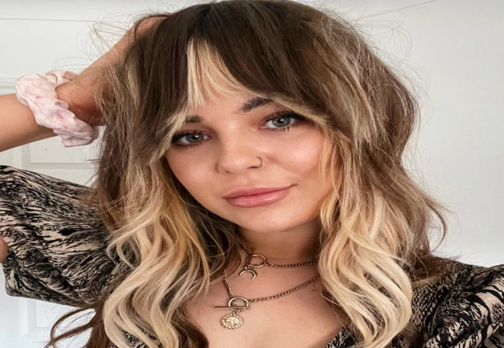

Triangle cut

The triangle cut features layers cut at sharp angles to create a triangular shape at the back of the head. This style helps add structure and volume, particularly for women with thick or coarse hair. It’s a bold, unique look that gives the hair an edgy, modern flair.

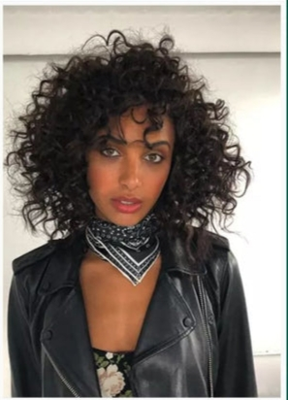

U-Cut

The U-cut is a simple yet elegant cut with the hair layered in a U-shape at the back. This cut enhances the natural flow of the hair, adding volume and texture while the edges remain smooth and even. It;’s ideal for medium to long hair and works well for those who prefer a clean, structured look.

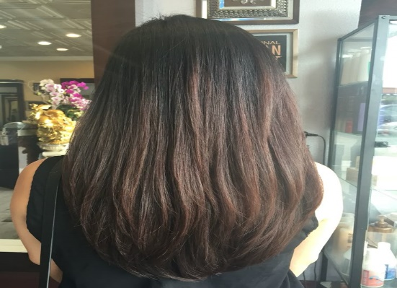

Feather cut

The feather cut is a textured, light-layered style that creates a soft, feathery look at the ends. The layers are cut to appear delicate and airy, offering a flowy, soft movement to the hair. It works beautifully on straight and wavy hair, adding volume without excess weight.



Long Step cut

The long step cut is a layered hair cut incorporating steps, or soft transitions, in length thoughout the hair. It adds volume and texture, with the layers starting from the chin and extending downwards to create a cascading effect. This cut is perfect for those with long hair who want movement and depth without compromising length.

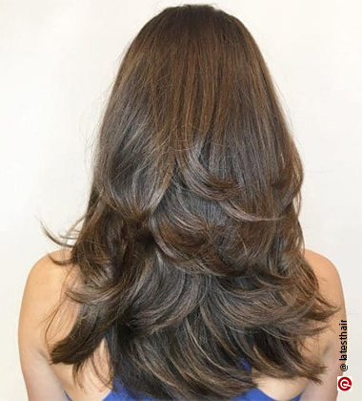

Mullet Haircut with layers

The Indian hairstyle for women combines the boldness of a mullet with the add texture and movement of layered cuts. The shorter front and longer back give the hair an edgy, rebellious feel, while the layers add volume and body. This style is ideal for women who want to embrace a retro, rock-inspired look with a modern twist.

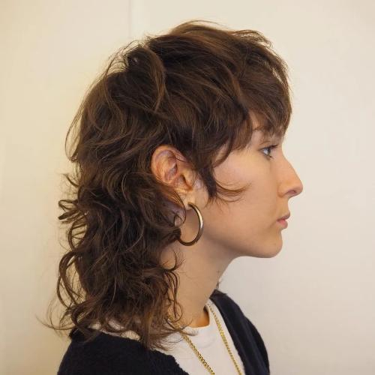

Chin-Length Blunt Bob with Side-Swept Bangs

The chin-length blunt bob with side-swept bangs is a chic, edgy style that combines precision and softness. The blunt bob creates a sharp, defined shape, while the side-swept bangs soften the look, framing the face beautifully. It’s perfect for women looking for a bold and flattering style with a touch of drama.

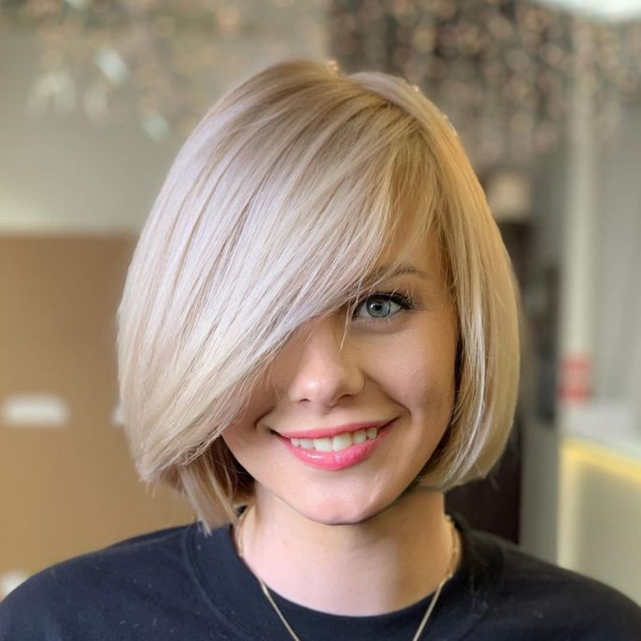

Classic Pixie cut

The classic pixie cut is short, chic, and low maintenance, offering a bold look with minimal styling. It works beautifully on women with angular features, creating a sophisticated, youthful appearance. The pixie can be tailored to suit any face shape, with subtle layers adding texture and volume.

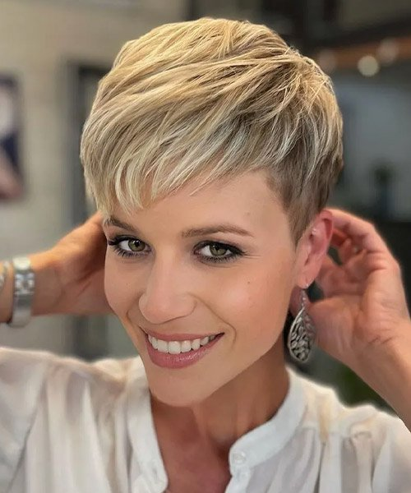

Asymmetrical bob

The asymmetrical bob features one side of the hair longer than the other, creating a dynamic, modern look. It’s an edgy style with sharp angles and an unexpected twist on the classic bob. This haircut works well with straight hair and is perfect for those looking to make a bold statement with their style.

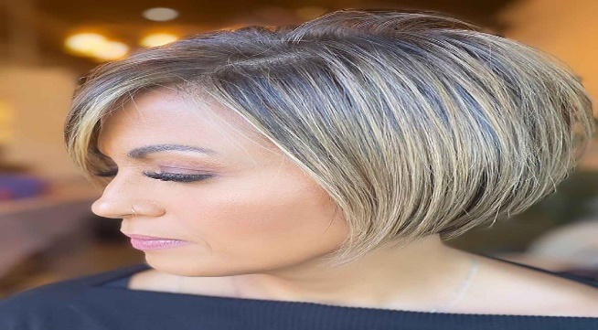

V Cut

The V-cut is a dramatic, angular hairstyle with a “V” shape at the back, giving it a sleek, elongated appearance. This cut is ideal for long hair, as it creates the illusion of volume without adding weight. It’s a great option for women who want a chic, structured look with plenty of movement.

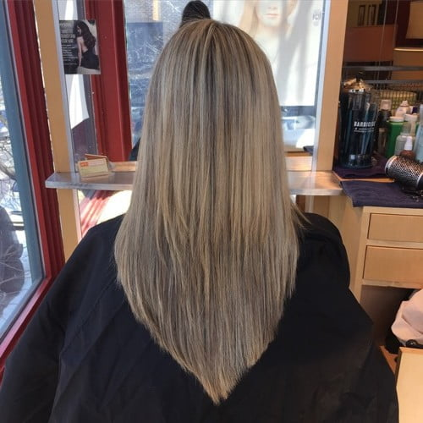

Curtain bangs

Curtain bangs are a softy, wispy fringe that frames the face, creating a relaxed and effortless vibe. They are parted in the middle and blend into the rest of the hair, providing a flattering and youthful look. This style works well with long and medium-length hair, offering a versatile fringe option for every face shape.

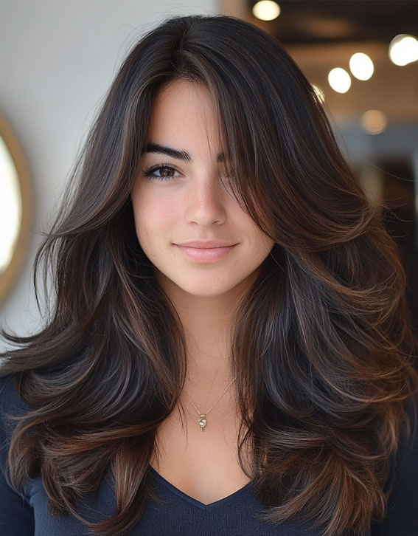

Butterfly cut

The butterfly cut is a modern, layered hairstyle that adds movement and volume. It often incorporates long, flowing, layers at the back and shorter layers around the face. This cut gives the illusion of fuller hair, creating a flattering, voluminous effect. It’s perfect for women who want a stylish and feminine look with minimal effort.

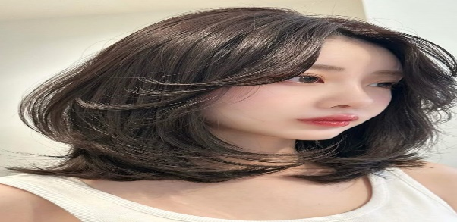

Blunt cut

The blunt cut is a bold, sleek style with sharp, straight-across edges. It offers a sharp contrast to softer, layered looks, making it an ideal choice for a clean, polished appearance. Best suited for straight hair, the blunt cut is a striking option that requires minimal styling to maintain its shape.

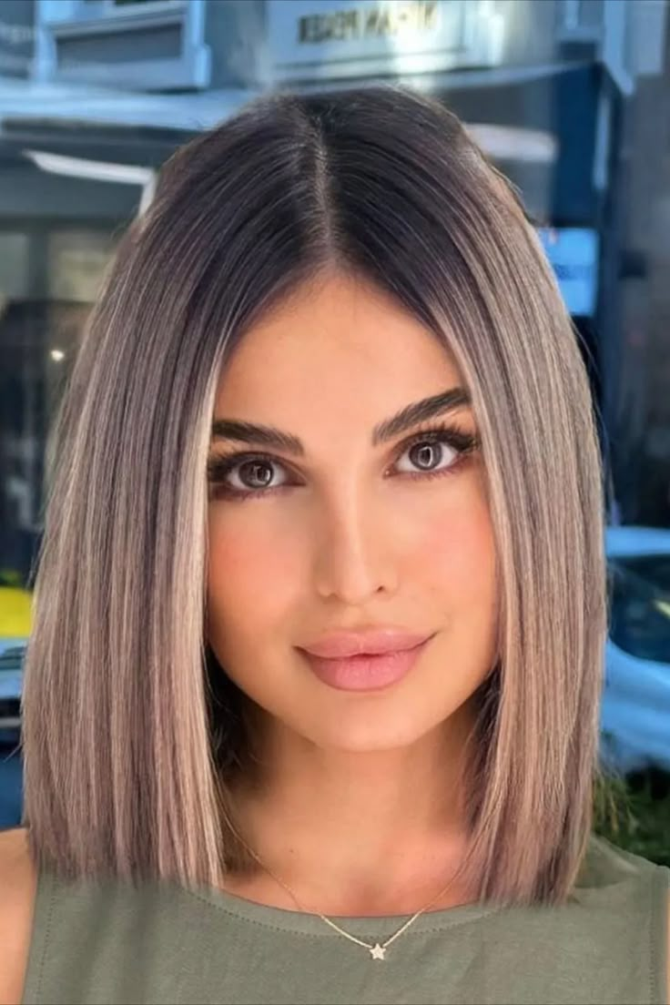

Short Wavy Bob

The short, wavy bob combines the chic look of a bob with the carefree charm of sot waves. This cut frames the face beautifully, adding volume and texture while maintaining a fresh, modern feel. It’s the best Indian hairstyle for those who want a low-maintenance yet stylish haircut full of movement.

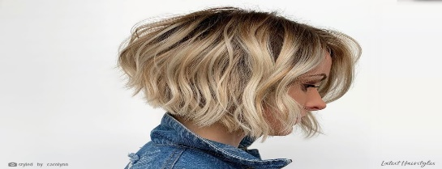

Classic layered haircut

The classic layered haircut is versatile and timeless for women with medium to long hair. Layers are cut to add texture and volume, enhancing the hair’s natural shape. This style works beautifully for straight and wavy hair, offering a balanced, flattering look that is easy to maintain.

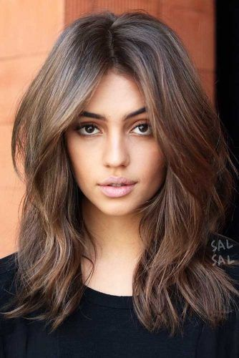

Classic Facial

A traditional classic facial includes cleansing, exfoliation, stream, massage, and a face mask. It’s the best facial for sensitive skin and provides numerous benefits, such as deep cleansing, removal of dead skin cells, improved blood circulation, hydration. A classic facial can revitalize and rejuvenate your skin, leaving it looking youthful and radiant.

Deep pore cleansing facial

The deep pore cleansing facial is ideal for those with oily or acne-prone skin. This acne facial deeply cleanses the pores, eliminates impurities such as dirt, oil, and dead skin cells, and reduces the appearance of large pores. It also enhances sin textures, reduces blackheads, and gives a refreshed appearance. A combination of cleansing, exfoliating, and extracting is used to achieve the desired results, and a facial streamer may be used to open up the pores.

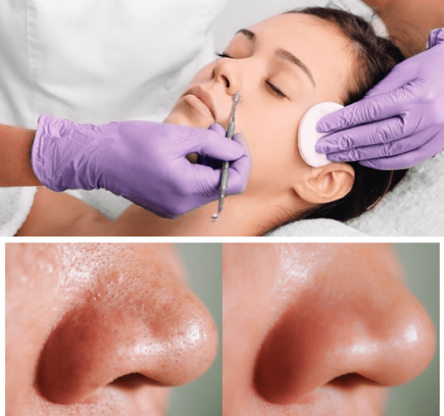

Microdermabrasion facial

The microdermabrasion facial is a non-invasive and mechanical exfoliation procedure that removes the outermost layer of dead skin cells, revealing a smoother, brighter complexion. This facial is suitable for all skin types and can reduce the appearance of fine lines, age spots, and acne scars. Additionally, it increases collagen production, improves skin texture, and evens out skin tone without any downtime.

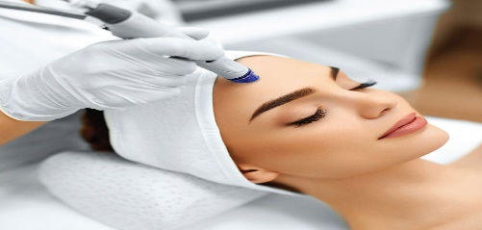

Chemical facial peel

A chemical facial peel is a cosmetic procedure that involves applying a chemical solution to the skin to remove dead skin cells and reveal smoother youthful looking skin. It is an excellent choice for people dealing with skin issues such as fine lines, wrinkles, acne scars, and uneven skin tone. The benefits of a chemical peel include improved skin texture, reduced fine lines and wrinkles, and an overall brighter and more youthful appearance.

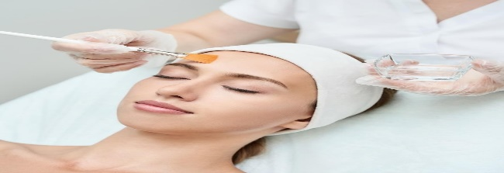

Vampire facial

The Vampire facial, also known as platelet-rich plasma PRP facial, is a ground-breaking skincare treatment that uses a patient’s blood to rejuvenate their skin’s appearance. The process involves drawing a small amount of the patient’s blood, processing it to isolate the platelet-rich plasma, and then applying it to the skin with micro-needling. It can reduce fine lines, wrinkles, and acne scars. The benefits include improved skin texture and tone, increased collagen production, and reduction in wrinkles and fine lines.



Silk peel facial

The Silk Peels facial, also known as Dermal infusion, is a non-invasive treatment that exfoliates, hydrates, and rejuvenates the skin. A diamond-tip wand is used to remove dead skin cells, and a customized serum is infused into the sin to target specific concerns such as acne, hyperpigmentation, or aging. It is great for all skin types and can be tailored to meet individual needs. The benefits include improved skin texture, reduced fine lines and wrinkles, increased hydration, and a brighter, more even skin tone.

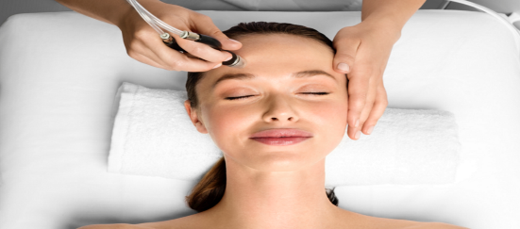

Microneedling

If you’re looking to reduce fine lines, wrinkles, and scars, microneedling could be the perfect facial for you. This treatment uses fine needles to create tiny punctures in your skin, stimulating collagen and elastin production. It’s ideal for improving skin texture, reducing pore size, and brightening your complexion .

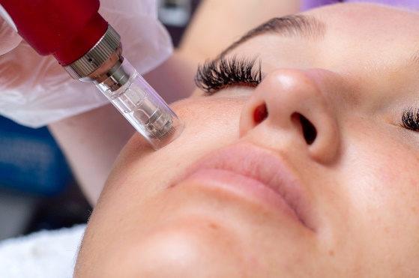

Dermaplaning

Dermaplaning is a gentle exfoliation technique that uses a surgical blade to remove dead skin cells and peach fuzz. This facial can help improve the appearance of dry, dull, or uneven skin, as well as fine lines. Dermaplaning has become popular due to the way it leaves your skin feeling soft and rejuvenated, making it a great choice for a pre-event treatment.

