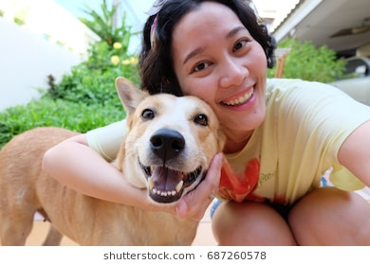

**JEN**

**“I love people and my dog. I would love to enjoy them both in my life.”**

**About**

Jen is an accountant who loves the outdoors and socializing. She lives with her dog, Bruce. Jen doesn’t get time to meet people outside of work very often but would love to spend more time with fellow dog owners. She loves to get outdoors on the weekends. She and Bruce enjoy going to parks, to the beach and going camping.

**Ultimate goals**

Wants to let Bruce interact with more dogs.

Wants to interact with more dog owners.

Wants an easy to use app to find what she needs.

**Interests**

Outdoors

Socializing

Travel