Design and Evaluation of an NLP-Based Recommender for Mental Wellness Resources in a Secure Web Platform

Abstract—Students under academic pressure often cannot find appropriate mental wellness support, and existing digital tools either scatter resources across platforms or process sensitive free text without evidence of safety. This paper presents the Mental Wellness Hub, a secure web platform whose core contribution is a safety-aware recommender that maps a student's free-text description of a concern to curated self-help resources, without diagnosis or treatment advice. The recommender compares keyword, sparse and dense sentence-embedding retrieval with a hybrid fusion, and is preceded by a crisis-detection gate that routes self-harm language to emergency support instead of recommendations. The platform uses the MERN stack with a security-by-design architecture: hashed credentials, short-lived tokens, field-level encryption, rate limiting and audit logging. A first system missed its pre-specified targets (crisis recall 0.76 against 0.95; recommendation p95 latency 4.8 s against 1 s). After a fix developed on development data only, the final system was evaluated once on a sealed held-out set of 128 author-written queries and 60 crisis queries. The hybrid ranker reached nDCG@5 = 0.518 (95% CI 0.465–0.564), 30% above BM25, with only a borderline margin over sentence embeddings alone. The crisis gate reached a recall of 0.95 (95% CI 0.88–1.00) at a 7.1% false-diversion rate. At 200 concurrent users on one laptop the 95th-percentile latency was 363 ms for API requests and 346 ms for recommendations. Code-mixed queries remain poorly retrieved, and all data are author-written. All 194 automated API tests passed in 19 repeated runs. A usability study is specified but has not yet been conducted. The system supports awareness and general wellness only and is not a substitute for professional care.
Keywords—Mental wellness, recommender system, natural language processing, sentence embeddings, crisis detection, responsible AI, web security

Introduction
Students at university level experience constant academic pressures and stigma and these problems stop them from asking for help. Technology gives access to information and resources [1]–[3]. But when a student says, "I can’t sleep before exams " he or she must search through lists to find a relevant resource. In this situation a distressed student often receives a suggestion instead of a direct referral, to a specific resource.
There are three reasons for doing this work. Firstly, platform studies primarily focus on user experience and feature coverage [4]-[6], while the quality of free text-to-resource matching is hardly benchmarked against a baseline. Secondly, the entry of free text into a mental health system constitutes a safety-critical interface, yet crisis handling is hardly ever defined or tested. Thirdly, sensitive information is held by these kinds of systems, and privacy and ethics research insists on consent-based and secure design [7]-[9].
The shortcomings mentioned above are addressed by our Mental Wellness Hub web portal, which incorporates awareness materials, self-help exercises, counselling and emergency requests, and whose recommender component is designed and evaluated as our primary research artefact. Our research questions are:
• RQ1. Which retrieval representation (keywords, sparse, dense, or hybrid) provides the most relevant self-help recommendations for students’ queries?
• RQ2. Is there any way to deploy a crisis gate that will be able to intercept the high-risk language prior to making any recommendations?
• RQ3. Can the platform satisfy basic requirements of security, performance and usability?
Contributions are the following: (1) a safety-aware recommendation engine that includes a crisis gate, a low-confidence failover, and a non-generative recommendation engine; (2) comparative evaluation of BM25, TF-IDF, sentence-embedding, and hybrid retrieval on a labelled query set; (3) a privacy-preserving and security-by-design architecture, threat model, and performed security tests; (4) a reproducible research methodology incorporating retrieval, safety, functional, security, load, and usability evaluations.

Related Work

Digital Mental Health Platforms
Current digital psychiatry includes various technologies like apps, chatbots, and social media tools [1]; the WHO classification serves as an agreed-upon terminology for digital health interventions [2]. Behavioural Intervention Technology Model determines how technical elements contribute to achieving the intervention objectives [10]; evaluation methods of digital interventions are covered in various reviews [3], [6]. Evaluation of web-based platforms using user-centered design [4] and user experience [5] has been done, and a cognitive behavioural therapy agent was tested in randomized controlled trials [11]. However, the above publications prove the importance and usability of the technology but don’t set the benchmark for mapping of student's words to the proper content.
- Positioning Against Related Work
Line of work | Typical evidence | Gap addressed here
Platform design studies [4], [5] | User-centred design; user experience | Retrieval quality and safety not benchmarked
Reviews and frameworks [3], [6] | Synthesis of evaluation practice | No executable protocol for free-text matching
Conversational agent trial [11] | Randomised trial of symptom outcomes | Not a retrieval benchmark or safety-gate test
This work | Retrieval, safety, security, load and usability in one protocol | —

Retrieval and Sentence Embeddings
However, sparse models like TF-IDF [12] and BM25 [13] are still very good, interpretable baselines [14]. Sentence-BERT yields dense sentence embeddings that can be compared using cosine similarity [15], while distillation techniques allow such models to run efficiently on small hardware, as done by MiniLM [16]. Ranking performance is traditionally measured using precision, reciprocal rank, and nDCG [17]. We use this toolkit in an application domain where it has not been used before.

Safety, Ethics and Privacy
Natural language processing can be employed to detect suicidal language in text [18], demonstrating feasibility and, more importantly, the cost of missing them; it therefore is a gate on the basis of the need for recall. Ethical/legal review processes emphasise consent, data protection, and accountability [7]–[9]. The Indian Digital Personal Data Protection Act [19] requires consent and purpose limitations as a matter of law, and we base our security threat assessment on OWASP Top Ten [20].

System Design

Architecture
The Hub is built using a 3-layer architecture (Figure 1). The client built using React and Tailwind CSS interacts with the REST API using the Node.js and Express framework over HTTPS (the API or a reverse proxy handles TLS). Authentication, authorization, validation, and rate limiting are performed by the REST API, which also handles storage in MongoDB and querying the recommendation from the Python (FastAPI) NLP service running in a private network. The client offers awareness information, self-help exercises (breathing, mood evaluation, gratitude journaling, memory game and relaxation), a counselling request form, an emergency screen and the recommender (Figure 2).
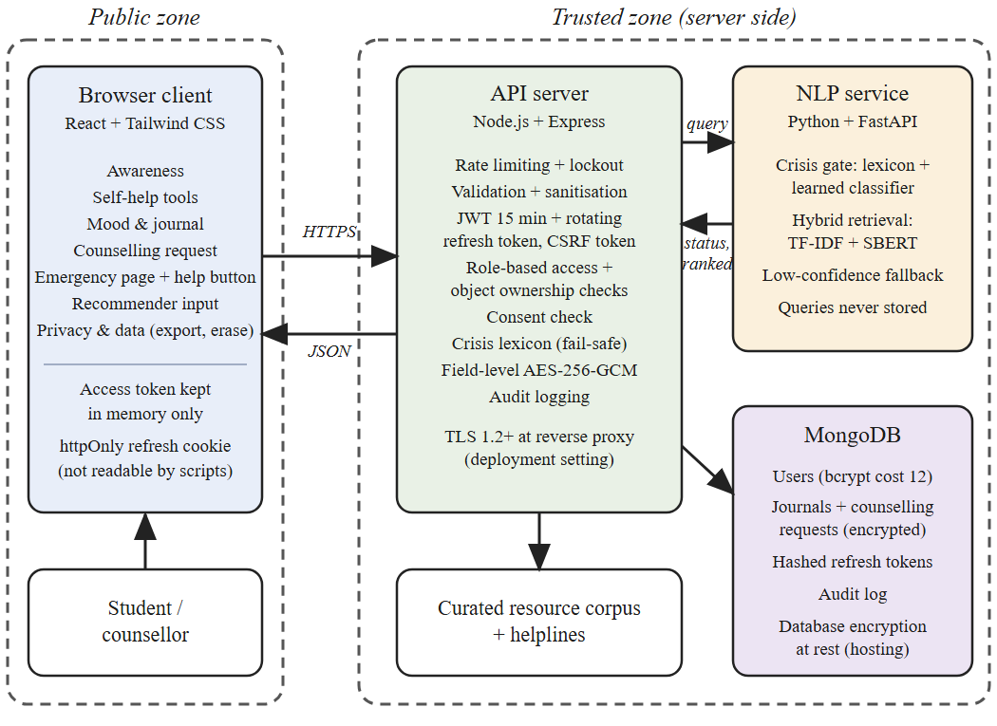
- System architecture with public and trusted zones.
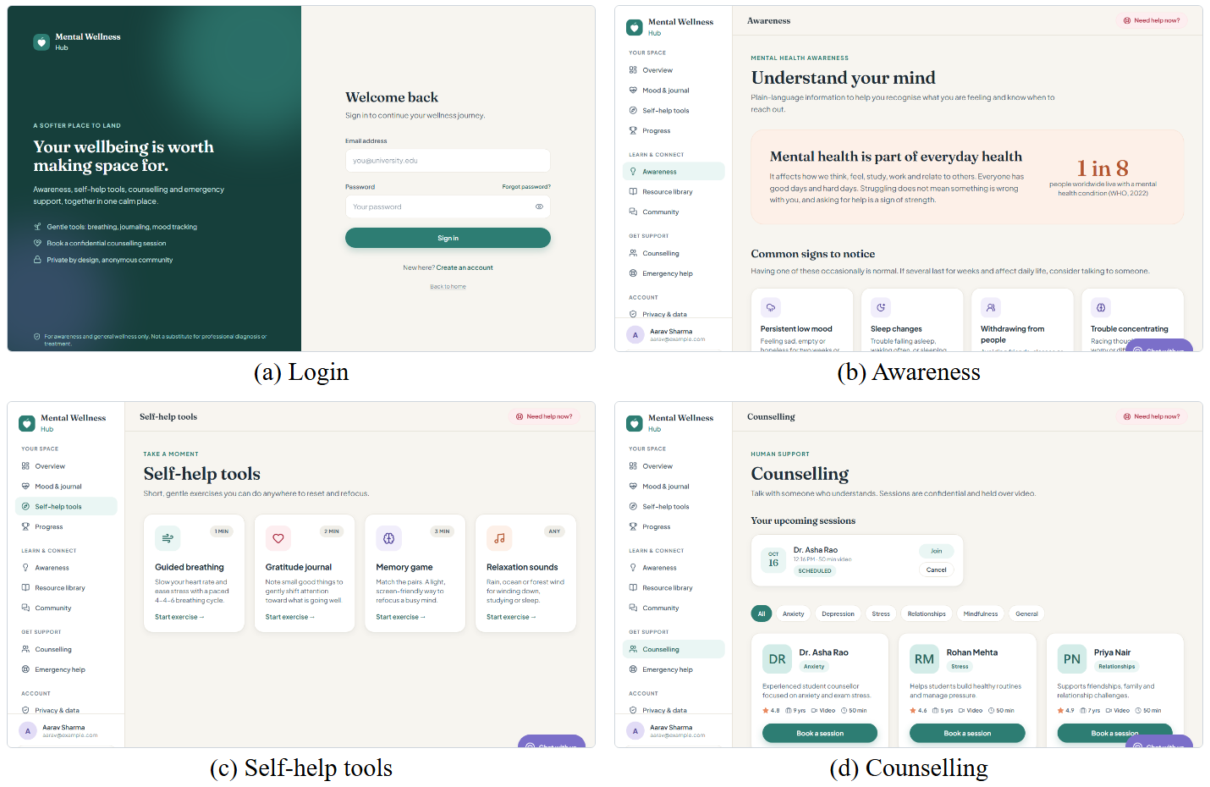
- Representative screens of the implemented client: (a) login, (b) awareness, (c) self-help tools and (d) counselling.

Security and Privacy by Design
Threats, taken from the OWASP Top Ten [20], are presented in Table II along with the associated control and the test used (Section V-D). The passwords are salted hashes using bcrypt with cost factor 12. Access tokens are JSON Web Tokens with 15 minutes validity and stored only in memory; the refresh tokens are sent in HTTP Only, Secure, and SameSite=Strict cookies and are invalidated every time they are used and can be invalidated server-side. Journals and counselling requests are encrypted with AES-256-GCM per field before being stored, besides the encryption of the databases at rest. Using again one of the invalidated refresh tokens invalidates all sessions of the same family.
- Threat Model and Verification
Threat | Control | Verified by
Brute force | bcrypt (cost 12); account lockout; limit of 5 failed attempts per 15 min | Rate-limit and lockout tests
Token theft or replay | Short-lived JWT; rotating httpOnly refresh cookie; revocation list | Expiry, rotation and revocation tests
Cross-site scripting | Output escaping; input sanitisation; CSP headers | Payload and header tests
CSRF | SameSite=Strict cookies; per-session anti-CSRF token on cookie-authenticated routes | Forged-request test
NoSQL injection | Schema validation; operator stripping | Injection payloads
Broken access control | Role-based access; object-level ownership checks | Authorisation matrix
Data exposure | TLS 1.2+ (deployment); field-level AES-256-GCM; keys outside database | Storage inspection

Consent, Minimisation and Retention
The user’s explicit consent during registration as well as for the recommender itself, separately, before its usage, is provided. The free-text search is performed in memory, is not saved anywhere, and the crisis events are recorded without the free-text search phrase. It is possible to export and delete users’ data, the text from the journals is deleted automatically after 180 days of use (by default, but moods scores are preserved to provide consistency of trends), and administrative access is audit-logged.

Recommendation Pipeline

Resource Corpus
The collection R comprises 60 self-help sources (texts, exercises, and brief readings) in 8 topics: exam anxiety, sleep problems, anxiety, low mood, loneliness, time management, relaxation and concentration, where each topic has 3 sub-topics. Every self-help source is characterized by the title, the description that consists of 27 to 48 words written by the authors, topics tags and estimated duration. Descriptions have been written not to contain any claims about diagnosing or treating disorders; consultation by a professional counsellor is the prerequisite of implementation.

Retrieval Models
Four ranking functions are compared. The BM25 [13] uses k1=1.5 and b=0.75 on the tokenized input following stop-word removal and rule-based suffix stripping (which is a light-weight lemmatization process) and removal of common Hinglish function words. The TF-IDF [12] uses unigram and bigram tokenization with sublinear term frequency, and measures cosine similarity between query q and resource r,
cos(q, r) = v_{q} · v_{r} / (‖v_{q}‖ ‖v_{r}‖) (1)
The model SBERT [15], [16] makes use of all-MiniLM-L6-v2 encoder for raw text with pre-calculated resource embeddings having 384 dimensions scored using (1). The hybrid ranker normalizes both scores to [0, 1] and combines them,
s_{H} = α ŝ_{S} + (1 − α) ŝ_{T} (2)
where ŝS and ŝT represent the normalised SBERT and TF-IDF scores. The scores are normalised using the min–max technique and fixed bounds (5th and 99th percentile of development scores for each ranker) instead of per query to maintain a usable confidence score after fusion. Fusion weights α and the confidence threshold τ are only learned from the development data set, and the list size is set to k = 5. When the highest score is below the threshold τ, category browsing replaces weak recommendations.

Crisis Gate
All queries go through a two-level gate prior to retrieval (Fig. 3). The first level compares the query to a lexicon of self-harm and suicidal language (25 patterns in English and Hinglish developed by the authors; expert assessment pending). The second level is a logistic-regression classification function g over the SBERT embedding and the hash of word and character n-grams, trained using 143 crisis and 423 non-crisis texts authored by the developers (development data only). If either the lexicon matches or g(q) ≥ θc (θc is the largest threshold where the cross-validation recall on this data achieves the 0.95 target), then the query is flagged. The previous system compared the query to 40 exemplar paraphrases (with the threshold optimized for F2). In case of a match or the flagging condition, the recommender is bypassed, and the user sees an emergency tab with national helplines (e.g., Tele-MANAS) and an instruction to reach out to a trusted individual or campus counsellor. The gate stage is incorporated into the API itself so that explicit mentions of self-harm are intercepted irrespective of whether the NLP service is available.
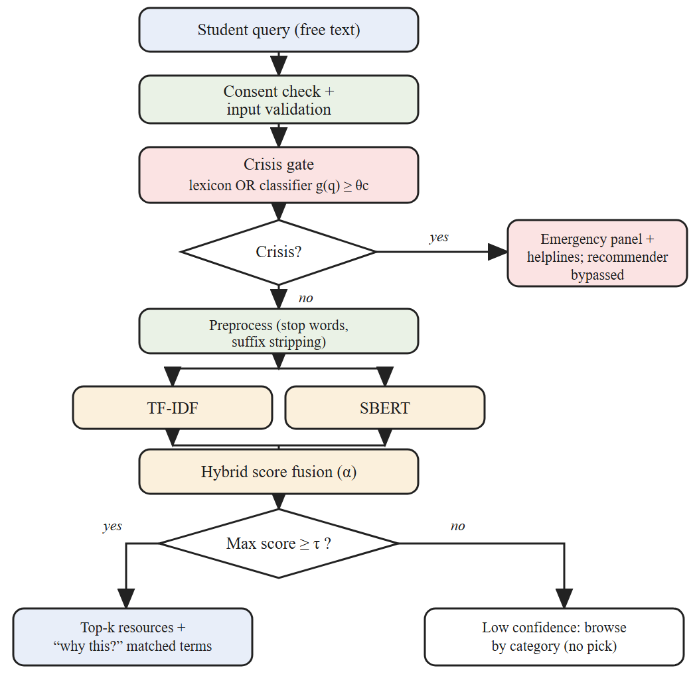
- Recommendation pipeline with crisis gate and low-confidence fallback. BM25 is a stand-alone baseline; the hybrid fuses TF-IDF and SBERT, and the gate's second stage is the learned classifier.
Algorithm 1 Safety-aware recommendation
Input: query q; corpus R; θ_{c}, τ, k, α
1 if lexicon(q) or g(q) ≥ θ_{c}: return EMERGENCY
2 q′ ← preprocess(q)
3 s_{T} ← TF-IDF(q′, R); s_{S} ← SBERT(q, R)
4 s_{H} ← α·norm(s_{S}) + (1−α)·norm(s_{T})
5 if max(s_{H}) < τ: return CATEGORY_BROWSE
6 return top-k of R by s_{H} with matched terms

Responsible-AI Constraints
Output is limited to retrieval alone; the system cannot produce new, unchecked advice or information. Each piece of advice is accompanied by “why this?” – a list of the terms and tags that match. A permanent banner is included, explaining that this is not medical treatment, and review of the corpus and lexicon is a requirement for release (unfulfilled).

Experimental Setup

Retrieval Data and Annotation
N_{Q} = 200 queries are composed using everyday language (24 queries with code-mixed Hinglish, 8 across multiple issues), based on fake user data. These are designed to address one of the sub-topics in the taxonomy of concerns; graded relevance comes from the taxonomy (2 for the target sub-topic, 1 for any other sub-topic within the issue, 0 otherwise). They are divided into development (60) and test (140) sets, 30/70 respectively, with stratification according to sub-topic. Following the first round of evaluation, a second set of 128 queries (24 code-mixed) was crafted without looking at the output of any models; these were verified to be disjoint from all previous texts, hashed with SHA-256, and evaluated only once after system freeze.

Baselines and Metrics
The ranking systems BM25, TF-IDF, SBERT, and the combined ranker are evaluated for k = 3 and 5 in terms of P@k, MRR and nDCG@k [17], where
DCG@k = Σ_{i=1..k} (2^{reli} − 1) / log₂(i + 1) (3)
and nDCG being the DCG normalized to its ideal value. Confidence intervals of 95% through bootstrapping (1000 samples) and paired bootstrap tests vs. BM25 are provided. P@k and MRR treat grade 2 results as relevant; since there are only two or three grade 2 documents per query, the highest possible value of P@5 is roughly 0.5.

Safety Evaluation
This set gives rise to 60 crisis-expressing queries (20 direct, 30 indirect, 10 code-mixed; 18 development and 42 test) and 270 non-crisis queries, while the held-out set contains NC=60 crisis queries (20 direct, 25 indirect, 15 code-mixed), and NN=198 non-crisis queries: 128 retrieval queries, 40 idiom hard negatives ("this exam is killing me") and 30 out-of-scope queries. All crisis queries are made up by the authors of this paper and are not provided by a mental health professional and actual users. They aim at testing the mechanism itself, not the clinical sensitivity. There is no overlap between the training and the held-out data for the classifier. We evaluate recall, precision and the recall-weighted score
F_{β} = (1 + β²) PR / (β²P + R), β = 2 (4)
with recall as the primary criterion, and the share of non-crisis queries wrongly diverted to the emergency panel.

Platform Testing
Functional: N_{T} = 194 automated API tests (using Jest, Supertest and in-memory MongoDB) and 13 NLP service and metrics tests (using pytest), 19 iterations of the former test suite out of 30 planned in order to identify flaky tests and measure line coverage (86.7%). The browser-based end-to-end tests are yet to be performed. Security: scripted payload, header, authorisation, token expiration, token rotation and rate-limit tests are described in Table II. No external vulnerability scanner or penetration test was executed. Performance: closed loop load test conducted with 50, 100 and 200 users concurrently (think time = 1 second, 30 seconds per level, 70% API reads and 30% recommendations) using one laptop with Intel Core i5-1334U CPU, 10 cores/12 threads, 15.7 GB RAM, Windows 11 which was hosting API, in-memory MongoDB, NLP workers and load generator; targets were defined before the test runs started.

Usability Study
A usability study is specified but has not yet been conducted, and no usability results are reported. The planned protocol has students complete five representative tasks (registering, a breathing exercise, logging a mood entry, finding a resource through the suggestion box and requesting a counselling session) and the ten-item System Usability Scale [22], scored with the supplied script and interpreted with published adjective ratings [23]. Participation will require informed consent and prior approval by the responsible institutional ethics body. No clinical data will be collected.

Reproducibility
Software versions, random seeds, the resource corpus, the author-written query sets with labels, the sealing hashes and all scripts will be released publicly with the final version of this paper and are available from the authors on request, to allow independent replication.

Results
Numbers mentioned below were all generated through the protocol in Section V. The results for the final system were obtained using the held out data which was in the sealed set and was run once when the system was frozen; the results of the first system on the first test split are cited for the sake of comparison. There was no change in the retrieval system between the two.

Retrieval Quality (RQ1)
- Retrieval Results on the Test Set
Method | P@3 | P@5 | MRR | nDCG@5
BM25 | 0.279 | 0.211 | 0.603 | 0.398
TF-IDF | 0.271 | 0.211 | 0.604 | 0.395
SBERT | 0.367 | 0.277 | 0.675 | 0.502
Hybrid | 0.393 | 0.287 | 0.689 | 0.518

The four rankers were compared on the held-out set (Table III): the inter-annotator agreement measure was not calculated since there is only one source for labelling (single annotator). The hybrid achieved the best nDCG@5 result (0.518, 95% CI 0.465–0.564), 30.1% better than that of BM25 (paired bootstrap p = 0.001, the lowest significance threshold possible for 1000 resamples); SBERT achieved 0.502 independently and TF-IDF performed identically to BM25. The difference between the results of the hybrid and SBERT was minimal and marginal (post hoc test: +0.015, 95% CI [+0.000, +0.032], p = 0.05). The retrieval component of the hybrid scored 0.550 on the first test split. The tuned parameters were α = 0.85, k = 5 and τ = 0.554; the fallback was activated for 16.4% of in-scope and 87% of out-of-scope queries. nDCG@5 of the hybrid was sensitive to the query style: keyword-sharing 0.72, multi-concern 0.62, paraphrase 0.55, long 0.51 and code-mixed 0.22. Out of the 10 worst-ranking queries, 7 were code-mixed Hinglish queries that are poorly handled by an English encoder and an English stop-word list, 2 long narratives and 1 paraphrase without any lexical overlap.

Safety, Platform and Usability (RQ2, RQ3)
- Safety, Platform and Usability Results
Measure | Result | Target
Crisis gate recall | 0.950 (57/60; 95% CI 0.883–1.000) | ≥ 0.95
Crisis gate precision / F₂ | 0.803 / 0.916 | —
Non-crisis wrongly diverted | 7.1% (14/198) | —
Functional tests passed (coverage) | 194 of 194 (86.7% lines); 19/19 runs | 100%
Security tests passed (auth, token, payload, crypto) | 54 of 54 | all
Authorisation matrix passed | 116 of 116 | all
p95 latency at 200 users (API / recommend) | 363 / 346 ms | ≤ 500 / ≤ 1000 ms
Error rate under load | 0.62% | < 1%

The results for Table IV include the performance of the system (gate + retrieval on the held-out set; platform tests on the final build). The gate detected 57 out of 60 crisis queries (recall 0.950, 95% CI 0.883–1.000): the point estimate is above the 0.95 goal, but the CI does include values lower than this. It detected 19 out of 20 direct, 23 out of 25 indirect, and 15 out of 15 code-mixed instances. The three false negatives included: “I cannot go on like this any more” (the lexicon pattern accepted “can't” but not “cannot”; corrected afterwards and not re-scored) and two implicit statements. It diverted 14 out of 198 non-crisis queries (7.1%): 7 out of 128 retrieval queries (4 English statements about self-worth, loneliness, or procrastination which the gate may appropriately interpret as sensitive, and 3 code-mixed) and 7 out of 40 idioms hard negatives. The lexicon alone managed to catch only 12 out of 60 (recall 0.20), so the API intercepts explicit statements only in case the NLP service is down and the persistent emergency button remains the last resort. The first gate achieved a recall of 0.76 at 10.6% false positives on the first test split and diverted all 15 code-mixed everyday queries. Defects discovered and corrected during testing were the ability to assign oneself an administrator role, account enumeration through the password reset response, and an oversized request resulting in a server error and a CORS header set for any origin. Load: the first build with one NLP worker failed to meet the recommendations target (p95 1642 ms at 100 and 4773 ms at 200 users). With torch threads pinned to workers and with three NLP workers, p95 was 19/39 ms (API/recommend) at 100 users and 363/346 ms at 200 users with 0.62% errors (18 timeouts in 2910 requests); the recommendations were met on this single laptop. Usability study hasn’t yet been done. These results confirm the conclusions made above only.

Discussion

Findings
RQ1: Dense retrieval definitely outperformed keyword matching (nDCG@5 +26% for SBERT and +30% for the hybrid compared to BM25), mostly due to paraphrasing and long queries; the hybrid's improvement over SBERT is marginal, so the fusion does not contribute much here, while the code-mixing queries still represent the major failing category. RQ2: The additional learning stage improved the recall from 0.76 to 0.95 and reduced the false diversion from 10.6% to 7.1% compared to the exemplar gate, however, the holdout range (0.88 – 1.00) still includes the values lower than the required one, idiomatics were diverted with 18%, and both the training and test texts belong to the same authors; therefore, it cannot be the only measure, which is why the permanent emergency button is not dependent on it. RQ3: All 194 API tests and 116-element authorization matrix passed successfully after the above-mentioned corrections. Pinning one thread to a worker and employing three workers per node allowed getting recommendation latency under the target value on a single node (346 ms for 200 users), though timeouts were observed during 200-user tests. In contrast to the platform testing in Table I, the contribution involves an executable and reproducible benchmark procedure for evaluating free-text matching, checking the safety pathway and ensuring the security controls in the same environment.

Threats to Validity
Internal: The relevance labels are created based on the taxonomy that is used to generate the queries, and the queries, the corpus and gate training texts are all written by the same people, which makes some systems more likely to succeed at finding that vocabulary and the absolute scores rather optimistic; there has been no independent annotation of the relevance judgements. The held out data was written after problems with the first system were known, and is biased towards code-mixed and indirect language (24 code-mixed queries; 25 indirect crisis queries). External: The queries and resources are author-written and predominantly in English, and may not apply to real students or real institutions, or even other languages. Construct: Topic-relatedness is not wellbeing-relatedness and the crisis dataset is constructed, not observed.

Limitations and Ethics
It does not include any clinical validation or long-term outcome results, as well as containing a small Hinglish subset in the crisis lexicon. The recall intervals for the gate are less than 0.95, the gate misidentifies idioms, and it retrieves poorly from code-mixed inquiries; therefore, it is not advisable to trust any of them until the changes mentioned below are made. The above-mentioned solution to the lexicon problem has been applied following the hold-out test run. Being able to pass all security tests guarantees that there are no vulnerabilities within the list but not necessarily that it is secure overall, as no scanner or penetration test has been conducted.

Conclusion and Future Work
We demonstrated the Mental Wellness Hub, a secure website where a safety-aware recommender retrieves self-help resources for student free-text questions and diverts crisis language to appropriate emergency services. A single methodology is used to assess the quality of retrieval, crisis gate, security and load, and usability study. The first implementation was not successful, however, after correcting the system based on development dataset, the evaluation in closed-set condition resulted in nDCG@5 score 0.518 for hybrid recommender and gate recall of 0.95 with 7.1% false diversions. Further steps involve creating a multilingual encoder and using code-mixed datasets for both retrieval and gate. In addition, more questions to be evaluated by independent annotators and counsellors, calibrating the gate with real data with informed consent, learning-to-rank using feedback from users with informed consent, performing multi-institution and longitudinal studies, and conducting privacy impact assessment.

Acknowledgment
The authors would like to express their sincere gratitude to the project guide for valuable guidance, support and suggestions during the entire tenure of this project. We also would like to thank you our college for providing necessary resources and facilities for this work. Last but not least, we would like to thank all team members for their hard work, dedication and cooperation in completing the project.

References
- J. Torous et al., “The growing field of digital psychiatry: Current evidence and the future of apps, social media, chatbots, and virtual reality,” World Psychiatry, vol. 20, no. 3, pp. 318–335, 2021, doi: 10.1002/wps.20883.
- World Health Organization, Classification of Digital Interventions, Services and Applications in Health, 2nd ed. Geneva, Switzerland: WHO, 2023.
- L. Balcombe and D. De Leo, “Evaluation of the use of digital mental health platforms and interventions: Scoping review,” Int. J. Environ. Res. Public Health, vol. 20, no. 1, p. 362, 2023, doi: 10.3390/ijerph20010362.
- W. W. S. Mak, S. M. Ng, and F. H. T. Leung, “A web-based stratified stepped care platform for mental well-being (TourHeart+): User-centered research and design,” JMIR Form. Res., vol. 7, p. e38504, 2023, doi: 10.2196/38504.
- S. R. Koushkaki et al., “Users’ experiences with web-based mental health app during COVID-19,” J. Technol. Behav. Sci., vol. 9, pp. 671–680, 2024, doi: 10.1007/s41347-023-00371-w.
- J. Catania et al., “Evaluation of digital mental health technologies in the United States: Systematic literature review and framework synthesis,” JMIR Ment. Health, vol. 11, p. e57401, 2024, doi: 10.2196/57401.
- C. L. Hall, A. D. Gómez Bergin, and S. Rennick-Egglestone, “Research into digital health intervention for mental health: 25-year retrospective on the ethical and legal challenges,” J. Med. Internet Res., vol. 26, p. e58939, 2024, doi: 10.2196/58939.
- N. Martinez-Martin, “A broader approach to ethical challenges in digital mental health,” World Psychiatry, vol. 23, no. 3, pp. 394–395, 2024, doi: 10.1002/wps.21237.
- S. R. Pendse et al., “Advancing a consent-forward paradigm for digital mental health data,” Nat. Ment. Health, vol. 2, pp. 1298–1307, 2024, doi: 10.1038/s44220-024-00330-1.
- D. C. Mohr et al., “The Behavioral Intervention Technology Model: An integrated conceptual and technological framework for eHealth and mHealth interventions,” J. Med. Internet Res., vol. 16, no. 6, p. e146, 2014, doi: 10.2196/jmir.3077.
- K. K. Fitzpatrick, A. Darcy, and M. Vierhile, “Delivering cognitive behavior therapy to young adults with symptoms of depression and anxiety using a fully automated conversational agent (Woebot): A randomized controlled trial,” JMIR Ment. Health, vol. 4, no. 2, p. e19, 2017, doi: 10.2196/mental.7785.
- G. Salton and C. Buckley, “Term-weighting approaches in automatic text retrieval,” Inf. Process. Manag., vol. 24, no. 5, pp. 513–523, 1988.
- S. Robertson and H. Zaragoza, “The probabilistic relevance framework: BM25 and beyond,” Found. Trends Inf. Retr., vol. 3, no. 4, pp. 333–389, 2009.
- C. D. Manning, P. Raghavan, and H. Schütze, Introduction to Information Retrieval. Cambridge, U.K.: Cambridge Univ. Press, 2008.
- N. Reimers and I. Gurevych, “Sentence-BERT: Sentence embeddings using Siamese BERT-networks,” in Proc. EMNLP-IJCNLP, Hong Kong, China, 2019, pp. 3982–3992.
- W. Wang et al., “MiniLM: Deep self-attention distillation for task-agnostic compression of pre-trained transformers,” in Proc. NeurIPS, vol. 33, 2020, pp. 5776–5788.
- K. Järvelin and J. Kekäläinen, “Cumulated gain-based evaluation of IR techniques,” ACM Trans. Inf. Syst., vol. 20, no. 4, pp. 422–446, 2002.
- G. Coppersmith, R. Leary, P. Crutchley, and A. Fine, “Natural language processing of social media as screening for suicide risk,” Biomed. Inform. Insights, vol. 10, 2018, Art. no. 1178222618792860, doi: 10.1177/1178222618792860.
- Government of India, “The Digital Personal Data Protection Act, 2023,” Act No. 22 of 2023, 2023.
- OWASP Foundation, “OWASP Top Ten 2021,” 2021. [Online]. Available: https://owasp.org/Top10/
- J. Cohen, “A coefficient of agreement for nominal scales,” Educ. Psychol. Meas., vol. 20, no. 1, pp. 37–46, 1960.
- J. Brooke, “SUS: A quick and dirty usability scale,” in Usability Evaluation in Industry, P. W. Jordan et al., Eds. London, U.K.: Taylor & Francis, 1996, pp. 189–194.
- A. Bangor, P. T. Kortum, and J. T. Miller, “An empirical evaluation of the System Usability Scale,” Int. J. Hum.-Comput. Interact., vol. 24, no. 6, pp. 574–594, 2008.

